

Modul Profile Manager

MicroStep HDO s.r.o

júl 2025

Pracovné postupy

Content

Obsah 5

1. Aplikácia Profile Manager 11

1.1. Ako sa prihlásiť do aplikácie 11

1.2. Horná lišta aplikácie 12

1.3. Zmena farby hornej lišty aplikácie 16

1.4. Ako pridať na plochu okná prieskumník, tabuľka a graf 16

1.4.1. Pravidlá pre názvy okien 17

1.5. Ako sa odhlásiť z aplikácie 18

1.6. Ako zmeniť jazykovú verziu 19

1.7. Ako zmeniť predvolené nastavenia 19

1.8. Ako zobraziť profil prihláseného užívateľa 20

1.9. Globálny dátumový rozsah 21

1.9.1. Ako aplikovať dátumový filter vo vybranom okne 22

1.9.2. Ako aplikovať dátumový filter vo všetkých oknách naraz 23

1.10. Ako obnoviť viditeľné dáta 23

1.11. Všeobecné nastavenia 23

1.11.1. Globálne všeobecné nastavenia 23

1.11.2. Všeobecné nastavenia pre tabuľku 28

1.11.3. Všeobecné nastavenia pre graf 31

1.11.4. Všeobecné nastavenia pre prieskumník 33

1.12. Nastavenia pre sviatky 35

1.12.1. Ako vytvoriť profil pre sviatky 35

1.12.2. Ako vybrať profil pre sviatky 39

1.12.3. Ako odstrániť profil pre sviatky 40

1.13. Ako zobraziť informácie o statuse 40

1.14. Ako zobraziť upozornenia 41

1.15. Ako zväčšiť okno stromovej štruktúry 42

1.16. Synchronizácia panelov 44

1.16.1. Zarovnať časové rozsahy 44

1.16.2. Ako synchronizovať tabuľky 45

1.16.3. Ako synchronizovať grafy 47

1.17. Ako importovať, exportovať a ukladať zostavy 47

1.17.1. Ako importovať zostavu 48

1.17.2. Ako exportovať zostavu 50

1.17.3. Ako aktualizovať zostavu 50

1.17.4. Ako uložiť novú zostavu 52

1.17.5. Ako zarovnať zostavu do stĺpcov 54

1.17.6. Ako zarovnať zostavu do riadkov 56

1.17.7. Ako zarovnať všetko do jedného panelu 58

1.17.8. Ako rozdeliť zostavu do samostatných panelov 58

1.17.9. Ako nastaviť globálny časový rozsah pri zobrazení zostavy 59

1.17.10. Ako zatvoriť zostavu 61

1.18. Ako horizontálne zarovnať okná 62

1.19. Ako vertikálne zarovnať okná 63

1.20. Ako zobraziť a stiahnuť exporty 63

1.21. Ako zobraziť importy 65

1.22. Klávesové skratky 67

1.23. Ako vyhľadať profil v aplikácii 71

1.24. Informovanie užívateľa o odhlásení 71

1.25. Ako zobraziť čas, ktorý ostáva užívateľovi do odhlásenia 72

2. Práca s adresármi a profilmi 74

2.1. Ako pridať nový adresár 74

2.2. Ako premenovať adresár 76

2.3. Ako editovať adresár 77

2.4. Ako zmazať adresár 78

2.5. Ako kopírovať adresár 78

2.6. Ako vystrihnúť/presunúť adresár 79

2.7. Ako nahrať súbor 79

2.8. Ako zmazať dáta profilov 81

2.9. Ako filtrovať adresáre a profily 84

2.10. Ako zrušiť filter adresárov a profilov 85

2.11. Ako zobraziť komentáre 85

2.12. Ako zobraziť tooltip 86

2.13. Ako zobraziť charakter 88

2.14. Ako obnoviť zoznam 89

2.15. Ako nastaviť práva používateľov a skupín 89

2.16. Ako vytvoriť export 94

2.17. Ako vytvoriť import 98

2.18. Ako pridať nový profil 101

2.18.1. Ako zadať definíciu pre počítaný typ profilu 105

2.19. Ako pridať novú zostavu 112

2.20. Ako premenovať profil 113

2.21. Ako editovať profil 113

2.22. Ako zmazať profil 114

2.23. Ako zobraziť závislosti profilu 114

2.24. Ako vytvoriť nový profil 116

2.25. Ako nastaviť Politiku profilu 116

2.26. Ako zobraziť informácie o profile 117

2.27. Ako skopírovať profil 118

2.28. Ako vystrihnúť/presunúť profil 121

2.29. Ako zobraziť náhľad časovej rady v strome 122

2.30. Ako zväčšiť okno pre vytvorenie a úpravu počítaného profilu 123

2.31. Ako premiestniť okná 123

2.32. Ako premenovať dokument 124

3. Spoločné ovládacie prvky pre prieskumník, tabuľku a graf 125

3.1. Ako obnoviť dáta v oknách 125

3.2. Ako zmeniť dátumový rozsah 125

3.3. Ako zväčšiť okno cez celú plochu aplikácie 126

3.4. Ako zatvoriť okno 127

3.5. Nastavenie názvu a farby panelu 127

3.6. Ako exportovať zobrazené dáta z okna Prieskumník 129

3.7. Ako skryť horný panel s tlačidlami v okne prieskumník, tabuľka a graf 129

3.8. Ako pridať profil do grafu a tabuľky 130

4. Práca s oknom Prieskumník 132

4.1. Ako zobraziť profily z vybraného adresára v okne Prieskumník 132

4.2. Ako vytvoriť nový adresár 132

4.3. Ako synchronizovať prieskumník so stromom 132

4.4. Ako filtrovať profil 133

4.5. Ako zoradiť dáta v stĺpcoch 134

4.6. Ako vypočítať hodnoty v stĺpcoch Min, Max, Sum, Avg a Count v okne Prieskumník 134

4.7. Náhľad časovej rady 135

4.8. Ako presunúť profil z okna Prieskumník do okna Graf alebo Tabuľka 138

4.9. Ako upraviť pridať alebo odobrať stĺpce v okne Prieskumník 139

4.10. Ako upraviť polia Názov a Komentár 141

4.11. Funkcie pre prácu s adresármi v okne Prieskumník 141

4.12. Funkcie pre prácu s filtrami v okne Prieskumník 142

4.13. Tlačidlo Branch view 143

4.14. Ako zobraziť vymazané položky v okne Prieskumník 145

4.15. Ako skopírovať zobrazené dáta 146

4.16. Použiť ako východzie nastavenie Prieskumníka 148

4.17. Ako filtrovať v stĺpcoch pomocou * wildcard 149

5. Práca s grafom 152

5.1. Ako zobraziť profil v grafe 152

5.2. Ako zobraziť informačné okno s hodnotami pre konkrétne miesto v grafe 153

5.3. Ako zmeniť v grafe dátum od-do 155

5.4. Ako uložiť graf vo formáte JPG 155

5.5. Ako skopírovať celý graf do nového okna 155

5.6. Ako nastaviť parametre grafu 156

5.6.1. Ako nastaviť počet desatinných miest pre každú z Y-ových osí 158

5.6.2. Ako vypnúť vodorovné čiary 159

5.7. Funkcie pre prácu nad označenými profilmi 160

5.7.1. Ako vybrať profily 161

5.7.2. Ako zobraziť vlastnosti profilu 161

5.7.3. Ako zmeniť nastavenia označeným 162

5.7.4. Ako označiť všetky profily 164

5.7.5. Ako odznačiť všetky profily 165

5.7.6. Ako invertovať označené profily 166

5.7.7. Ako zobraziť len označené profily 167

5.7.8. Ako označené profily nezobrazovať 167

5.7.9. Ako odstrániť označené, všetky alebo chybné profily 168

5.7.10. Ako nastaviť koeficient označeným profilom 169

5.7.11. Ako nastaviť offset 171

5.7.12. Ako zobraziť štatistické čiary 172

5.7.13. Ako nahradiť text označeným 174

5.8. Funkcie pre prácu s jedným profilom 175

5.8.1. Ako upraviť nastavenia 176

5.8.2. Ako odstrániť profil 178

5.8.3. Ako presunúť profil na začiatok 179

5.8.4. Ako posunúť profil hore 180

5.8.5. Ako posunúť profil dole 181

5.8.6. Ako presunúť profil na koniec 181

5.8.7. Ako zobraziť komentár 182

5.8.8. Ako nájsť prvú hodnotu 183

5.8.9. Ako nájsť poslednú hodnotu 183

5.8.10. Ako zobraziť subprofily 184

5.8.11. Ako otvoriť umiestnenie profilu 185

5.8.12. Ako otvoriť info okno 187

5.8.13. Ako nastaviť koeficient 189

5.8.14. Ako zadať offset 190

5.8.15. Ako vymeniť profil 193

5.8.16. Ako editovať profil 194

5.8.17. Ako nastaviť farbu pre profil 196

5.8.18. Ako nastaviť veľkosť bodu 197

5.8.19. Ako zobraziť profil v tabuľke 201

5.9. Rýchla zmena typu grafu 203

5.10. Ako priblížiť vybranú časť grafu 205

5.11. Ako posúvať graf 206

5.12. Ako zrušiť zoom 207

5.13. Ako zobraziť/skryť legendu 207

5.14. Ako zobraziť/skryť tooltip 208

5.15. Ako nastaviť y-ovú os, aby bolo vidieť hodnoty 209

5.16. Ako vymeniť profil 211

6. Práca s tabuľkou 215

6.1. Ako zobraziť profil v tabuľke 215

6.2. Ako nastaviť stĺpcové zobrazenie 216

6.3. Ako prepnúť na jednoprofilové zobrazenie 217

6.4. Ako zmeniť časový formát zobrazenia 219

6.5. Ako nastaviť počet stĺpcov 219

6.6. Ako vybrať spôsob prevzorkovávania 221

6.7. Ako zobraziť prvú hodnotu 222

6.8. Ako zobraziť poslednú hodnotu 222

6.9. Ako zobraziť aktuálny deň 222

6.10. Ako zobraziť konkrétny dátum 223

6.11. Ako posúvať dátum o deň, týždeň, mesiac 224

6.12. Ako pridať stĺpec Suma, Priemer, Min, Max 225

6.13. Ako zapnúť/vypnúť tooltip 226

6.14. Ako zapnúť/vypnúť zvýraznenie riadku 227

6.15. Ako upraviť hodnotu profilu v tabuľke 228

6.16. Ako zmeniť definíciu profilu 229

6.17. Ako odstrániť profil z tabuľky 230

6.18. Ako zapnúť automatické nastavenie šírky stĺpcov 230

6.19. Ako otvoriť umiestnenie profilu 231

6.20. Ako pridať profil 232

6.21. Ako exportovať zobrazené dáta do CSV 235

6.22. Ako zmeniť definíciu 236

6.23. Ako zmeniť metadáta profilu 236

6.24. Ako odstrániť profil zo zobrazenia 238

6.25. Ako zobraziť profil v grafe 239

6.26. Ako nájsť pozíciu v grafe 240

6.27. Ako otvoriť profil v strome 241

6.28. Označiť blok pomocou ľavého tlačidla myši 241

6.29. Ako nastaviť, aby sa kurzor posúval v tabuľke pomocou kolieska myši 242

6.30. Ako zmeniť poradie profilov v tabuľke 244

7. Aritmetika počítaných profilov 247

7.1. Pravidlá prevzorkovávania 247

7.1.1. Pravidlá prevzorkovávania vstupného profilu na výstupný so zohľadnením charakteru 247

7.2. Počítaný profil 248

7.2.1. Spôsob zápisu výrazu 250

7.2.2. Vyčíslenie výrazu 250

7.2.3. Aritmetické operácie: 250

7.2.4. Funkcie 251

8. Príplatkové/doplnkové funkcie 262

8.1. Monitorovanie profilov 262

8.1.1. Ako vytvoriť nový monitorovací job 262

8.1.2. Ako editovať job v JMW 268

8.1.3. Ako zmazať job 269

8.1.4. Ako exportovať monitorovacie joby a výsledky jobov 269

8.1.5. Ako zobraziť všetky monitorovacie joby 270

8.1.6. Ako obnoviť zoznam jobov v okne „Monitoring“ 270

8.1.7. Ako zobraziť prehľad výsledkov monitorovacieho jobu 270

8.2. Analýza profilov 270

8.2.1. Ako vytvoriť analýzu profilov 271

8.2.2. Ako zobraziť existujúcu analýzu profilov 274

8.2.3. Ako zmeniť platnosť vytvorenej analýzy profilov 275

8.2.4. Ako exportovať zobrazené dáta v analýze profilov 275

8.3. Report Manager 276

8.3.1. Ako vytvoriť nový report 276

8.3.2. Práva pre Report Manager 283

8.4. Ako obnoviť vymazané položky z koša 284

# Profile Application Manager

"The 'Profile Manager' application is a tool serving for the presentation of profiles (time series) in graphical or tabular form as well as their basic management. A profile is an unbounded sequence of values of different significance. Documentation applies to version 4.3.301."

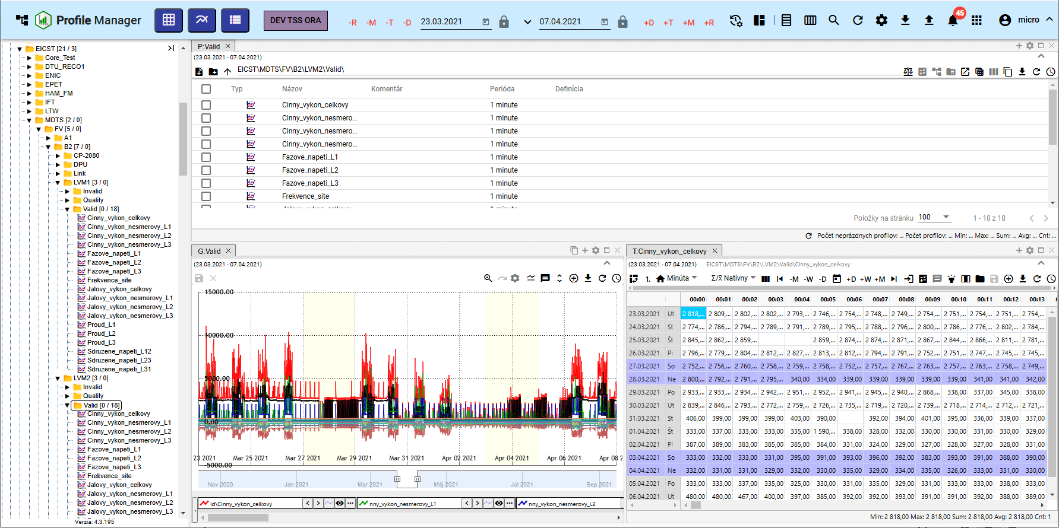

Image 1: Profile Manager application

## I want to sign up for the application

"When launching the 'Profile Manager' application, a login screen will appear. You need to enter your username and password. Ticking the box 'Remember Me' will cause you not to have to re-enter your login information at the next login. The application remembers them instead. Press the 'Log In' button for login."

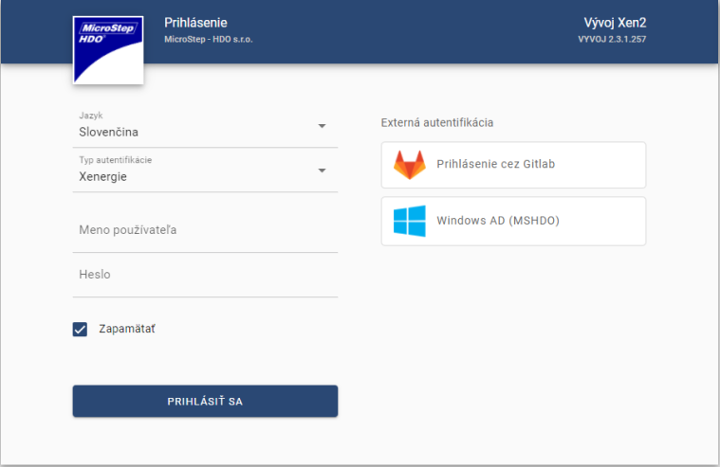

Image 2: Registration to the application "Profile Manager"

## Upper application list

"In the top menu of the application, there is:"

* "a button which allows minimizing and maximizing an application's menu"

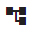

Image 3: Button for hiding and displaying the application menu.

* The name of the application is “Profile Manager” – after pressing the button, the Profile Manager application is loaded again.

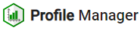

"Picture 4: Button 'Profile Manager'"

* "The 'Add table' button - by dragging the button to the screen, an 'Table' window will be added."

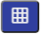

Picture 5: Add table button

* "Button 'Add Graph' - serves to add a window 'Graph' on the application screen."



Image 6: Button "Add Graph"

* "Button 'Add Inspector' - by moving the button to the application screen, you will add a window 'Inspector'."



Picture 7: Button "Add Scout"

* "The button representing the name of the environment - for the button, it is possible to set the text as well as the color."



Picture 8: Environment Title

* Global time range - represents a date filter, chapter 1.9



"Image 9: Global date range"

* The "Sync panels" button – allows to sync time ranges (1.16.1) and synchronize tables (1.16.2)



Image 10: Sync Panel Button

* "download and export buttons - procedures are described in chapter 1.17"



Picture 11: Stay button

* "button for profile search - profile searching is described in chapter 1.23"



Button 12: Search Profile

* "Button 'Restore visible data' - serves for restoration of data in application, chapter 1.10"



Picture 13: Refresh Visible Data Button

* The "Export" button - contains a list of exports, chapter 1.20.



Image 14: Export button

* The "Import" button – contains a list of imports, chapter 1.21.



Image 15: Import button

* The "Notifications" button - indicates performed changes in the application, chapter 1.14



Picture 16: Warning button

* "Button to display application list. There is a list of applications for the given environment here. By clicking on an application in the list, the application will open in a new browser tab."



Picture 17: Button for displaying list of applications

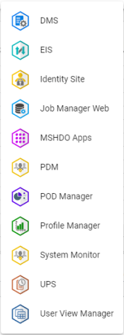

Picture 18: List of Applications

* "login button, which allows:"
  + Menu language version of application, chapter 1.6,
  + Restore preselected settings, chapter 1.7,
  + "display keyboard shortcuts,"
  + View profile, 1.8,
  + "Displaying information about the application and service state, chapter 1.13,"
  + **[TRANSLATION FAILED AFTER 3 RETRIES] odhlásenie z aplikácie, kapitola 1.5.**

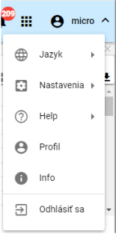

"Image 19: Button with the name of the registered user"

* "The 'Hide upper tool rail' button serves to hide the upper rail, after which the appearance of the button changes and it serves to display the upper tool rail, Figure 21."

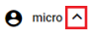

Picture 20: Button "Hide Upper Slide Rail"

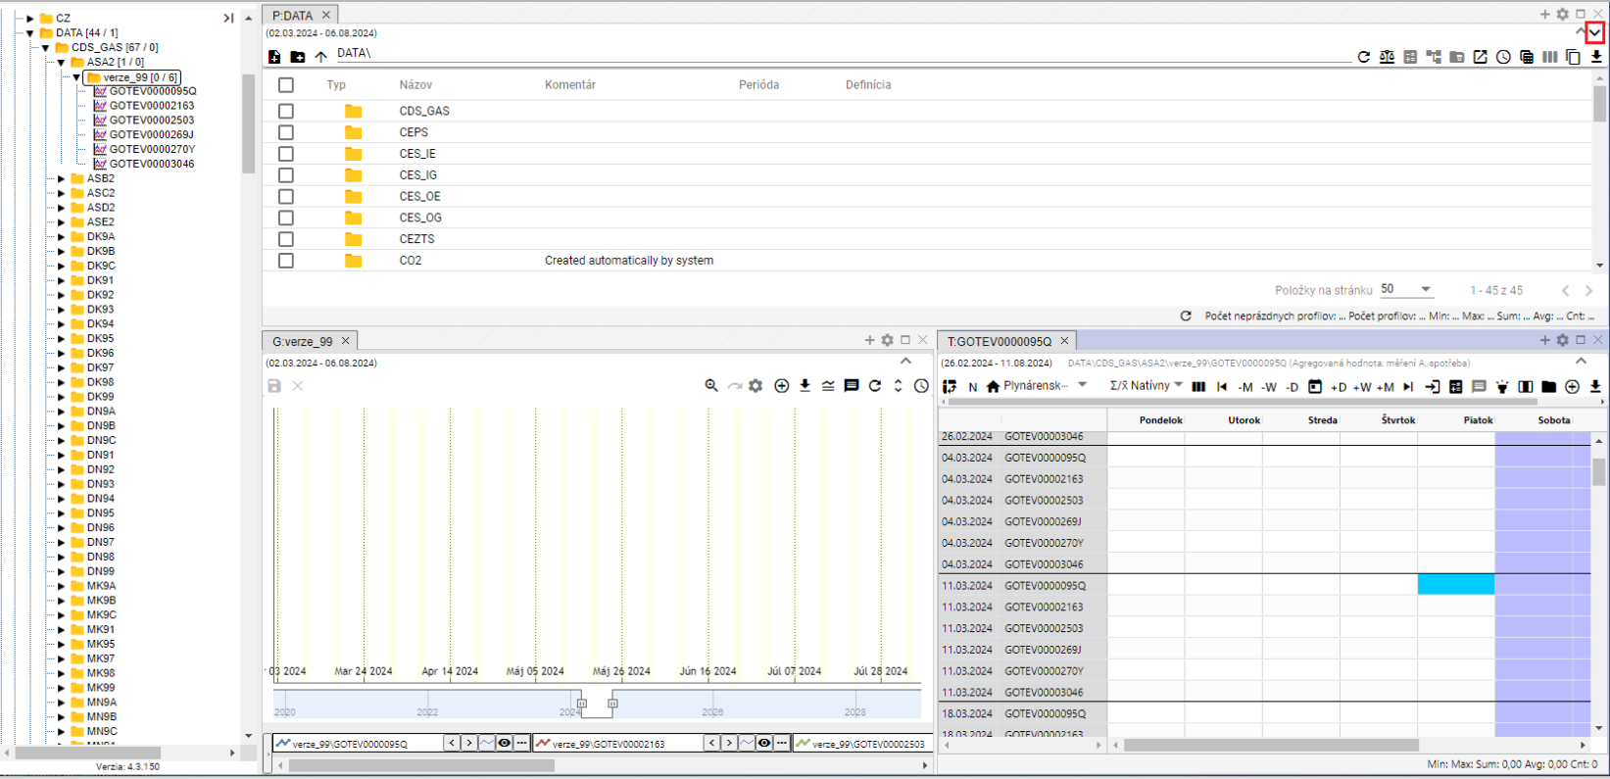

"Image 21: Button for showing top tool strip"



"Picture 22: Top bar of application"

## Colour change of the top bar of the application

The customer may request a change of the top strip color of the tools. A change of the top strip color serves to distinguish the Developmental, Testing and Production environment.



Image 23: Top bar of application

## To add to the window area an inspector, table and graph

"The explorer window, table and graph can be added in any quantity to the profile manager application area. Proceed:"

1. "Left-click on the mouse button and drag it to the application surface."
2. Hold the button above the surface and slide to the place where you want to add a window.
3. Choose the shape that the window should have.

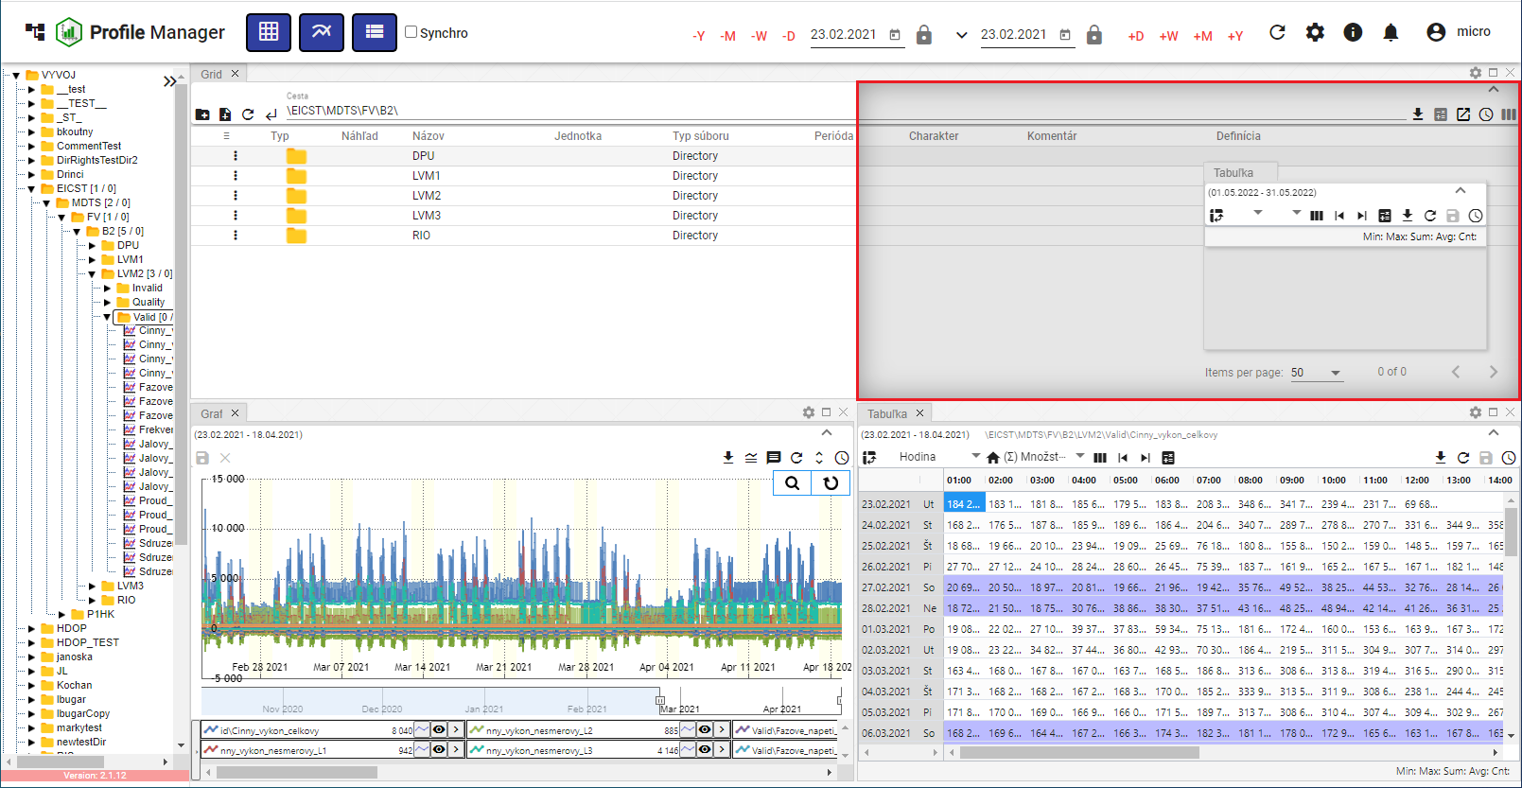

Picture 24: Selection of window shape and placement

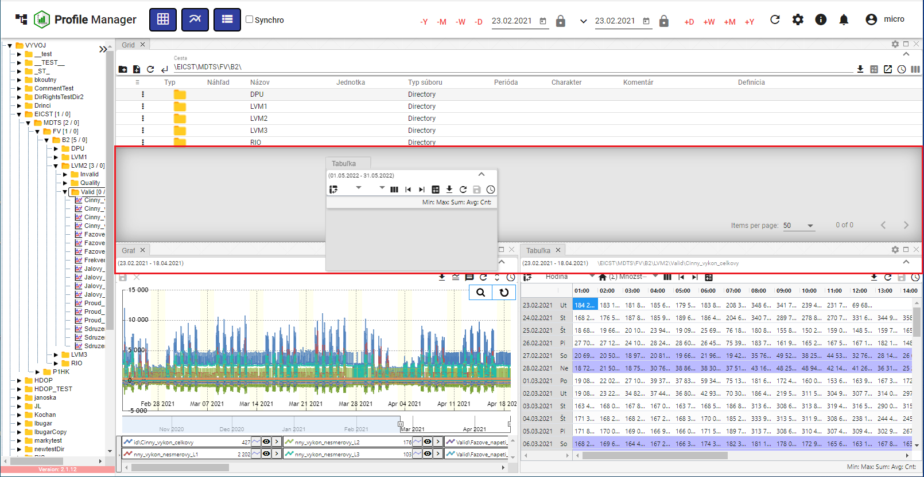

"Picture 25: Shape and Arrangement of Window Table"

1. "By clicking on the button, a window will be added at the chosen place."

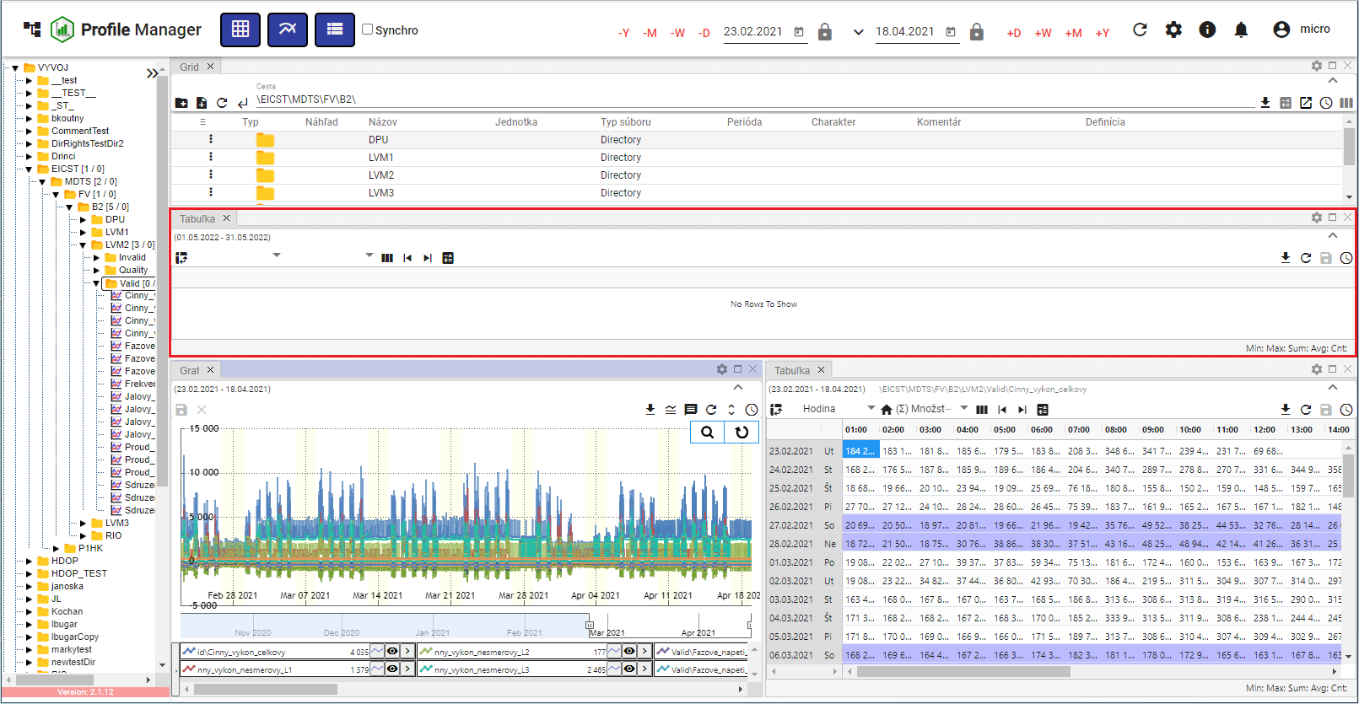

"Image 26: Added table window"

### Window naming regulations

"Windows Explorer, Graph and Table are automatically named according to the following rules:"

Table

The name for the table is "T: <name of first profile in table>".

"Example: 'T:ProfilHPFC'."

Graph

The name for the graph is “G: <name of the first profile in the graph>”.”

Example: "G: Profile of HPFC".

Explorer

The name for the search tool in Slovak and Czech is "P: <name of addressee in which I am>".

Example: "P: Address TEST".

In case of an addressee's root, then there will be the word "P:Root".

"In English, the spy has the name 'E: [name of addressee where I am]'."

Example: “E:\Address Book TEST”.

In case of an addresser being root, it will be the word "E:Root".

Explorer - Branch view

"The Explorer - Branch view has the name 'B: <name of the addressor in which the branch view was started>''."

Example: „B:AdresarTEST“. In case of an addresser root will be the name „B:Root“."

"For each change of profiles or address, the corresponding window title will be adjusted. If the user enters a window title using the button, from now on, automatic setup will turn off and will no longer apply."

## I'd like to opt out of the application

"Click on the 'Log out' button of your username to log out from the application. A window will appear where you click on 'Log out'."

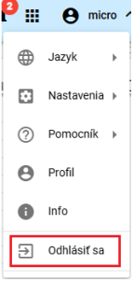

Image 27: Item "Log Out"

## I would like to change the language version

"Before changing the language version, click on the button with your username and then move your cursor to the 'Language' section. In the displayed window, select the desired language version."

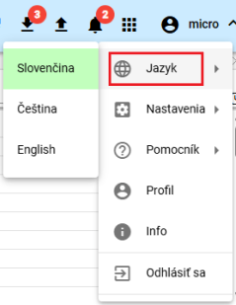

Image 28: Change of language version

## How to change default settings

"Default settings in the 'Profile Manager' application will be reset as follows:"

1. "Click on the button with the name of the registered user."
2. "Use the mouse pointer to navigate to the 'Settings' section."
3. Press the button "Set default settings".

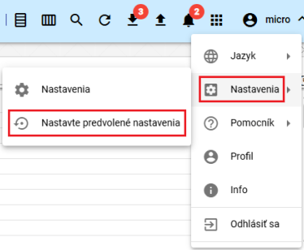

Image 29: Settings item

1. "A window will appear for confirmation, where you click the 'Yes' button."

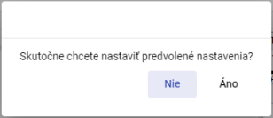

Image 30: Confirmation for setting preferred settings

## Show the profile of the logged-in user

Show profile of registered user:

1. Press the button with the name of the registered user.
2. Click on the item "Profile".

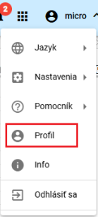

Image 31: Item "Profile"

1. In the new bookmark of the browser, the profile of the registered user will be displayed in the "IdentitySite" application.

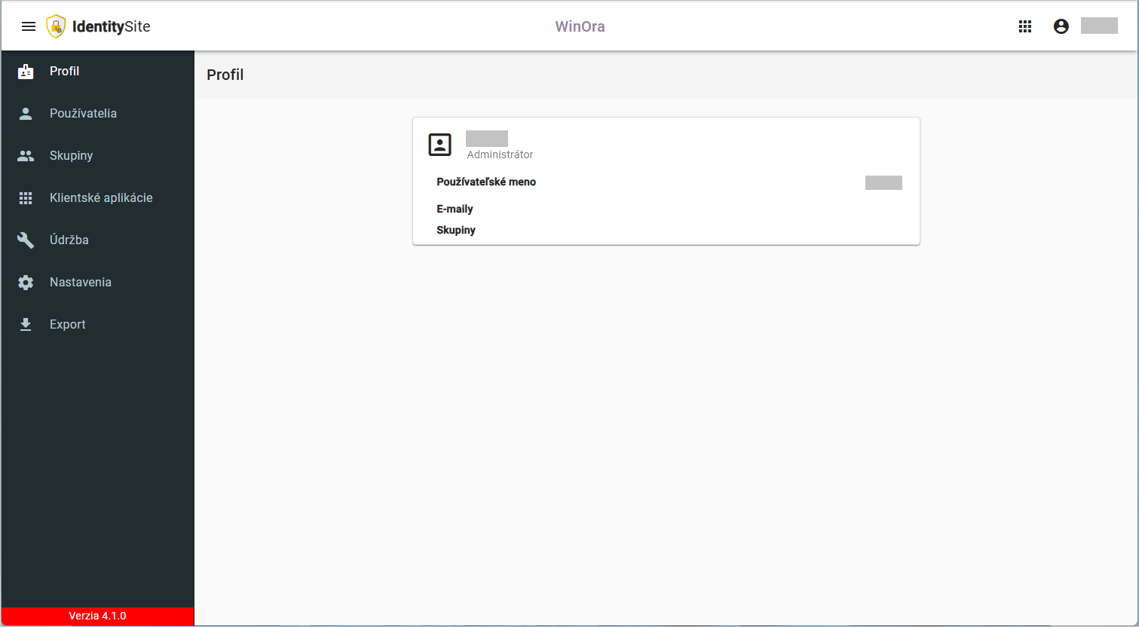

Image 32: Profile of a logged-in user in the application "IdentitySite"

## Global time range

The date filter is set to the current date.



Image 33: Global time range

"By clicking on the button you will display the preselected date range options, Image 34."

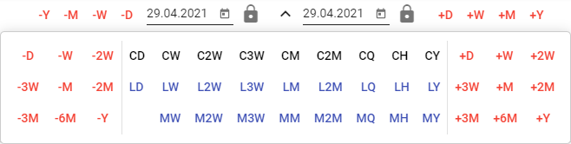

Image 34: Date range options

You can lock the dates. When changing the date range, the locked date does not change.



Picture 35: Locking Date

### I want to apply a date filter in the selected window.

The date range in the application header is linked to the designated window. If the date range in the designated window changes, it also changes in the application header. If the date range in the application header changes, it applies to the designated window.

Proceed:

1. "Mark the window where you want to apply the filter by clicking in the top part of the window, Picture 36."

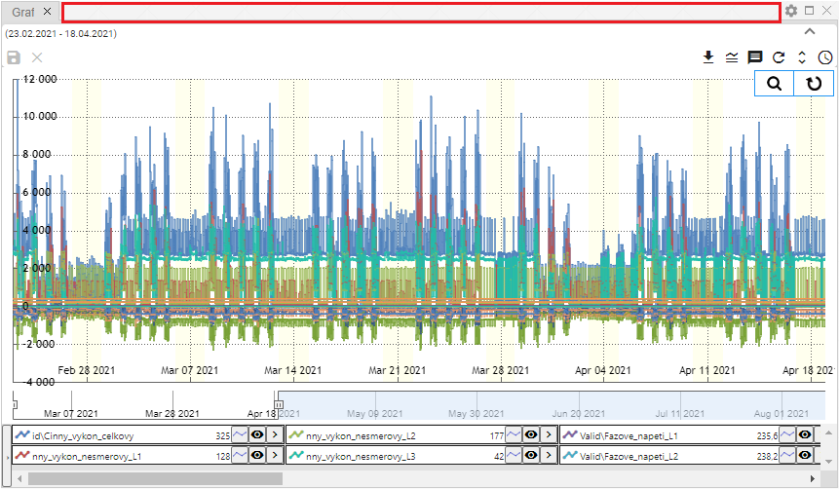

Image 36: Place for window sign

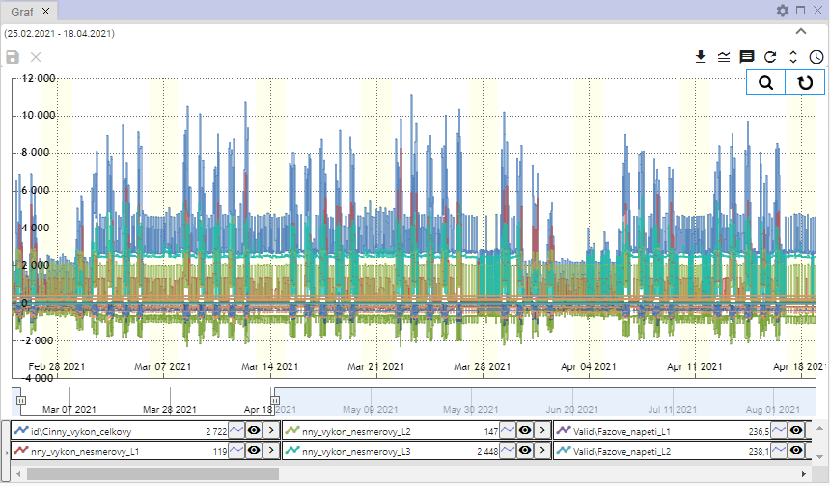

Image 37: Selected window for filtering

1. "In the top menu of the application, select date filter."



Image 38: Global date range

1. "The data will be displayed in the designated window according to the selected date filter."

### I want to apply a date filter in all windows, but it crashes.

Follow

1. Click the "Sync" checkbox.



Image 39: Checkbox "Sync"

1. "Select one of the Explorer, Table or Graph windows by clicking on the top part of the window, Figure 36 and Figure 37."
2. "Next, enter a date filter into the top bar of the application."



Picture 40: Global Time Range

1. "Date filter is applied to all windows in the application."

## If I were to restore visible data.

Before updating data in the "Profile Manager" application, press the "Update visible data" button located in the top bar of the application.



Image 41: Restore visible data button

## General settings

The "General" tab in the "Settings" window is divided into parts:

* Global – general settings for the "Profile Manager" application,
* "Table – general settings for table,"
* "Graph – general settings for graph,"
* "Inspector - general settings for an inspector."

"Individual settings are listed in the following subchapters."

### Global General Settings

#### When to turn on automatic refresh after profile update

Would you like to restore data after saving? Please proceed:

1. Click the button with the name of the registered user, which is located in the top bar of the application. Move the mouse cursor to the item "Settings" and click on it in the displayed window.

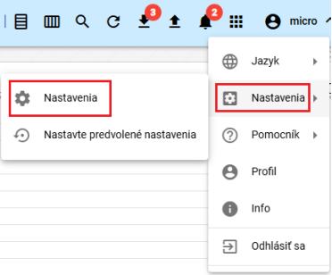

Image 42: Settings Item

1. "A settings window will appear."
2. "In the 'General' section, click on 'Restore displayed data after saving'."

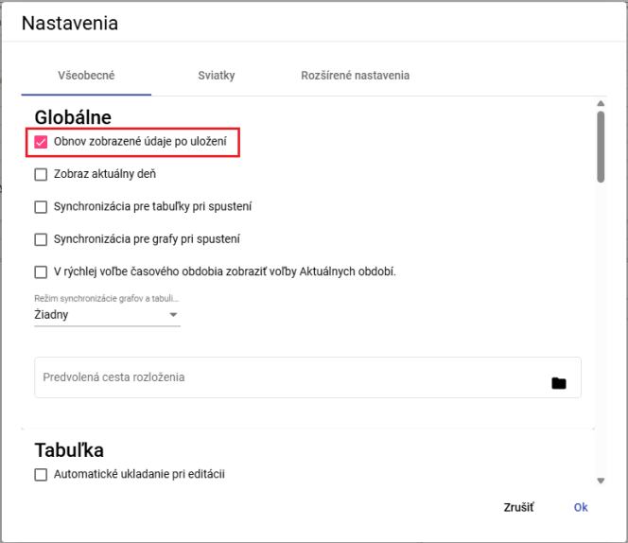

Image 43: Field "Restore displayed data after saving"

1. Save changes by pressing the "OK" button.

#### To display new windows on the current day

"If you want the Explorer, Table and Chart to display on current day, proceed:"

1. "Click the field 'Show current date' in the section 'Global' in the tab 'General' in the window 'Settings.'"
2. Save changes by pressing the "OK" button.

#### I will synchronize time for clocks

If you wish to synchronize time for tables, proceed:

1. "In the 'Settings' window, in the 'General' section of the 'Global' tab, click on the 'Table synchronization at launch' field. Picture 43."
2. You will save changes by pressing the "OK" button.
3. Restart the application afterwards.
4. When you click on the button "Synchronization for tables at start-up", it will also click the button "Synchronize tables", 1.16.2.

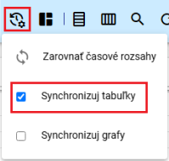

Picture 44: Pole "Sync Tables"

1. In the window of table, the text "SYNC" will appear.

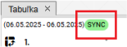

Image 45: In the table, will be displayed the text “SYNC”

#### I synchronize time for graphs

"If you want to synchronize time for calendars, follow:"

1. "Click the 'Synchronization for graphs at startup' field in the 'Global' part of the tab 'General', in the window 'Settings'."
2. Changes will be saved by pressing the "OK" button.
3. Restart the application afterwards.
4. When you click on the field "Synchronization for graphs at launch", the button "Synchronize graphs" will also be clicked, 1.16.3.

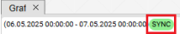

Picture 46: In graph, will be displayed text "SYNC"

#### I would like to activate synchronization between the chart and the table.

**[OLLAMA FORMATTING ERROR - MANUAL REVIEW NEEDED] Pre zapnutie synchronizácie medzi grafom a tabuľkou postupujte:**

1. In the "Settings" window in the "General" part of the "Global" tab, select the item in the field "Chart and table synchronization mode". You can choose:
   1. "No - synchronization between chart and table is turned off,"
   2. "start - synchronized with the start of the graph,"
   3. "syncs with the middle of the graph."

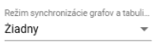

Picture 47: Regime of synchronization of graphs and tables

1. You will save changes by pressing the button "OK".
2. Restart the application afterwards.

#### "As for showing elections of the current period on a fast-forward scale"

"In fast time selection, the elections of AR, AM, AT, AD will be shown instead of +R, +M, +T, +D. Instead of -R, -M, -T, -D will show MR, MM, MT, MD."

Proceed:

1. Click on the field "To show elections of Actual periods" in quick choice time period.
2. Save changes by pressing the "OK" button in the "Settings" window.
3. Restart the application. Then, changes will be reflected in the application.



Image 48: Quick Time Selection

#### "If I am to set a course for the preferred distribution"

The pole "Default layout path" is used to set the path to a saved profile of the application "Profile Manager". When ever the application "Profile Manager" is opened, it will show the saved profile.

Follow instructions:

1. In the "Settings" window in the "General" section of the "Global" tab, enter a path to your saved layout or click on the button to display the "Select Layout" window, where you can find the saved layout.

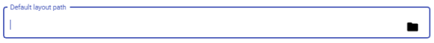

Image 49: Setting "Default layout path"

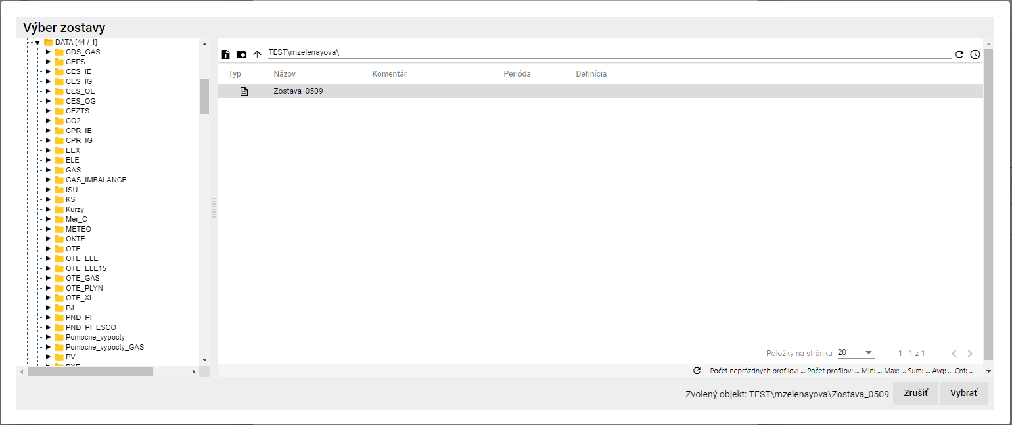

The Picture 50: Selection of the Squad

1. In the window "Team Selection", click on the button "Select".
2. In the folder "Default layout path" is the path to your selected group.



Picture 51: Selected ensemble

1. "Click on the 'OK' button in the 'Settings' window before making any changes."

### General settings for table

#### "How to set up automatic saving of changes in the table"

"By setting up automatic saving in the table, changes made to the table are saved immediately. Proceed:"

1. "Click on 'Automatic saving upon editing' in the tab 'Table' in the section 'General' in the drawer 'Setup'."

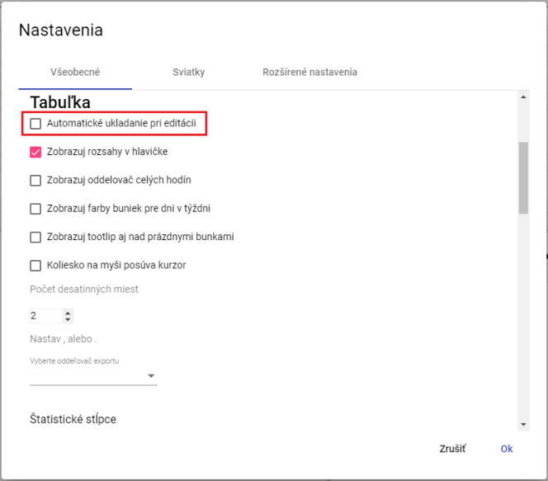

Picture 52: Settings for table

1. Save changes by pressing the "OK" button.

#### How to display ranges in header for table

You set up the header for the tabulation regarding the window of Tabuľka

1. "Click on 'Show header sizes' in the 'Table' section, tab 'General', window 'Settings', button 'Settings'"
2. Save changes by clicking on the "OK" button.

#### "How to set up hour separator for calendar table"

"Display separator for whole hours in Tabulator window you set:"

1. "Click on 'Show separator of full hours' in the menu item 'Table' in the tab 'General' in the folder 'Settings'."
2. Save changes by pressing the "OK" button.

#### "How to set up a color display for days of the week on a table"

"Setting color of socks for days of the week:"

1. "Click on 'Show cell colors for days of the week' in the menu item 'Table' under the tab 'General' in the folder 'Settings'."
2. Save changes by clicking on the "OK" button.

#### "Show tooltip also above empty cells in table"

"Before setting up tooltips for display, also over empty cells in the table proceed:"

1. "Click on ‘Settings’ in the tab ‘General’ under ‘Table’, Picture 52."
2. Save changes by pressing the "OK" button.

#### "Set up so that the mouse wheel moves the cursor"

"Moving the cursor by means of mouse wheel is set:"

1. "Click on 'Wheel to move cursor' in the tab 'Table' under the bookmark 'General' in the section 'Settings'."
2. Save changes by pressing the "OK" button.

#### "How to set decimal places in table"

"Before setting decimal places in the window Table Proceed:"

1. "In the 'Settings' window in the 'General' tab of the 'Table' part, set the 'Decimal places' option, Figure 52."
2. Save changes by pressing the "OK" button.

#### "How to set up an exporter separator for the table"

Before setting up the export separator for the table, proceed:

1. "In the 'Settings' window in the 'General' tab within the 'Table' section of the 'Choose export delimiter' field, select a delimiter."
2. Save changes by pressing the "OK" button.

#### How to reset used statistical columns in the table

"Before setting up which statistical columns are to be used in the table, proceed:"

1. "In the 'Settings' window within the 'General' tab of the 'Table' section, select the statistical columns that are to be used. You can choose columns for Sum, Average, Min and Max."

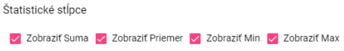

Picture 53: Statistical columns

1. Press the "OK" button to save changes.

#### "To tighten connection on the right"

"Before setting balance right in table go:"

1. "Click the 'Show attachment on the right' field in the 'Table' part, under the 'General' tab in the 'Settings' window."



Image 54: Item "Show attachment on right"

1. Save changes by pressing the "OK" button.

#### "Set table columns to default width"

Before setting the default width of table columns, proceed:

1. "If you want to set the default values for column widths, click on the 'Use default values' field which can be found in the 'General' tab of the 'Table' section within the 'Settings' window."

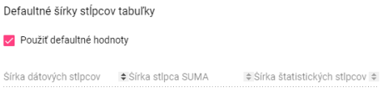

Image 55: Option "Use default values"

1. "If you want to set your own values for column widths, make sure the field 'Use default values' is not checked. This will make the fields for setting column widths accessible."

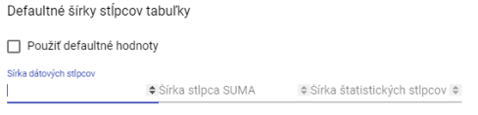

Image 56: Assigning personal values for column widths

1. Enter column widths and click on the "OK" button.

### Global settings for chart

#### How to set a standard line type for graph

The standard type of the graph line can be either "Line" or "Dashed line". To set the standard type of the line, proceed:

1. "In the 'Settings' window in the 'General' tab of the 'Graph' section, you can choose a standard line type."
2. By clicking on the field “Default line type”, you can select “Line” or “Dotted line”.

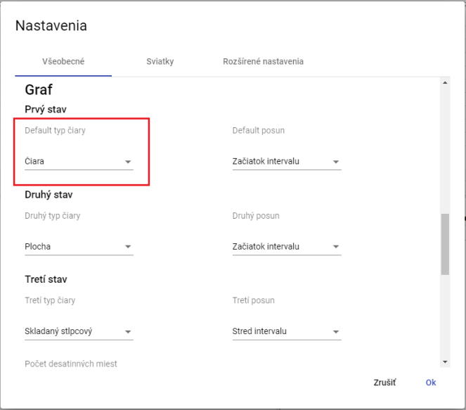

Figure 57: Selection of standard line type for graph

1. "Changes will be saved by pressing the button 'Ok'."

#### "Set up second and third line type for graph"

"Before setting up the second and third type of line, proceed:"

1. "Click in the field 'Second Line Type' in the window that appears after clicking on 'Settings' in the tab 'General' in the part 'Chart', where you select the type of line."
2. "Click on the field 'Third line type' before selecting the third type of line. This will display a window in which you select the type of line."
3. "Save changes by pressing the 'OK' button."

#### To set a standard shift, second and third shifts for the graph

Follow:)

1. "In the 'Settings' window, in the 'General' tab of the 'Graph' section, click on the 'Default offset' field and select one of the displayed options."
2. "In the 'Second Spring' game, choose the item for the second spring."
3. In the game "Third Move" choose a piece for the third move.
4. "Save changes by pressing the 'OK' button."

#### Set the decimal places for graphing

Proceed:

1. "In the 'Settings' window in the 'General' tab in the 'Graph' section, enter the decimal places."
2. Save changes by pressing the "OK" button.

#### How to set up displaying date of start for line graph

Proceed:

1. "In the window 'Settings' in the tab 'General' in the section 'Graph', click on the field 'Show start date of line'."
2. Save changes by pressing the "OK" button.

#### What's the current time?

Proceed:

1. "In the 'Settings' window in the 'General' tab under 'Graph', click on the field 'Show current time'."
2. Save changes by pressing the "OK" button.

#### To set zoom out, mark to the left

**[TRANSLATION FAILED AFTER 3 RETRIES] Funkcia „zoom“ slúži pre priblíženie vybraného miesta v grafe. Funkcia „zoom out“ spôsobí vzdialenie vybraného miesta v grafe. Ak chcete priblížiť určité miesto v grafe, kliknete ľavým tlačidlom myši do grafu a kurzorom myši označte miesto v grafe potiahnutím zľava doprava. Ak chcete vzdialiť miesto v grafe postupujete opačne, miesto v grafe označíte zprava dole smerom doľava hore.**

Proceed:

1. "Click the field 'Zoom out marking to the left' in the tab 'General' in the section 'Graph' on the bookmark 'Setup'."
2. "Changes will be saved by pressing the 'OK' button."

#### "As it approaches, it automatically switches to slide"

"The 'Automatically switch to pan after zoom' checkbox means that when you click the 'Zoom in' button in the graph window, the graph will automatically switch to pan after zooming in on a selected area. If this box is not checked, clicking the 'zoom' feature will activate zoom until it is deactivated."

Proceed:

1. "Click the field 'Switch to zoom automatically' in the tab 'General' in the part 'Graph' in the bookmark 'Settings'."
2. Changes will be saved by pressing the button "OK".

### General settings for the scanner

#### "How to set decimal points in the Windows Explorer"

"Before statistics in the window Explorer you can set the number of decimal places according to the following procedure:"

1. "In the 'Settings' window, in the bottom part of the 'Settings' window within the 'Browser' section, set decimal places."

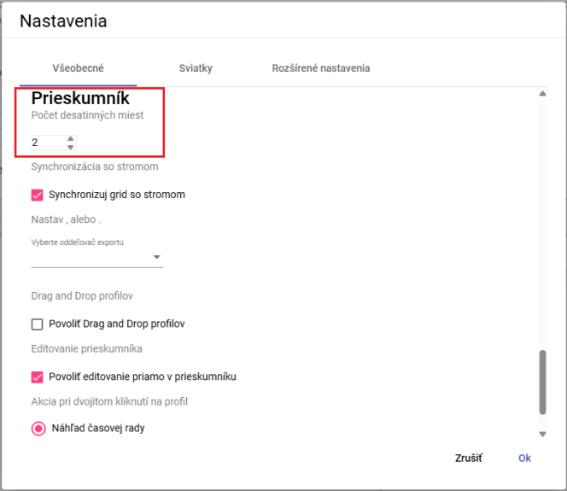

Image 58: Task count of decimal places in a browser window

1. You will save changes by clicking the button "OK".
2. "In the window Explorer statistics will be displayed with the specified number of decimal places."

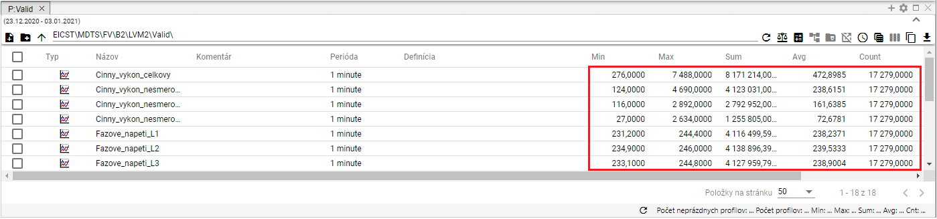

"Image 59: Selected decimal places in the Windows Explorer"

#### I would like to synchronize the Explorer window with the tree

"Before synchronization of the probe with the tree, proceed:"

1. "Tap on the 'Settings' tab in the bottom part of the window, then select the 'General' tab and click the 'Sync grid with tree' field in the 'Explorer' section."
2. Save changes by pressing the "OK" button.

#### "How do I set up an export delimiter for an explorer"

"Before setting up the export separator for an explorer follow:"

1. "In the lower part of the window 'Settings' in the tab 'General' in the section 'Explorer', there is a field 'Select export delimiter', where you can choose either a point or an underline."
2. Save changes by pressing the "OK" button.

#### "To enable drag and drop functionality for profiles"

Before enabling the function "drag and drop profiles," proceed:

1. "In the lower part of the window 'Settings' in the tab 'General' in the section 'Searcher', click on the field 'Drag and drop profiles'."
2. Press the "OK" button to save changes.

#### "Allow editing directly within Explorer window"

"The item 'Allow editing directly in the inspector' is normally active. It allows you to edit the fields 'Name', 'Comment' and 'Definition' directly in the Inspector window."

"Click 'Allow' to continue:"

1. "Discard the suggestion 'Allow editing directly in the explorer'."
2. Press the "OK" button to save changes.

#### "How to choose action for double click on profile"

After double clicking on a profile you can select an action that will be launched. Proceed:

1. "In the lower part of the window 'Settings', in the tab 'General' in the section 'Searcher', select one of three actions."

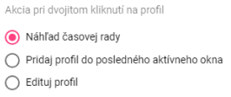

Image 60: Selection of action for double-clicking on profile

1. "Save changes by pressing the 'OK' button."

## Christmas preparations

### How to create a profile for Christmas.

"This profile allows the display of holidays in all profiles. To create a holiday, you need to have created a holiday profile, Image 61, in which you will enter the value 1 on days when there is a holiday and NaN (Not a Number) on days when there isn't one. Create the holiday profile with period DAY."

The benefit of the holiday profile is that you decide yourself which holidays to display - Slovak or from another country, or from several countries at once. A created holiday profile can be shared with other applications as well.

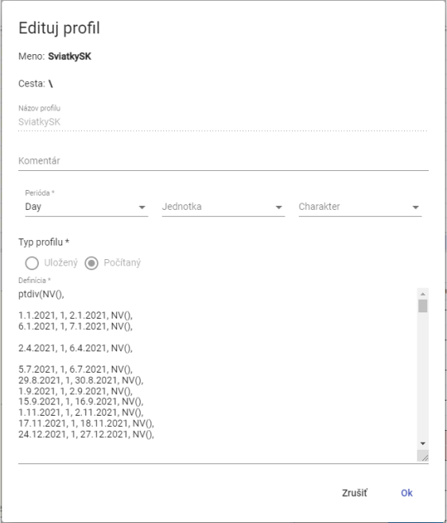

Image 61: Example definition of a sacred profile

Create profile before holidays will you?

1. Click on the "User" button in the top bar of the application. With your mouse cursor, navigate to the "Settings" option and click on it in the displayed window, Image 42.
2. "A window titled 'Settings' will appear, where you click on the tab 'Holidays'."

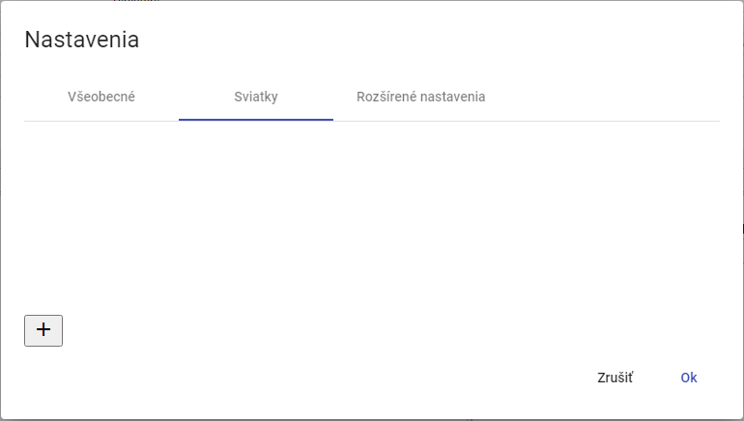

Picture 62: Bookmark "Holiday"

1. Click on the button to create a profile.

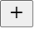

Image 63: Button for creating profile

1. "A window called 'Festivals' will appear, which is used for creating a profile."

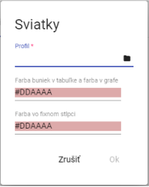

Image 64: Creation of profile

1. In the profile section, click on the profile button or press the profile selection button.
2. After pressing the button, a window for selecting the profile will appear.

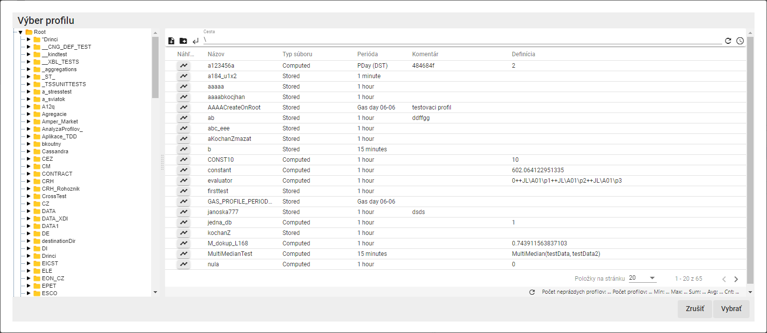

Picture 65: Window for selecting profile

1. "Select holiday profile and click on the 'Choose' button."
2. Choose the color for fields "Color of bars in table and color in graph" and "Color in fixed column".

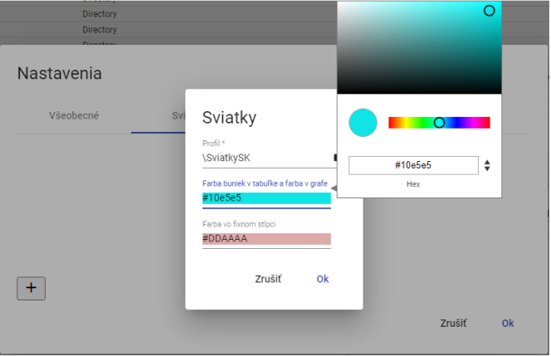

Image 66: Color selection

1. You will create a profile by pressing the button "OK".
2. "In the window 'Holiday' a created profile for holidays will be shown."

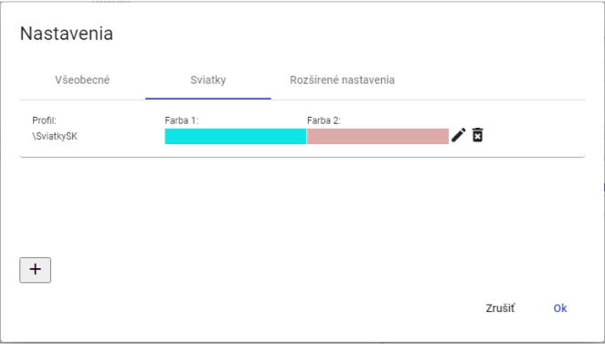

Picture 67: Created profile for holidays

1. You will save the created profile by clicking on the "OK" button.

### How to choose a profile for New Year's (or Christmas, possibly)

Profile for holidays you will set up:

1. Click on the login user button located in the top toolbar of the application. Move your mouse cursor to the "Settings" option and click on "Settings" in the displayed window, see Fig. 42.
2. "A settings window will be displayed, where you click on the tab 'Holidays'."
3. Press the edit button at the profile you want to modify.



Image 68: Button for editing profile

1. "A 'Holiday' window will appear for profile editing."

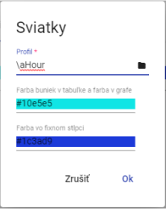

Picture 69: Editing profile for Christmas

1. Edit data.
2. You will save changes by pressing the "OK" button.
3. In the window "Settings", click on the button "OK".

### "How to delete a profile for holidays"

Profile before holidays you will edit:

1. "Click the user name button located in the top bar of the app. Move your mouse cursor to the 'Settings' option and click on it in the displayed window, Image 42."
2. "A settings window will appear, where you click on the tab 'Holidays'."
3. "To delete the profile you wish to remove, press the deletion button."



Image 70: Button for profile removal

1. "A confirmation window will be shown where you click the 'Yes' button to delete your profile."

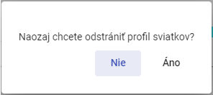

Image 71: Confirmation of profile deletion

1. His profile has been removed from the list of profiles for Christmas.
2. Confirm profile deletion by clicking on the "Settings" window and pressing the "OK" button.

## How to display information about status

**[TRANSLATION FAILED AFTER 3 RETRIES] Pre zobrazenie informácii o statuse stlačte tlačidlo s názvom prihláseného užívateľa. Zobrazí sa ponuka, v ktorej vyberte položku „Info“. Následne sa zobrazí okno „Informácia o stave“, ktoré poskytuje informácie o stave aplikácie „Profile Manager Web“ a o stave servís TSS Service, TSS Core, MSHDO.DMST.API, DMS a MSHDO.Xenergy.UTS.Api.**

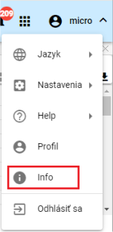

**[TRANSLATION FAILED AFTER 3 RETRIES] Obrázok 72: Položka „Info“**

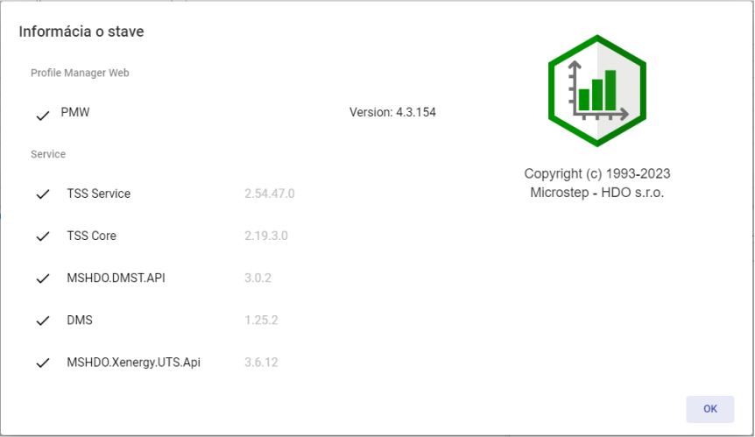

Picture 73: Window "Information about state"

## I want to display notifications

"The 'Notifications' button signals that changes have been made to the system. For example, creating an address and similar. If there are notifications in the application, in the top right corner of the 'Notifications' button is a red circle with the number of notifications."



Image 74: Warning button

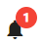

Picture 75: New warning

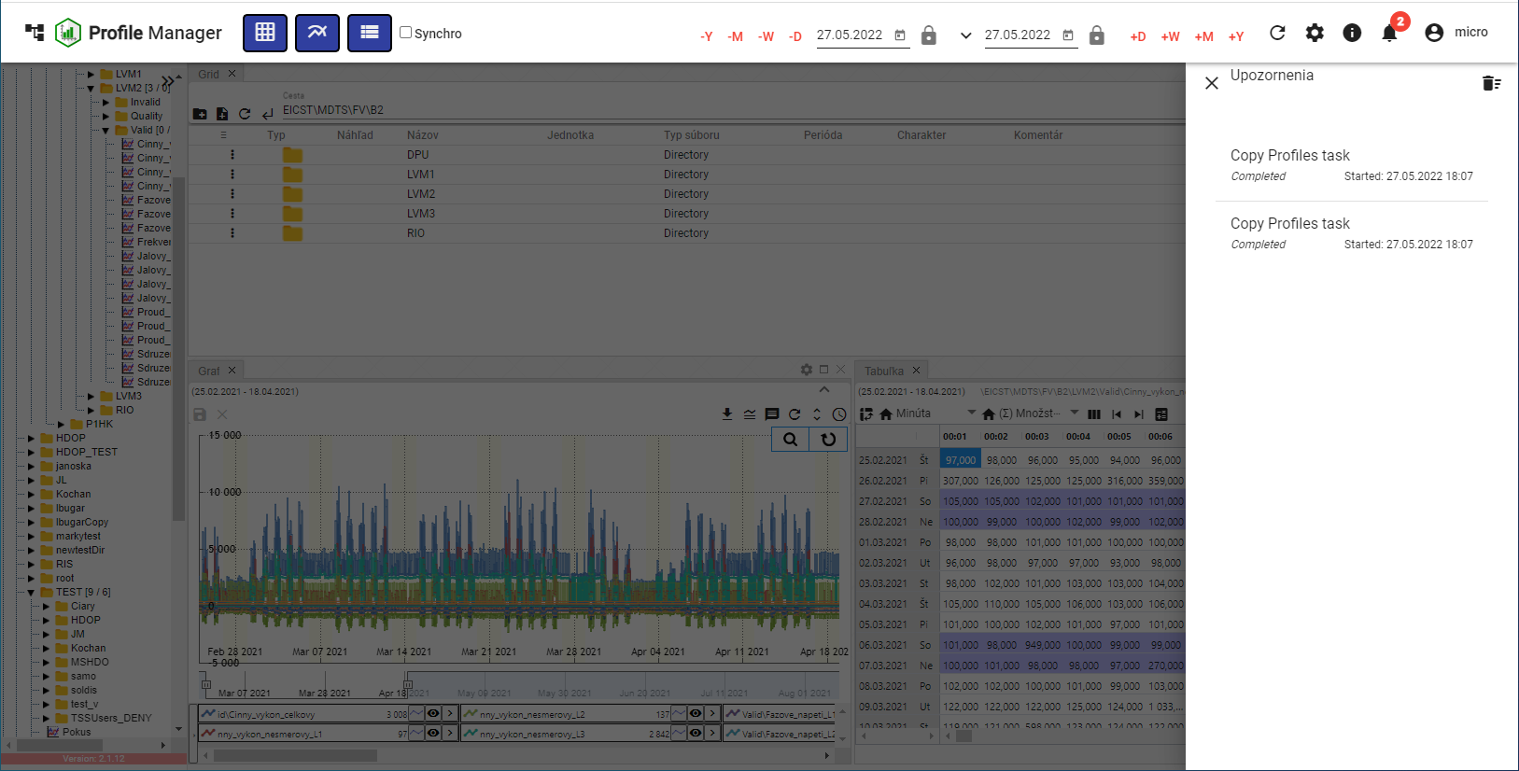

Image 76: Warning Block

"Click on the trash can icon in the top right corner of the 'Alerts' block to delete alerts. A confirmation window will appear where you click 'Yes'."

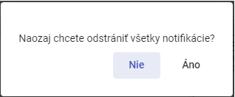

Picture 77: Window for confirming notification removal

## To expand the window of tree structure.

**[TRANSLATION FAILED AFTER 3 RETRIES] Okno stromovej štruktúry zväčšíte stlačením tlačidla, Obrázok 78, ktoré sa nachádza v pravom hornom rohu stromovej štruktúry. Okno stromovej štruktúry sa následne zväčší, Obrázok 80. Pre vrátenie stromovej štruktúry do štandardnej šírky stlačte opäť tlačidlo v pravom hornom rohu stromovej štruktúry, Obrázok 79.**

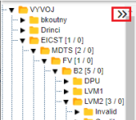

Image 78: Button for expanding tree structure

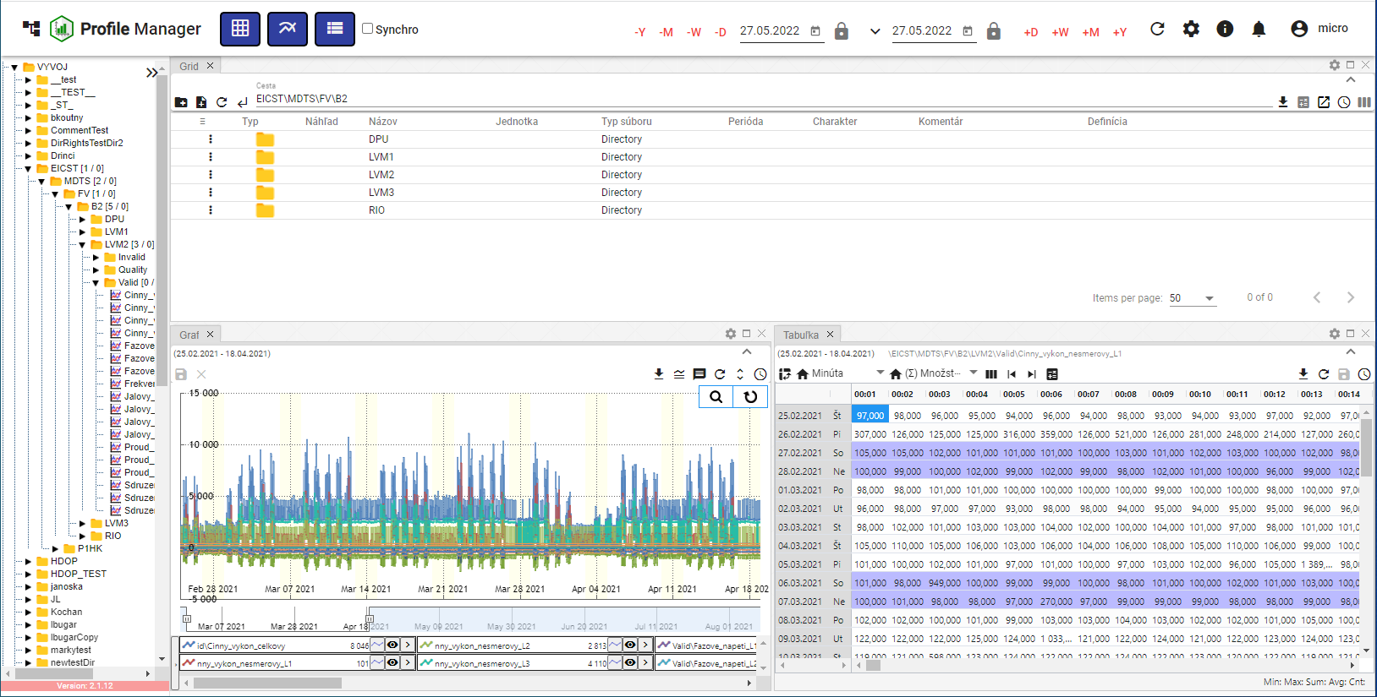

Picture 79: Standard window width of a tree structure

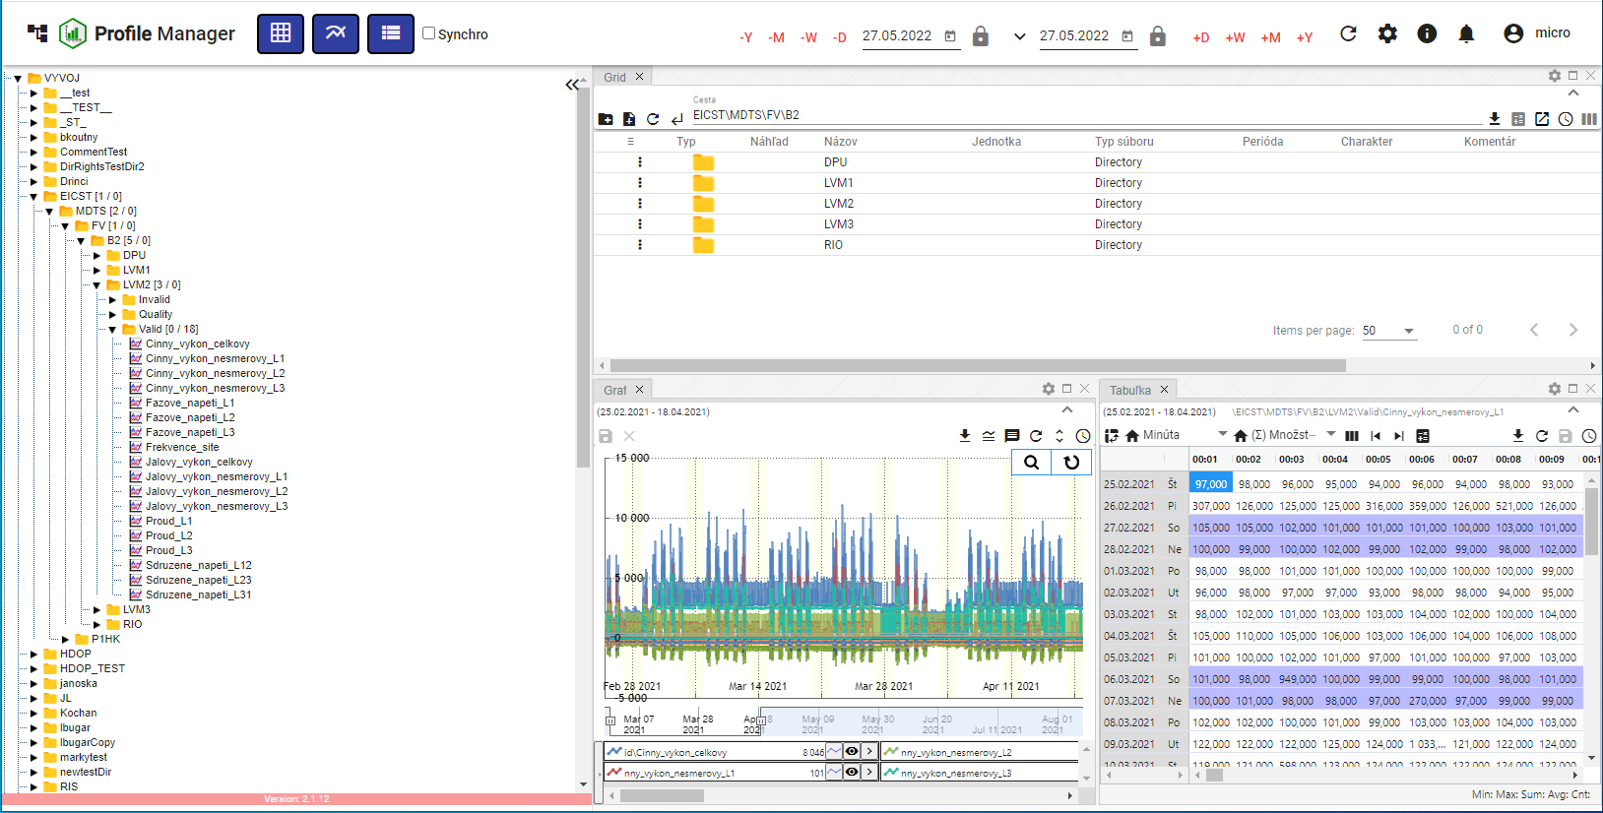

"Picture 80: Enlarged window of a tree structure"

## Screen synchronization

"The 'Sync Panels' button serves to sync open windows in the 'Profile Manager' application. It enables time ranges synchronization (chapter 1.16.1) and table syncing (chapter 1.16.2)."

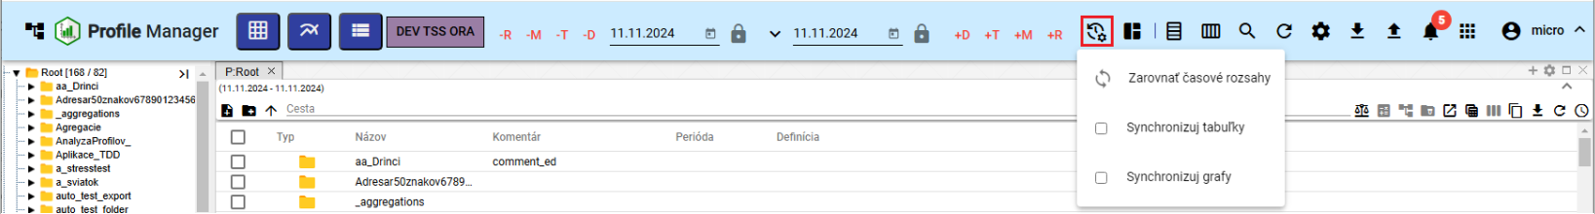

Picture 81: Synchronization button for panels

### Synchronize time ranges

"If you have different date ranges set in your windows and you want to set the same date range in all open windows, follow:"

1. Click on the window header whose date range you want to set in other windows.

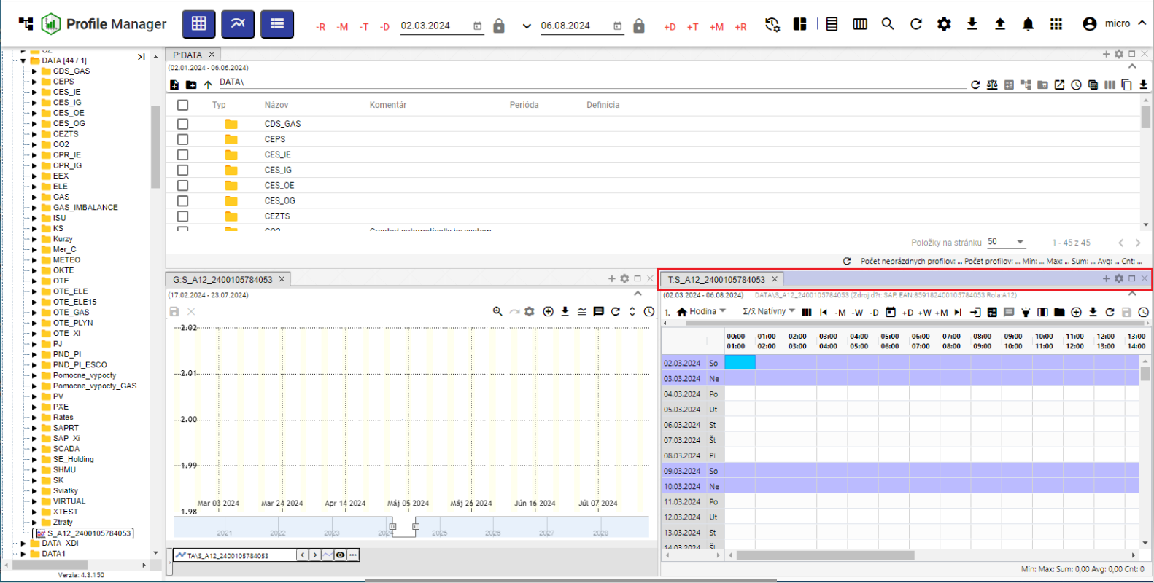

Window 82: Active window

1. Press the button "Sync Panels" and click on the item "Sync Time Ranges".

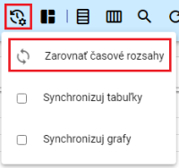

Image 83: Item "To synchronize time intervals"

1. In all windows, the date range set up in the active window will be applied.

### I synchronize tables

"The item 'Synchronize tables' means that the start of range and cursor are synchronized with all open tables."

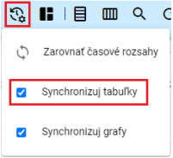

Picture 84: Item "Sync tables"

"If you want tables to synchronize every time they are launched, in the 'Settings' window in the 'General' tab of the 'Global' section, click on the field 'Synchronization for tables at launch' (Figure 85). If table synchronization is enabled, the table window will display the text 'SYNC' (Figure 86)."

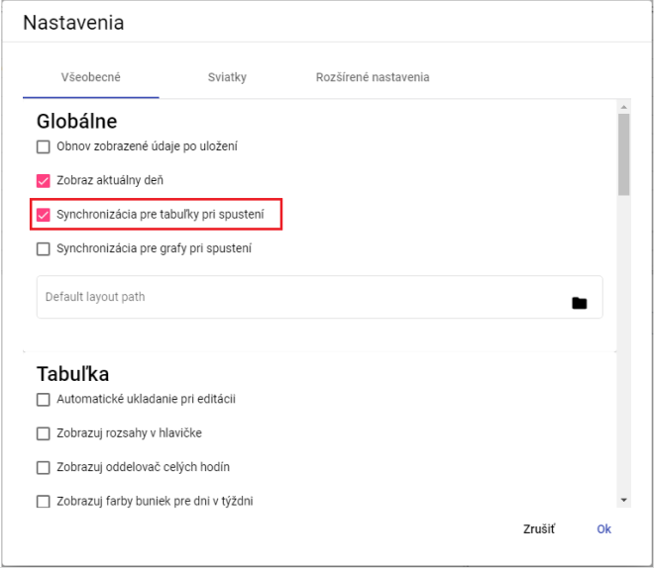

Image 85: Pole "Synchronization for tables at startup"

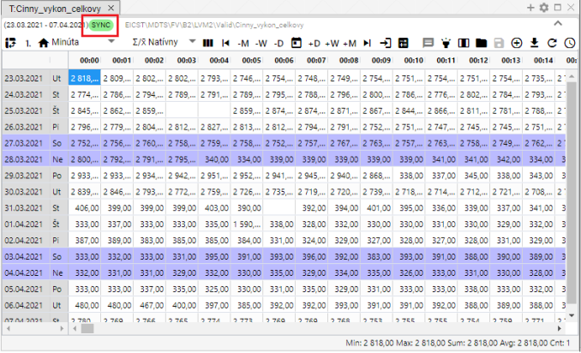

"Image 86: The text 'SYNC' will be displayed if table synchronization is enabled."

### I synchronize graphs

If you want the graphs to synchronize every time they are launched, in the "Settings" window in the tab "General" in the section "Global", click on the field "Synchronization for graphs at launch" (Figure 85). If you set synchronization of graphs in the "Settings" window, the "Sync Graphs" field will be checked in the button "Panel Synchronization" (Figure 87), and in the graph window the text "SYNC" will appear (Figure 88).

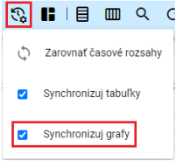

Image 87: Menu item "Sync graphs"

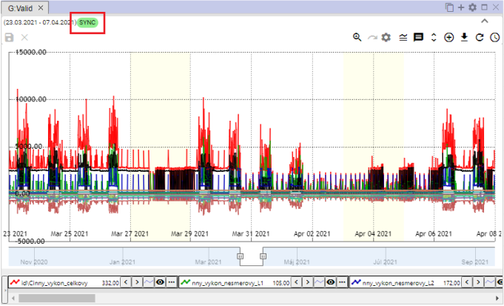

Image 88: The text "SYNC" will be displayed if graph synchronization is enabled.

## Import, export and store lists

"Button, Picture 89, serves for import, save and download leftovers. Import of leftovers is processed in the following chapter 1.17.1 and downloading leftovers is described in Chapter 1.17.2."

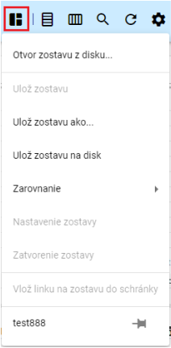

Image 89: Button "Stay Report"

### I will assemble/import a set of parts/assembly

"Proceed before import:"

1. "Press the button 'Save changes', which will appear a window in which you select an item 'Open assembly from disk...'".

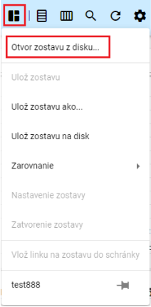

Picture 90: Item "Compose opening track from disc..."

1. "A window will appear where you can select the roster you want to import."

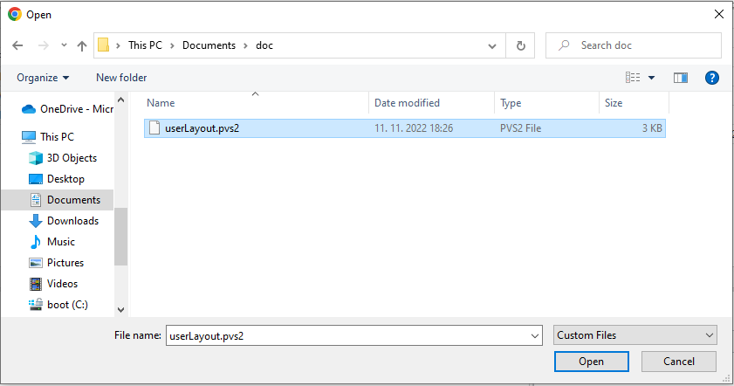

Image 91: Selection of the squad for imports

1. "Confirm your selected team for import by pressing the 'Open' button."
2. "Selected team is imported and the appearance of the 'Profile Manager' application will change according to selected team's settings – number and size of windows, data shown in windows and alike."
3. "Next to the 'Save As' button, the name of the imported workbook will be displayed."



Picture 92: Title of imported quilt

### I will export the roster.

We will be exporting the following:

1. Press the "Remain on Record" button.
2. Select "Save assembly to disk".

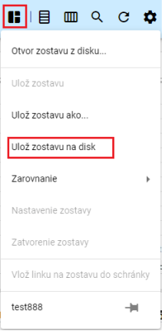

Image 93: Option "Save assembly to disk"

1. The costume will then be removed.

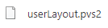

"Image 94: Downloaded assembly"

### I will update the roster

"Proceed with roster update:"

1. "Click on the profile menu and open the group you want to update. You will open a group by left-clicking the mouse button on its name in the profile menu."

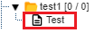

Picture 95: Profile remaining

1. Subsequently, upon clicking on the button "Message remains", the name of the open-ended list will appear.

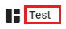

Picture 96: Title of an Open Society

1. Make changes to the team you want to save.
2. "You will save changes by pressing the button 'Save layout' and then selecting the item 'Save layout'."

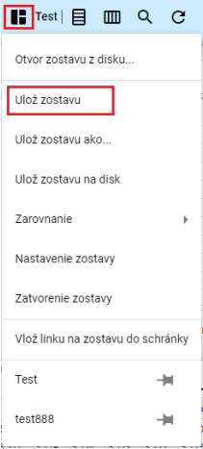

Image 97: Add to favorites

1. "A window will appear asking you to click the 'Yes' button."

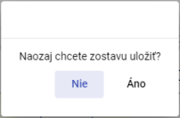

Image 98: Window for confirmation of savings deposit

1. The software is being updated.

### I will compile a new list

The appearance of the "Profile Manager" application - number and size of windows shown, data displayed in windows, you can save as a layout.

"The new team will be saved in your profile stream as follows:"

1. Set up settings in an application that you want to save as a compilation.
2. "Press the 'Save as...' button and in the shown window select 'Save configuration as...'."

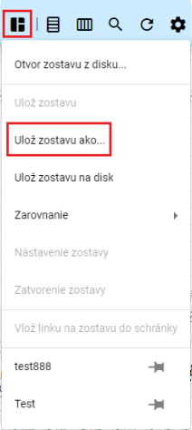

Image 99: Save as template...

1. It will show a window called "New Roster".

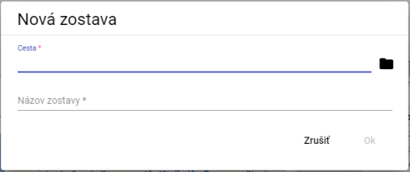

Picture 100: Window "New Formation"

1. "In the menu 'Path', enter the path where you want to save your playlist. You can also enter the path by pressing the button and selecting the recipient in the profile tree, where the playlist should be saved."

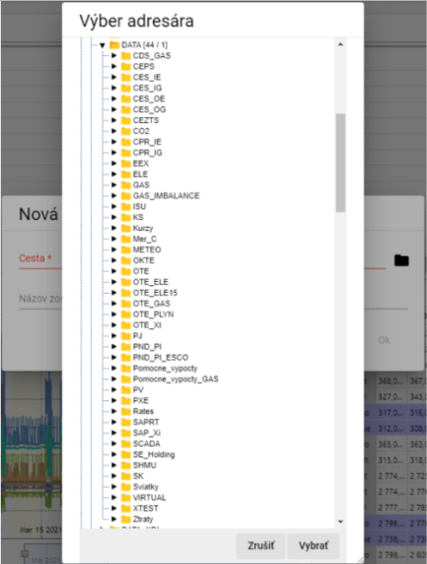

Image 101: Selection of recipient for depositing savings

1. Submit team name.

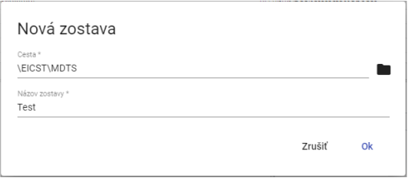

Image 102: Given data

1. Save the new configuration by clicking on the "OK" button.
2. "To refresh your profile tree, click on the folder icon in the top right corner and select 'Refresh'."

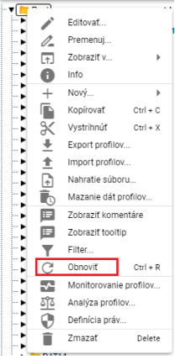

Picture 103: Item "Restore"

### I'll compile the team into columns

Follow this procedure:

1. "Click on the button 'Message remains', which can be found in the top bar of the application."
2. "An offer will be shown where with the mouse pointer you set on the item „Alignment“ and set with the mouse pointer on the item „To columns...“.
3. The offer will be displayed, where you select the number of columns.

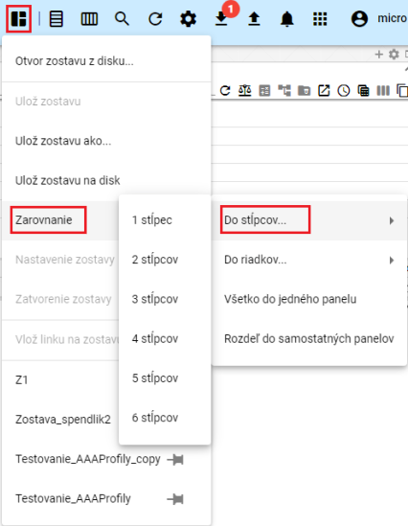

Image 104: Item "To the stairs"

1. "Windows in the application 'Profile Manager' are adjusted to the selected number of columns."

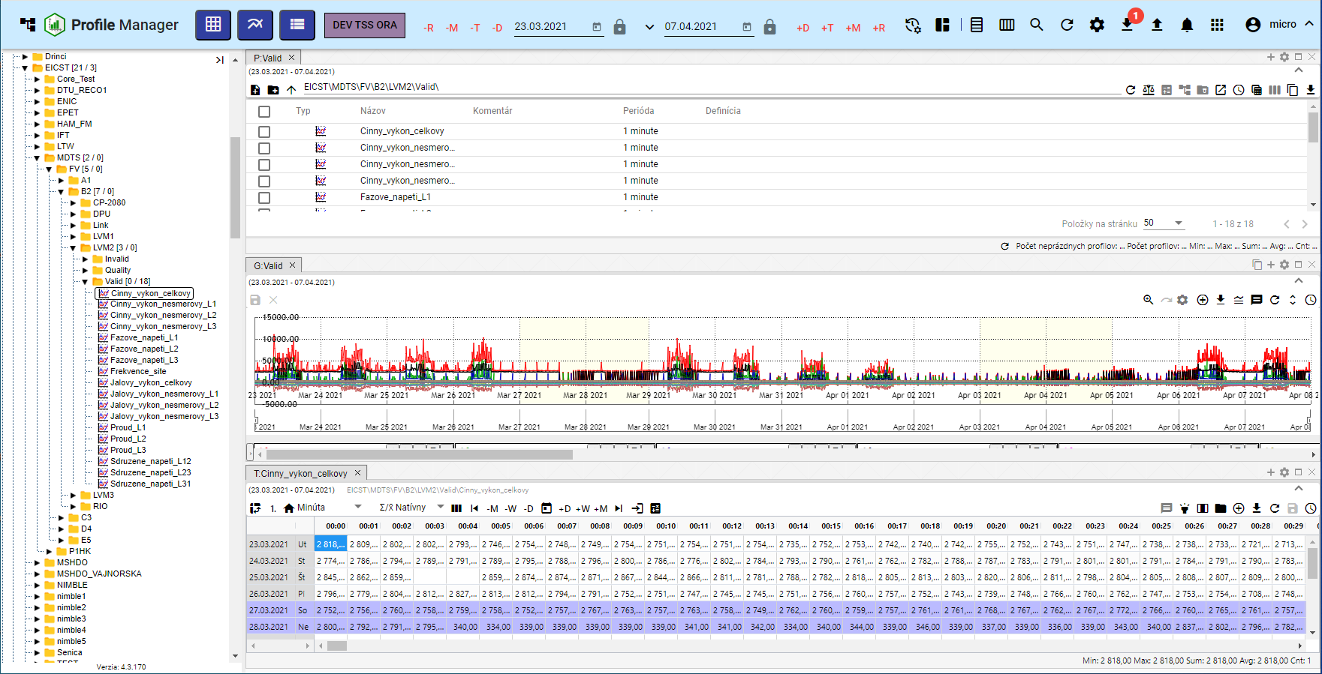

Picture 105: Aligning windows to one pillar

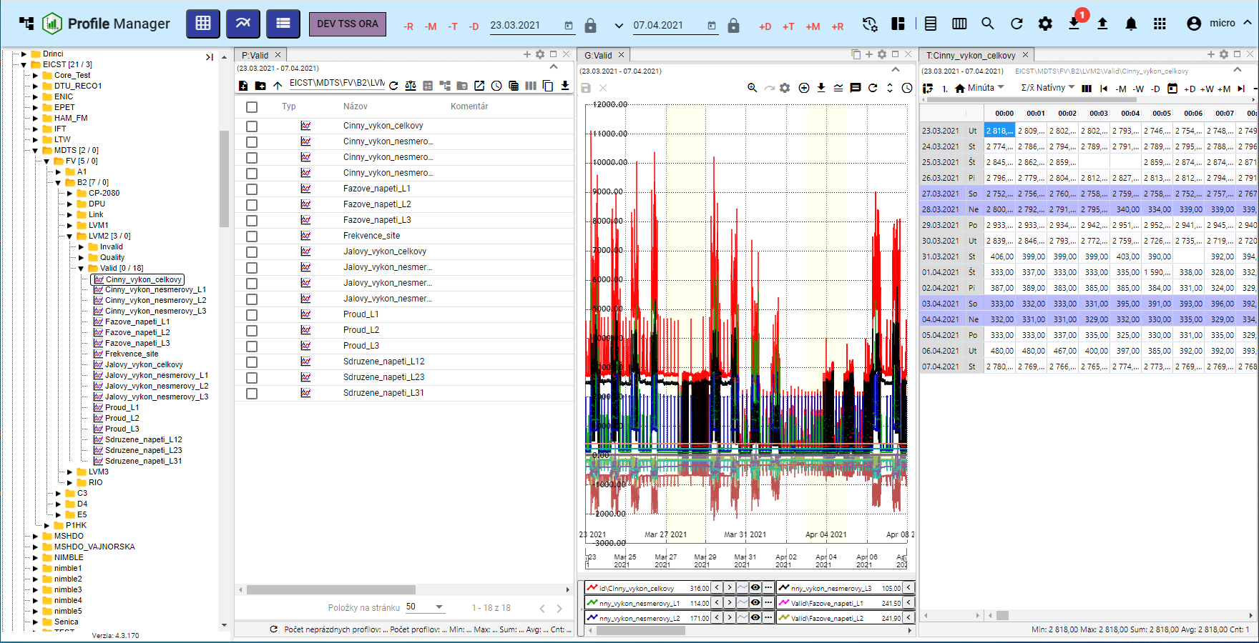

Picture 106: Balancing on three sticks

### I will arrange the team in rows.

Proceed

1. Click on the button "Stay Report", which is located in the top bar of the application.
2. It will be shown an offer where with the mouse cursor you set on the point “Alignment” and then set with the mouse cursor on the point “To rows”.
3. "An offer will appear where you select the number of rows."

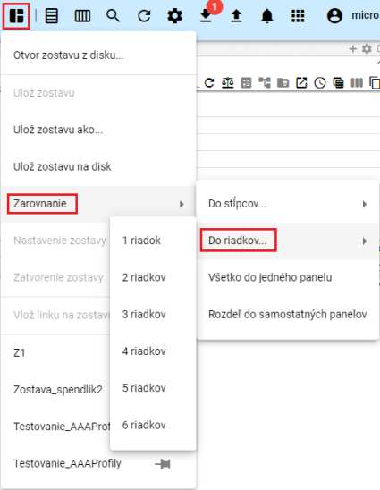

Picture 107: Item "On the alert"

1. Windows within the application will be aligned with a selected number of rows.

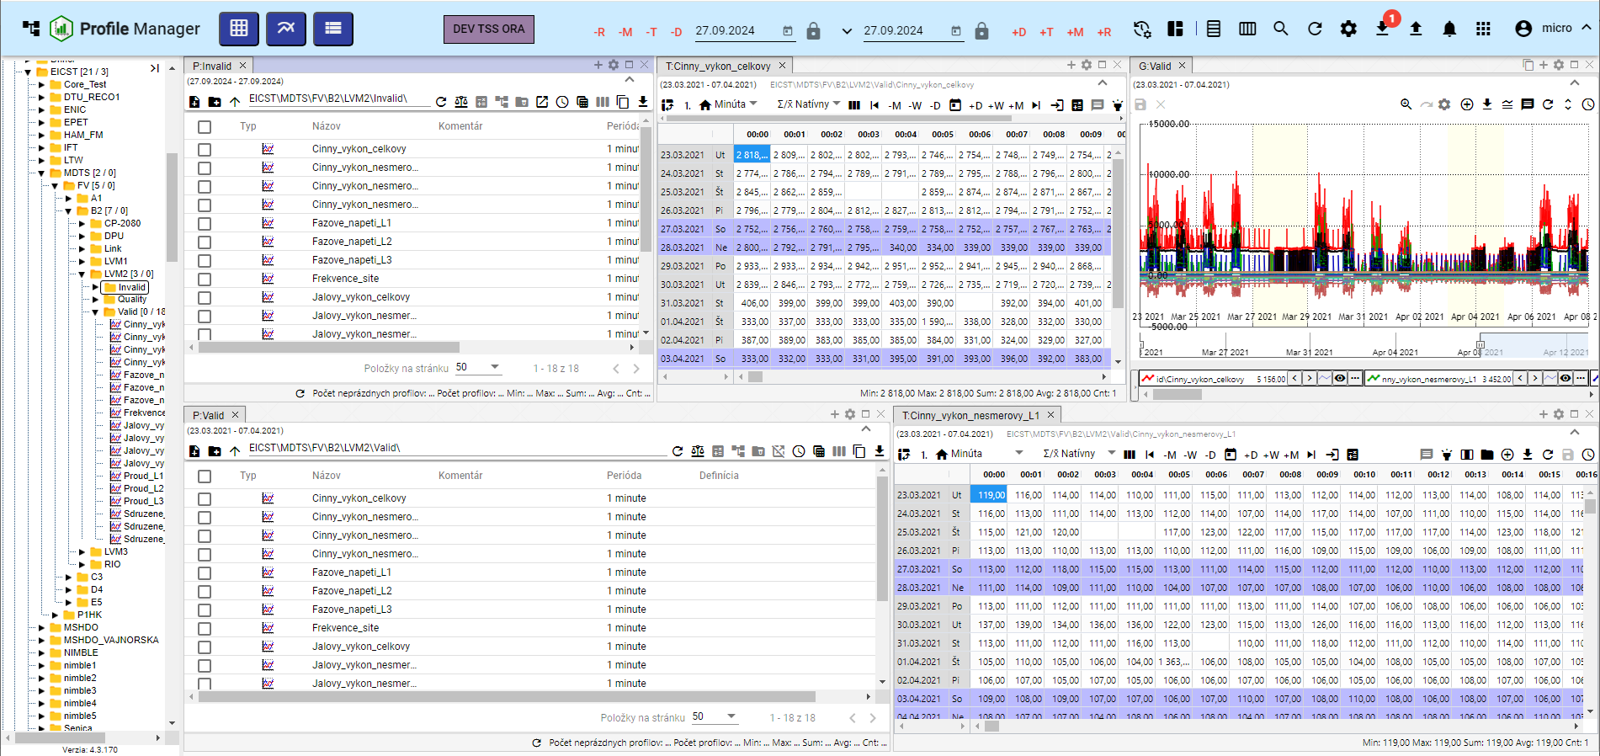

Image 108: Adjustment to two rows

### I want to put everything into one box.

Proceed:

1. "Click on the button 'Report Absence'."
2. "The offer will be displayed in which you can click with the mouse cursor on the point 'Alignment' and select the item 'Everything to one panel'."
3. All windows will be displayed on one panel.

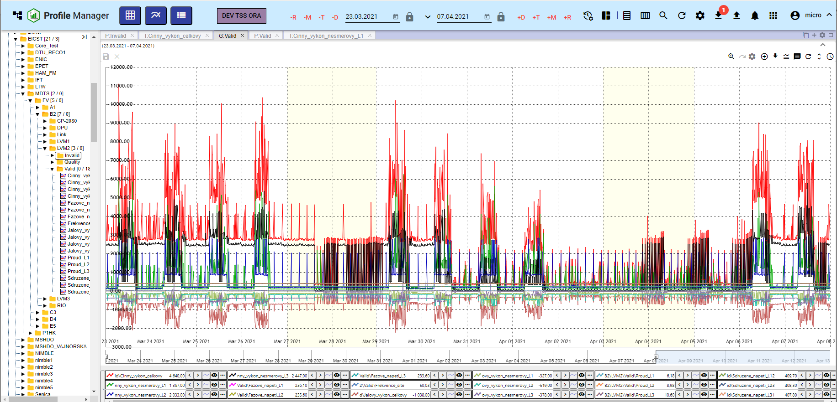

Image 109: Alignment to one panel

### "How to divide the team into separate panels"

Proceed:

1. Click on the button "Save for later".
2. "An offer will be displayed in which you navigate with the mouse pointer to the item 'Alignment' and select the item 'Divide into separate panels'."
3. Every open window will be displayed on its own panel.

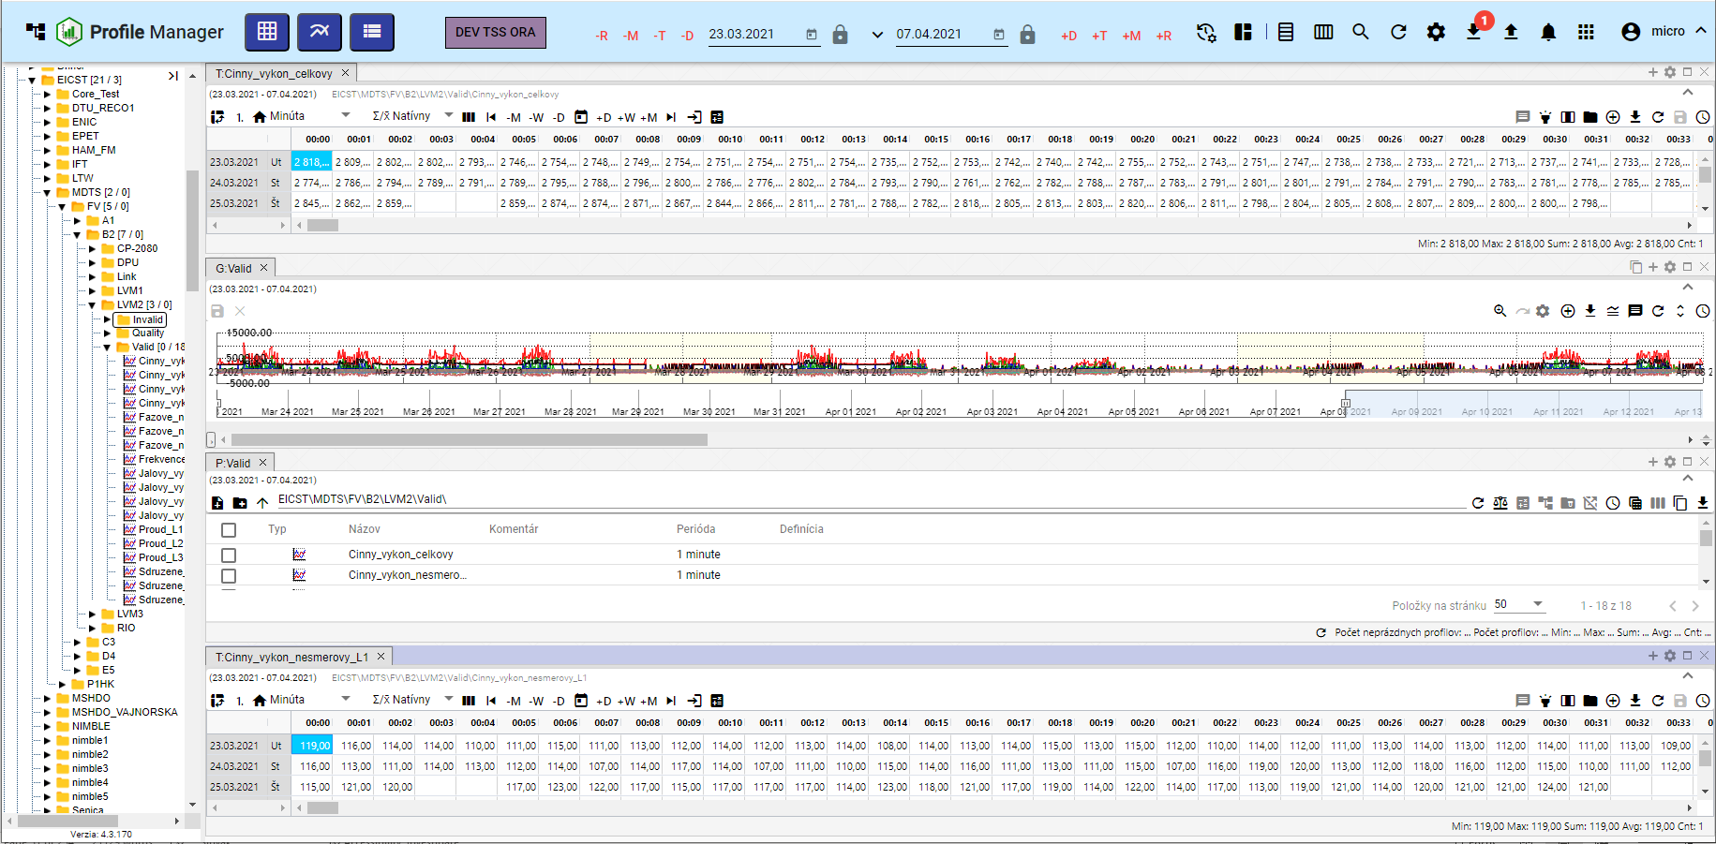

Image 110: Division into separate panels

### **[OLLAMA FORMATTING ERROR - MANUAL REVIEW NEEDED] Ako nastaviť globálny časový rozsah pri zobrazení zostavy**

"Before changing the global time range for the stored composition, proceed:"

1. Press the "Remain" button.
2. Choose the item "Team settings".

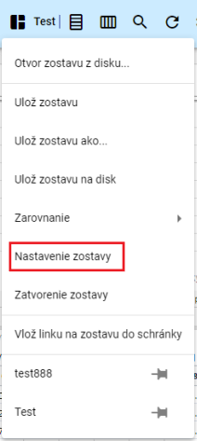

Image 111: Item "Team Settings"

1. The window "Team Settings" will appear.

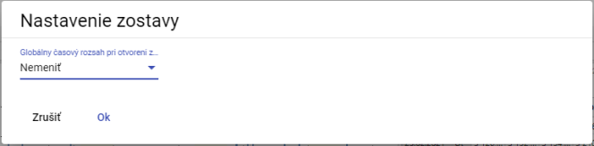

Picture 112: Window "Settings Squad"

1. "Click on the field 'Global time range at opening of the fleet'."
2. "A selection will be shown, from which you can select a date range."

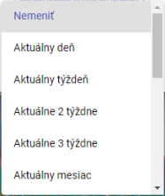

Image 113: Offer for setting global time range

1. Pressing the "OK" button will save it.
2. "A window will appear for confirmation, where you click the 'Yes' button."

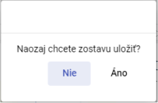

Image 114: Window for confirmation of storage

### **[OLLAMA FORMATTING ERROR - MANUAL REVIEW NEEDED] Ako zatvoriť zostavu**

Press the button "Club info" before closing and select the item "Close club". The club will then close.

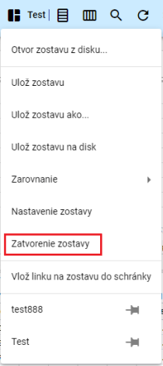

Picture 115: Item "Closure of the cloister"

## **[OLLAMA FORMATTING ERROR - MANUAL REVIEW NEEDED] Ako horizontálne zarovnať okná**

"To align windows horizontally press the 'Horizontal alignment' button located in the top toolbar of the application. Windows open in the 'Profile Manager' app will be aligned horizontally, Figure 117."



Image 116: Horizontal Alignment Button

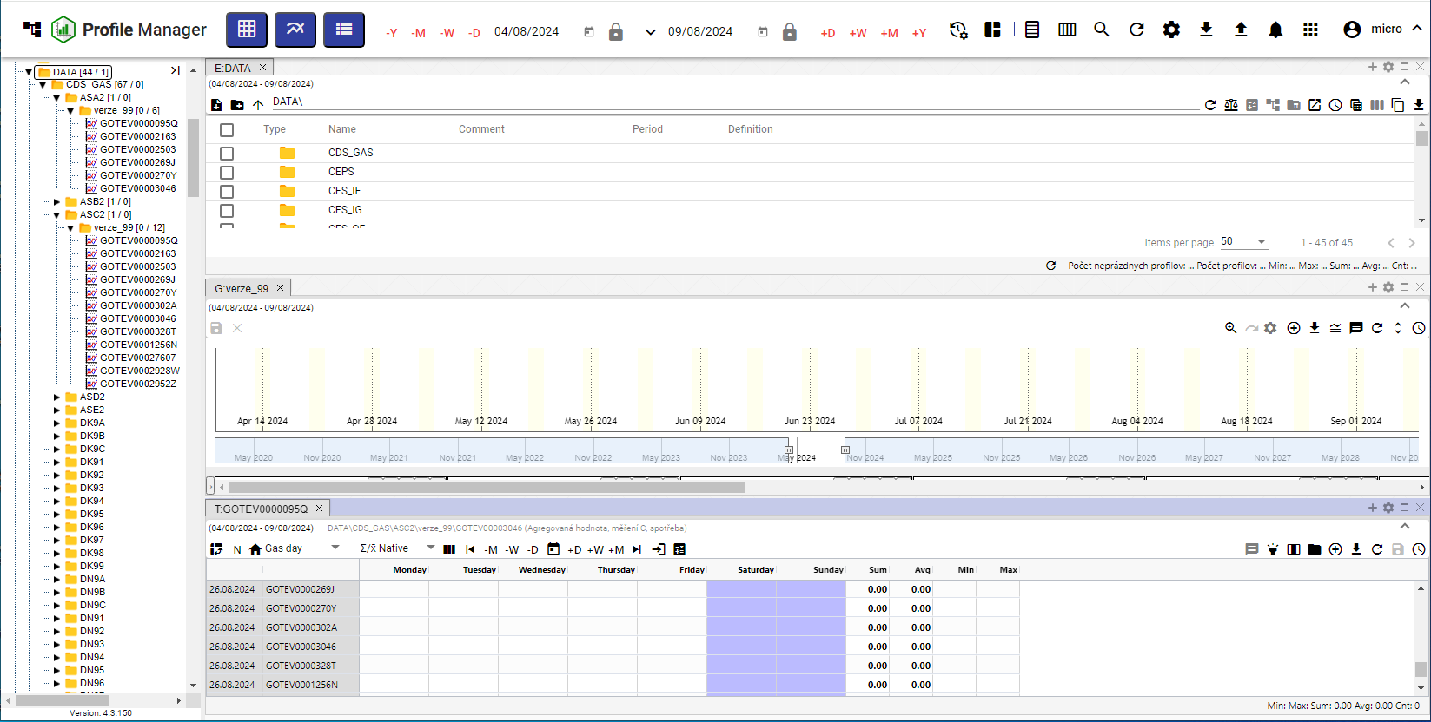

Picture 117: Horizontal window alignment

## To install windows vertically

"To align windows vertically click the 'Vertical alignment' button which can be found in the top menu of the application. Windows open within the 'Profile Manager' application are aligned vertically, Figure 119."



Picture 118: Vertical alignment button

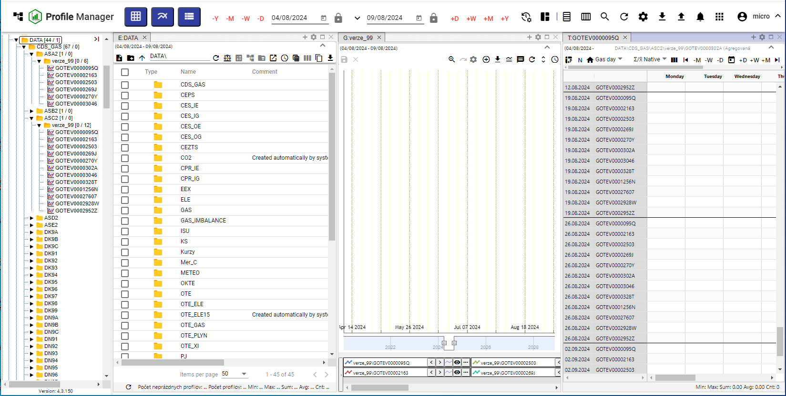

Picture 119: Vertical alignment of windows

## **[OLLAMA FORMATTING ERROR - MANUAL REVIEW NEEDED] Ako zobraziť a stiahnuť exporty**

"In the bottom tab of the 'Profile Manager' application, there is a button called 'Export', which serves to show a list of exports in the 'Exports' window. If the export was successful, it can be downloaded by pressing the green download button. The procedure for creating an export is detailed in Chapter 2.16."



Image 120: Export button

The number of unprinted exports will appear as a number in a red circle next to the "Export" button, Image 121. Unprinted export in the "Exports" window has a red "N" at the "Print" button, Image 122.

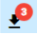

Image 121: Three exhausted exports

Exports may be in a state:

* Current exports.
* "COMPLETED – successfully exported, it can be downloaded by clicking the button "Download"."
* There was an error during export.
* "ERASED – the export was erased. Information about erasing the export came from the application Export Service."

"Export statements come from the Export Service and in the 'Profile Manager' application, they serve only for display. The 'Exports' window can be closed by clicking on the 'Cancel' button."

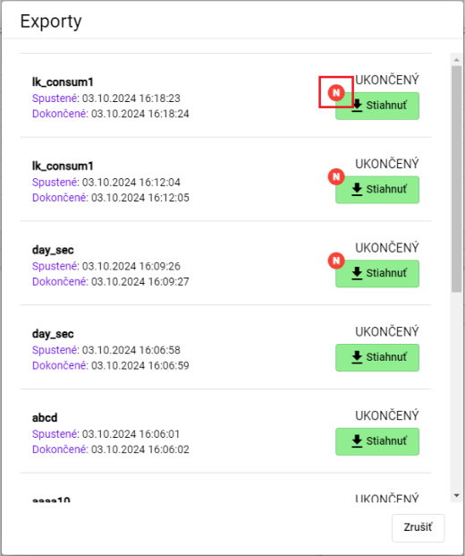

Image 122: Window "Exports"

## How to display imports

"In the top-right corner of the application 'Profile Manager', a button labelled 'Import' is located, which serves to display a list of imports in the window 'Imports'. The procedure for creating an import can be found in chapter 2.17."



Image 123: Import Button

After clicking the "Import" button, an "Imports" window will appear, in which it is possible to display details of imports, Image 125.

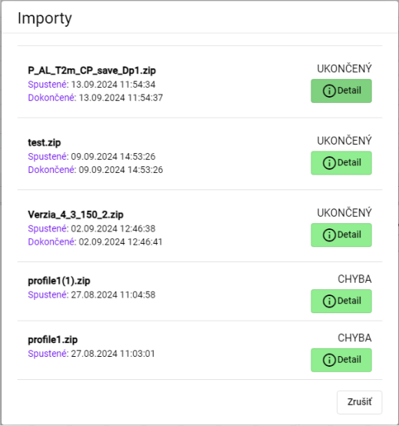

Picture 124: Window "Imports"

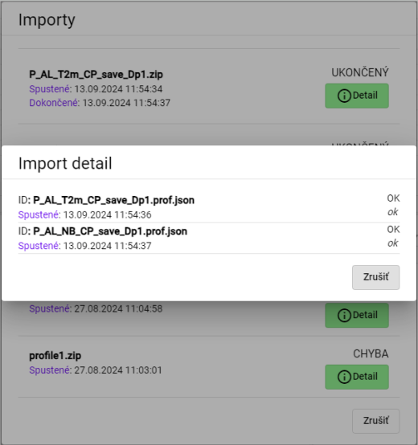

Picture 125: Display of Import Details

## Keyboard shortcuts

"You can display the list of keyboard shortcuts in the 'Profile Manager' application:"

1. "Click on the button with the name of the registered user, which is located in the top bar of the application."
2. "A menu will appear, where you can navigate with the mouse cursor to the item «Help»."
3. Click on the item "Keyboard shortcuts".

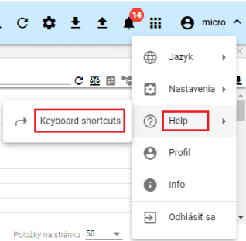

Image 126: Item "Keyboard shortcuts"

1. "A window named 'Keyboard shortcuts' will appear."

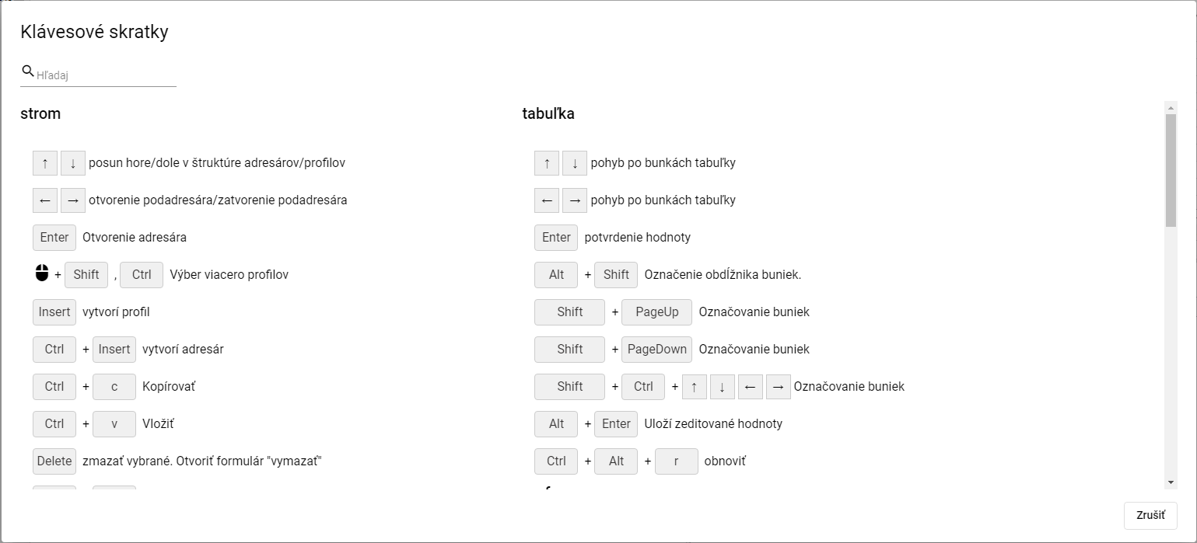

Image 127: Window "Keyboard Shortcuts"

1. Keyboard shortcuts can be searched by entering the text into the "Search" field located in the upper left corner of the window. Automatically, a list of keyboard shortcuts will appear matching the entered text.
2. "Close the window by pressing the 'Cancel' button."

"In the application 'Profile Manager' you can use keyboard shortcuts that are listed in the following table."

|  |  |  |
| --- | --- | --- |
| Klávesová skratka | Časť aplikácie | Popis |
| šípky HORE/DOLE | strom | Posun hore/dole v štruktúre adresárov/profilov |
| šípky HORE/DOLE | prieskumník | Posun hore/dole v štruktúre adresárov/profilov |
| šípky HORE/DOLE | tabuľka | Pohyb po bunkách tabuľky |
| šípky HORE/DOLE | graf | Hore zoom OUT, dole zoom IN |
| šípky Doprava a doľava | strom | Otvorenie podadresára/zatvorenie podadresára |
| šípky Doprava a doľava | prieskumník | Posun celej tabuľky doľava a doprava, aby bolo možné vidieť schované stĺpce |
| šípky Doprava a doľava | tabuľka | Pohyb po bunkách tabuľky |
| šípky Doprava a doľava | graf | Posun grafu o jedno zobrazené časové okno doľava a doprava |
| ENTER | strom | Otvorenie adresára |
| ENTER | prieskumník | Otvorenie adresára/Otvorenie editačného okna profilu |
| ENTER | tabuľka | Potvrdenie hodnoty |
| ENTER | graf | Bez akcie |
| Výber myšou pomocou Shift, Ctrl | strom | Výber viacero adresárov/profilov |
| Výber myšou pomocou Shift | prieskumník | Výber viacero adresárov/profilov |
| Výber myšou pomocou Shift, Ctrl | graf | Výber viacero profilov |
| Alt + Shift | tabuľka | Označenie obdĺžnika buniek |
| Insert | prieskumník | Založí profil |
| Ctrl + Insert | prieskumník | Založí adresár |
| Insert | strom | Založí profil |
| Ctrl + Insert | strom | Založí adresár |
| Ctrl + ALT + K | graf | Zmena koeficientu označeného profilu / označených profilov |
| Ctrl + ALT + W | graf | Skryje označený profil / označené profily |
| Ctrl + ALT + Q | graf | Odkryje označený profil / označené profily |
| Ctrl + ALT + T | PMW | Nové okno Tabuľka |
| Ctrl + ALT + G | PMW | Nové okno Graf |
| Ctrl + ALT + E | PMW | Nové okno Prieskumník |
| Ctrl + C | strom/ prieskumník | Kopírovať |
| Ctrl + ALT + C | prieskumník | Export prieskumníka do clipboardu |
| Ctrl + V | strom/ prieskumník | Paste |
| Ctrl + S | PMW | Uloženie zostavy. Ak nie je žiadna otvorená ponúkne formulár na uloženie do stromu. |
| Ctrl + O | PMW | Otvorenie zostavy z disku |
| Ctrl + ALT + F4 | PMW | Zavretie grafu/tabuľky |
| Ctrl + šípka NAHORU/DOLŮ | graf | Posun/radenie zobrazovaných profilov pod grafom |
| Alt + ENTER | graf | Uloží rozkreslenú čiaru |
| Alt + ENTER | tabuľka | Uloží zeditované hodnoty |
| Delete | graf | odoberie z grafu vybrané profily |
| Delete | strom/prieskumník | Zmazať vybrané. Otvoriť formulár "Delete" |
| CTRL+ R | strom/prieskumník | Refresh |
| CTRL+ ALT + R | graf/tabuľka | Refresh |
| Koliesko myši | graf | Zmena rozsahu časovej osi |
| Koliesko myši + CTRL | graf | Zmena rozsahu ľavej osi |
| Koliesko myši + CTRL + ALT | graf | Zmena rozsahu pravej osi |
| SHIFT + šípka NAHORU/DOLŮ | prieskumník | Výber adresárov/profilov |
| SHIFT + HOME | prieskumník | Výber viacero adresárov/profilov |
| SHIFT + END | prieskumník | Výber viacero adresárov/profilov |
| CTRL + X | prieskumník /strom | Presun adresárov/profilov |

## How do I find my profile in the application?

"Before searching for your profile, proceed:"

1. "Click on the button located at the top of the application's window."
2. "A field called 'search profile' will appear, where you write the name of the profile."

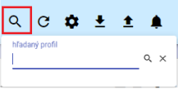

Image 128: Search for profile picture

1. "Please enter the text you'd like to search for profiles by."
2. Press the Enter key or search button.

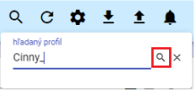

Picture 129: Search button

1. In the active window, a tab labeled “B:Root” will appear containing profiles matching the specified text.

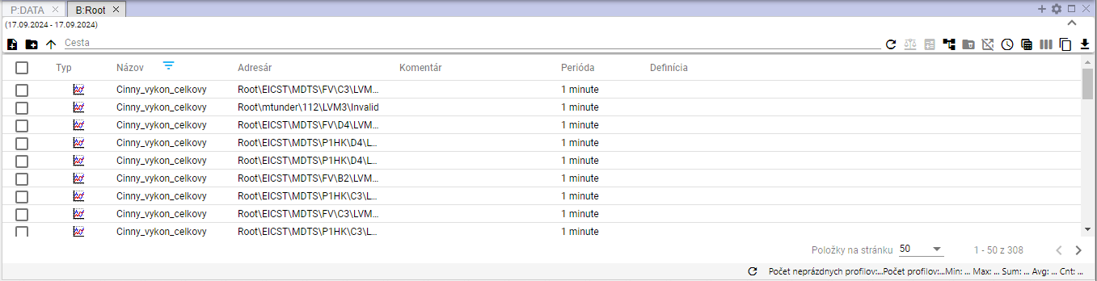

Image 130: Search results

## User notification about unsubscribing

**[TRANSLATION FAILED AFTER 3 RETRIES] Ak má užívateľ otvorenú aplikáciu „Profile Manager“ vo viacerých záložkách prehliadača a v niektorej zo záložiek sa užívateľ odhlási, zobrazí sa okno informujúce o odhlásení užívateľa, Obrázok 131. Ak sa chcete prihlásiť, stlačte tlačidlo „Prihlásiť sa“. Zobrazí sa prihlasovacia obrazovka, kde zadajte používateľské meno a heslo pre prihlásenie, Obrázok 2. Po prihlásení je aplikácia „Profile Manager“ v stave v akom bola pred odhlásením.**

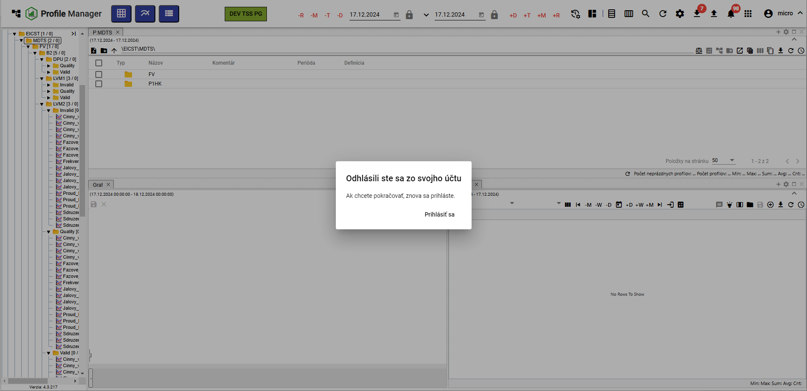

Image 131: Window "You have logged out of your account"

## **[OLLAMA FORMATTING ERROR - MANUAL REVIEW NEEDED] Ako zobraziť čas, ktorý ostáva užívateľovi do odhlásenia**

**[OLLAMA FORMATTING ERROR - MANUAL REVIEW NEEDED] Ak s aplikáciou „Profile Manager“ aktívne nepracujete, odpočítava sa čas, ktorý ostáva do odhlásenia užívateľa z aplikácie „Profile Manager“. Ak s aplikáciou pracujete, čas sa obnovuje.**

**[OLLAMA FORMATTING ERROR - MANUAL REVIEW NEEDED] Koľko času do odhlásenia ostáva si môžete skontrolovať:**

1. **[OLLAMA FORMATTING ERROR - MANUAL REVIEW NEEDED] Kliknite na tlačidlo s názvom prihláseného užívateľa.**
2. **[OLLAMA FORMATTING ERROR - MANUAL REVIEW NEEDED] Zobrazí sa menu, v ktorom sa nachádza informácia o aký čas vyprší doba prihlásenia, Obrázok 132.**

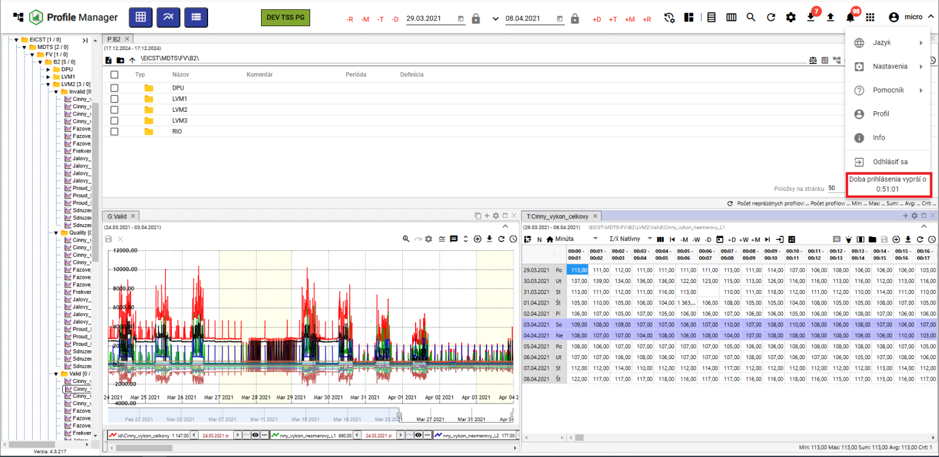

"Image 132: Information about the time remaining until user logout"

"If the user did not actively work with the 'Profile Manager' application and the login period has expired, the user is logged out of the application. The window 'Login period expired' appears. If you want to log in again, click the 'Log in' button."

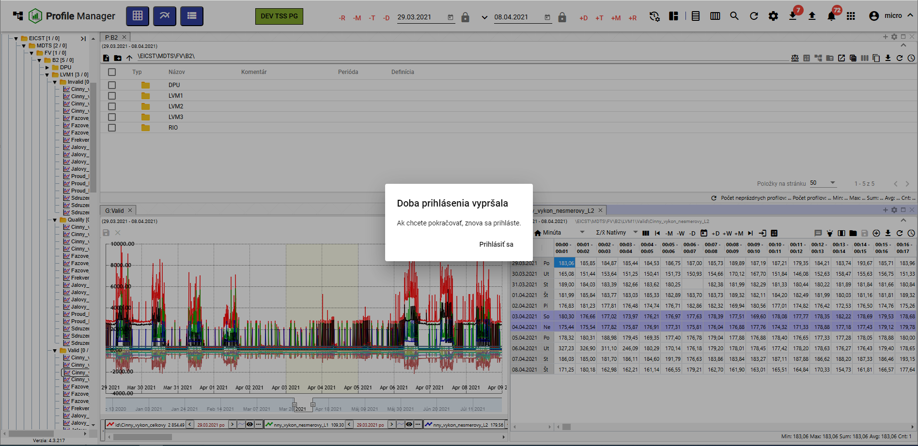

Image 133: Notification of the expiration of registration time

# Work with address books and profiles

"In the stream structure, there are addresses and profiles that you can create, convert, edit and delete. You can filter addresses."

"The address book allows for the logical grouping of data into one group. Each address book can contain further address books or profiles."

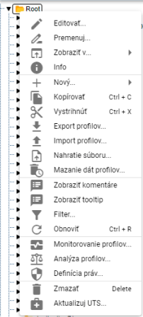

Image 134: Window with features for recipient and profiles

## I will add new folder

"Before adding a new recipient, proceed:"

1. Click the right mouse button on the directory in the tree structure where you want to add a new directory.
2. Choose an item called “New” and then “Address book”.

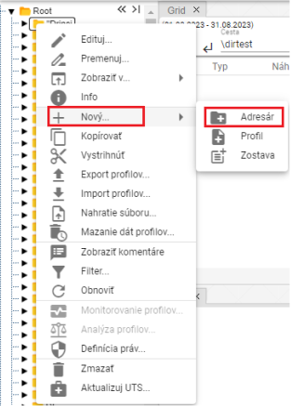

Image 135: Item "Address Book"

1. "A window will appear for creating an address."

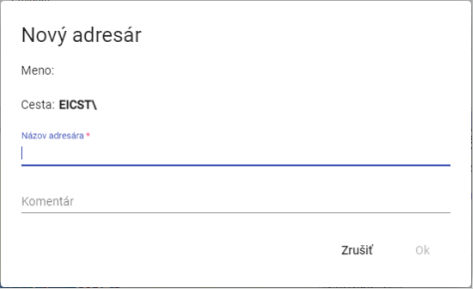

Picture 136: Window for creating an addressee

1. Fill in the details. The field "Name of recipient" is mandatory. The name must not start with a number and may contain letters, numbers, and underscores. The name must be at least 3 characters long and no longer than 50 characters. If you do not enter a name or if you enter an invalid name, a message about the name for the address book will appear, Image 137. The rules for entering the recipient's name may vary depending on the configuration of the given environment.

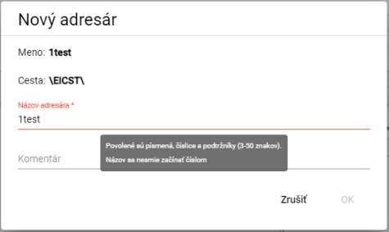

Image 137: Information about rules for entering the recipient's name

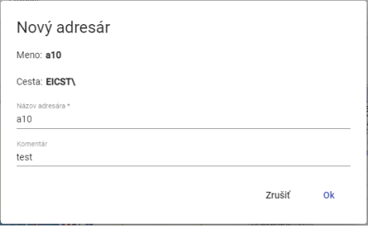

Picture 138: Task - giving name and comments

1. You will create an address book by pressing the "OK" button.

## How to rename a folder

"Procedure for renaming addressee:"

1. Click the left mouse button on the recipient's name and press the "F2" key or click the right mouse button on the folder you want to rename and select the item "Rename".

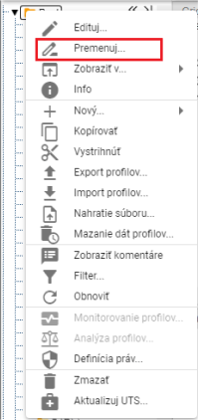

Image 139: Item "Rename"

1. **[TRANSLATION FAILED AFTER 3 RETRIES] Zobrazí sa okno, v ktorom napíšte nový názov adresára. Názov adresára sa nesmie začínať číslom. Môže obsahovať písmená, číslice a podčiarkovníky. Názov musí mať minimálne 3 znaky a maximálne 50 znakov. Ak nezadáte názov alebo by ste zadali neplatný názov, zobrazí sa informácia k názvu pre adresár. Pravidlá pre zadanie názvu adresára sa môžu líšiť podľa konfigurácie daného prostredia.**

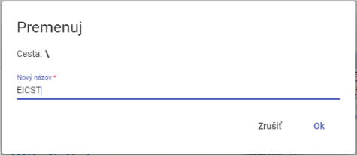

Image 140: Window for address conversion

1. You will save changes by pressing the "OK" button.

## How to Edit an Address Book

"Before editing the addressee, proceed:"

1. Click with the right mouse button on the folder that you want to edit.
2. Choose item "Edit" from drop-down menu.
3. A window will appear where you can edit the field "Comment".

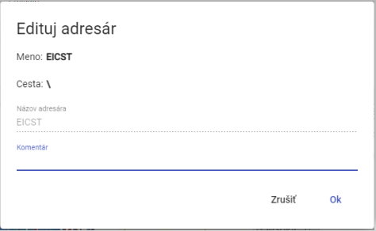

Image 141: Window for editing addressee

1. You will save changes by pressing the "OK" button.

## I want to delete the folder

Remove contact list

1. Click with the right mouse button on the folder you want to delete.
2. "An offer will be shown, from which you select 'Delete'."
3. "In the window, click 'Yes' to confirm deletion."

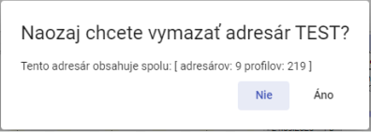

Picture 142: Window for confirmation of erasure

## I will copy the directory

"Before copying the recipient, proceed with:"

1. Click with the right mouse button on the folder you want to copy.
2. In options, select "Copy."
3. Click the right mouse button on the folder to which you want to paste the copied folder and select the item "Insert".
4. "A window titled 'Move/Copy' will appear."

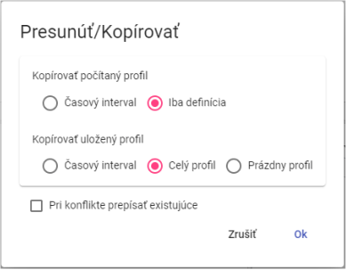

Picture 143: Window for copying address

1. Click on the "OK" button.

## To pull out or move a file folder.

"For the removal of a node from one location to another within a tree structure, use the 'Delete' item. To delete a node, proceed:"

1. Click with the right mouse button on the folder you want to extract.
2. "Tick the box 'Export'."
3. Click the right mouse button on the folder where you want to insert the folder.
4. Choose the item "Insert".
5. "A window will appear where you click 'OK'."

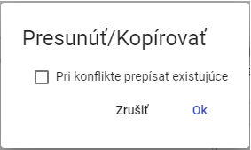

Picture 144: Window "Move/Copy"

## To upload a file

Before submitting files, please follow:

1. Click the right mouse button on the location in the tree structure where you want to upload a file.
2. "A window will appear where you select 'Save file...'."

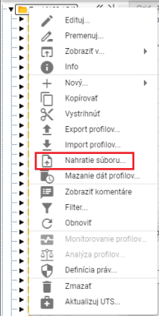

Picture 145: Item "Submission of society..."

1. "A window titled 'Upload' will appear, click on it and select the file you want to upload. You can also upload a file by dragging it into the 'Upload' window."

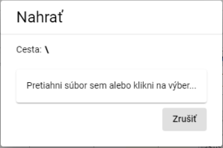

Picture 146: Upload window

1. The window will close and at the bottom of the screen will appear an announcement: "The upload request has been sent."

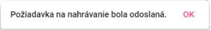

Image 147: Notification: “Recording request has been sent.”

Recognized File Types:

* "Page two - reports"
* There were leftovers
* "xlsx - template for teams"

## **[TRANSLATION FAILED AFTER 3 RETRIES] Ako zmazať dáta profilov**

"The function 'Deleting data from profiles' will cause all data in selected columns to be deleted within a specified time interval for all profiles. You can also select multiple columns at once or multiple profiles at once. Data can also be deleted in subfolders."

"Before deleting your profile, proceed:"

1. "If you want to erase data only in a selected folder (or its subfolders) or in one profile, click the right mouse button on the selected folder or profile. A window will appear where you select the item 'Delete data from profiles...'."

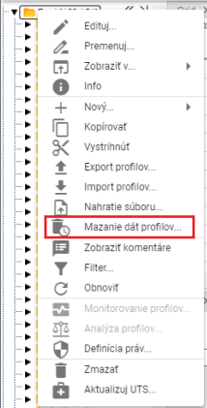

Picture 148: Item "Smearing date profiles..."

1. If you want to erase data from multiple folders or profiles at once, proceed:
   1. Mark folders or profiles where you want to erase data.
   2. "To select multiple items in sequence, click the left mouse button on the first item, hold down the SHIFT key and then click on the last item you want to select. All items between them will be selected."

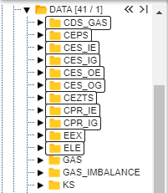

Image 149: Selection of various sandwiches

* 1. "Click the left mouse button on the first folder, hold down the Ctrl key and click the left mouse button to select other folders you want to pick."

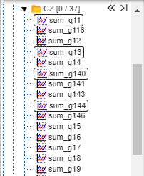

Picture 150: Selection of several profiles

* 1. "Click on the selected fields or profiles with your right mouse button and select the item 'Clearing data of profile...'."

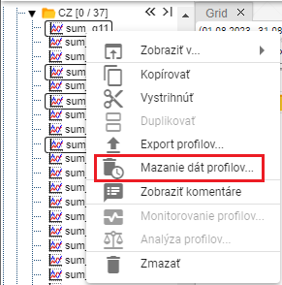

Picture 151: Item "Smearing dates on profile..."

1. "A window titled 'Range Smoothing' will appear, in which you can select a daily or minute time interval. The default is a one-minute time interval."

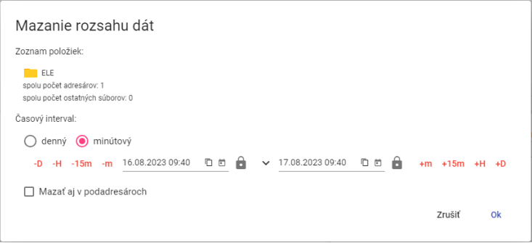

Image 152: Window "Range Selection" for one selected folder.

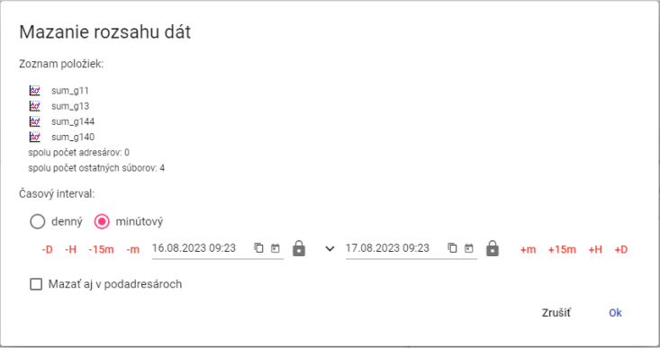

Image 153: Window "Scrubbing date range" for multiple selected profiles

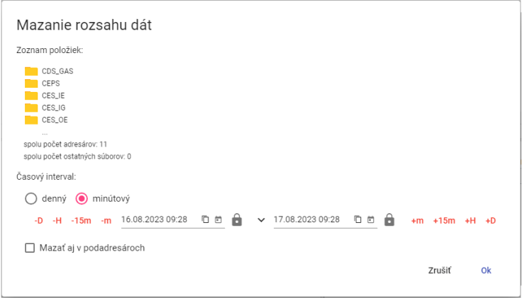

Image 154: Window "Scanning data range" for selected multiple rows

1. "Next, specify the time interval during which the data should be deleted."
2. "If you tick the box 'Also erase in sub-addresses', then sub-addresses will also be deleted and data from profiles will be erased according to the selected time interval."
3. Press the "OK" button.

## I filter email addresses and profiles

"Before filtering addresses and profiles, proceed:"

1. "Click on the right mouse button on folder."
2. Choose the item "Filter".
3. "A window for filtering will appear. If you want to filter contacts, enter the name or part of the contact's name in the 'Filter contacts' field. To filter profiles, enter the name or part of the profile's name in the 'Filter profiles' field. Star convention is not used here; any substring is searched. Filtering is also case sensitive - sensitive to uppercase and lowercase letters."

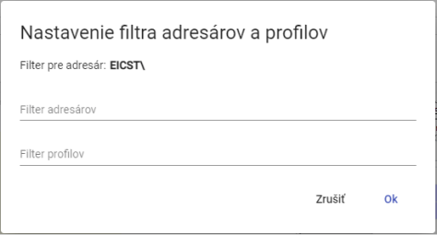

Image 155: Window "Setting up recipient and profile filters"

1. "Confirm by pressing the 'OK' button."

## "To disable address and profile filters"

Proceed with filter cancellation:

1. Click on the folder where the filter is set up with the right mouse button.
2. Choose the item "Filter".
3. "Turn off the set filter."
4. Save changes by pressing the "OK" button.
5. "After disabling the filter, all senders and profiles will be displayed in the tree structure."

## Show comments

"When creating recipients and profiles, it is possible to input a comment. Displaying comments in tree structure turn on:"

1. Click the right mouse button on any address book or profile in the tree structure.
2. "A window will appear, in which you can navigate to the 'Show' option using your mouse cursor and select 'Show comments'."
3. "When displaying comments is enabled, the names of recipients and profiles are shown in parentheses before the comment. Image 156. If a comment has not been entered, only the names of recipients or profiles are shown in parentheses. Image 157."



Image 156: Address book with comments turned off



Image 157: Comment section not included

1. "Comments can be turned off by clicking the right mouse button on any folder or profile in the tree. In the window that appears, set the cursor to the 'Show' item and select 'Hide comments'."

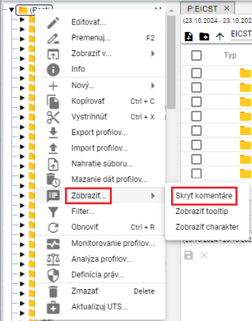

Picture 158: Item "Hide comments"

1. "Comments are then hidden and names or profiles of recipients appear without rounded brackets."



Image 159: Address book with hidden comments

## How to show tooltip

"Before showing tooltips for profiles in a tree structure, proceed:"

1. "Click the right mouse button on any address book or profile in the tree structure."
2. "A window will appear, in which you should position the mouse cursor on the item 'Show...' and click on the item 'Show tooltip'."

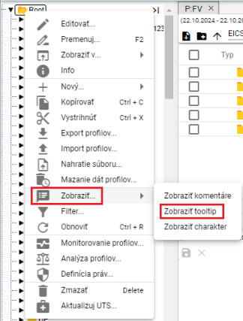

Image 160: Item "Show Tooltip"

1. The tooltip will appear when you move your mouse cursor over the profile name.

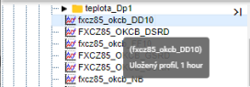

Image 161: Shown tooltip

1. "Disable tooltips by clicking the right mouse button on any folder or profile in the menu. In the window that appears, click the cursor on 'Show' and select 'Hide tooltip'."

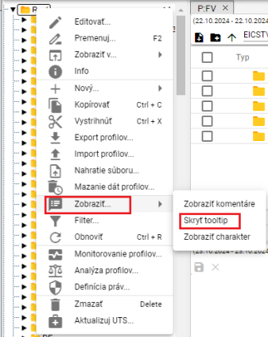

Image 162: Item "Hide tooltip"

## To display the character

Character profile can be "Cumulative" or "Trajectory", which are represented by marks.

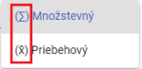

Picture 163: Symbols representing the quantitative and processual character

"Before displaying character in profiles within a stream structure, proceed:"

1. Click the right mouse button on any folder or profile in tree structure.
2. "A window will appear where you can set the cursor on the item 'Show...' and click on the item 'Show character', Image 160."
3. "He is very good-natured, a nice character will be shown before the profile name."

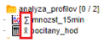

Picture 164: Character shown at profiles

1. To turn off character display, click the right mouse button on any address book or profile in your menu. In the window that appears, use your cursor to select "Display" and choose "Hide Character".

## If I were to restore the list

"Click on the folder in the tree structure with the right mouse button and press the 'Restore' button to restore the list of profiles and addresses."

## How to set up user and group rights

Rights for users and user groups are set up:

1. Click with the right mouse button on the folder for which you want to set up permissions.
2. Choose item "Definition of rights".

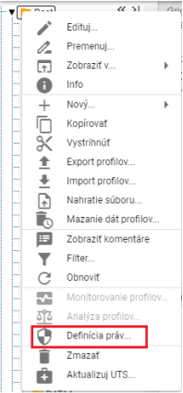

Image 165: Item "Definition of Rights"

1. The settings window will appear.

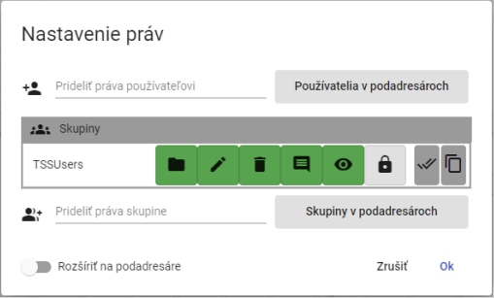

Image 166: Window Settings

1. "Click the field 'Add user rights' before adding rights to user, start typing the username. A list matching the entered text will automatically appear."

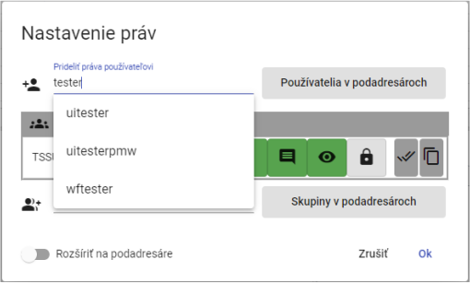

"Image 167: In a field in Pridoli, assign rights to user start writing the name of user"

1. "Select a user which will display the table 'Users' containing the selected user."

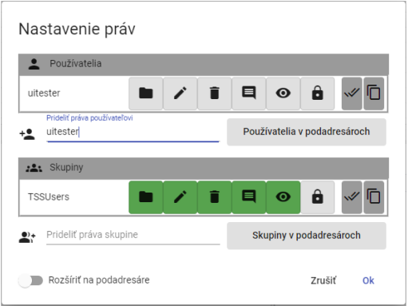

Image 168: Selected user

1. Click on the buttons to add user rights.

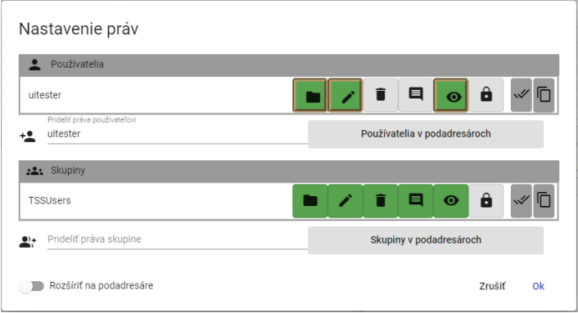

Image 169: Granting rights to the user

1. "Before assigning rights to a group, select the group from the field 'Assign rights to group'."

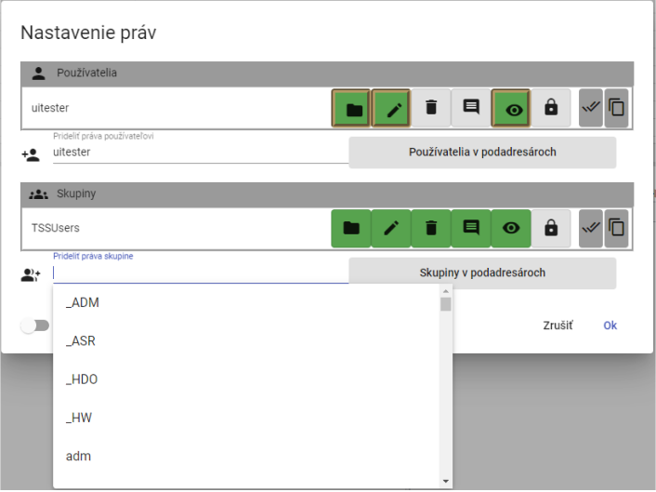

Image 170: Group Selection

1. "The selected group will be displayed in the table 'Groups'."

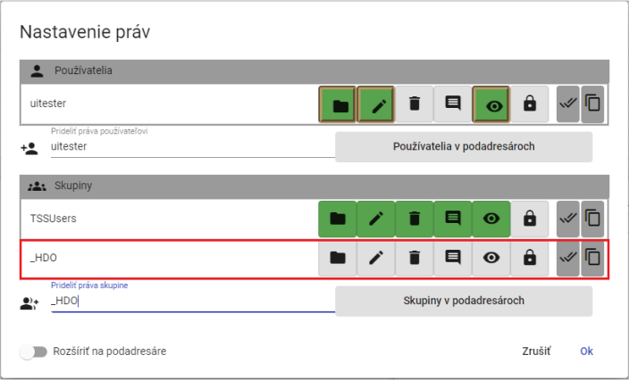

Image 171: Selected Group

1. Click on the buttons to set permissions for the selected group.

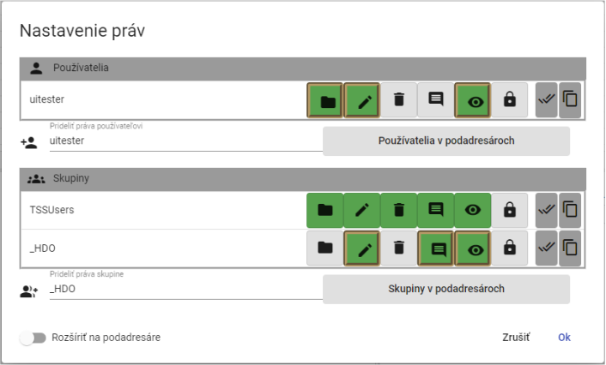

Image 172: Rights assignment to group

1. If you'd like to set rules for sub-users as well, click the "Extend to sub-users" button.

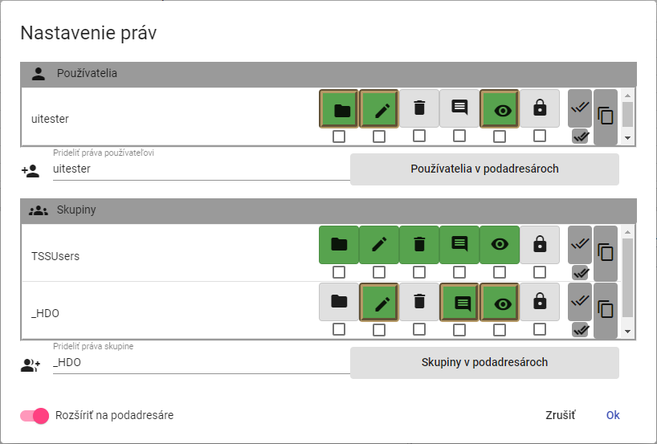

Picture 173: Permission to Expand to Subaddresses

1. "Under the buttons representing user and group rights will be checkboxes to click. Click checkboxes under the buttons where you want the right to apply to subaddressers."

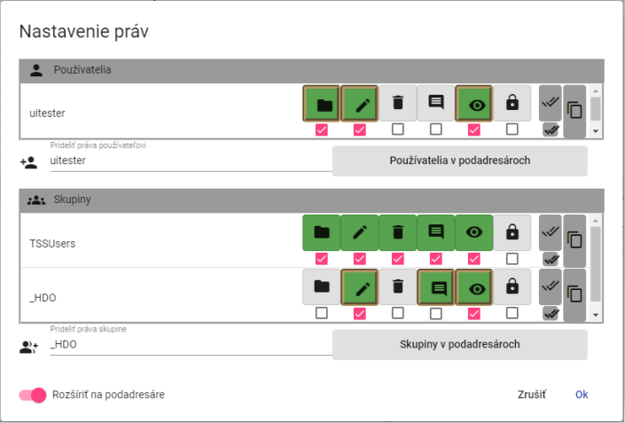

Image 174: Settings for user and group permissions for sub-agents

1. Save changes by pressing the "OK" button.

## How to create an export

"Before exporting profiles, proceed with:"

1. "Click the right mouse button in the stream structure on a directory or click the right mouse button in the explorer window on the line with the directory from which you want to export profiles."
2. Choose item "Export profiles..."

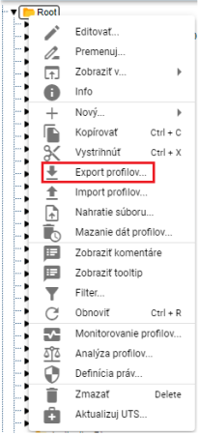

Image 175: Item "Export profiles..."

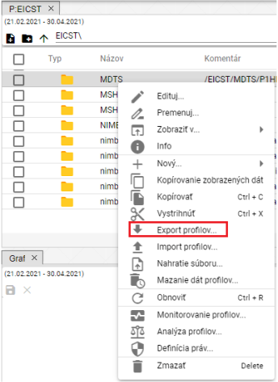

Picture 176: Export item in Explorer window

1. The window "Export" will appear, which contains two tabs: "Everything" and "Profiles (CSV)". By default, the "Everything" tab is displayed. The "Everything" tab allows exporting counted profiles in a statement form. The "Profiles (CSV)" tab exports only data.

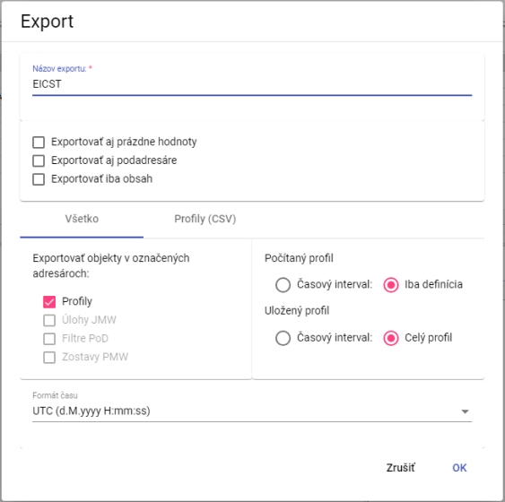

Picture 177: Export window bookmark "Everything"

1. "The field 'Export name' is normally filled with the name of the sender from which you want to export profiles. You can change the export name."
2. In the top part of the window, select what to export (including subaddresses and empty values, just the content)."
3. In the "Everything" box in the section "Export objects to selected recipients", select which objects you want to export.
4. "Select 'Calculated profile' and choose whether to export 'Time interval' or 'Only definition'."
5. In the section "Saved Profile", select whether to export a "Time Interval" or a "Full Profile".
6. In the game "Time Format", choose your time format.
7. "If you want to export profiles in the CSV format, click on the tab 'Profiles (CSV)".
8. "In the section 'Time Interval (mm/dd/yyyy)' select dates in fields 'Date From' and 'Date To'."
9. Click on the field "Column separator" and select a separator.
10. **[TRANSLATION FAILED AFTER 3 RETRIES] Kliknite do poľa „Oddeľovač desatinných miest“ a vyberte oddeľovač.**
11. In the country "Time Format" choose time format.

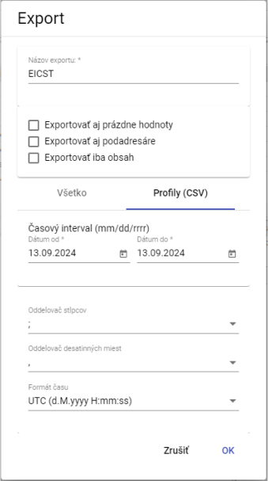

Picture 178: Export window Tab "Profiles (CSV)"

1. Press the "OK" button to export.
2. "Information about the state of export will be displayed in the window 'Exports', which is dealt with in chapter 1.20. In the window 'Exports' it will then be possible to download completed export."

## How to create an import

"Proceed before importing:"

1. Click with the right mouse button on the folder tree structure into which you want to import a file.
2. Select the item "Import profiles..."

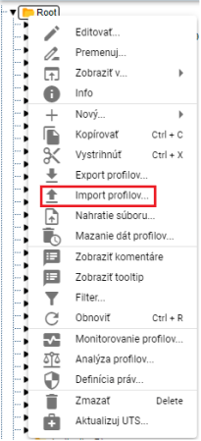

Picture 179: Item "Import profiles..."

1. The import window will appear.

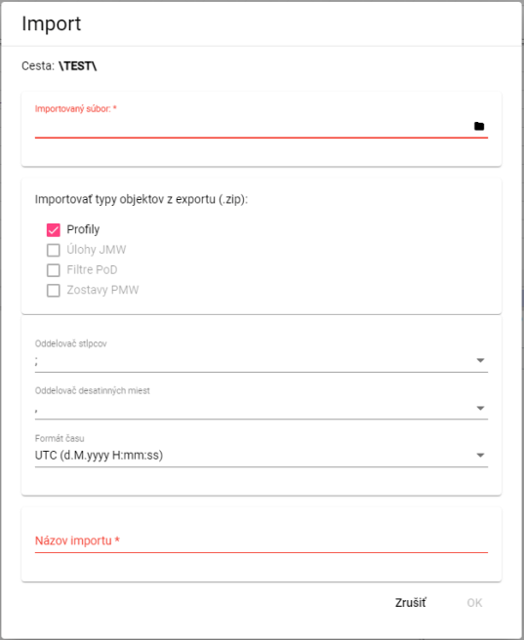

Picture 180: Window "Import"

1. **[OLLAMA FORMATTING ERROR - MANUAL REVIEW NEEDED] V časti „Importovaný súbor“ kliknite na čiernu ikonu súboru a vyberte súbor, ktorý chcete importovať.**
2. In the part "Importing object types from export (zip)" select what to import. The standard item selected is "Profiles."
3. Click on the field "Column Separator" and select separator.

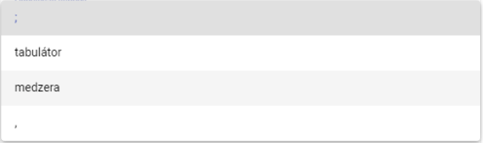

Image 181: Offer for item "Column separator"

1. **[TRANSLATION FAILED AFTER 3 RETRIES] Kliknite do poľa „Oddeľovač desatinných miest“ a vyberte oddeľovač.**
2. In the field "Import name", enter a name for the imported file.
3. You import the file by pressing the "OK" button.
4. The selected recipient will display the imported file.



Image 182: Imported file

Information about the state of imports will be displayed in the window "Imports", which is dealt with in chapter 1.21.

## I'll add a new profile

Before adding a profile, proceed with:

1. Click on the right mouse button on the folder to which you want to add a profile.
2. Choose item "New" and then "Profile".

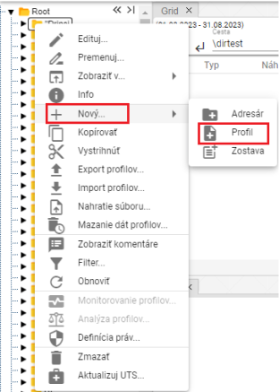

Image 183: Creation of Profile

1. It will show a window for creating a profile.

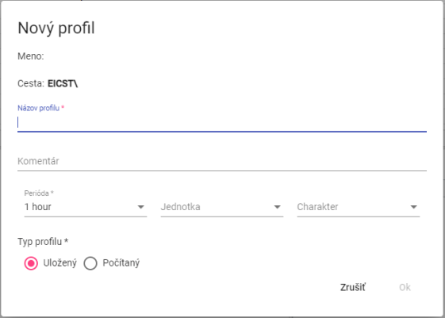

Picture 184: Window for creating profile

1. Fill out the data.
2. "The fields 'Profile name', 'Period' and 'Profile type' are compulsory."
3. **[TRANSLATION FAILED AFTER 3 RETRIES] Názov profilu sa nesmie začínať číslom. Môže obsahovať písmená, číslice a podčiarkovníky. Názov musí mať minimálne 3 znaky a maximálne 50 znakov. Ak nezadáte názov alebo by ste zadali neplatný názov, zobrazí sa informácia k názvu pre profil. Pravidlá pre zadanie názvu profilu sa môžu líšiť podľa konfigurácie daného prostredia.**

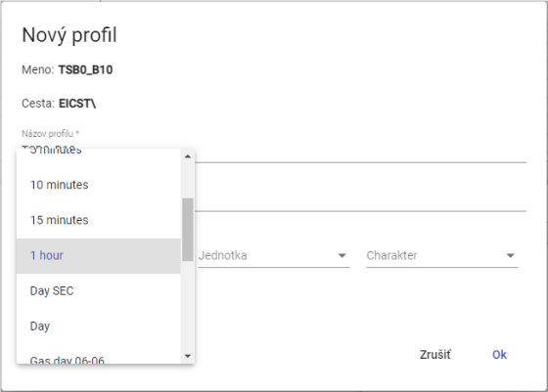

Picture 185: Selection of Period

1. "Once you select the calculated profile type, please define it. For example, profileA+2*(profileC-2). The arithmetic options are described in document „Xenergie TSS Kompl_prehl_fnc_G2 R12.xlsx“. Chapter 2.18.1 deals with defining a calculated profile."

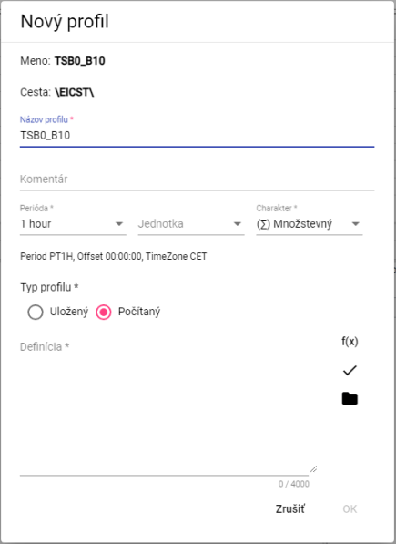

Picture 186: Computed Profile Type

1. You will create a profile by pressing the button "OK".

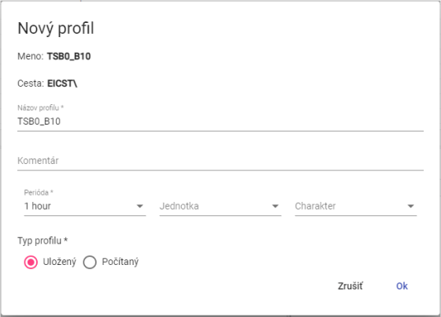

Image 187: Saved Profile Type

**[TRANSLATION FAILED AFTER 3 RETRIES] Charakter profilu:**

"Quantitative - represents for example the quantity of energy consumed over a certain time period."

The state-type - represents the state of a certain quantity at a specific time, for example the course of temperature.

"Unregistered - If the profile does not explicitly define one of the two characters mentioned above, the system behaves towards it as if it were a Behavioral. This behavior was chosen with regard to preserving back-compatibility with older versions of the Xenergie system and allows for an unproblematic transition to newer versions of the system."

This profile serves for identification of the method how values are being passed from a finer to coarser sampling. For example, energy values in MWh over a quarter hour should be summed up during conversion, while power values in MW over a quarter hour should be averaged.

"Character profile is used exclusively and only in connection with the necessity of transposing (transferring the profile to another period) a profile. In the case of using a profile in its native period, this setting is irrelevant."

### What is the definition for a counted profile type?

Before defining the calculated profile type, proceed with:

1. "In the window 'New Profile' click on the button 'Assign Wizard', which will display a function selection window."



Image 188: Button "The Wizard on Duty"

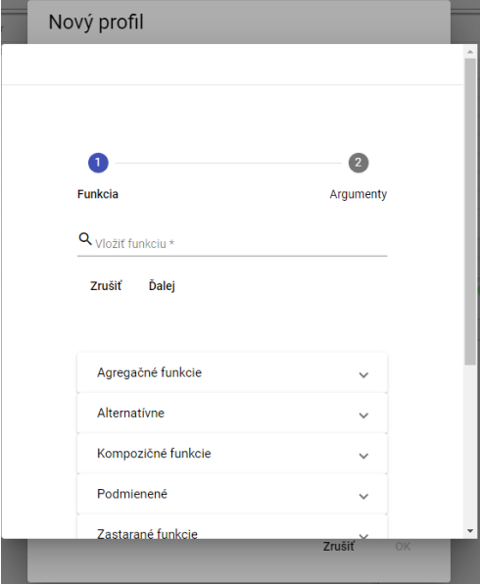

Image 189: Wizard for function assignment

1. Click on the field "Insert Function".

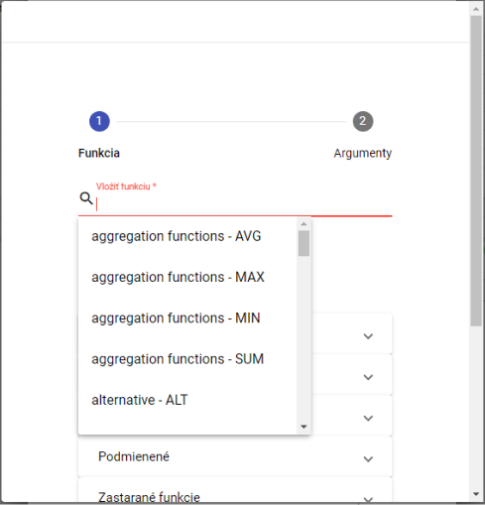

Picture 190: Selection function

1. "A list of functions will be shown, from which you select a function."
2. "After selecting the function, a description will appear."

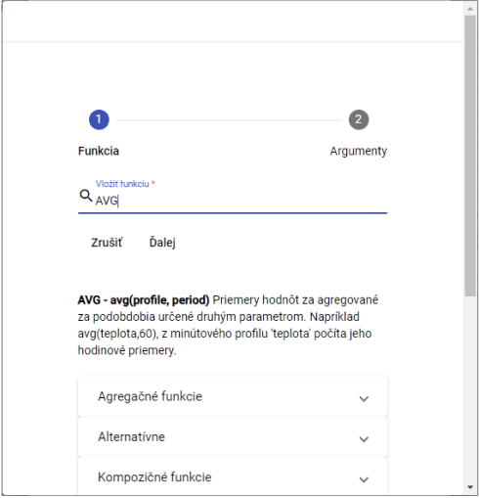

"Image 191: After selecting the function, a description of the function will be displayed"

1. By clicking on the functions group, a list of functions with description will appear.

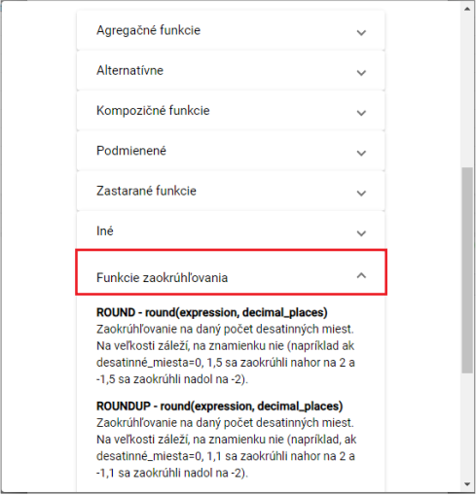

Picture 192: Description of Functions

1. "Write the path to your profile or press the button , which will display a window 'Select Profile', in which you select your profile."
2. Fill out the period.

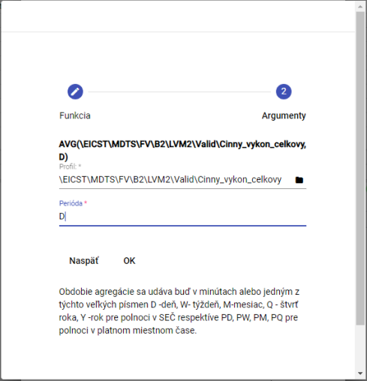

Image 193: Period task

1. Press the "OK" button.
2. "In the 'New Profile' window, click on the 'Check Definition' button after entering the definition."

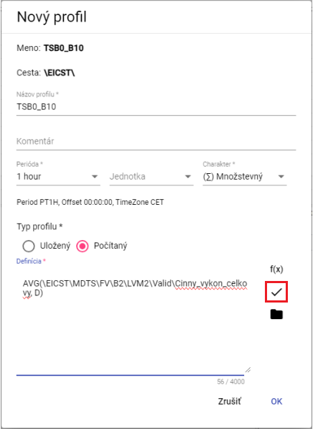

Picture 194: Button "Check definition"

1. "A window called 'Status' will be shown, which can be closed by pressing the 'OK' button."

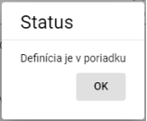

Picture 195: Status Window

1. The button serves for adding profile.
2. **[OLLAMA FORMATTING ERROR - MANUAL REVIEW NEEDED] Profil uložíte stlačením tlačidla „OK“.**

## Add a new team.

You will create a new team.

1. Click on the folder where you want to add a new project with the right mouse button.
2. "Select the item 'New...' and then select the item 'Remain'."

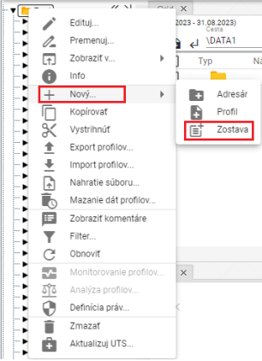

Picture 196: Item "Stay"

1. The window "Name of group" will be shown.

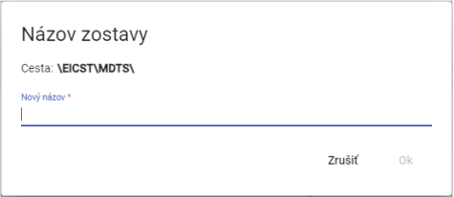

Image 197: Window "Team Name"

1. Enter name for the new team. The team name should not start with a number. It can contain letters, numbers and underscores. The name must have at least 3 characters and at most 50 characters. If you do not enter a name or would enter an invalid name, an information with rules for the name will be displayed. Rules for entering names may vary depending on the configuration of the given environment.

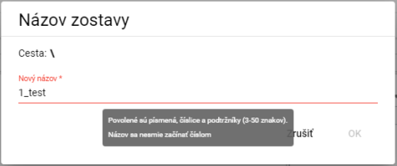

"Image 198: If the name is not valid, an information with rules for naming will be displayed"

1. Click "OK" to confirm.
2. "A new lineup will be added to the designated slot."

## How to change my profile

Your Profile

1. "Click with the right mouse button on the profile you want to convert."
2. Choose item "Renew" in the menu.
3. **[TRANSLATION FAILED AFTER 3 RETRIES] Zobrazí sa okno, v ktorom zadajte nový názov. Názov profilu sa nesmie začínať číslom. Môže obsahovať písmená, číslice a podčiarkovníky. Názov musí mať minimálne 3 znaky a maximálne 50 znakov. Ak nezadáte názov alebo by ste zadali neplatný názov, zobrazí sa informácia k názvu pre profil. Pravidlá pre zadanie názvu profilu sa môžu líšiť podľa konfigurácie daného prostredia.**

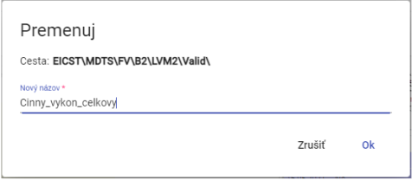

Picture 199: Profile Renaming

1. You will save changes by pressing the "OK" button.

## Edit my profile

Before editing your profile, proceed:

1. Click on the profile you want to edit with your right mouse button.
2. Choose item "Edit" on purpose.
3. It will display a window where you can edit the data.

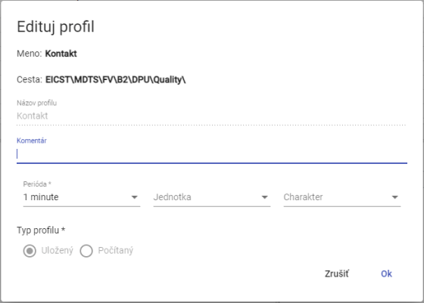

Image 200: Window for editing profile

1. You will save changes by pressing the "OK" button.

## To delete my profile

"Procedure for deleting profile:"

1. "Click with the right mouse button on the profile you want to delete."
2. "Click on 'Delete'."
3. "A window will appear where you confirm the deletion of your profile by clicking on the 'Yes' button."

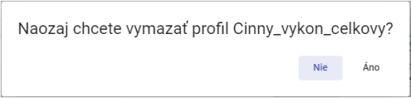

Image 201: Window for confirmation of deletion

## To view profile dependencies

"Dependency profile will be displayed:"

1. "Click on the right mouse button on a profile in tree-like structure."
2. Choose the item "Dependencies".
3. "A window will appear with three tabs labeled 'Used profiles', 'Full definition' and 'Dependent profiles'. The first tab contains a list of used profiles."

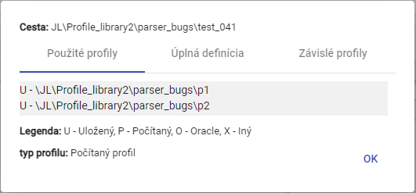

Image 202: Bookmark "Used profiles"

1. The second tab "Full Definition" contains the definition of the profile entered when creating a profile.

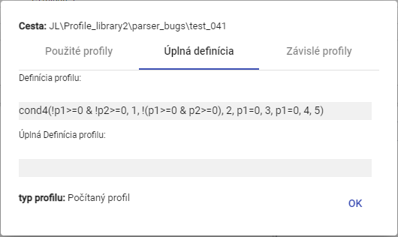

Image 203: Bookmark "Full Definition"

1. The third tab "Dependent profiles" contains a list of dependent profiles.

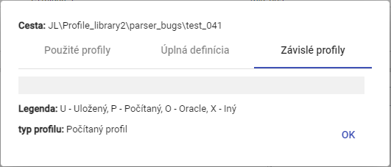

Picture 204: Bookmark "Dependent profiles"

## Create a new profile

In the window of the inspector, you create a new profile by clicking on the "Create New Profile" button located in the top left corner of the inspector window. A "New Profile" window will appear. The process for creating a profile is detailed in Chapter 2.18.

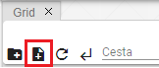

Image 205: Button "Create new profile"

## Set up the Political profile

"Policy defines special behavior of the profile. Policies are added to the system based on special requirements from the customer."

Time policy profile:

The time policy of the profile is a property of the profile that allows to solve very specific cases of data transformation in profiles.

One of the uses of policy is the possibility to change the period of a stored profile from 1 hour to 15-minute without the need for gradual and slow transformation of data. After applying the "1h to 15min" policy, the originally hourly stored profile becomes 15-minute and this applies across the board. All applications that use this profile will see it as 15-minute since the moment of transformation. The policy is therefore fully transparent to other applications outside TSS.

"The '1h to 15min' policy must have a firmly set date of change within itself, from which the profile will be used as fully functional 15-minute. Prior to this date, the profile will appear as 15 minutes, but all four values in an hour will always be equal. Their value will depend on the specified character of the profile."

Example:

The original hourly profile contained a value of 100 MWh. If the character profile setting is set to "Massive", then the 15-minute profile will return a value of 25 MWh in each 15-minute interval.

"If the time period is set to "Time series", then a 15-minute profile set up with the policy will return a value of 100 MWh in each 15 minute given hour."

Before setting policy proceed:

1. Click on the right mouse button on a profile in tree-like structure which you want to set policy for.
2. Select the item "Policy".
3. "A window called 'Policy settings' will appear."

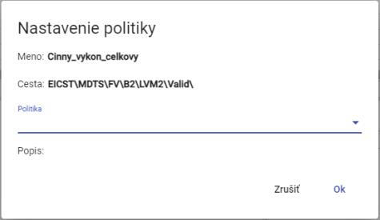

Image 206: Settings window

1. "Two policies are currently available"

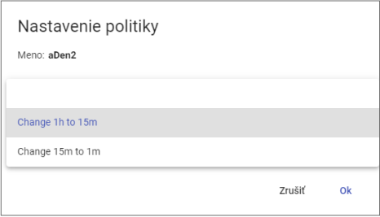

Image 207: Selection of Policy

1. Changes will be saved by pressing the "OK" button.

## How to view profile information

"Before viewing information about your profile, proceed:"

1. "Click with the right mouse button on the profile you want to display information about."
2. Select the item "Info".
3. It will show an information window.

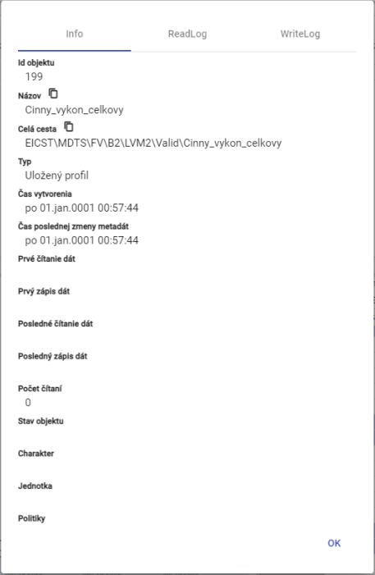

Image 208: Information about profile

## Copy profile

"Before copying the profile proceed:"

1. "Click on the right mouse button on the profile you want to copy."
2. Select item "Copy"
3. Click on the right mouse button in the folder to which you want to insert the copied profile and select the item "Insert".
4. The window "Move/Copy" will appear.

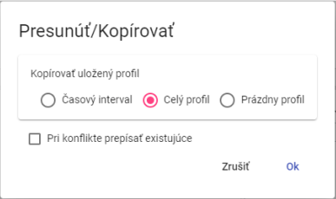

Image 209: Move/Copy window

1. Choose whether to copy only the time interval, the whole profile, or an empty profile. By default, the "Whole Profile" item is selected.
2. Click the "OK" button.

"The saved profile can be copied from one recipient to another by catching the profile with the left mouse button and dragging it over the recipient you want to copy the profile to."

"Before copying the addressee, proceed:"

1. "Take address book and move it to the address book from which you want to copy profile."
2. Next, empty the address book over the recipient, which will display a window "Move/Copy".

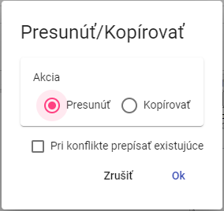

Picture 210: Window for profile transfer

1. Click on the "Copy" action.

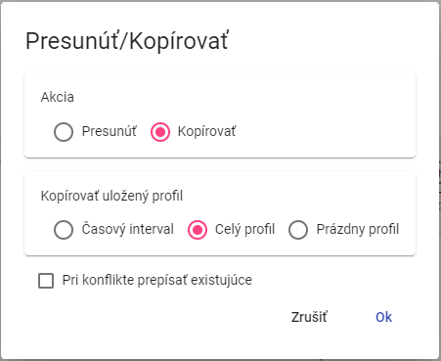

Picture 211: Window for copying profile

1. "In the part 'Copy Saved Profile', choose whether to copy the entire profile, a time interval of the profile or an empty profile."
2. "Once you select a time interval, enter the time interval to be copied."

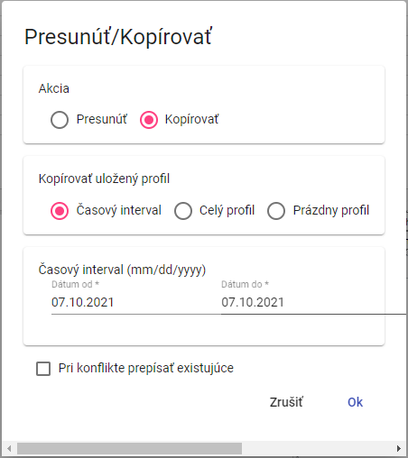

Picture 212: Window for copying a time interval of the stored profile

1. "Checking the box 'Write over existing in conflicts' means that if there is an existing profile in your directory with the same name as the one you're trying to copy, it will overwrite the original. If the checkbox isn't checked and a conflict occurs, the original profile will remain."
2. "Copy profile by pressing 'OK' button."

## To pull out/displace a profile

Before profile export, proceed with:

1. "Click with the right mouse button on the profile you want to drag out."
2. Choose item "Restart" in Safe Mode.
3. "Click with the right mouse button on the folder where you want to insert the profile."
4. Choose item "Add".
5. "A window will be displayed for confirmation, where you click the 'OK' button."

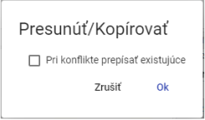

Window "Move/Copy"

"You can move the saved profile from one recipient to another by catching it with the left mouse button and moving it above the recipient you want to move it into."

"Before addressing the addressee, proceed:"

1. "Get the profile and move it into the folder where you want to move the profile."
2. "Then close the sender's profile, which will display a window 'Move/Copy'."



Picture 214: Window for profile transfer

1. Checking the box "Rewrite existing in conflicts" means that if an account with the same name as the one you want to move exists in the address book, it will be rewritten. If you do not check the box and a conflict arises, the original account will remain.
2. You will save the profile by clicking on the "OK" button.

## How to display time schedule overview in tree view

"Click twice on the left mouse button on your profile in the tree structure to display a preview of the time schedule. The 'Preview Time Schedule' window will appear. The 'Preview Time Schedule' window is described in Chapter 4.7."

## "To enlarge the window for creation and editing of calculated profile"

"Click on 'Expand' to create and edit the calculated profile. Proceed:"

"Left-click the button - and hold. Resize the window to your desired size and left-click again."

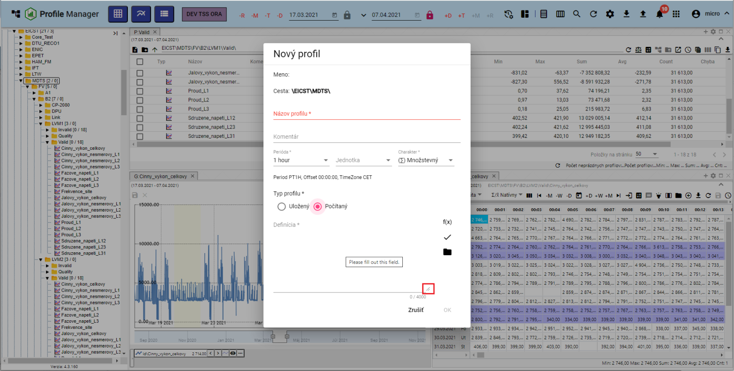

Picture 215: Button for enlarging window "New Profile"

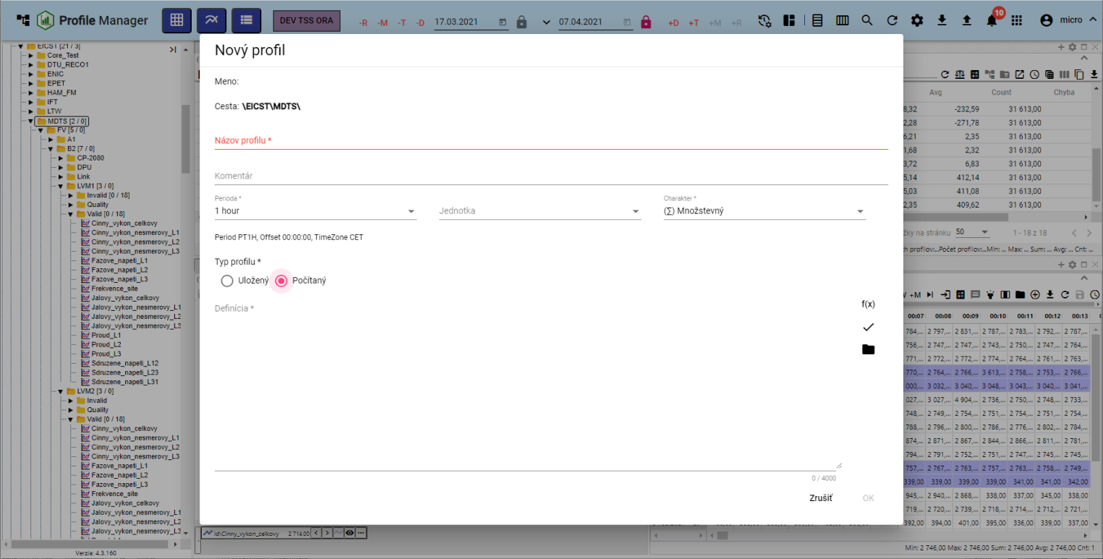

Image 216: Enlarged window "New Profile"

## I want to move windows

"Move the window in the application 'Profile Manager' by clicking on the top part of the window with your left mouse button and moving it to the desired location."

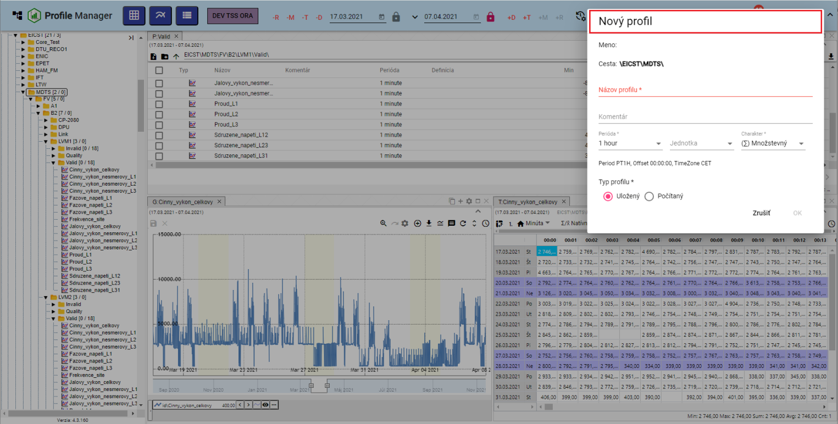

Image 217: Replacement of the window "New Profile"

## How to Convert Document

Document (for example roster, report) please translate:

1. "Click with the right mouse button on the document you want to convert."
2. "Tick on 'Rename'."
3. "A window will show 'Rename'."

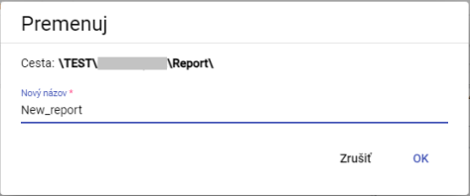

Picture 218: "Rearrange" Window

1. Change the name.
2. Press the "OK" button.

# "Shared control elements for explorer, table and graph"

"In the top part of the window, an inspector, table and graph are located buttons for window manipulation. Work with these buttons is discussed in the following subchapters."

## To restore data in windows

"Before loading data, click the button that displays Image 219."



Image 219: Restore data button in explorer window, table, graph

## "Change date range"

"Date range in explorer window, table or graph will change:"

1. "Press the button 'Change time range', which is located in the top right corner of the window."



Picture 220: Time range button

1. The calendar settings window will appear.

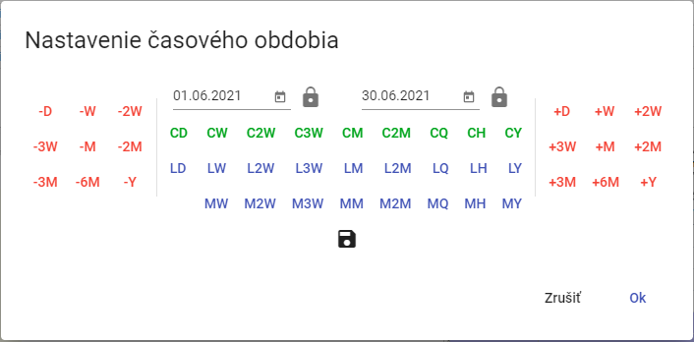

Picture 221: Window for changing date range

1. "You can set the date by pressing buttons, selecting a date or typing in a date directly."
2. "The new date range can be saved by pressing the floppy disc button. At most, it is possible to save 3 date ranges."



Image 222: Save date range button

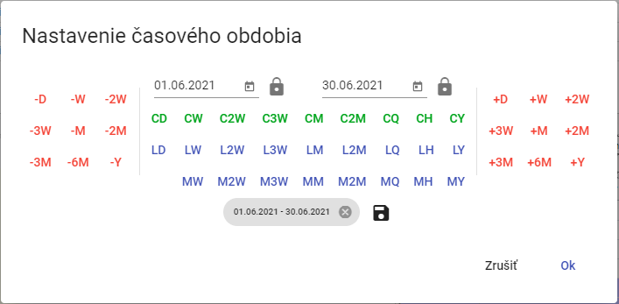

"Image 223: Saved date range"

1. "You will trigger date range by pressing the 'OK' button."

## I want to enlarge the window across the entire application surface

"You can enlarge the graph, inspector and table by pressing the 'Maximize' button (Fig. 224) or double-clicking on the top toolbar bar, Fig. 226. The window will then appear across the entire application area. After pressing the 'Maximize' button, a 'Restore size' button will appear in its place, which can be used to return the window to its original size. You can also reduce an enlarged window by double-clicking on the top toolbar bar."



Image 224: "Maximize" button



Image 225: Button "Restore size"

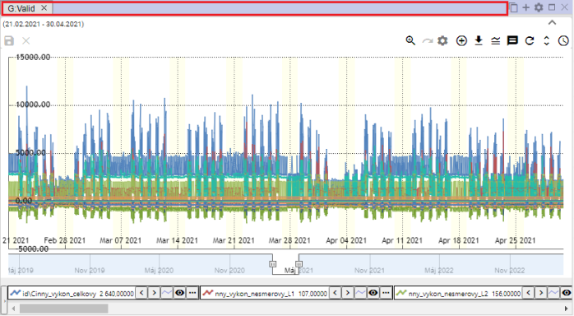

Picture 226: Upper row of the panel

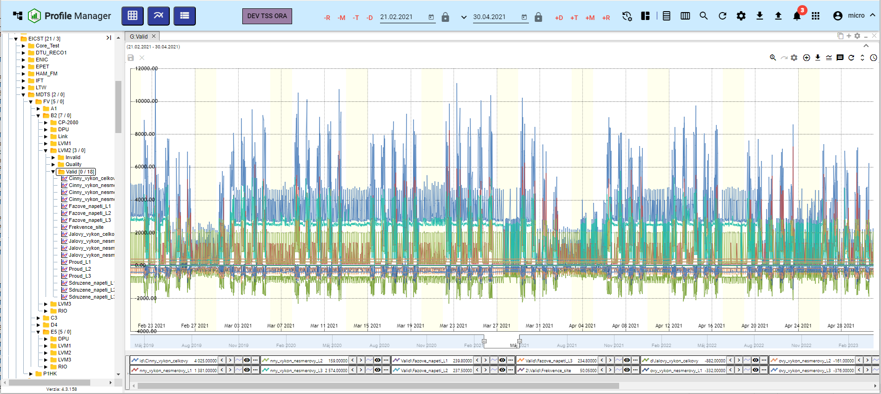

Image 227: Enlarge window graph

## If you close the window

"Click the 'X' button located at the top-right corner of the window and above the name of the window to close the graph, explorer, and table."



Image 228: Button "Close" for closing the window

## Setting name and color of panel

They have standard names Explorer, Table and Graph. You can change the name and color of the panel as follows:

1. "Click on the 'Panel settings' button, which can be found at the top right corner of the window."



Picture 229: Button "Panel settings"

1. "A settings window will appear."

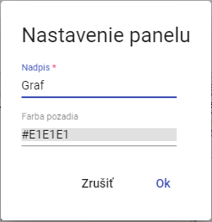

Image 230: Window "Panel Settings"

1. In the field "Caption" enter a title.
2. "To change the background color, click on the 'Background color' field and select a color."

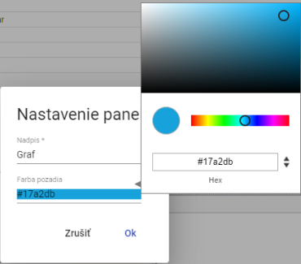

Picture 231: Selection of color

1. Save changes by pressing the button "OK".

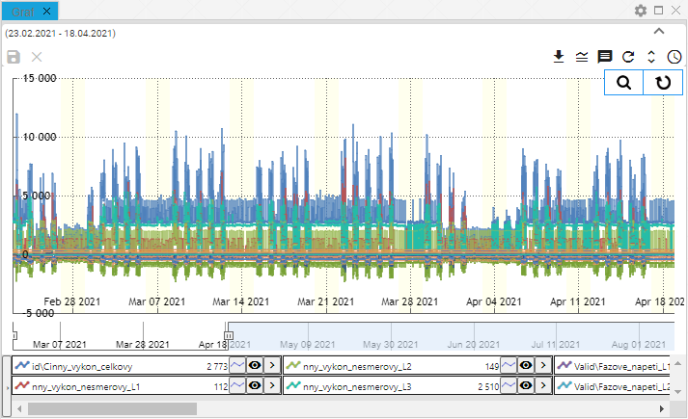

Picture 232: Changed color of the panel

## I would like to export the data shown from the Explorer window.

"The data shown can be exported to the inspector window, table or graph by clicking on the export button, Image 233."



Image 233: Export Button

## I'd like to hide the top panel with buttons in the window of the explorer, table and graph.

"The upper part of the inspector, table and chart in windows can be hidden by clicking on a button displaying Image 234. To show the upper part in windows again, click on the button again, Image 235."

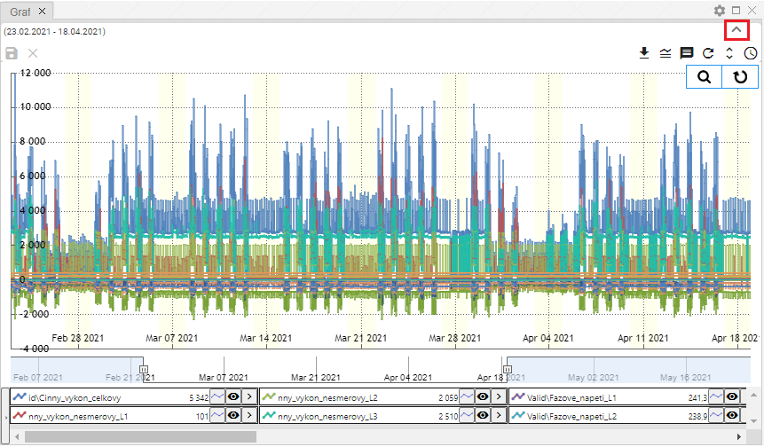

Picture 234: Toggle button to hide the upper part in windows explorer, table and graph

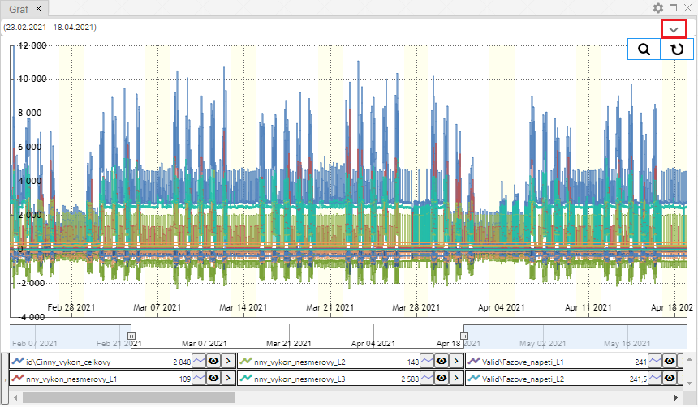

"Image 235: Button to show the top part in explorer windows, table and graph"

## Add profile to chart and table

"In the graph and table window you can add a profile according to the following procedure:"

1. "Click the 'Add Profile' button, which is located in the top part of the chart or table window."



Photo 236: Add profile button

1. A window called "Add Profile" will be shown.

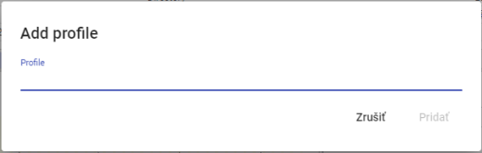

Picture 237: Window "Add profile"

1. "Please provide a path where the profile is stored."

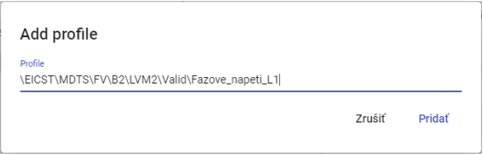

Image 238: Task Path Profile

1. Click on the "Add" button.
2. The selected profile will be added in the graph/table window.

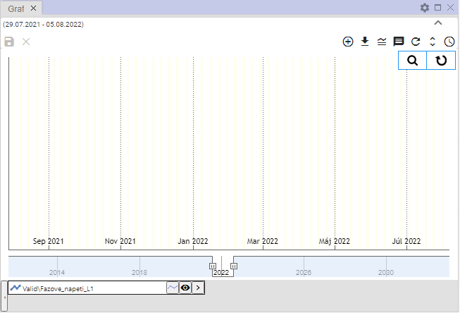

Image 239: Added profile in graph window

# "Work with an Open Window Researcher"

After starting the "Profile Manager" application, the browser window is filled with directories and profiles from a tree structure. During operation of the application, you can open any number of additional windows.

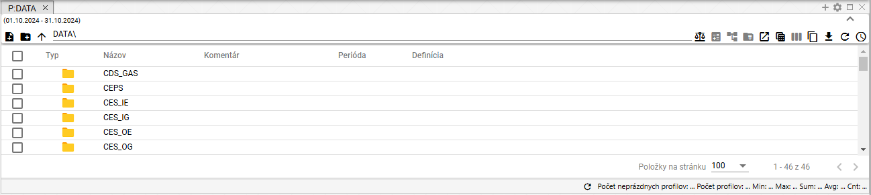

Picture 240: Window of the "Explorer"

## "How to display profiles from a selected recipient in the Explorer window"

"In the window Explorer, standard addresses and profiles from a tree structure are displayed. Profiles of selected address will be shown by double-clicking on left mouse button on button in column 'Type'."

"You can return to the list of addressees by clicking on the arrow"

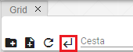

"Picture 241: Back button"

## I will create a new folder

"On the Prieskumník window you can create a new folder by pressing the 'create new folder' button. A window titled 'New Folder' will appear. The procedure for creating a folder is in Chapter 2.1."

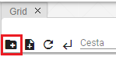

Image 242: Create new folder button

## I will synchronize the scanner with the tree

"The button 'Synchronize with tree' means that the inspector is synchronized with the tree. The unchecked button 'Synchronize with tree' means that if the directory in the tree changes, this change will not appear in the inspector's window."



Picture 243: Sync button with Tree



Picture 244: Tree synchronization cancelled

## "Filter profile"

You can filter the displayed profiles in the inspector window by individual columns. Proceed with:

1. "Use the mouse pointer to place it on the name of the column you want to apply a filter to."
2. "Click on the button and a window for filter entry will appear."



Image 245: Filter button

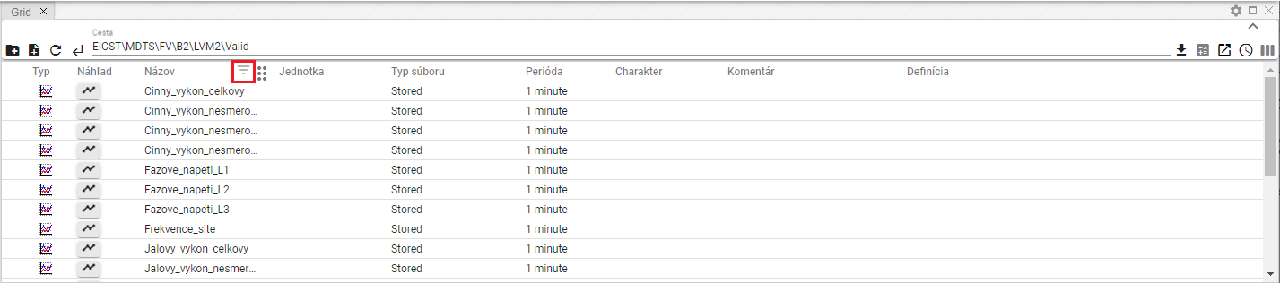

Image 246: Button for filtering over the column "Name"

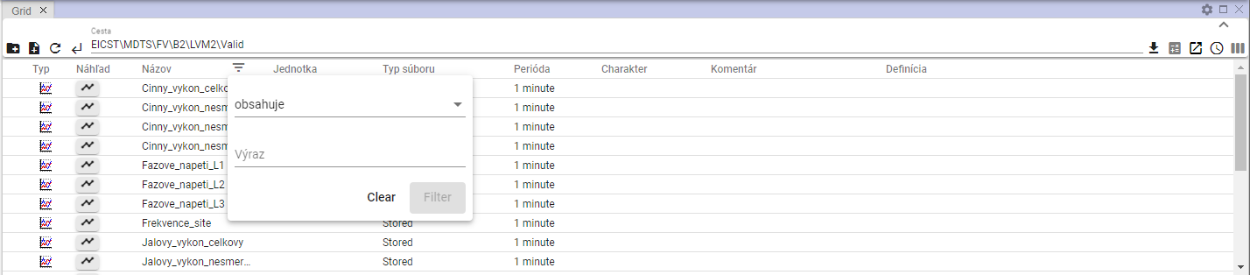

Picture 247: Window for filtering

1. Enter filtering criteria.

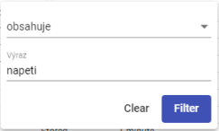

Image 248: Assignment of filtering criteria

1. Press the "Filter" button or press the Enter key.
2. "Profiles showing conformity with filtering criteria are displayed."

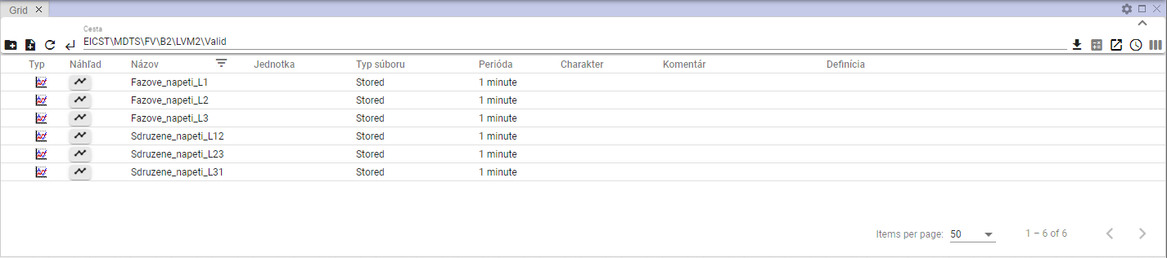

Image 249: Applied Filter

1. "Above the column, where an applied filter is displayed is a button ."
2. By clicking on the button, it will be deleted. A window for filtering will appear and then by pressing the "Clear" button.

## To sort data in columns.

"Before ordering data in the column, place your mouse cursor on the column title and click on the arrow that appears next to the column title."



"Image 250: Button for sorting data in column"

## "I calculate values for columns Min, Max, Sum, Avg and Count in the Window Explorer"

Before calculating values in the columns of the window, proceed:

1. In the window show the recipient profiles to which you want to calculate cumulative values.

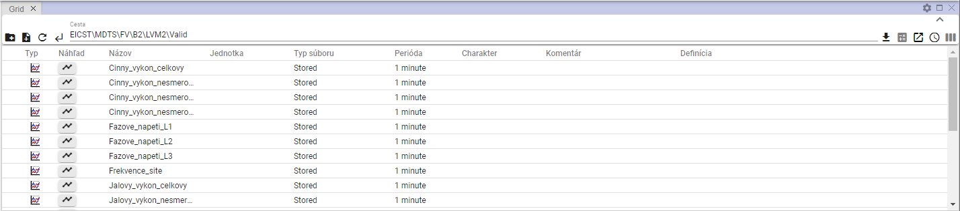

"Picture 251: Displaying recipient in window of browser"

1. Click on the "Statistics" button.



Picture 252: Statistics button

1. It supplements values in columns “Min”, “Max”, “Sum”, “Avg” and “Count”.

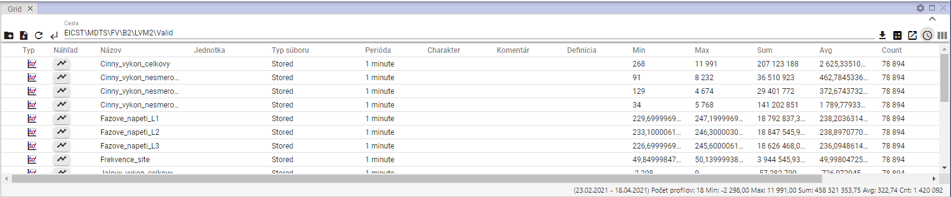

"Picture 253: Calculating statistics in a browser debugger"

## A glimpse into the timeline

Before viewing the time chart, please proceed:

1. "In the window 'Explorer' in the column 'Type', click twice with the left mouse button on the profile icon whose time series preview you want to display."

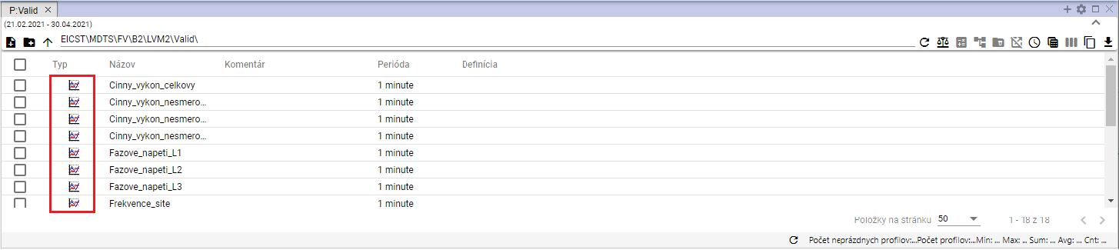

"Image 254: Button for viewing the 'Timeline Preview' window"

1. "A window 'Preview of time line' will appear."

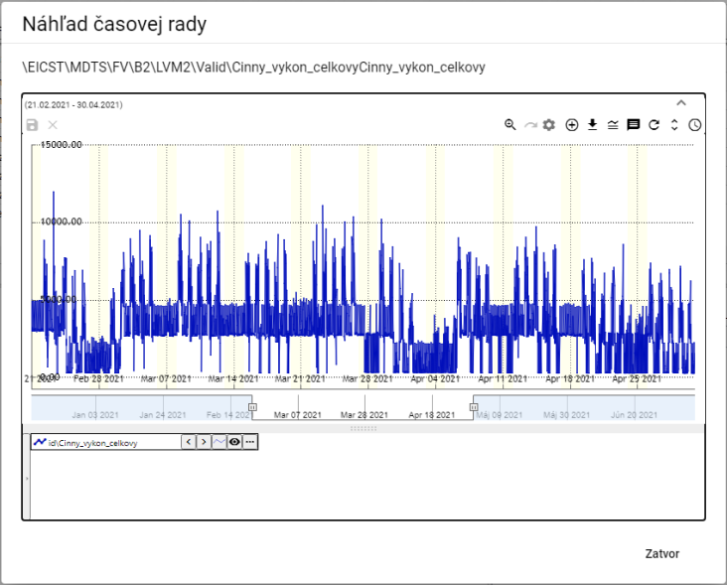

Image 255: Window "Temporal View"

1. Activities related to the buttons located in the upper right corner of the graph are dealt with in subchapters of Chapter 5.



Picture 256: Tools for working with graphics

1. "At the bottom part of the window, there is a profile name. Clicking on the right mouse button on the profile name will show you a list of functions for working with the profile. The functions are elaborated in chapter 5.7."

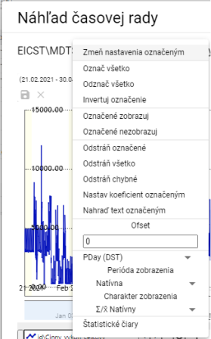

Image 257: Functions for working with profiles

1. "Clicking on the arrow next to the profile name will display a window with functions that are elaborated in Chapter 5.8."

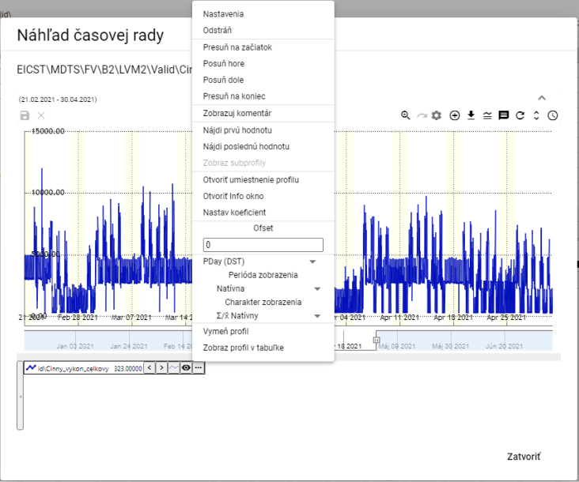

Image 258: List of functions for working with profile

## "Move profile from Explorer window into Graph or Table window"

You can drag the Navigator from the window of the Navigator into windows of Navigator or Table. The Address Book in the window of the Navigator you may drag into the Graph window. A Profile, which is located in the window of the Navigator, may catch and drag into the window Graph or Table.

Proceed:

1. In the Prieskumník window you set the cursor to the address row or profile that you want to move into the Graphics tab or Table tab.

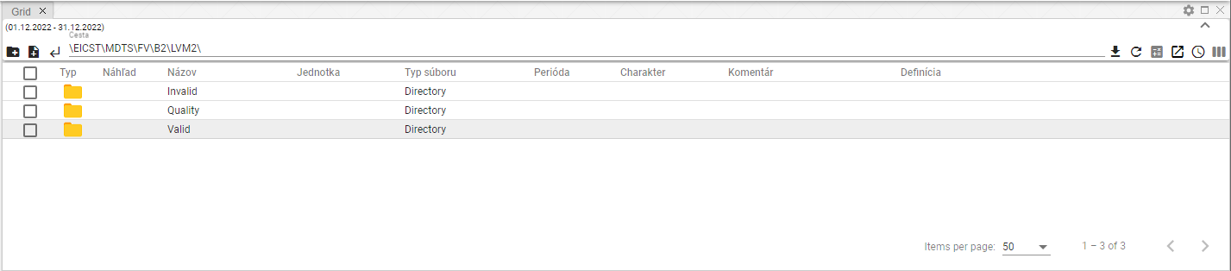

Picture 259: Selected Profile

1. Click on the left mouse button to select a line in the Window Explorer and move it above the window in which you want to display it and then click.

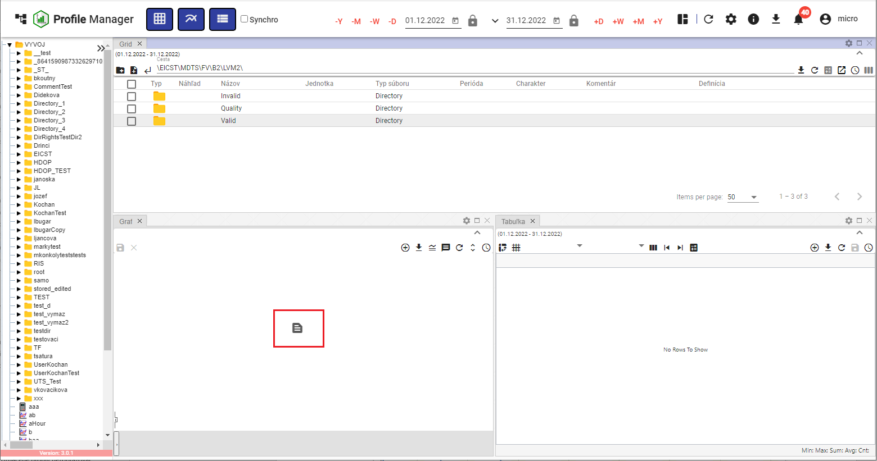

Image 260: Profile moved into window Graph

1. "The profile will be displayed in the selected window."

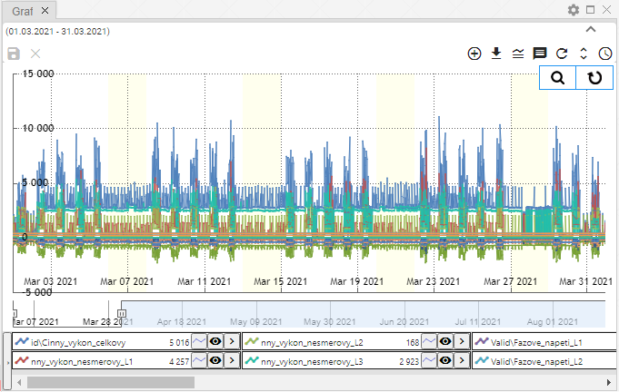

Image 261: Profile moved from Explorer window to Graph window.

## "How to add or remove columns in the window Explorer"

"The list of columns displayed in the Explorer window can be changed. You can add columns or remove them."

"Before changing displayed columns:"

1. "Press the 'Select columns' button, which is located in the top right corner of the Explorer window."

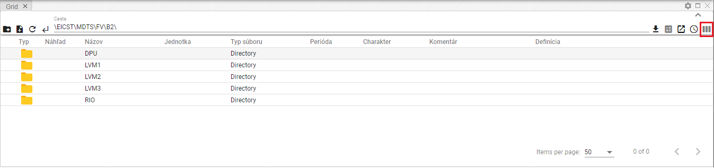

Image 262: Select columns button

1. "It will display a block with a list of columns."

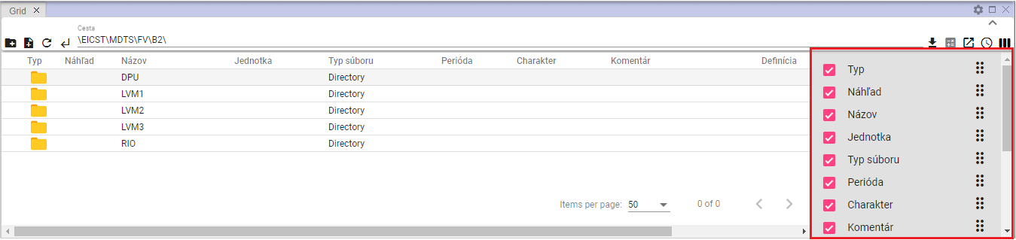

Picture 263: Column list

1. Add/Remove columns which should be displayed. While editing the list of selected columns, a change will automatically occur in the inspector window.
2. "You can change the column order in the explorer window. If you want to change the column sequence, grab the column's move button and drag it to its desired position in the list."

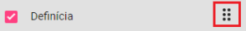

Image 264: Button for column reordering

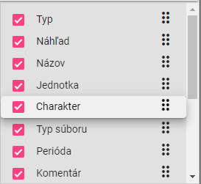

Image 265: Relocation of the "Character" column

## "Correct Fields Name and Comment"

"Polls 'Name' and 'Comment' for profiles and addresses can be adjusted in the window Explorer."

Before the adjustment, proceed with:

1. "Click twice on the left mouse button on the field to gain access for editing."

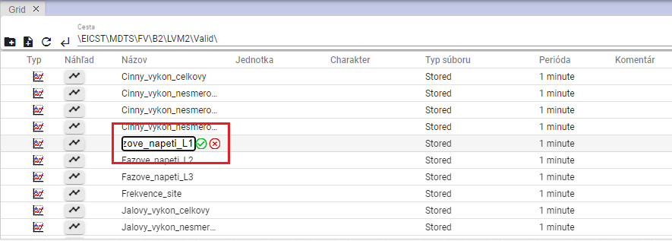

Picture 266: Profile name adjustment

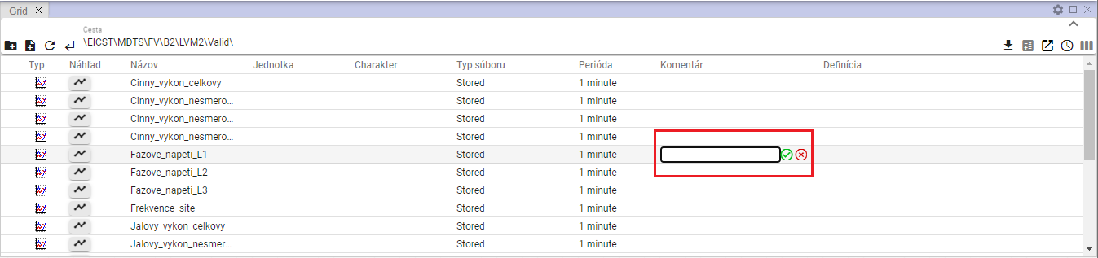

Picture 267: Task for Commenter of Profile

1. Edit the text.
2. Save changes by pressing the button.

## "Functions for working with address books in the Prieskumník window"

"Functions for working with your address will be displayed by clicking the right mouse button on the folder in the File Explorer window. Working with functions is further explained in Chapter 2."

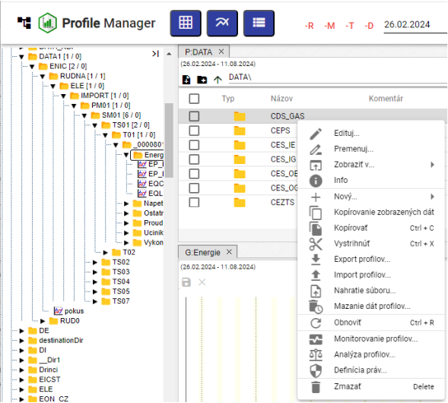

Picture 268: List of functions for working with address books

## Functions for work with filters in the window Explorer

"You can view the functions for working with a profile by clicking on the right mouse button on the profile in the Browser window. Working with functions is covered in Chapter 2."

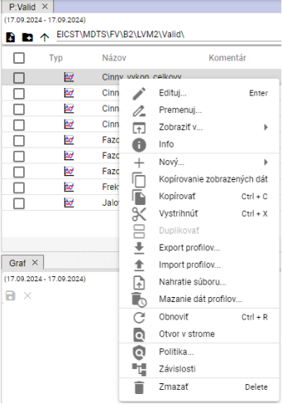

"Image 269: List of functions for working with profiles"

## Button View by Branch

"The 'Branch view' button enables mass operations to be performed on all profiles in the database, regardless of which addresser the profile is with. From mass operations, you can use 'Edit' and 'Delete'."

"The 'Branch View' button will display items from the selected address without grouping them into inner addresses, Image 271. To display standard address directories in the File Explorer window click the 'Branch View' button again."

"Steps for mass editing of profiles:"

1. Press the button "Branch view", which will display a list of profiles without recipients.

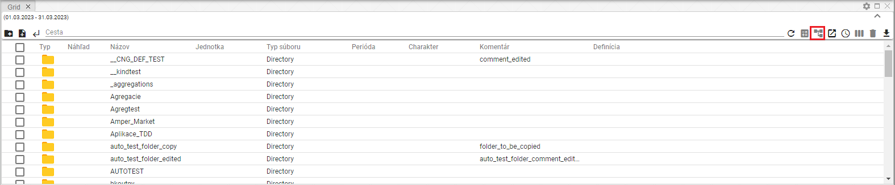

Image 270: Button "Branch view"

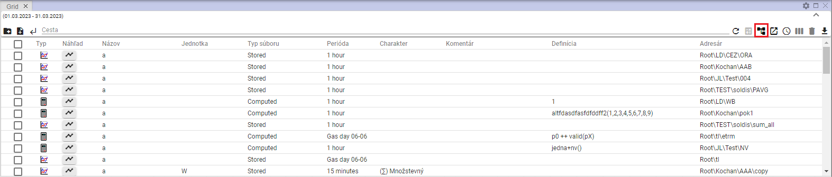

Image 271: Displaying profiles without separating them from recipients.

1. "Apply a filter to get the list of profiles you want to perform bulk actions on."

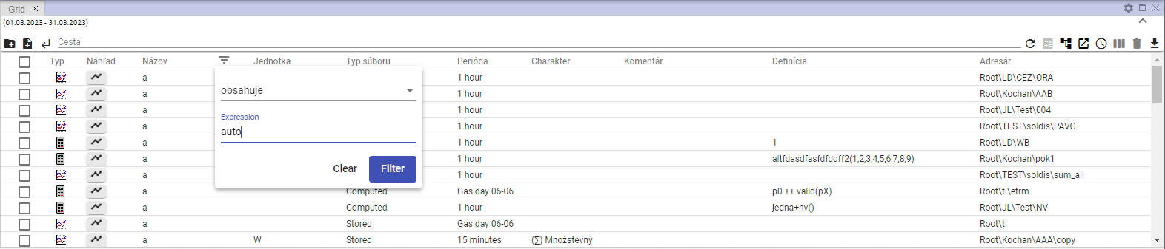

Picture 272: Filter Task

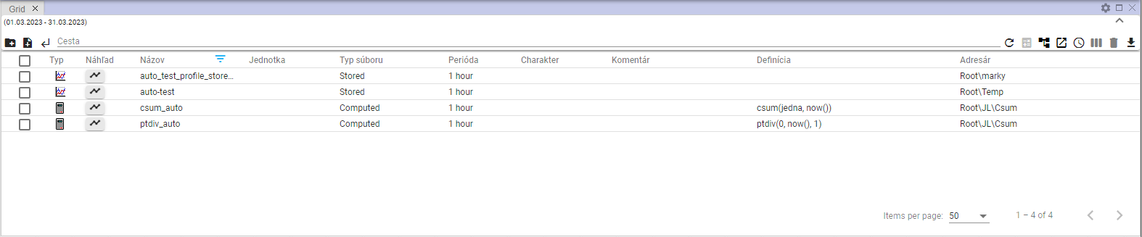

"Image 273: Filtered items"

1. "Click on the checkbox in the first column to select profiles that will be affected by the bulk operation. If you want to select all profiles, click the topmost checkbox and other checkboxes will be automatically marked."

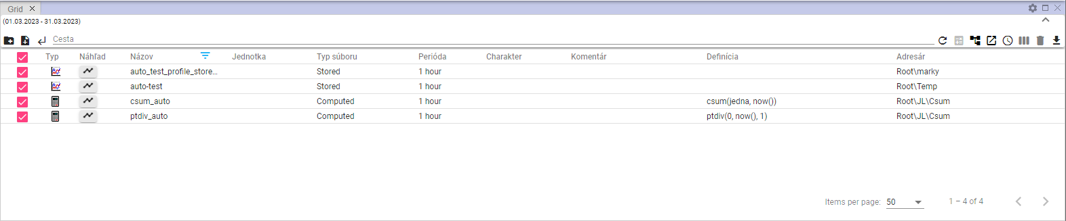

Image 274: Selected profiles

1. Click the right mouse button on any location of the selected profiles and select the option “Edit”.

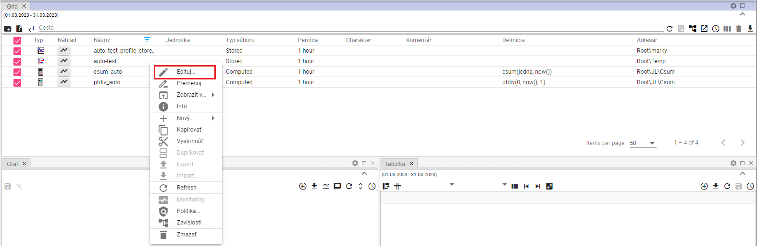

Image 275: item "Edit"

1. "The 'Bulk Editing' window will appear."

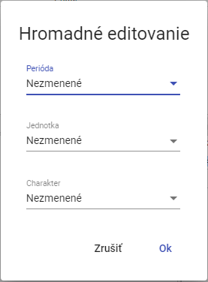

Image 276: Window "Bulk editing"

1. You can correct the fields "Period", "Unit" and "Character".
2. "Update data and save by clicking on the 'OK' button."

## "How to display deleted items in the Explorer window"

"The 'Trash' button in the Explorer window serves to display deleted items. The button is normally inactive – gray. After clicking it turns black. To remove the display of deleted items, click on the 'Trash' button again. Subsequently, the addresses and profiles from the tree structure will be displayed in the Explorer window."



Image 277: Button "Kôž" - inactive



Picture 278: Push-button "Kôš" – active

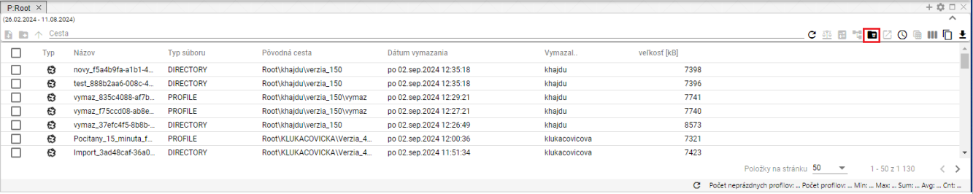

Image 279: Display of content button "Corner"

## I will copy displayed data.

"The 'Copy displayed data' button, Fig. 280, serves to copy data from the 'Inspector' window. Fig. 282 shows copied data."

Proceed:

1. "In the window inspector display the data you want to copy."
2. If you want to copy all the shown data, press the button "Copy Shown Data".

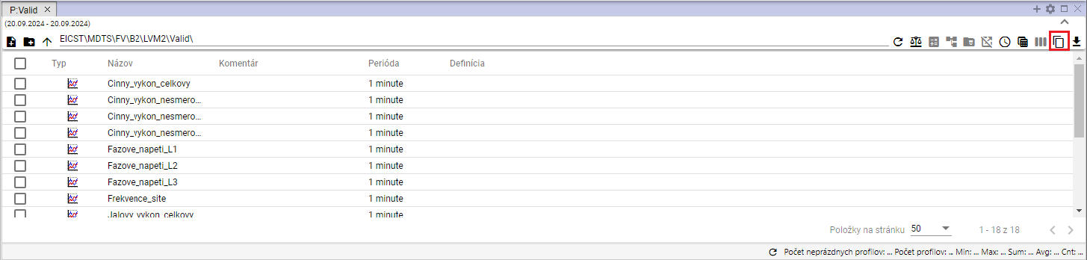

Image 280: Button "Copy displayed data"

1. "If you want to copy a specific folder or folders, select them in the Explorer window. Right-click on selected folders and choose 'Copy shown data'."

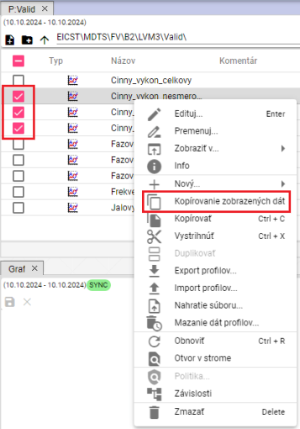

Image 281: Item "Copy displayed data"

1. "Copied data can be inserted into the program Microsoft Excel."

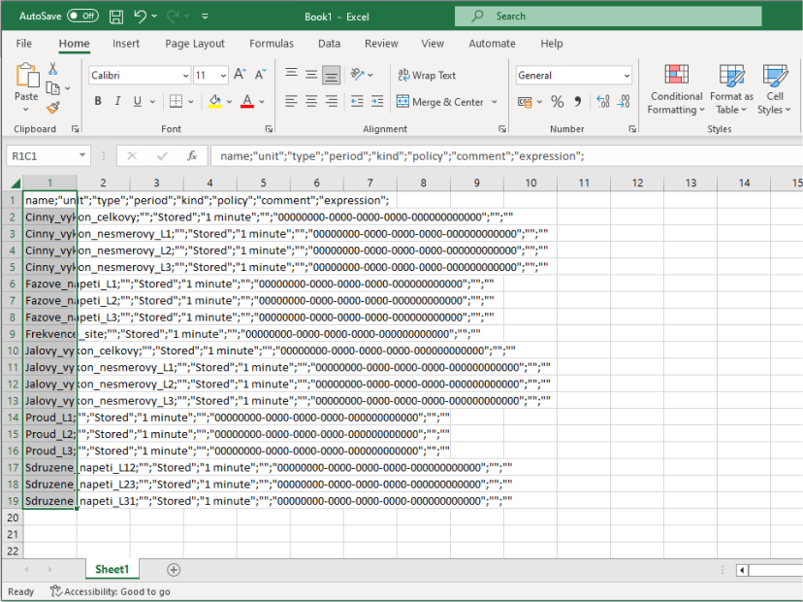

Image 282: Data copied into MS Excel

## Use as default settings Scanner

"The current column layout can be set as default. At each opening of a new browser or at the opening of the 'Profile Manager' application, the saved column layout will be displayed."

"If you want to set the explorer columns to current settings as default, proceed:"

1. Press the button "Use as default settings for Scanners", which is located in the top right corner of the Scanner window.



"Image 283: Button 'Use as Explorer's home setting'"

1. "A window will appear for confirmation, where you click the 'Yes' button."

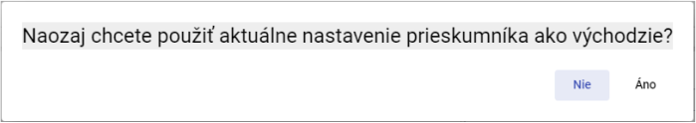

Image 284: Confirmation window for saving the explorer's settings.

## I filter through columns using the * wildcard

"In the window you can filter through columns using wildcards, using *."

Examples:

* "Search for everything that starts with the given text"
* **[OLLAMA FORMATTING ERROR - MANUAL REVIEW NEEDED] *Text - vyhľadá sa všetko, čo končí na zadaný text**
* **[OLLAMA FORMATTING ERROR - MANUAL REVIEW NEEDED] *Text* - vyhľadá sa všetko, čo obsahuje zadaný text**

"Example: Cinny* - search everything that starts with "Cinny""

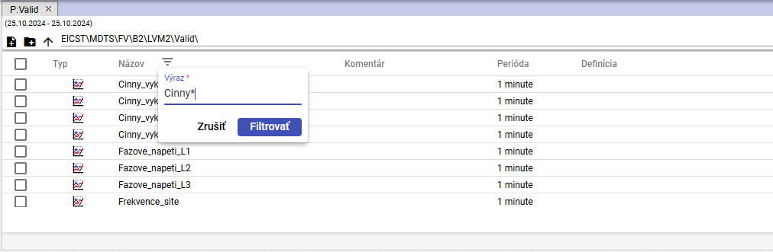

Picture 285: Task for filter searching profile names starting with "Cinny""

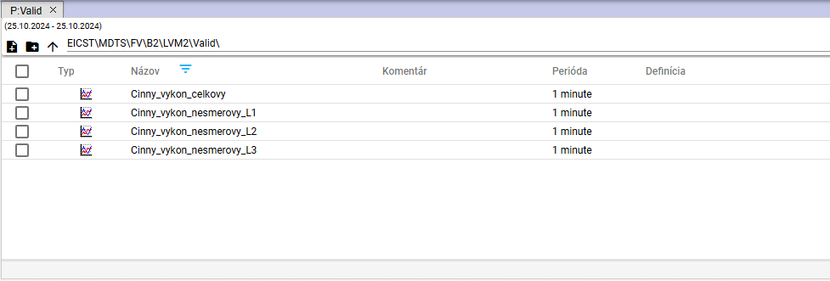

Image 286: Search profiles starting with “Cinny”

**[OLLAMA FORMATTING ERROR - MANUAL REVIEW NEEDED] Príklad: *L2 - vyhľadá všetko čo končí s textom „L2“**

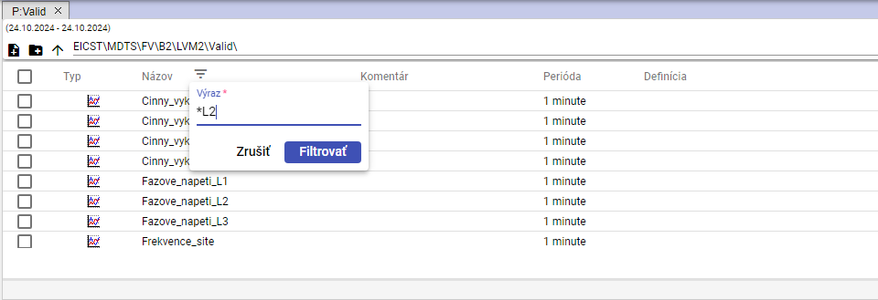

Image 287: Task for filter searching names of profiles ending with "L2"

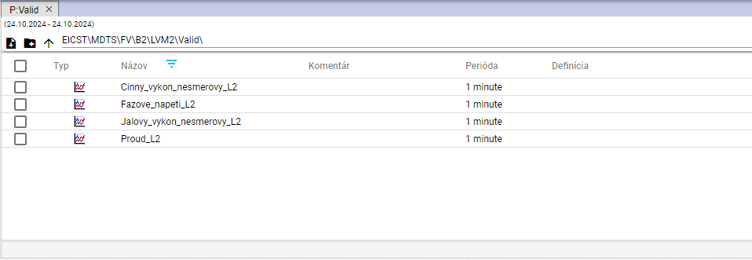

Photo 288: Searching for profiles ending at "L2"

Example: *tension* - find everything that contains the text “tension”

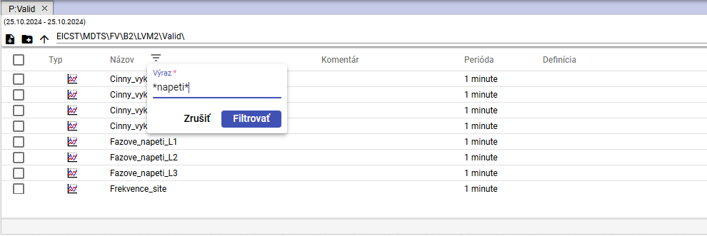

Image 289: Filter task for searching profile names containing the text "volt"

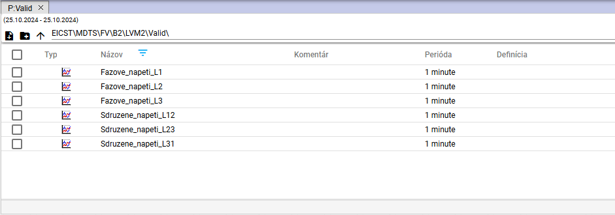

Picture 290: Search for profile names containing the text “tension”

# Work with letters

After launching the "Profile Manager" application, a working window with an empty graph sheet will open. During work with the application, you can add any number of windows for the graph. In one graph, you can display any number of profiles.

## Show my profile in graph

"Before displaying your profile in the graph window, proceed:"

1. The standard window graph is empty.

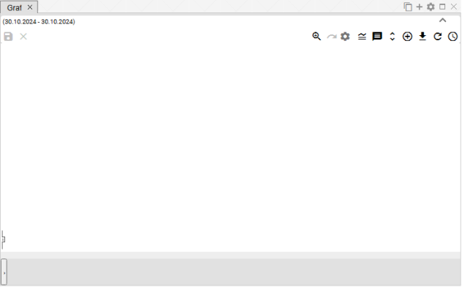

Image 291: The window for displaying a graph is normally empty

1. "Click on the profile stream with your left mouse button on the profile or folder of profiles and drag it into the graphics window. The dragged profile or folder of profiles in the graphics window click."

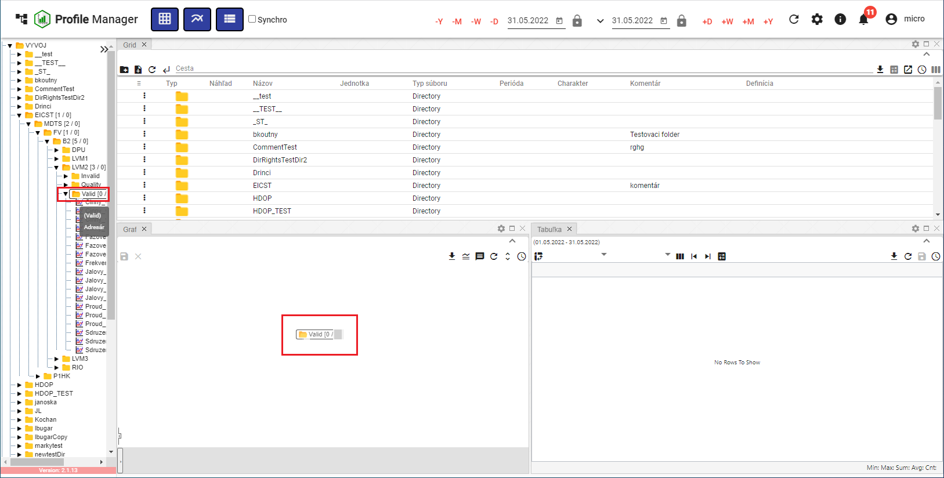

Image 292: Redirecting the addressee to the graph plane

1. "In the graph window, data is drawn as a graph."

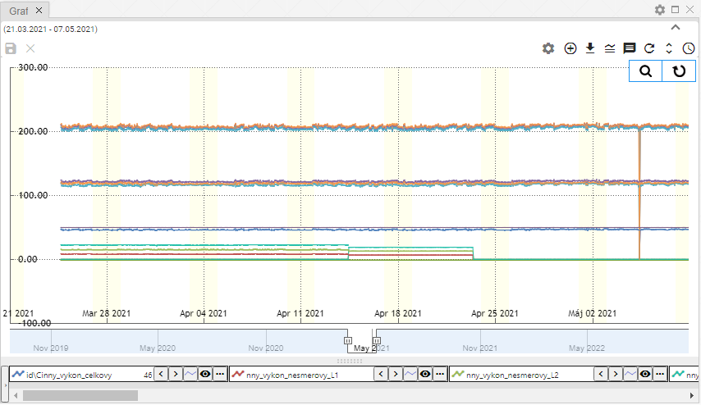

Image 293: Graphical representation of profiles

## "To display an information window with values for a specific location in the graph"

"If you want to display values for a specific location in the graph, move your mouse cursor over the selected location."

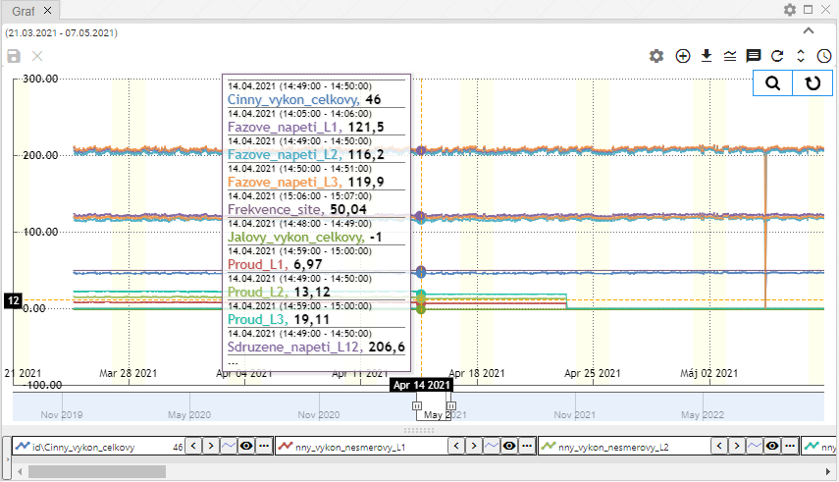

"Image 294: Displaying a profile's values on a specific location in the graph"

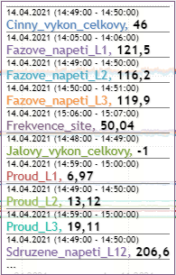

Picture 295: Profile values at selected point on graph

"If the data are incomplete within this scope (decimal places), a yellow warning sign will be displayed (Figure 296)."

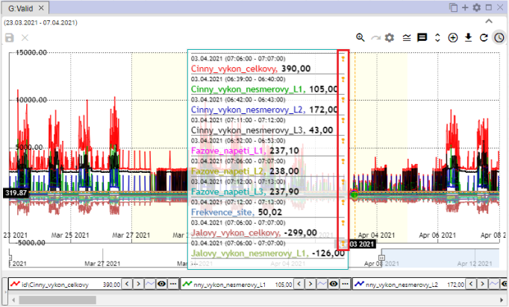

Image 296: Yellow Cuckoo

## "How do I change the date range in the graph"

Time range that the graph is displayed in can be changed using the "Change time range" button located in the top-right corner of the graph window. The procedure is described in Chapter 3.2.



Image 297: Button "Change Time Range"

## Save graph as JPG file

You can save it as an image in JPG format. Proceed:

1. Click on the button "Export graph to JPG", which is located in the top-right corner of the graph window.



Image 298: Button "Export chart to JPG"

1. A picture of the graph will be created and saved among downloaded files on the computer.

## I would like to copy the entire graph to a new window.

You can copy the entire graph into a new window:

1. "Press the button 'Copy entire graph to new window'."
2. The graph is copied and displayed in a new tab in the graphics window.

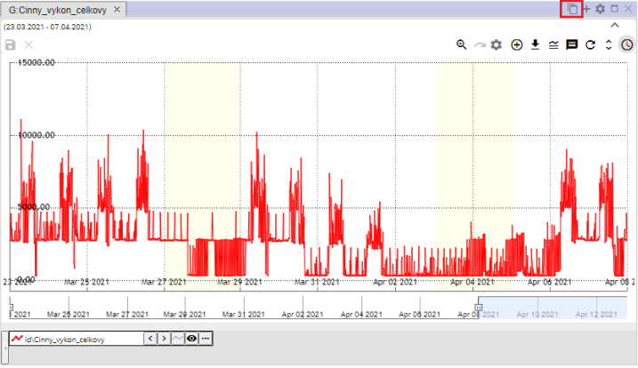

Image 299: Button "Copy whole graph into new window"

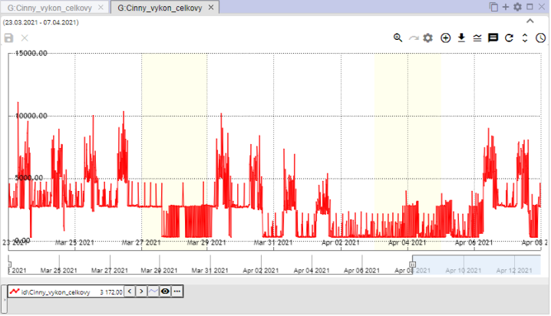

"Image 300: Copied graph in new tab"

## How to adjust graph parameters

You can set parameters for the graph, such as font size for the title of the graph.

1. "Press the button 'Chart settings', which is located in the top-right corner of the window 'Graph'."



Image 301: Settings button for graph

1. "A window called 'Legend of Chart' will appear, where you set parameters."

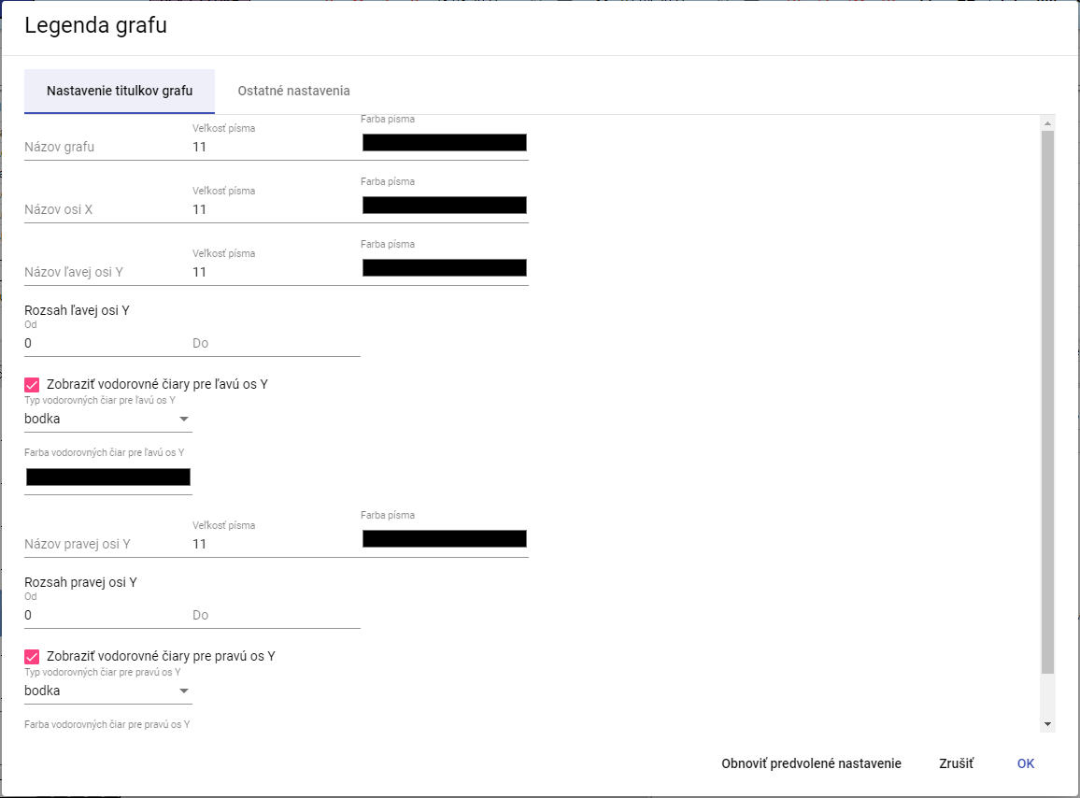

Image 302: Window "Legend of graph"

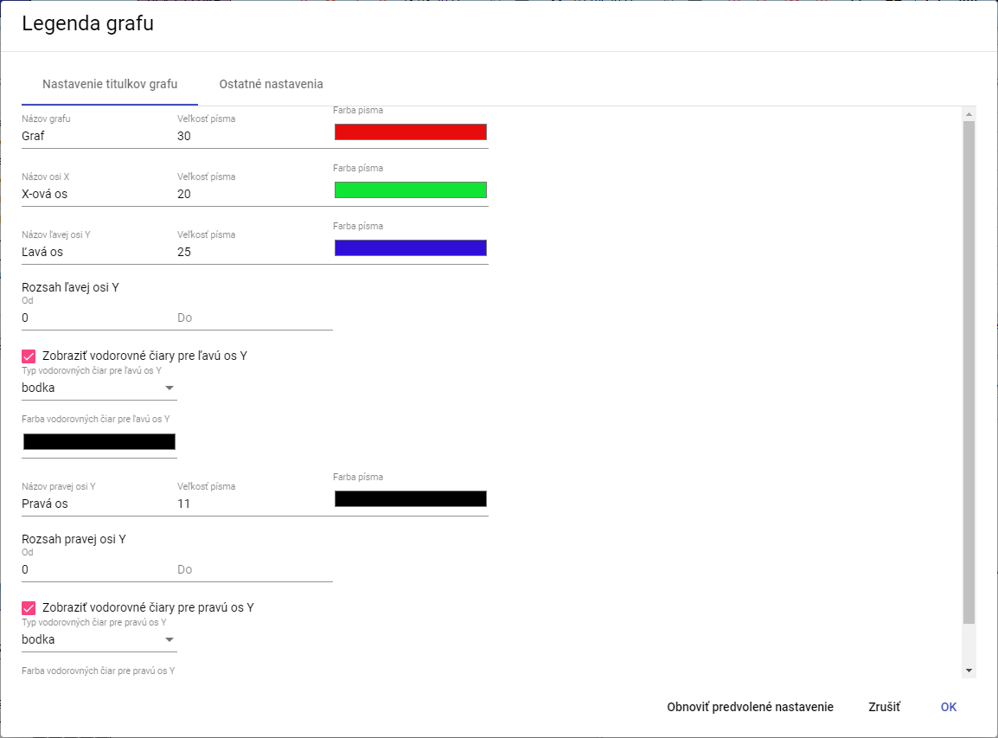

Image 303: Changes in the window of "The Legend of Graph"

1. You will save changes by pressing the "OK" button.

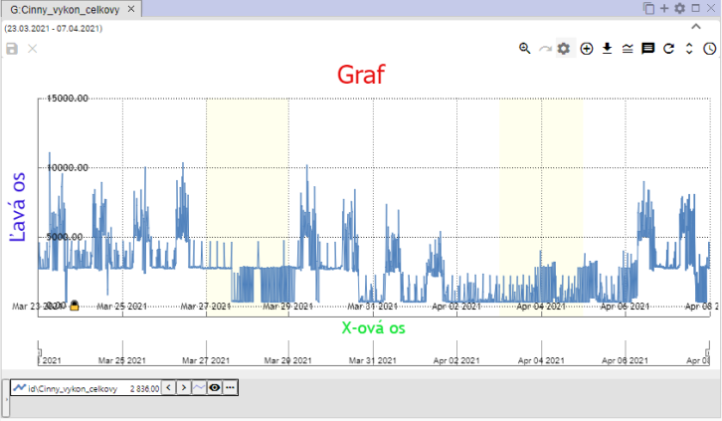

Picture 304: Changes in the window Graph

### "How to set decimal places for each of Y's axes"

**[OLLAMA FORMATTING ERROR - MANUAL REVIEW NEEDED] Postupujte:**

1. **[OLLAMA FORMATTING ERROR - MANUAL REVIEW NEEDED] V okne „Legenda grafu”, zadajte počet desatinných miest pre ľavu a pravú os Y.**

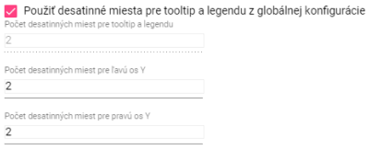

Image 305: Settings for the Y-axis

1. **[OLLAMA FORMATTING ERROR - MANUAL REVIEW NEEDED] Ak chcete zadať hodnotu pre pole „Počet desatinných miest pre tooltip a legendu”, odkliknite pole „Použiť desatinné miesta pre tooltip a legendu z globálnej konfigurácie”.**

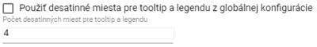

Image 306: Task to set new value for field "Number of decimal places for tooltip and legend"

1. **[OLLAMA FORMATTING ERROR - MANUAL REVIEW NEEDED] Zmeny uložte stlačením tlačidla „OK”.**

### **[OLLAMA FORMATTING ERROR - MANUAL REVIEW NEEDED] Ako vypnúť vodorovné čiary**

**[OLLAMA FORMATTING ERROR - MANUAL REVIEW NEEDED] Pre vypnutie vodorovných čiar v grafe postupujte:**

1. **[OLLAMA FORMATTING ERROR - MANUAL REVIEW NEEDED] Stlačte tlačidlo “Nastavenie grafu”, Obrázok 301.**
2. **[OLLAMA FORMATTING ERROR - MANUAL REVIEW NEEDED] V okne “Legenda grafu” odkliknite polia “Zobraziť vodorovné čiary pre ľavu os Y” a “Zobraziť vodorovné čiary pre pravú os Y”.**

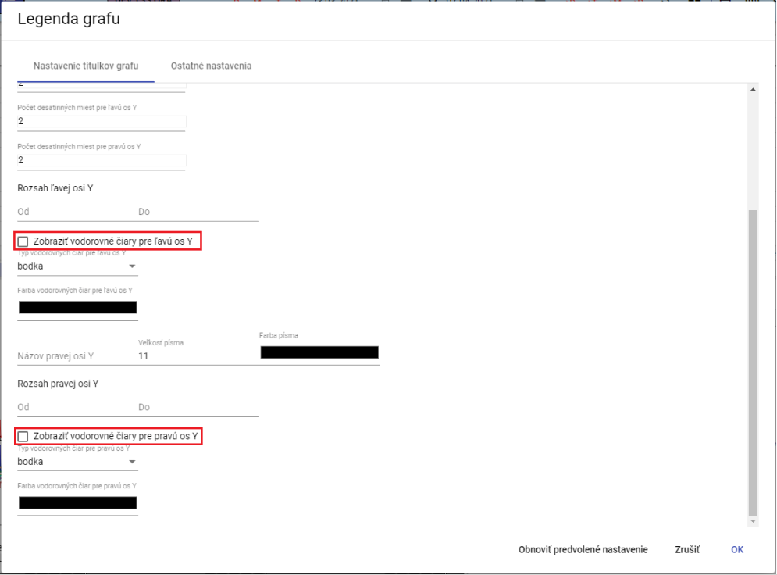

Picture 307: Turning off horizontal lines in graph

1. **[OLLAMA FORMATTING ERROR - MANUAL REVIEW NEEDED] Zmeny uložte stlačením tlačidla “OK”.**

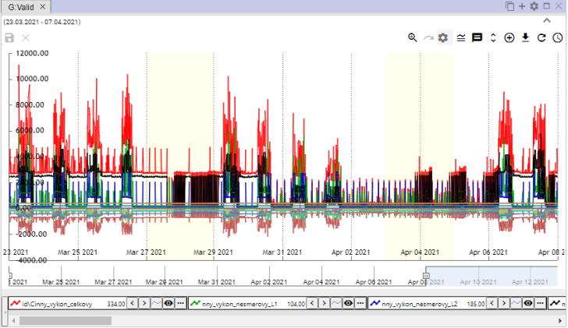

Picture 308: Horizontal grid lines turned off in graph

## Functions for work on designated profiles

"Before showing features over multiple profiles, proceed:"

1. "Press the Ctrl key and mark selected profiles by clicking the left mouse button on the names of the selected profiles. After marking, the name of the profile has a blue color."
2. Press the button which is located at the lower left corner of the graph window.

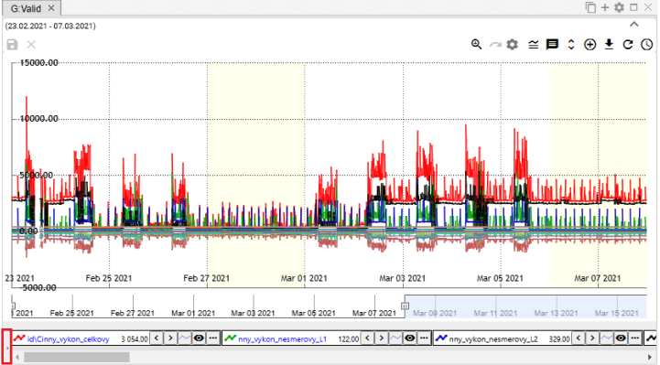

Image 309: Button to display functions for marked profiles

1. "A list of functions for designated profiles will be displayed. Functions are elaborated in the following chapters."

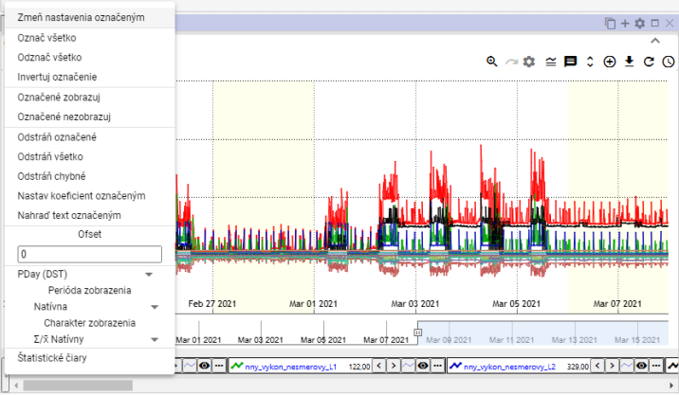

Image 310: List of functions for marked profiles

### "To pick profiles"

"Click the Ctrl key and click on the profile name. You can select multiple profiles at once. The text color of the selected profile will change from black to blue."

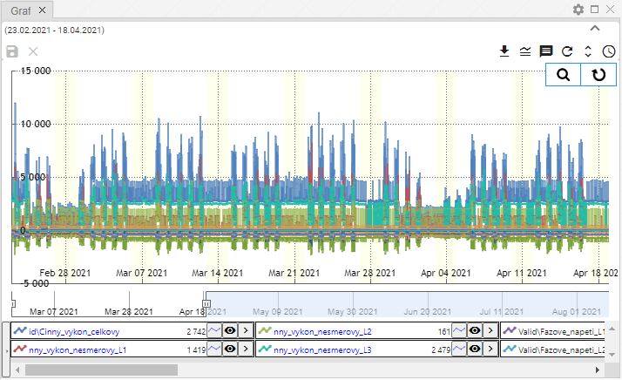

Image 311: Marking of multiple profiles

### Show profile properties

"Profile properties will be displayed:"

1. Click on the button that is located before the name of the profile in the bottom part of the window Graph.

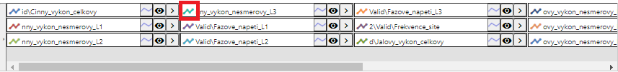

Picture 312: Button for displaying profile properties

1. "A window 'Line Profile Property' will be shown."
2. Update data.
3. You will save changes by pressing the "OK" button.

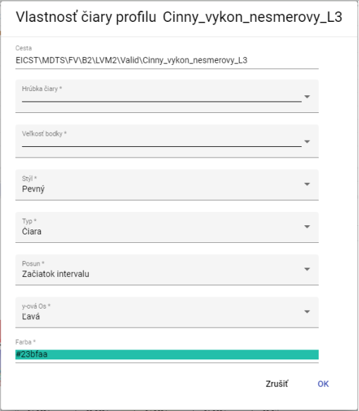

Picture 313: Attribute "Profile Line" window

### I would like to change the settings marked

"Changing settings for more marked profiles at the same time:"

1. "Select profiles you want to change settings for."
2. Click the right mouse button on the name of any one of these profiles.
3. "Click on the shown window and select the item 'Change settings marked'."

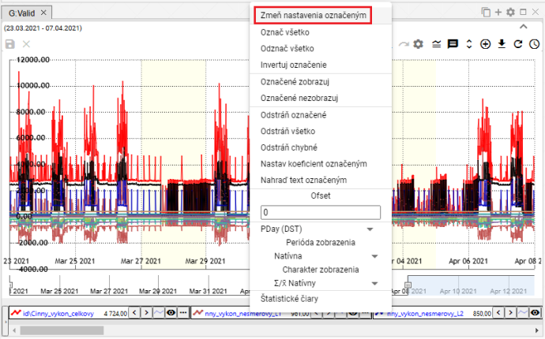

Image 314: Option "Change settings marked"

1. "A window will appear in which you can change settings for the marked profiles."

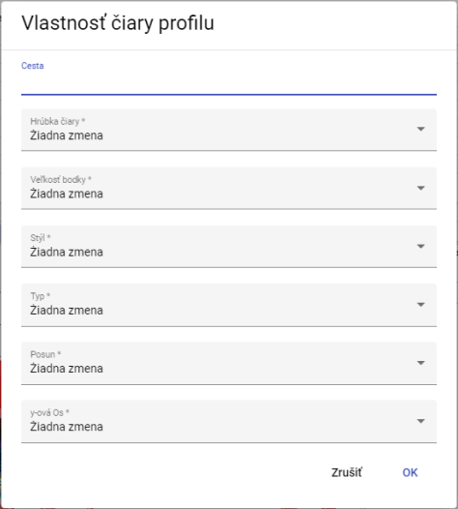

Image 315: Window for setting marked profiles

1. You will save changes by pressing the "OK" button.

### I'll mark all profiles

"Click the right mouse button on the name of each profile and select 'Mark all', Figure 316. All profiles are marked, Figure 317."

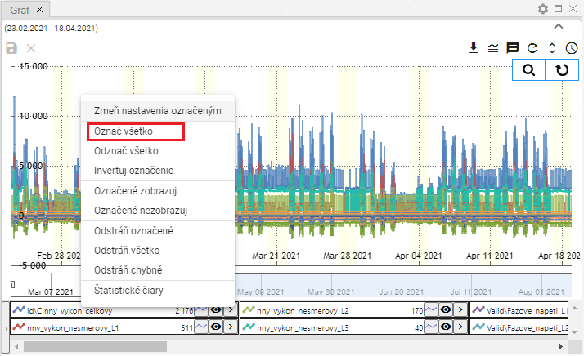

Image 316: Check all items

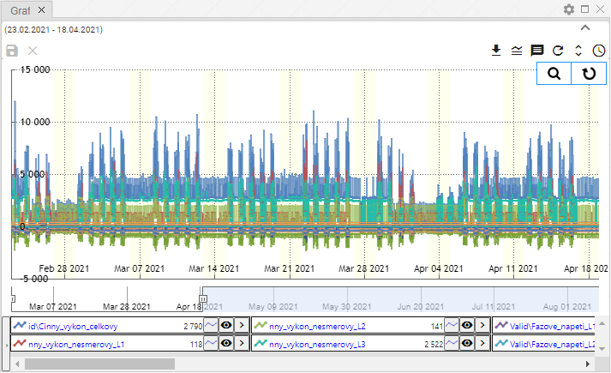

Picture 317: Marked Profiles

### "I will mark all profiles"

"The 'Unlabel everything' option is used to delete labels from all labeled profiles."

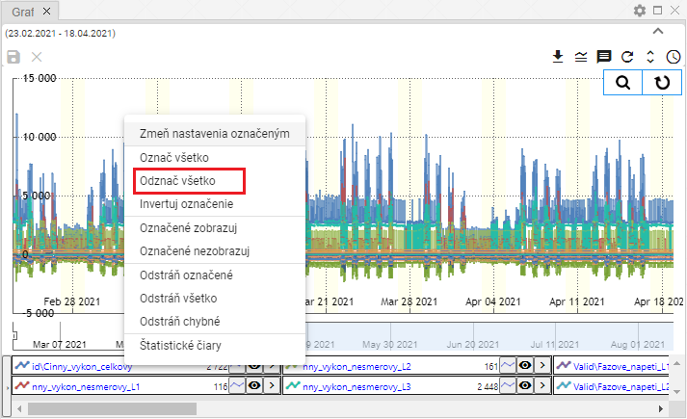

Image 318: Item "Mark all as read"

### I am reversing marked profiles

"The entry 'Invert label' will switch the labels of profiles. Profiles that were labeled will be unlabeled and vice versa, Image 320."

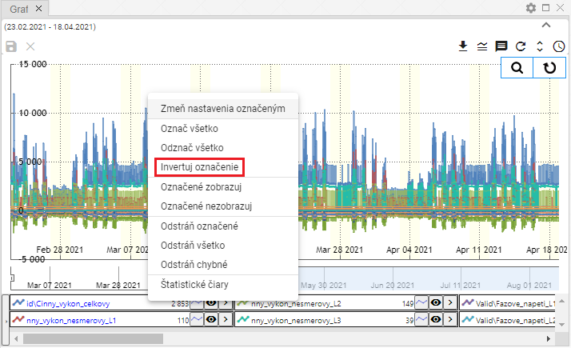

Image 319: Item "Invert Label"

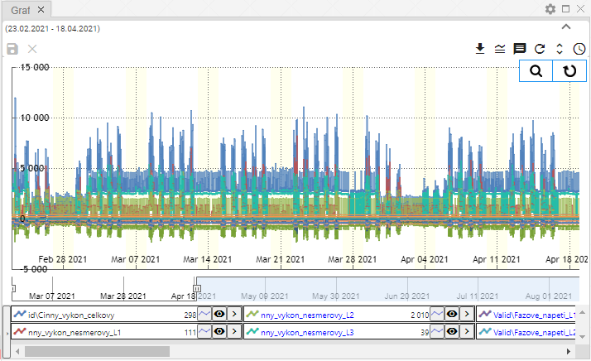

"Image 320: Inverted profile designation"

### "Show only marked profiles"

"The item 'Show marked' serves for showing marked profiles."

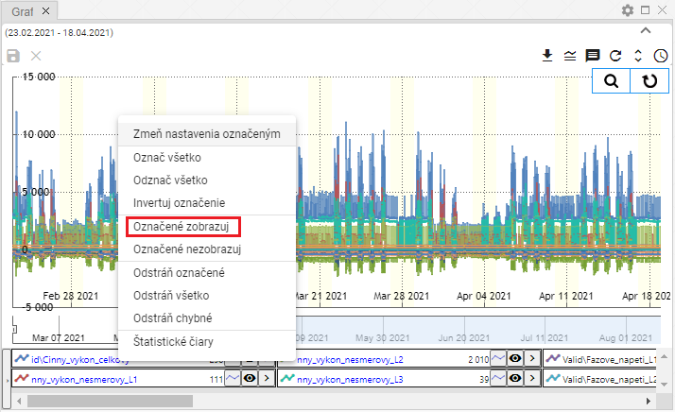

Image 321: Item "Show marked"

### "Do not display designated profiles"

"If you do not want to display marked profiles in the graph, proceed:"

1. Hide the profiles you don't want to see.
2. Click on the name of the profile with your right mouse button.
3. Select item "Hidden not shown".

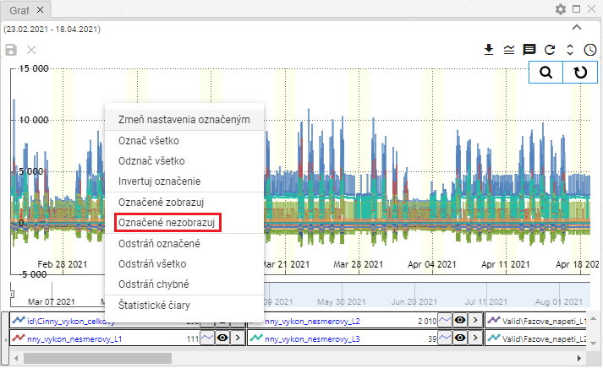

Image 322: Item "Do not display marked"

1. "Selected profiles hide."

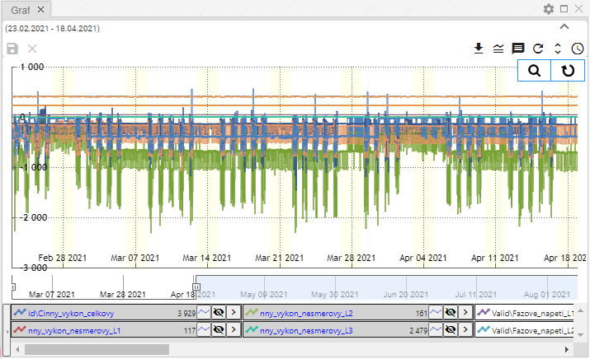

Picture 323: Unclear Profiles

### "If I remove the marked, all or incorrect profiles"

Before removing profiles, you can use three functions:

* "Remove selected - serves for removal of marked profiles,"
* "Remove everything - all profiles will be removed,"
* Remove incorrect accounts, they will only remove the profiles with errors.

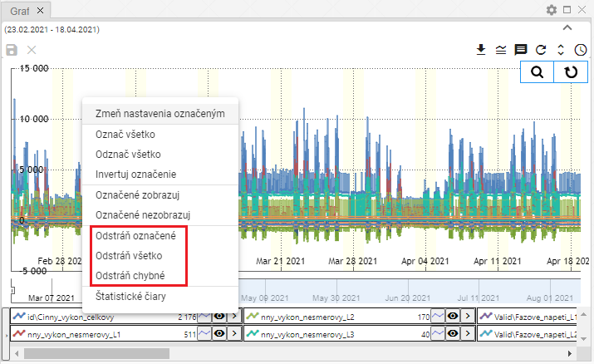

Image 324: Options "Remove marked", "Remove all" and "Remove incorrect".

"Before profile removal, proceed:"

1. If you want to remove the marked profiles, mark the profiles that you want to remove.
2. Click on the profile name with your right mouse button.
3. Select the item "Remove marked", "Remove all" or "Remove faulty".
4. The profile will be deleted.

### If I set the coefficient by profile

Set coefficient settings:

1. By clicking on the name of the profile, mark the profiles for which you want to set the coefficient.
   1. "If you want to select more profiles, click the left mouse button on the profile name, hold down the Ctrl key and click the left mouse button to select the names of the profiles you want to choose."
   2. **[TRANSLATION FAILED AFTER 3 RETRIES] Viac profilov súčasne môžete označiť kliknutím ľavého tlačidla myši na názov prvého profilu, držaním klávesy Shift a kliknutím ľavým tlačidlom myši na posledný profil. Označia sa všetky profily medzi nimi.**
2. "The designated profile names will be colored blue."
3. Click on the name of one of the marked profiles with your right mouse button.
4. "A window will appear where you choose 'Set coefficient marked'."

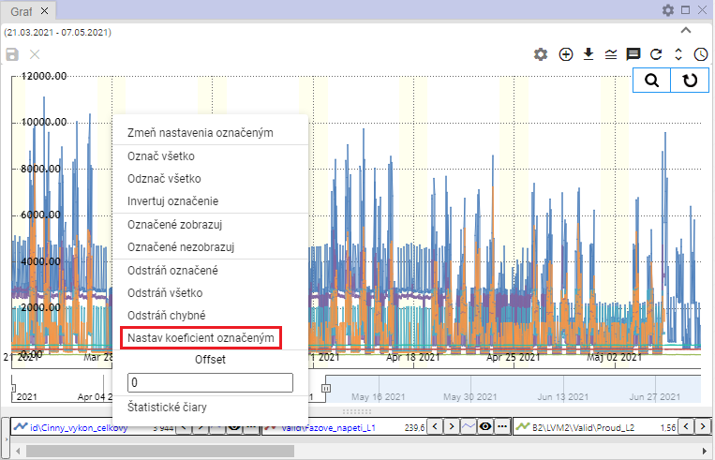

Image 325: Item "Set coefficient marked"

1. "A window titled 'Coefficient settings' will appear."
2. "Continue with coefficient and save by pressing the 'OK' button."

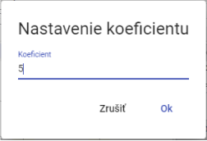

Image 326: Setting coefficient window

1. The selected profiles will be set with a coefficient. Under the profile names, there will be an information about the set coefficient displayed.

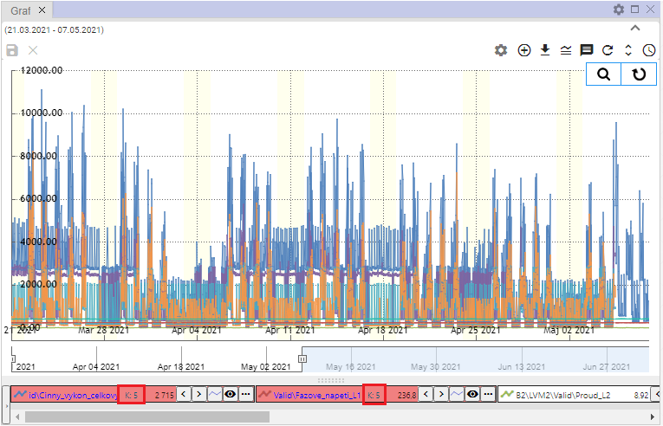

Image 327: Set coefficient

### I will set the offset

**[OLLAMA FORMATTING ERROR - MANUAL REVIEW NEEDED] Pre nastavenie offsetu postupujte:**

1. By clicking on the names of the profiles, mark the profiles for which you want to set an offset.
2. "Click on the right mouse button on the name of one of the selected profiles."
3. **[TRANSLATION FAILED AFTER 3 RETRIES] Zobrazí sa okno, v ktorom zadajte offset a stlačte klávesu Enter.**

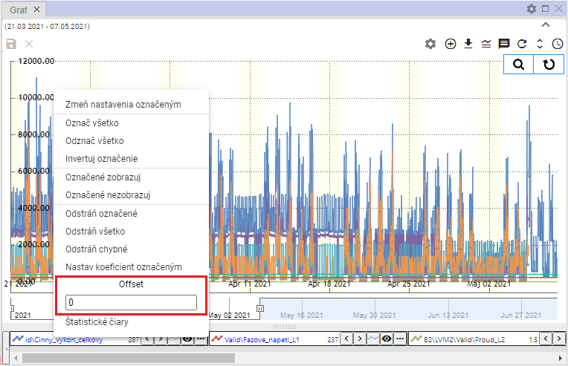

Picture 328: Pole "Offset"

1. "On selected profiles, information about the set offset will be displayed."

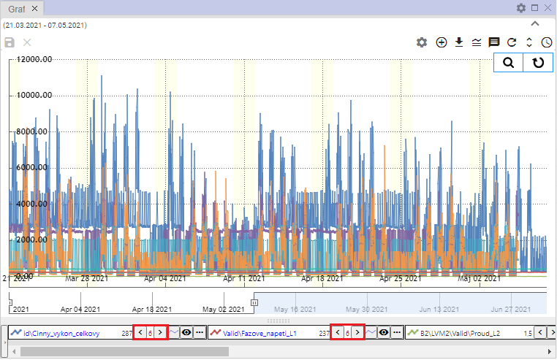

Image 329: Set Offset

### How to display statistical lines

"Proceed with viewing statistical lines:"

1. "If you want to display statistical lines only for some profiles, hold down the Ctrl key and click on the names of the profiles for which you want to display statistical lines."
2. Click with the right mouse button on the profile name.
3. Select item "Statistical Lines".

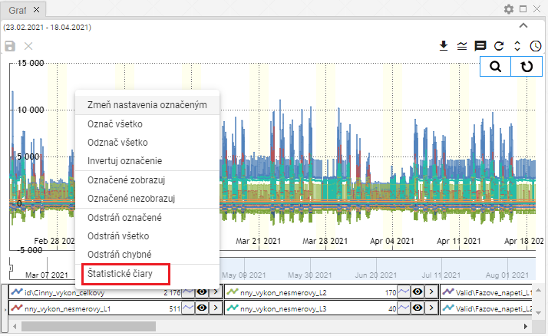

Image 330: Category "Statistical lines"

1. The window "Statistical lines" will be shown.

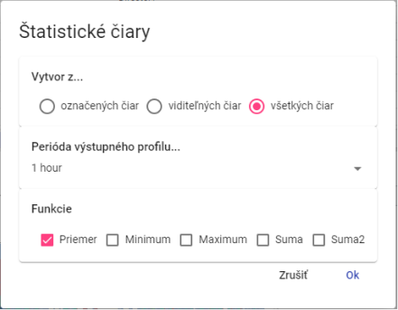

Picture 331: Window of "Statistical Lines"

1. "Choose whether statistical lines are to be created from marked visible or all lines."
2. Select a function. You can select multiple functions at once.
3. Click on the button "OK".

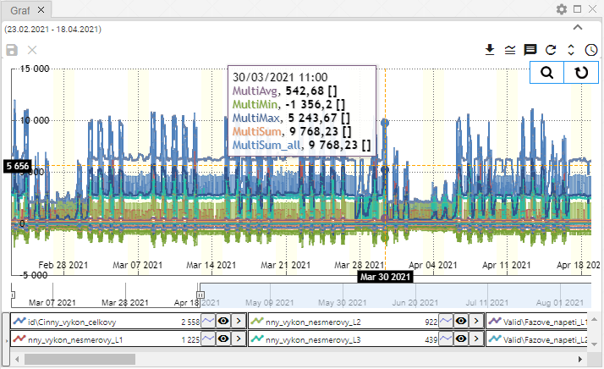

Image 332: Statistical lines

### I should replace this text marked

This function is used for batch change of profile names. Proceed:

1. "Mark profiles you want to change the text in profile path."
2. Click on the name of the profile with your right mouse button.
3. "The offer will be displayed, where you can select the item 'Replace marked text'."

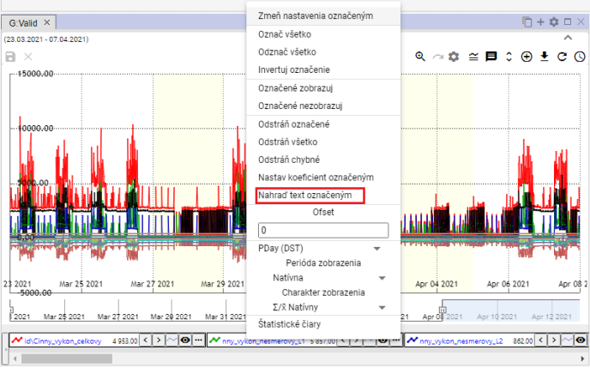

Image 333: Replace text with captioned image"

1. A window titled "Replace text in profile path" will appear.
2. "In app 'Find' type a text you want to replace."
3. "In the 'Replace' field, enter the text that should replace the text in the 'Find' field."

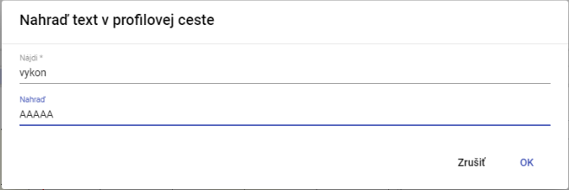

Image 334: Window "Replace text in profile path""

1. "Confirm by pressing the 'OK' button."
2. The assigned text will be replaced by a new text.

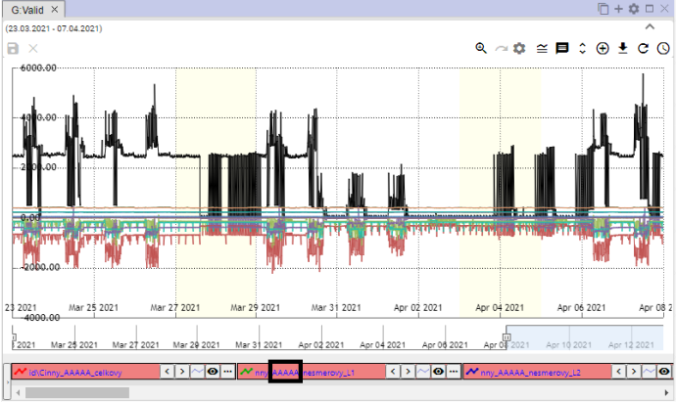

Image 335: Replaced text

## Job functions with one profile

Every profile has a button above its name, which serves to show the functions. Functions serve for working with selected profiles.

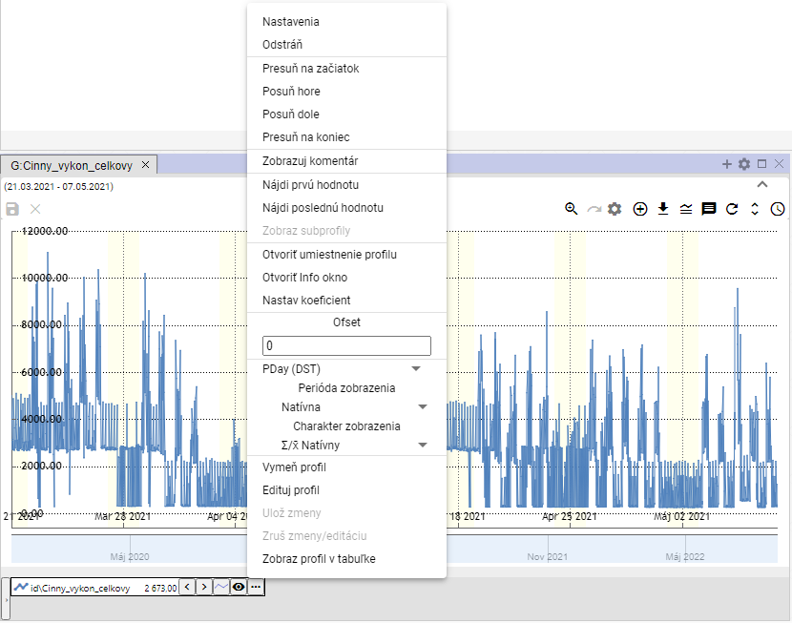

Image 336: Functions for working with profile

### "Adjust settings"

"You can change the display of profile data in the graph in the settings window. For example, you can change the color with which the profile is displayed, line style..."

Before changing the settings, proceed:

1. Click on the button next to the profile name that you want to change settings for.
2. "A window will be shown where you select the item 'Settings'."

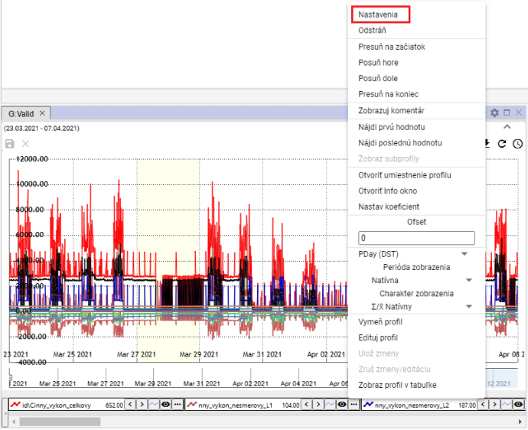

Image 337: Settings item

1. In the window that will appear, change profile settings.
2. Save changes by pressing the "OK" button.

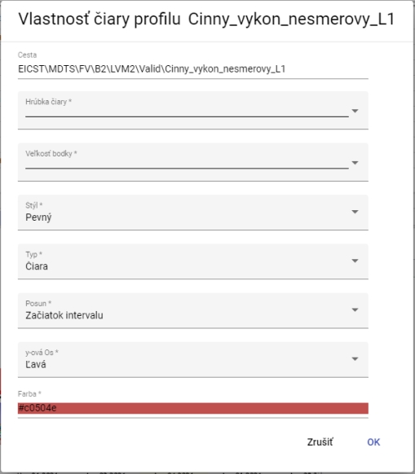

Picture 338: Profile settings

### Delete profile

Remove profile:

1. "Click on the button next to the profile name you want to delete."
2. The profile is removed from the list of profiles at the bottom of the window Graph and from the display of profiles.

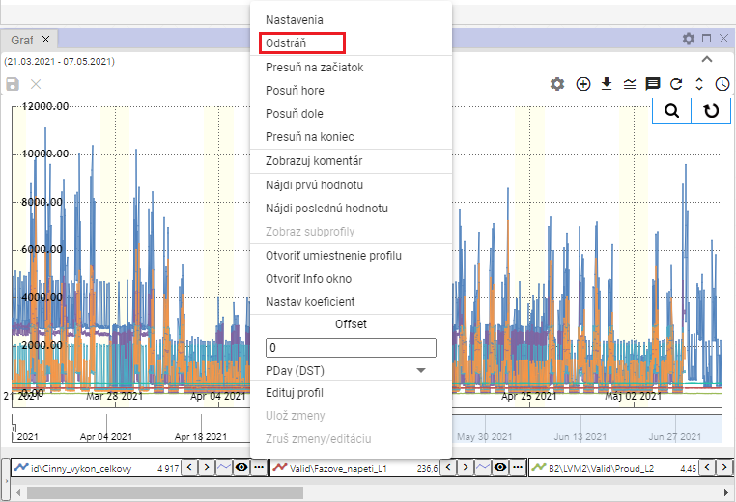

Image 339: Entry "Delete"

### "To move profile to start"

"If you want to move the profile to the top of the profiles list, proceed:"

1. Click on the button next to the profile name you want to move to the top.
2. Choose item "Move to start"
3. The selected profile will be moved to the top of the list.

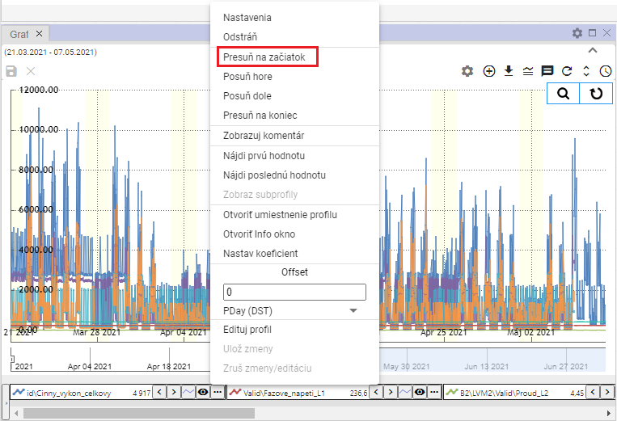

Image 340: Option "Move to start"

### Move the profile up

"The entry 'Move up' is used to move the profile name in the list of profiles at the bottom of the 'Chart' window one position higher, for example from third to second place."

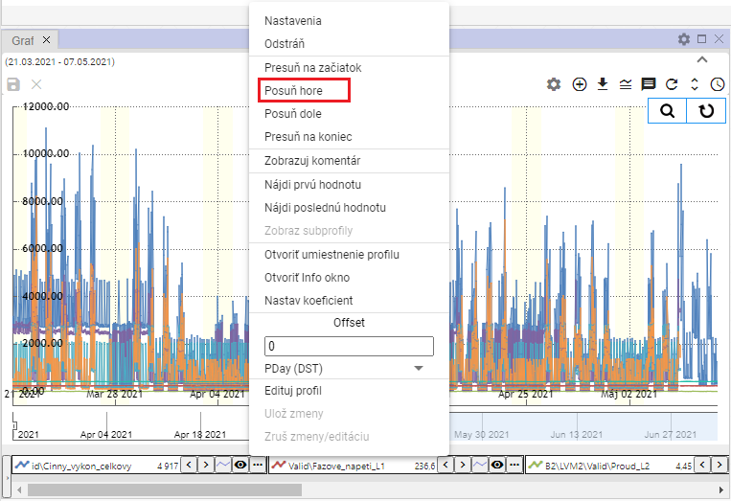

Picture 341: Article "Shove off!"

### Move the profile down

"The item 'Move Down' serves to move the profile name in the list of profiles at the bottom of the 'Graph' window one position lower down, for example from second place to third."

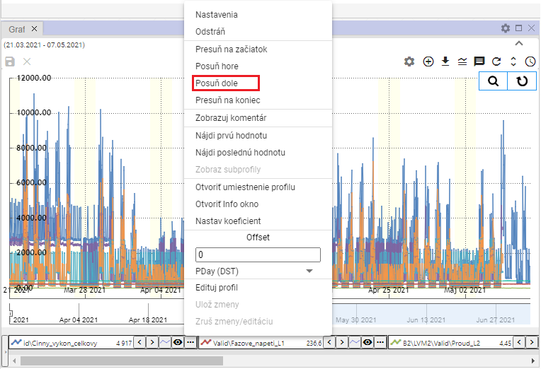

Image 342: Item "Slide down"

### I will move the profile at the end

"The item 'Move to End' serves for moving the profile to the end of the list of profiles in the lower part of the window 'Graph'."

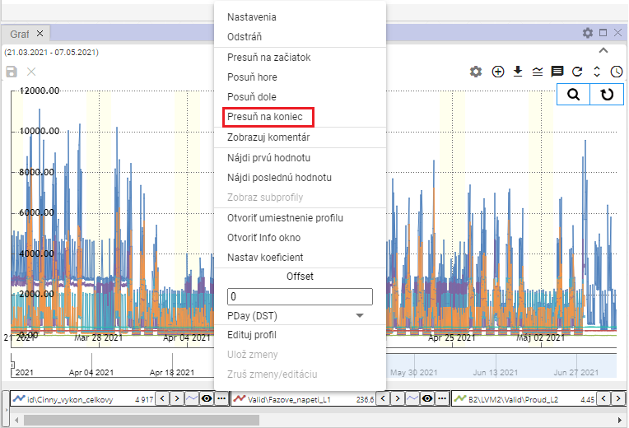

Image 343: Position "Move to End"

### Show comments

"The item 'Show comment' determines the display of profile name. Upon selecting the item 'Show comment', instead of the profile name, a comment, Image 345 will be displayed. To show the profile name again, click on the item 'Show comment' again."

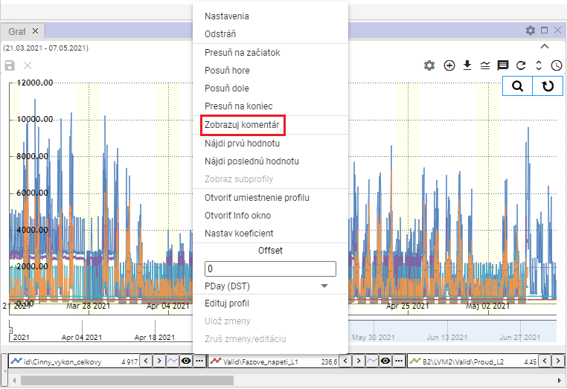

Picture 344: Item "Show comments"

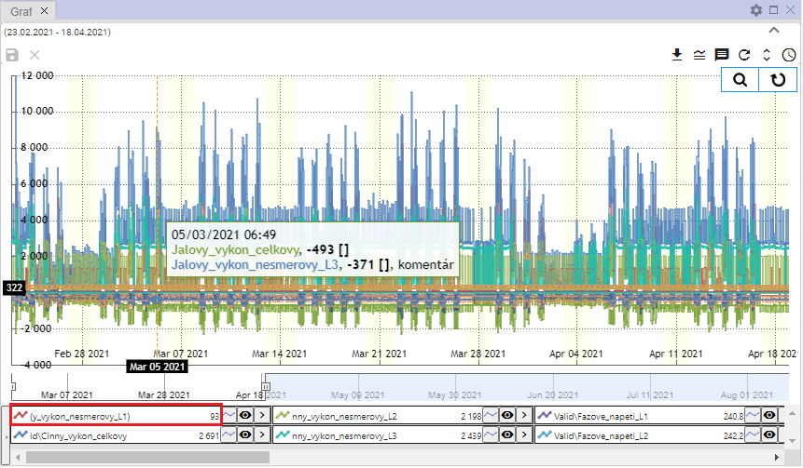

Picture 345: Displayed comment profile picture

### How to find the first value

The entry “Find the first value” serves to find the first profile value in a graph.

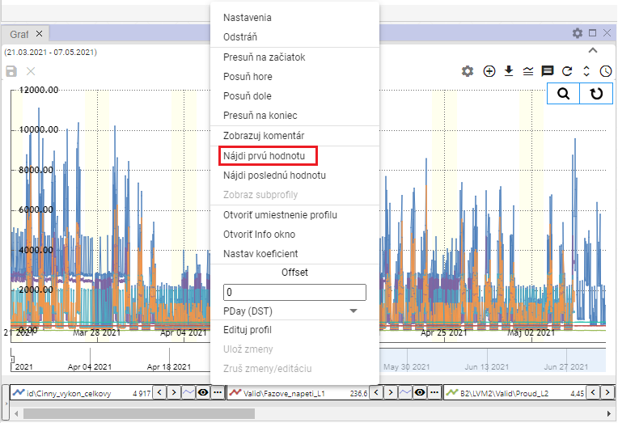

Image 346: Item "Find First Value"

### I will find the last value

"The entry 'Find last value' serves to find the last profile value in a graph."

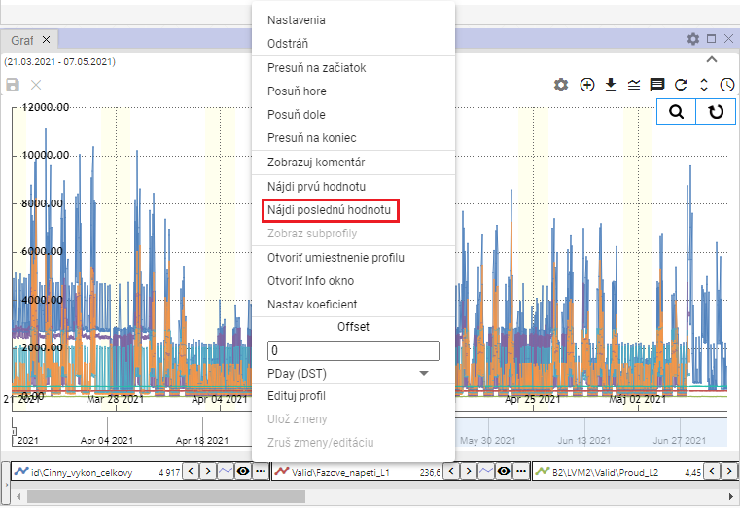

Image 347: Item "Find Last Value"

### I want to see sub-profiles

"A calculated profile can have other profiles, so-called subprofiles, used in the definition. For their display proceed:"

1. "Click on the button next to the profile name you want to change settings for."
2. "A window will appear where you select the item 'Show sub-profiles'."
3. All profiles used in the definition of the calculated profile are displayed.

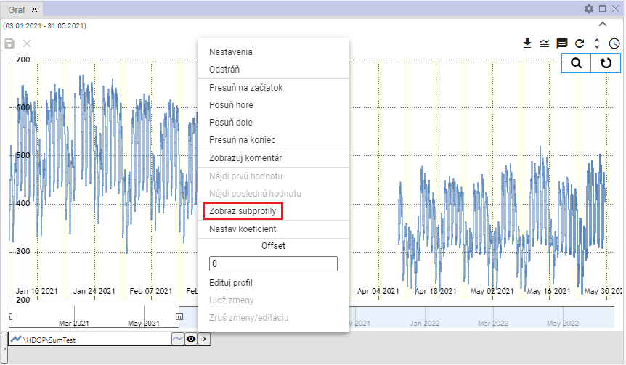

Image 348: Item "Show subprofiles"

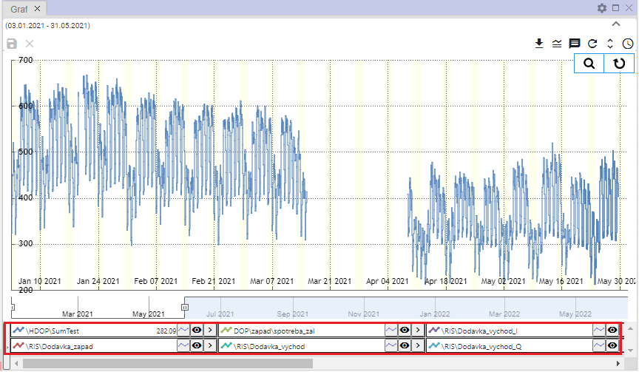

Image 349: Shown subspecies profiles

### If I open my profile setting

"Profile configuration in riverine structure will be displayed:"

1. "Click on the button next to the profile name you want to open in the branch."
2. "A window will appear, in which you select the item 'Open profile settings'."

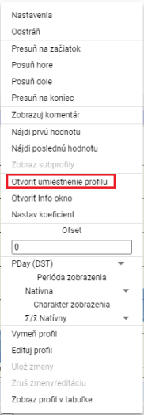

Picture 350: Item "Open location profile"

1. In the stream structure, an address book will open, where a profile is located.

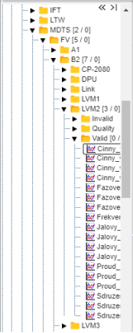

Image 351: Placement of a profile within a network structure

### If you open an information window

"You can open a window with information for each profile, such as the name of the profile, path to the profile, type of profile."

"Window with information will open:"

1. Click on the button with three dots, which is located at every profile.



Picture 352: Button for showing functions

1. Select item "Open info window".

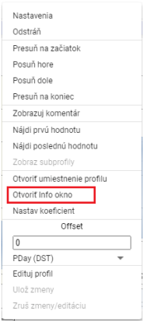

Image 353: Open info window item

1. "In the stormy structure, an address book will open, in which a profile is located, Image 351."
2. Next, a window with profile information will appear, which contains three tabs: "Info", "ReadLog" and "WriteLog", Image 354.
3. You can copy the name and path of the profile by clicking on the button under the tab "Info".

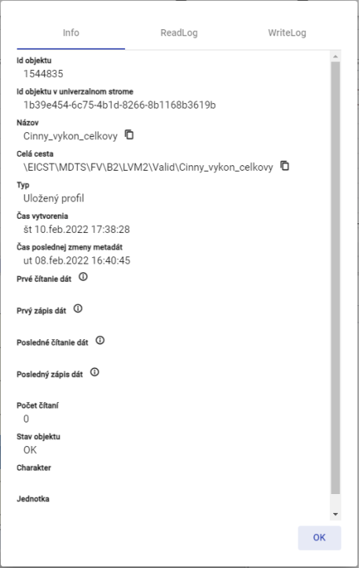

Picture 354: Tab "Info""

### How to set a coefficient

"Before setting the coefficient, proceed:"

1. Click on the button next to the profile name that you want to set the coefficient for.
2. Choose item "Set coefficient".

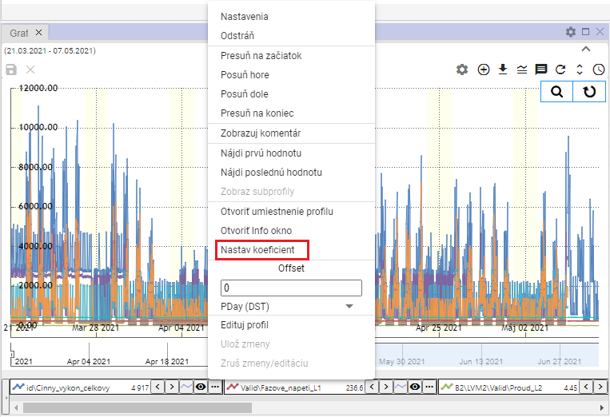

Image 355: Setting coefficient item

1. "A window will appear where you enter the coefficient."

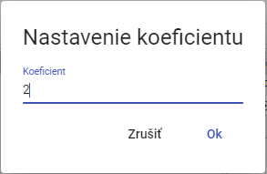

Image 356: Setting of coefficient

1. Click "OK" to save.
2. "On the profile name, information about the set coefficient will be displayed."



Image 357: Configured coefficient

### I'm setting an offset

"Before setting the offset, proceed:"

1. "You can enter the offset by clicking on the arrows next to the profile name or click on the button and in the 'Offset' section, enter a value and press the 'Enter' key."



Image 358: Settings for setting up an offset press

1. "The uniform value which you have set for the offset using arrows next to the profile name will also appear after clicking on the button in the 'Offset' section."

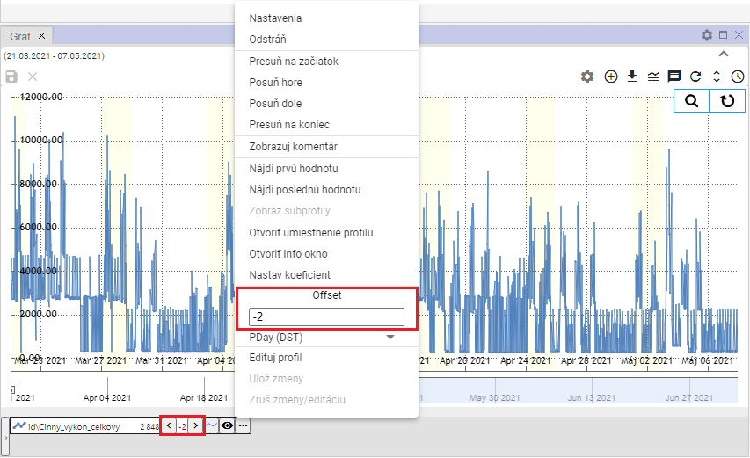

Image 359: Set Offset

1. "Under the forest Offset there is a field for choosing an offset period, Picture 360. Upon expanding the field, a list of time periods for offset will appear, Picture 361."

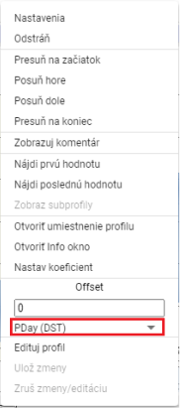

"Image 360: Select period for offset"

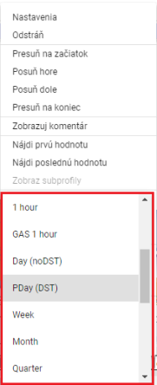

Image 361: Selection of time period for offset printing

### "To change profile"

Before swapping profiles for another profile, proceed:

1. Click on the button next to the profile name you want to change.
2. Select the item "Edit profile".

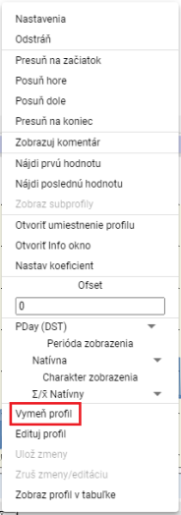

Image 362: Item "Expand Profile"

1. "A window 'Change Profile' will appear."

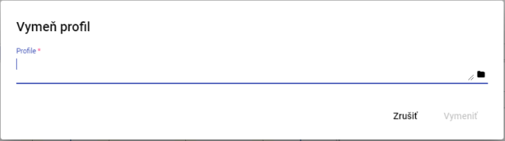

Picture 363: Tab "Edit Profile"

1. Write your way to profile or click on the button .
2. "Click the 'Replace' button after confirmation."

### Edit my profile

Before editing the profile, proceed:

1. "Click on the button next to the profile name you want to edit."
2. Choose item "Edit profile".

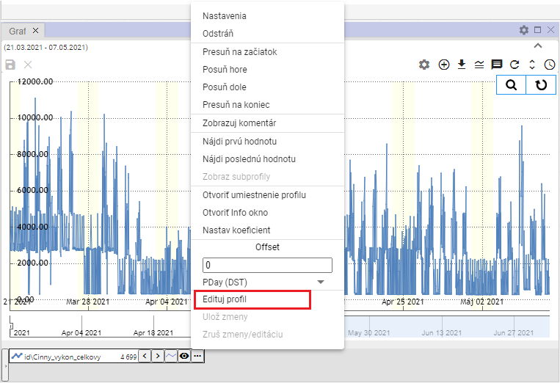

Picture 364: Edit profile item

1. A copy of the profile will be created. Fields with names of the original and copied profiles will be highlighted in green color.

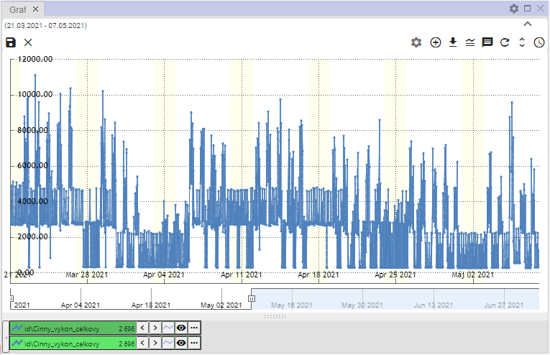

The Portrait 365: A copy of my profile will be created.

1. Edit profile.
2. "Changes will be saved by clicking on the button and selecting the item 'Save changes' or by pressing the disc icon located in the top left corner of the graph."

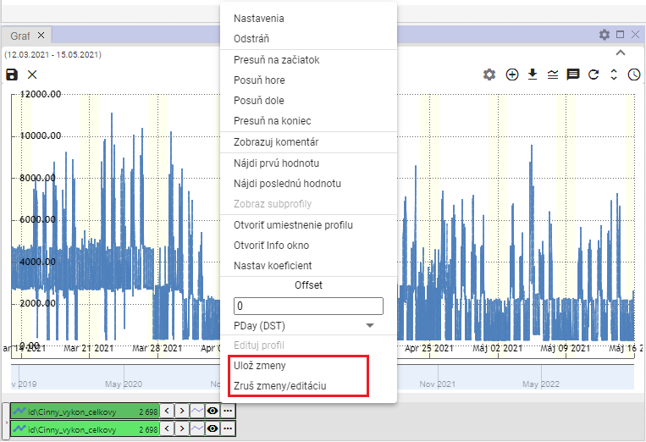

Image 366: Items "Save changes" and "Undo changes/editing""

1. "If you want to cancel changes, select the item "Cancel Changes/Edit" or press the 'X' button in the top-left corner of the graph."

### "Set up color for profile"

Set profile color beforehand:

1. "Press the button next to the profile for which you want to set up a color."
2. Select the item "Settings", which will show you a window called "Line Profile Property".



Image 367: Setting item

1. "Click on the 'Color' field for the 'Line Profile Property' window."
2. "A window for color selection will appear. At the bottom is a color palette for quick color selection."

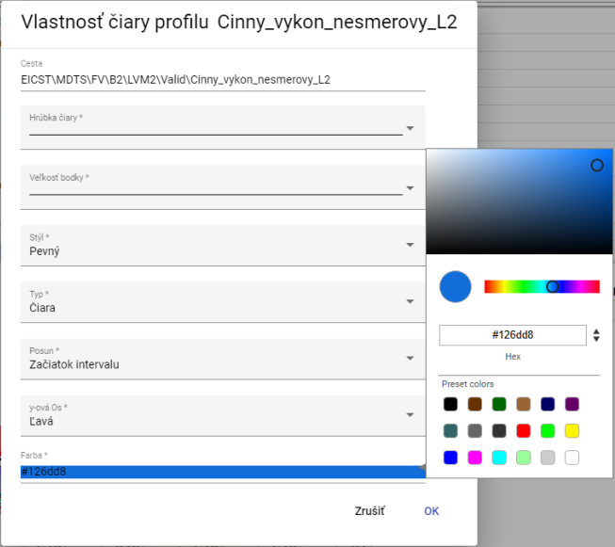

Picture 368: Color selection

1. "Click on the selected color."
2. You will save changes by pressing the "OK" button.

### How to set the size of a point.

"Before setting the size, proceed with points:"

1. "Click on the button next to the profile name for which you want to set the font size."
2. Select the item "Settings", which will display the window "Properties of Profile Line".



Image 369: Item "Settings"

1. Click on the field "Point size".

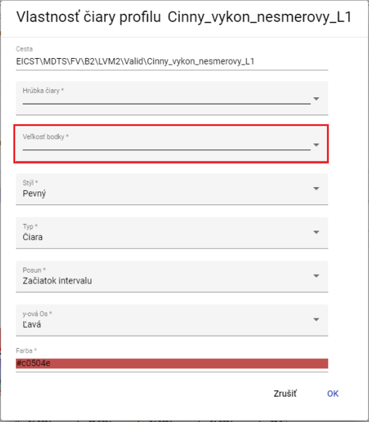

Image 370: Pole "Size of dot"

1. "A window will appear, in which by clicking you can select the display size for a point."

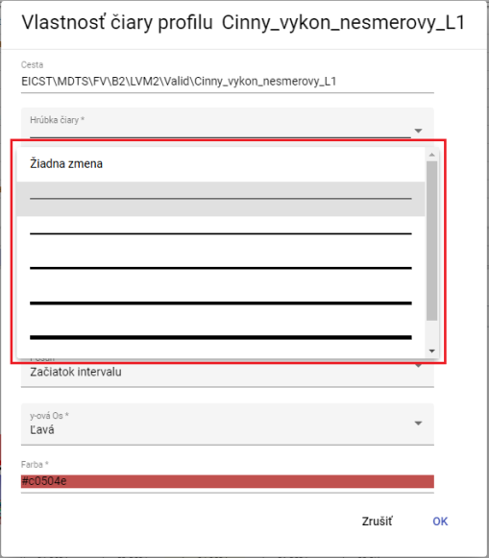

Image 371: Selection of point sizes

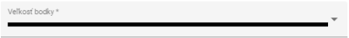

Image 372: Selected size

1. Changes will be saved by pressing the "OK" button.

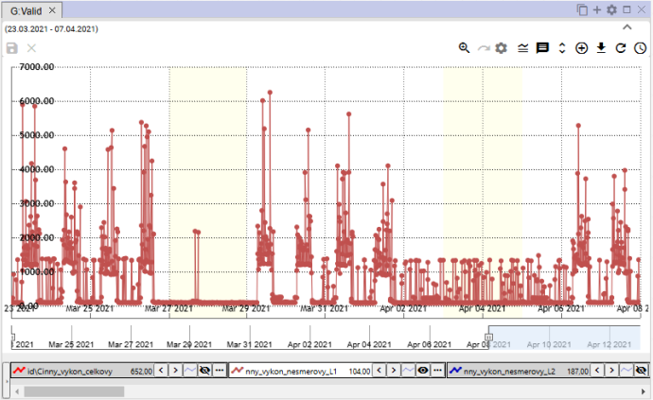

Image 373: Set point size

### To view profile on table

"Profile in the window graph will be shown in a table as follows:"

1. **[TRANSLATION FAILED AFTER 3 RETRIES] Kliknite na tlačidlo pri názve profilu, ktorý chcete zobraziť v tabuľke.**
2. "Select item 'Show profile in table'."

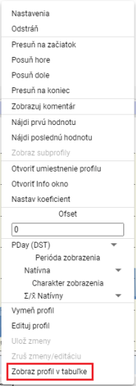

Image 374: Position "Show profile in table"

1. "On the window of Graf, there is a new tab called Table."

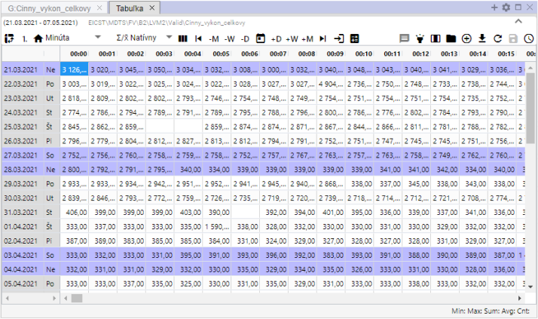

Image 375: Displaying profile in table.

## "Rapid change of graph type"

"At the bottom part of Graph window, there is a button for quick change of graph type next to each profile name. The button with graph icon allows switching between StepLine, StepArea and StackedColumn graphs. One can also switch the graph type through 'Type' field in 'Profile properties' window, procedure is described in chapter 5.8.1."



Image 376: Button for quick change of graph type

The standard graph type in the Graph tab is "StepLine", Figure 377. Pressing the button sets the graph type to "StepArea", Figure 378, and changes the button's appearance to . Pressing the button again sets the graph type to "StackedColumn", Figure 379, and changes the button's appearance to .

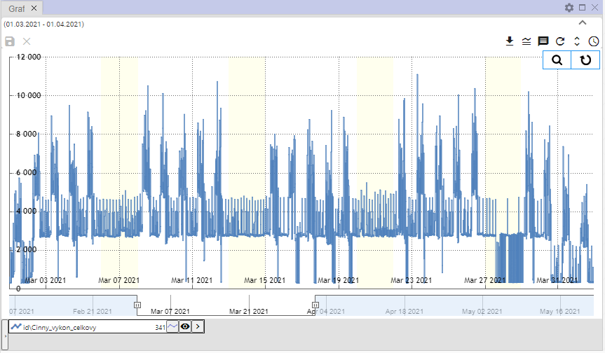

Image 377: Type of graph "StepLine""

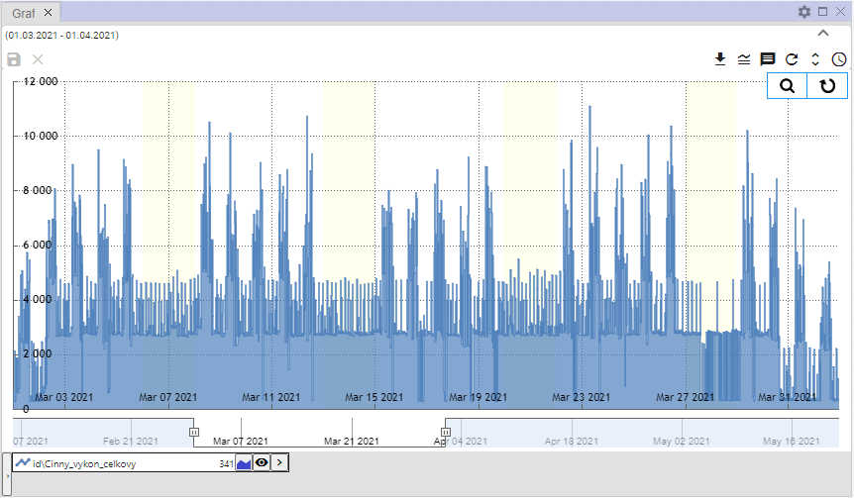

Image 378: Graph type "StepArea"

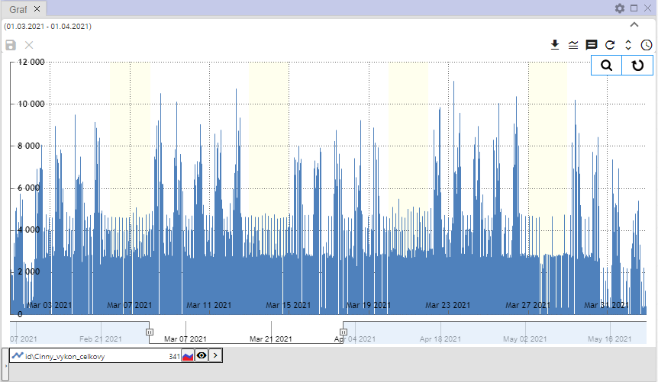

Picture 379: Chart type "StackedColumn"

## To zoom in on a selected part of the graph

"Before enlargement of selected part in graph:"

1. "Click on the 'Join Zoom' button, which can be found in the top right corner of the graph."

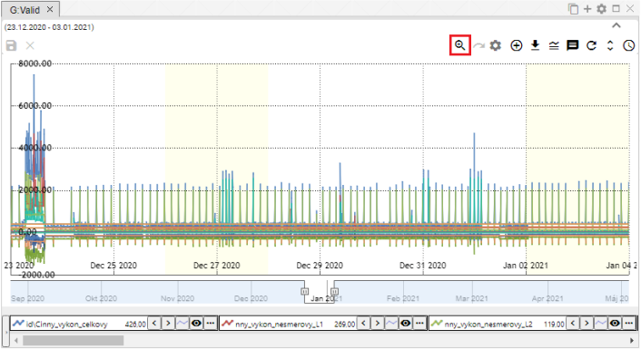

Picture 380: Click button "Join on Zoom"

1. Click the left mouse button and mark the area on the graph.

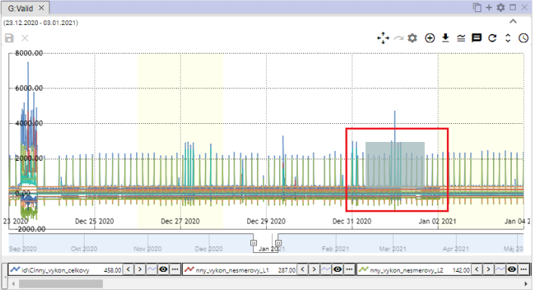

"Picture 381: Marked location on map"

1. Click the left mouse button.
2. "The selected area will approach."

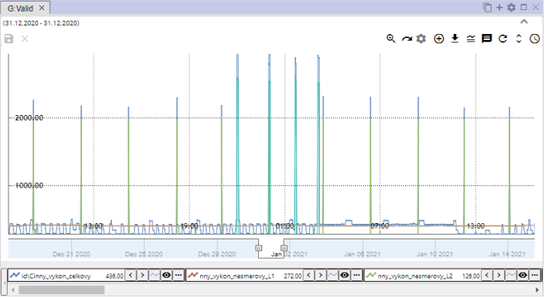

Image 382: Enlarged location in graph

1. "Before restoring your y-axis, press the 'Reset zoom' button, chapter 5.12."

## I will plot a graph

By clicking on the "Zoom to" button, image 380, the button will change from zoom in to "Zoom to", image 383. It allows you to move within the graph. To move within the graph, click and drag a location within the graph with your left mouse button."

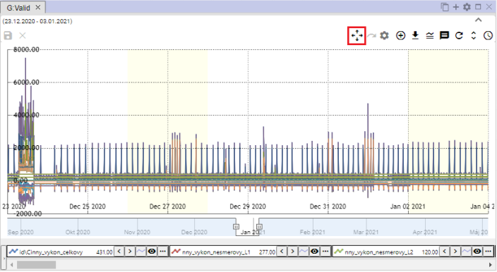

Image 383: Button "Slide forward"

## Can you cancel the meeting?

"After you have brought the selected area into view in the graph using the zoom function, you will restore the graph by pressing the 'Reset zoom' button."

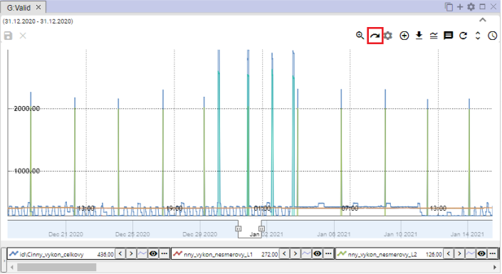

Image 384: Reset Zoom button

## Show/Hide Legend

"At the bottom part of the graph window, a list of displayed profiles, called legend, can be found. To hide the profile list, click on the button 'Show/hide Legend', which is located in the top right corner of the Graph window. To show the legend again, click once more on the 'Show/hide Legend' button."



Image 385: Toggle button Show/hide legend

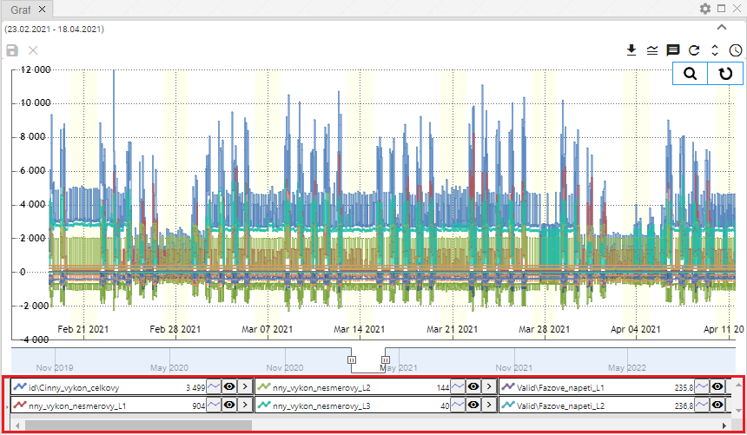

"Picture 386: Displayed Legend"

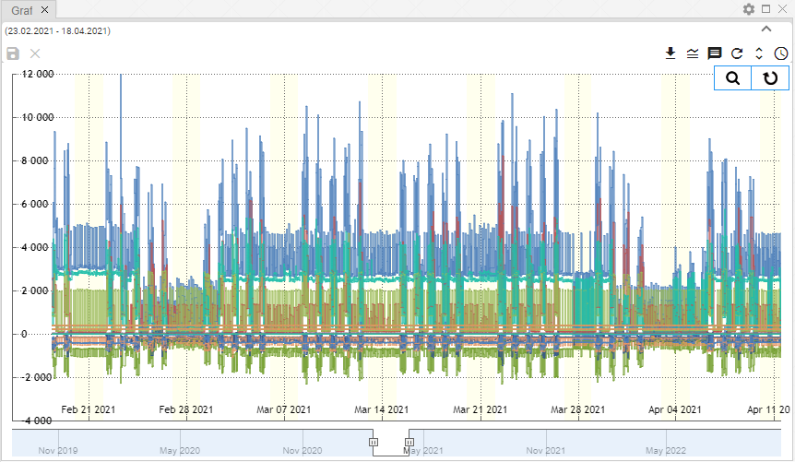

Picture 387: Secret Legend

## Show/hide tooltip

To display the values (tooltip) for a specific point in the chart, place your mouse cursor on the chosen location in the chart. The tooltip can be hidden by clicking on the "Show/Hide Tooltip" button located in the top right corner of the Chart window. To show the tooltip again, click on the "Show/Hide Tooltip" button once more.



Image 388: Button "Show/Hide Tooltip"

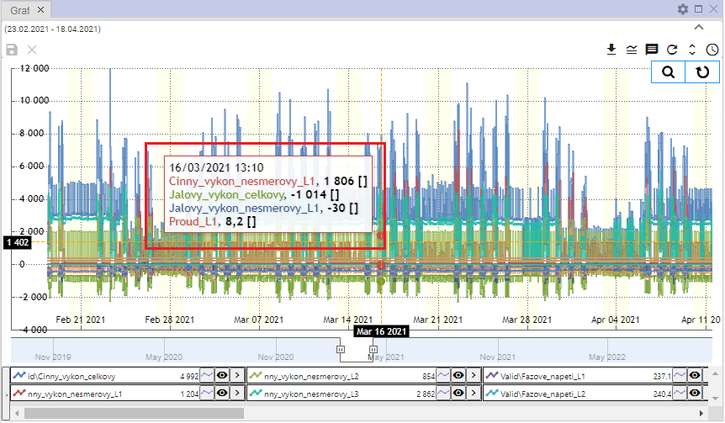

Image 389: Shown tooltip

## "If I were to set up a Y-axis so that values could be seen"

"The button 'Make y-axis visible' serves to unzoom the y-axis in case it's not well visible when zooming (all lines). The y-axis is then unzoomed so that all values are visible. The x-axis remains unchanged."

Proceed:

1. Click on the "Zoom" button, which is located in the top-right corner of the Graphics window.



Image 390: Zoom button

1. Please point out the location on the graph that you would like to zoom in.

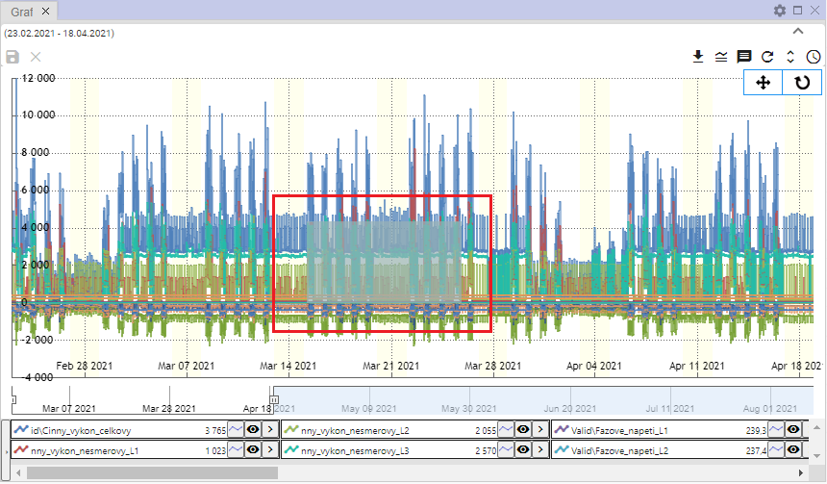

Find location on graph 391:

1. The town is getting closer in the graph.

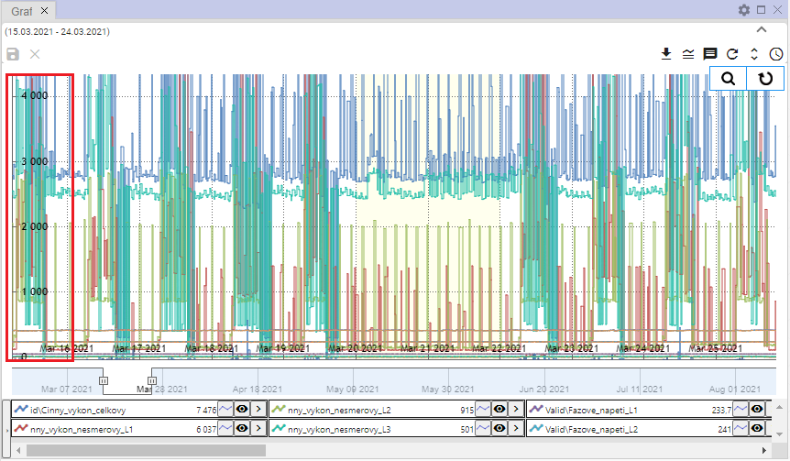

Picture 392: Magnified area from graph

1. "Press the button 'Set Y-axis so that it's visible'."



Picture 393: Button "Set Y-axis value visible"

1. The Y-axis is zoomed out.

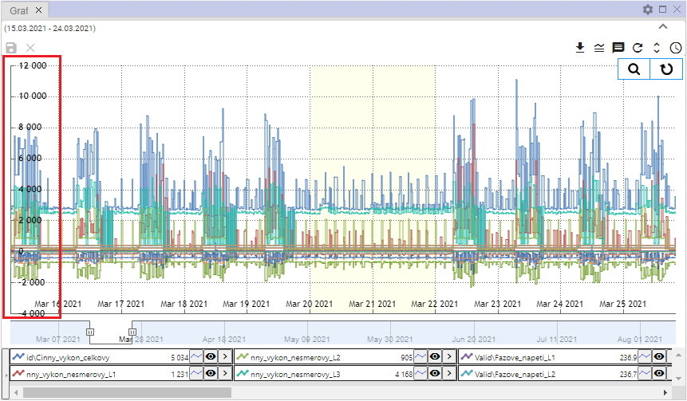

Image 394: Altered y-axis

## Change Profile

Proceed with profile change:

1. Click on the button next to the profile you want to replace.
2. Choose item "Edit profile".

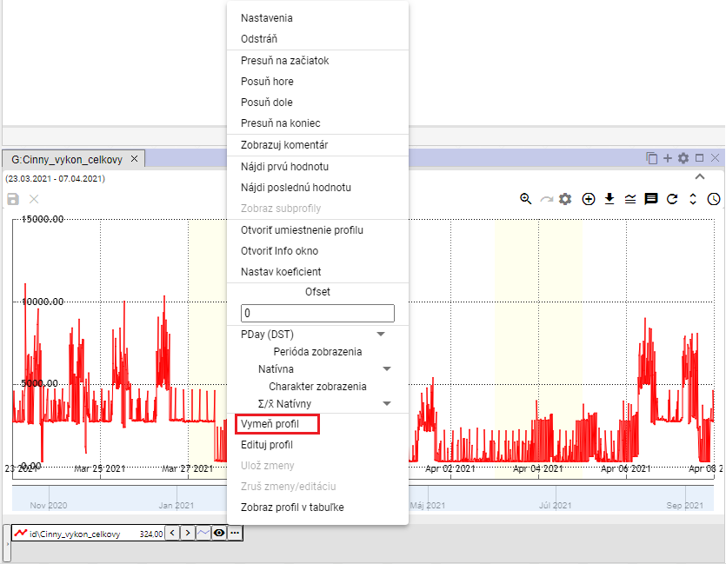

Picture 395: Item "Set profile"

1. "A window titled 'Edit Profile' will appear."

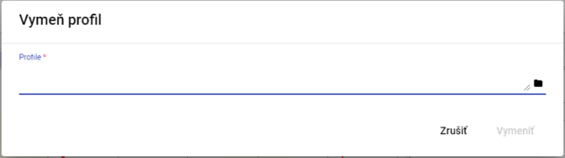

Image 396: Profile Window

1. "Enter profile path or click on button and search for profile."

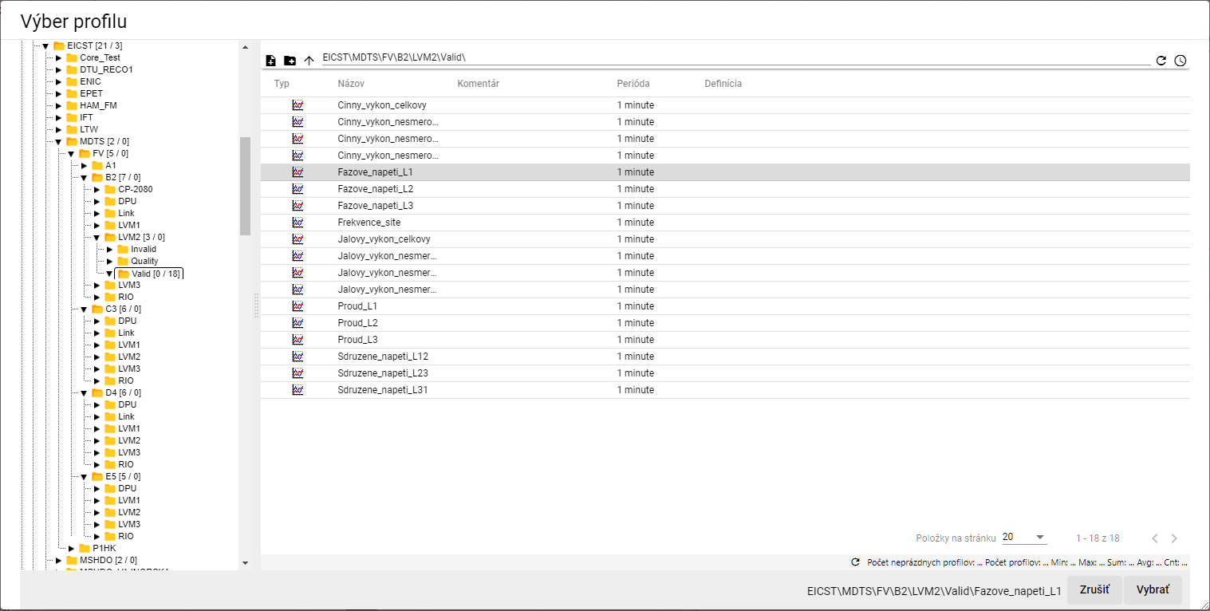

Picture 397: Profile selection window

1. "Click on the 'Replace profile' button in the window and then click on 'Replace'."

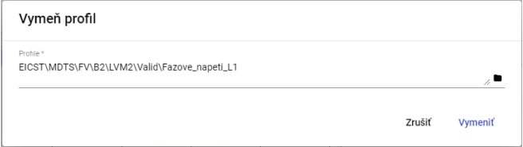

Picture 398: Selected Profile

1. "The profile in the window graph is replaced with the selected profile."

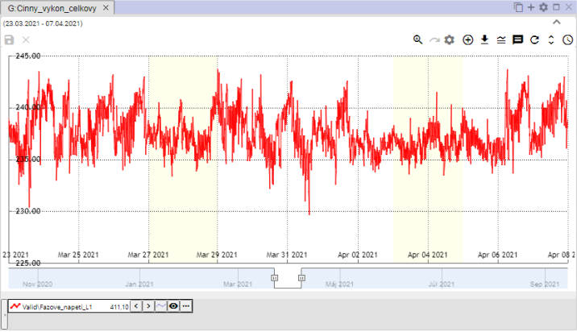

Picture 399: Profile with holes

# Work with the table

"The 'Profile Manager' application offers, in addition to work with the graph and explorer, also the possibility of working with data in a table. Each table contains data from one profile and was created in a separate window."

"The user closed the table with unsubmitted data window; a window - Image 400 will be displayed."

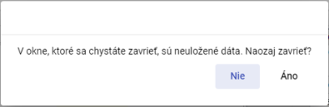

Picture 400: I am announcing unpaid data

## Show profile on table

"You can display the profile in a table by transferring the profile from the scanner to the table (Chapter 4.8) or by transferring the profile from the profile tree to the table."

"Before displaying the profile from the profile tree table, proceed:"

1. "The standard window is an empty table."

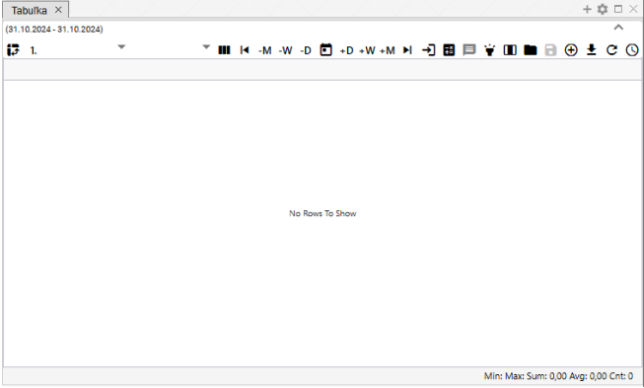

Picture 401: Normally, the window for displaying the table is empty

1. "Click with the left mouse button on the profile you want to display in the table."
2. "Move the profile above the table window and put it in."

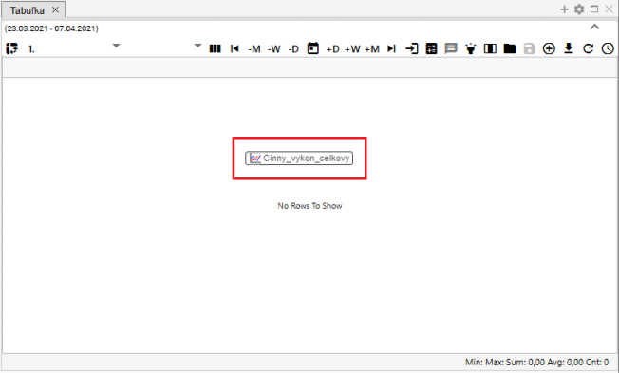

Image 402: Adding profile to table

1. In the window of a table, values of profile will be shown.

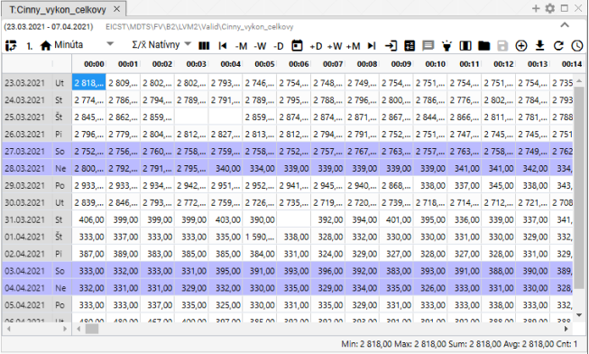

Image 403: Profile display in table

## "How to set up column display"

"The default display is in table format. To switch to column format, press the button 'Switch to column view'. To return to table view, press the button 'Switch to column view' again."

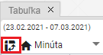

Image 404: Button "Switch to column display"

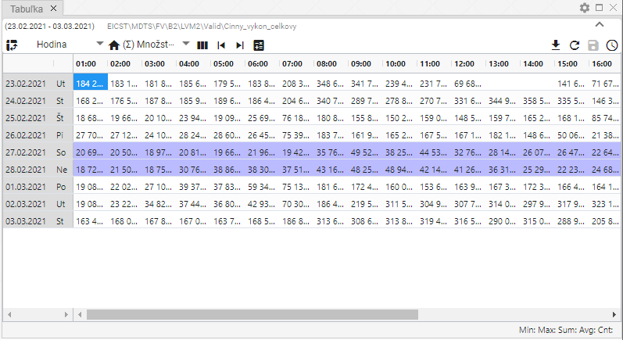

Image 405: Emergency display

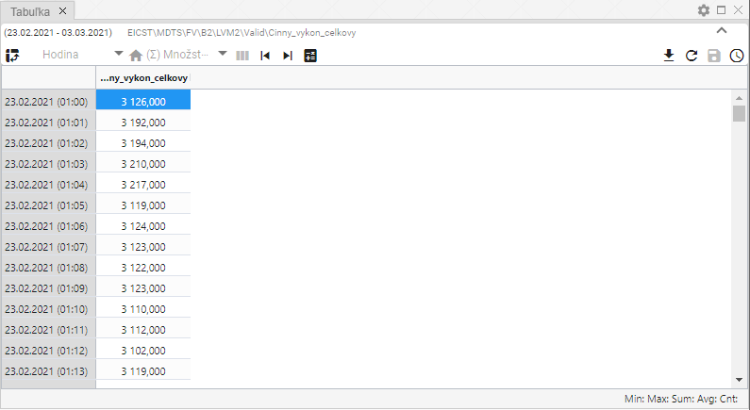

Picture 406: Column image

## To configure for single-profile display

"Standardly the window of 'Table' is set to single-profile display, Picture 409. By pressing the button that shows Picture 407, the table will switch to multi-profile display, Picture 410. Switching back to the multi-profile display will change the appearance of the button from Picture 407 to Picture 408, which serves to switch the table back to single-profile display."



Picture 407: Button "Switch to multiprofile view"



Image 408: Button "Switch to single-profile view"

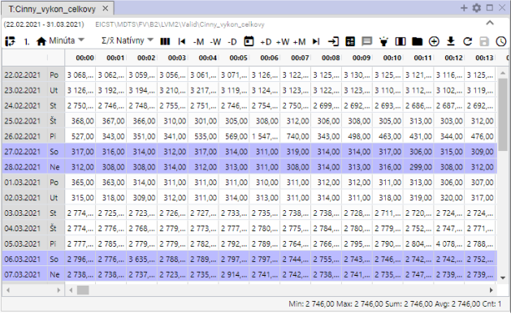

Image 409: One-line display

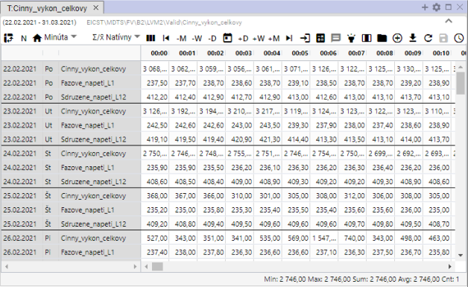

Picture 410: Multidirectional display

## Change time display format

**[TRANSLATION FAILED AFTER 3 RETRIES] Dáta sa v tabuľke štandardne zobrazia v takej perióde, ako je vytvorený profil, ktorého dáta zobrazujete v tabuľke, vždy jeden deň v jednom riadku. To znamená, že pre hodinový profil sa zobrazí 24 stĺpcov, pre 15 minútový sa zobrazí 96 stĺpcov, pre 1 minútový sa zobrazí 1440 stĺpcov a pre sekundový profil sa zobrazí  900 stĺpcov.**

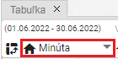

Picture 411: Button for time format change

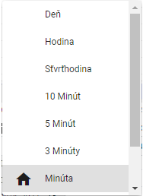

Image 412: List of time formats in table

Data can also be displayed in periods:

* Day – daily overview of data
* Hour - hour overview data
* Quarter-hour - 15-minute overview of data
* "10 Minutes - A 10-minute overview"
* "5 minutes – 5 minute review of data"
* "3 minutes – a 3-minute overview"
* A minute - minute-by-minute overview of data
* "Second - second overview of data"
* The unknown – will be shown if the table does not recognize the profile period. Then, the values of the profile are stretched into one column and the column with time is filled according to the data.

## How to set the number of columns

"In the window Table you can set the number of columns that should be displayed. Proceed:"

1. "Click the 'Columns' button, which is located in the upper part of the Tab window."

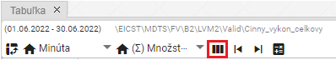

Image 413: Button "Number of columns"

1. "A window titled 'Set number of columns' will appear."

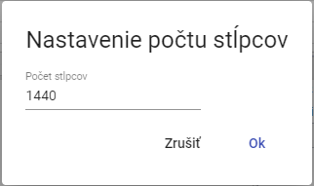

Picture 414: Window "Setting number of columns"

1. "Enter the number of columns to display."

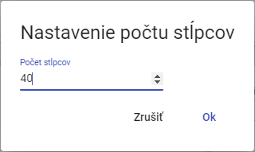

Image 415: Number of columns changed

1. The number of columns will be adjusted. Above the "Number of columns" button, the set number of columns will appear.

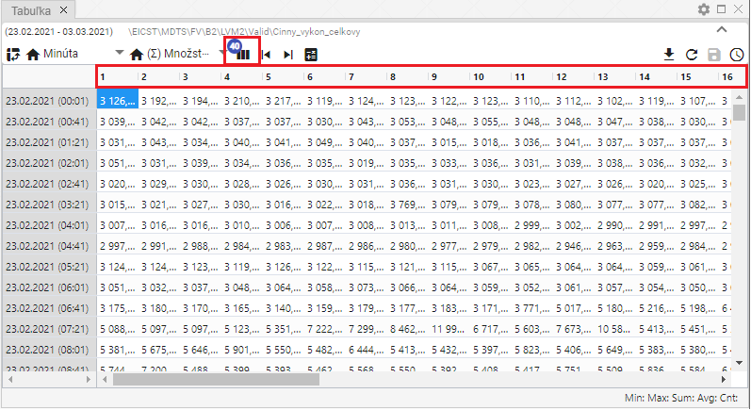

Image 416: Set column count

1. "Before restoring the column count, press the 'Column Count' button and in the 'Set Column Count' window, press the 'Cancel' button."
2. "Next, the original number of columns will be restored."

## How to choose an interpreter

"The method of prefetching determines how the profile will be prefetched when shown in other periods than its 'natural' period."

"In the 'statistical' way of resampling, the base profile will be understood as statistical (e.g. energy) and when shown in smaller periods it will be divided by the corresponding ratios. In the case of 'piezoelectric' resampling method, the base profile will be understood as time-dependent (e.g. temperature) and when resampled to lower periods, the value of the profile will remain at the same level."

**[TRANSLATION FAILED AFTER 3 RETRIES] „Natívny“ spôsob znamená, že sa vyberie charakter profilu, ktorý je pre daný profil nadefinovaný. To znamená, že pre priebehový profil sa použije priebehový charakter a pre množstevný profil sa použije množstevný charakter. Táto voľba je dôležitá hlavne v prípade ak mám zobrazených viac profilov s rôznym charakterom. Vtedy sa zobrazuje každý podľa svojej definície.**

This setting only affects the display of profiles in a table. Changing it does not affect the behavior of the underlying profile in the system or the behavior of profiles dependent on it.

"The method of previewing can be accessed by pressing the 'Preview Method' button and selecting from the window that appears, Figure 418."

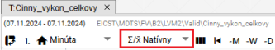

Image 417: Button "Way of prevyoking"

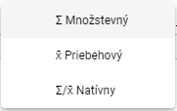

Picture 418: Selection of way of transmission

## How to display the first value

"The 'Go to first value' button serves for displaying the first measured profile value."

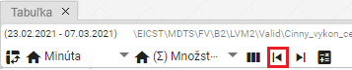

Image 419: Button "Go to first value"

## To show the last value

"The 'Go to last value' button serves for displaying the last measured profile values."

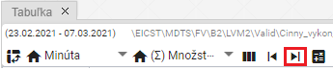

Image 420: Button "Go to Minimum Value"

## How do I display today's date

"Press the 'Go to today' button before displaying the current day. The cell in the table representing the current date and time will be highlighted."

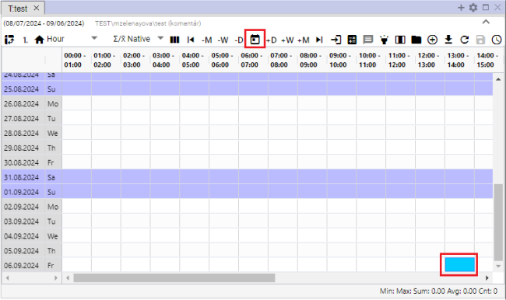

Picture 421: Item "Go to current date"

## To display a specific date

"Show specific date on table:"

1. "Click on the button 'Choose a specific date'."

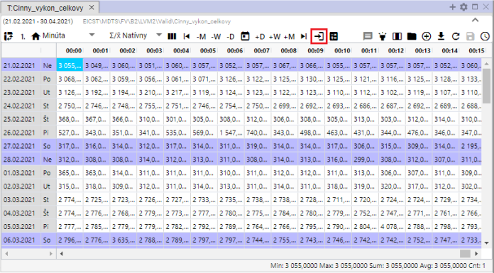

Image 422: Button "Go to specific date"

1. Choose a date.

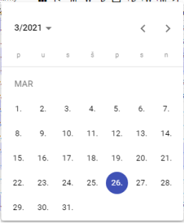

Image 423: Task date

1. "The selected date will be shown and the first cell in the selected date is highlighted with blue colour."

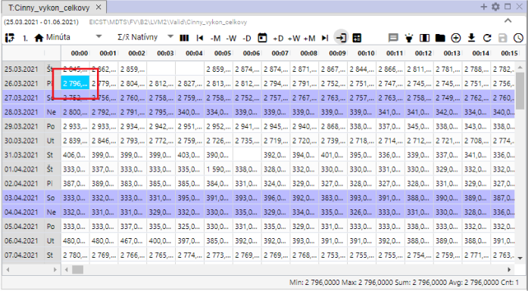

Picture 424: Display of selected date

## I consider today's date as a day, a week, a month.

"The date range for which data is displayed in the table can be moved using the sliders:"

* **[TRANSLATION FAILED AFTER 3 RETRIES] „-M“ - odpočíta od vybraného dátumu jeden mesiac,**
* **[TRANSLATION FAILED AFTER 3 RETRIES] „-W“- odpočíta od vybraného dátumu jeden týždeň,**
* "-D" subtracts one day from the chosen date.
* **[TRANSLATION FAILED AFTER 3 RETRIES] „+M“ - pripočíta k vybranému dátumu jeden mesiac,**
* **[TRANSLATION FAILED AFTER 3 RETRIES] „+W“ - pripočíta k zvolenému dátumu jeden týždeň,**
* "'Add one day' - adds one day to selected date."

Follow instructions:

1. "Click on the box that represents the date from which you want to add or subtract the selected date range. The box is highlighted in blue."
2. Press the selected button for date shift.
3. The display of dates in the table will shift by the chosen date range.

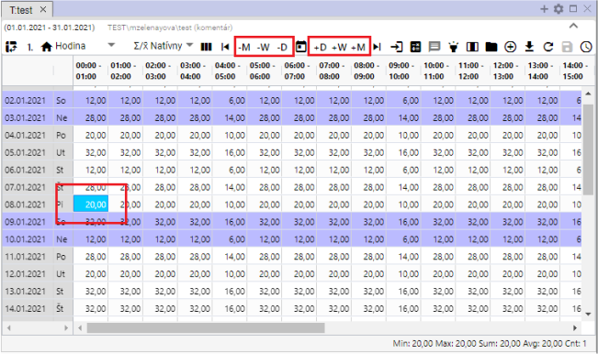

Picture 425: Pressing buttons for shifting a date by one day, week, month

## I add column Sum, Average, Min, Max

Can you add columns?

* "Sum – turns/switches the calculation of daily sum in the table on/off. In the table, a column 'Sum' is added."
* "Default - toggle on/off calculation of daily average values in the table. In the table, a column called 'Average' will be added."
* "Turns on/off the minimum value display for a given day. A column titled „Min“ will be added to the table."
* "Max - toggles display of the maximum value for given values of the day. A new column 'Max' is added to the table."

"The standard table does not contain columns Sum, Average, Min and Max. To add them proceed:"

1. Press the "Regulatory Statistics" button at the top of the table window.
2. "A window will appear in which you select which columns should be shown."
3. "You can pin the columns to the right side of the table by clicking on the field „Pinned to the right“. If you do not select the item „Pinned to the right“, the columns Sum, Average, Min and Max will be added at the end of the table. If you do select the item, the selected columns will be pinned to the right side of the table."

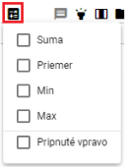

Picture 426: Emergency Statistics Button

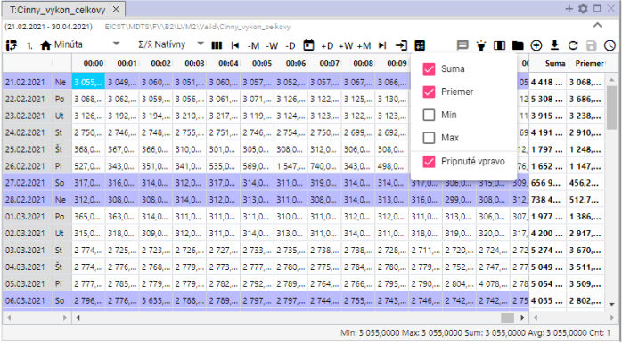

Picture 427: Linked columns "Sum" and "Mean"

## To turn on/off tooltips

The standard display of tooltips in the table is turned off. You can turn it on by clicking the "Turn on/off tooltip" button located in the top right corner of the window Table. If you want to show values (tooltip) for a specific place in the table, move your mouse cursor over the chosen location. To hide the tooltip again, click the "Turn on/off tooltip" button once more.

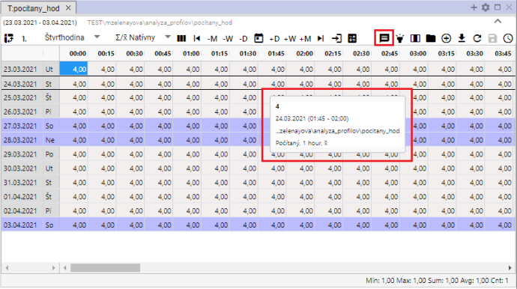

Picture 428: Tooltip image shown in table

## To turn on/off line highlighting

Highlighting a line means that the line will be highlighted if you place the cursor on it with your mouse. If the "Turn line highlighting On/Off" button is black, highlighting is turned on. The button is off when it's gray.

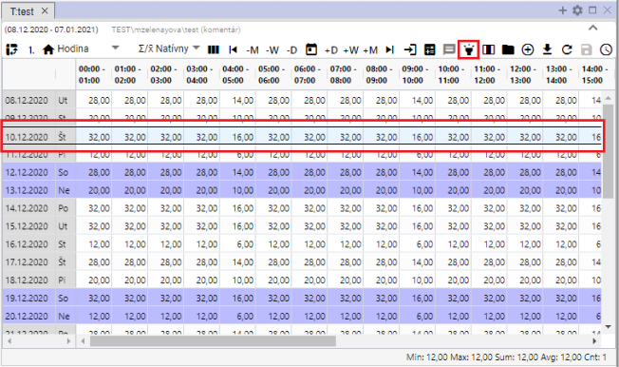

"Picture 429: The toggle switch for turning line highlighting on/off and the highlighted row"

## "Adjust the profile value in the table"

"The values of the stored profile can be adjusted in the window Table. The calculated profile cannot be changed."

Proceed:

1. "Click to select a cell in the Table window."

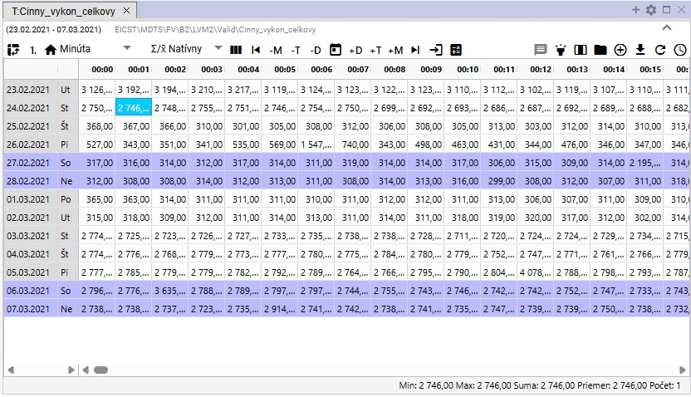

Picture 430: Selection of a bunker

1. Click twice on the bunker and enter your value.

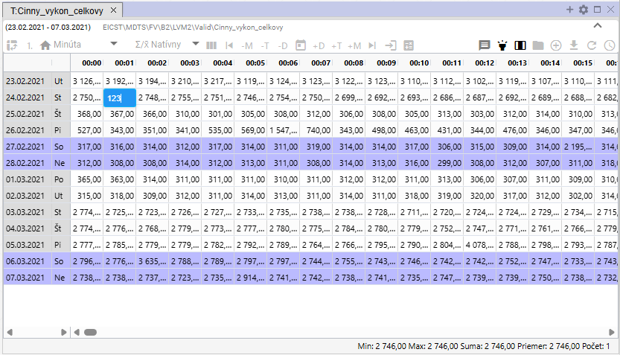

Picture 431: Inserting value

1. Click on another cell in the table after value adjustment. The floppy disk icon button will become active.

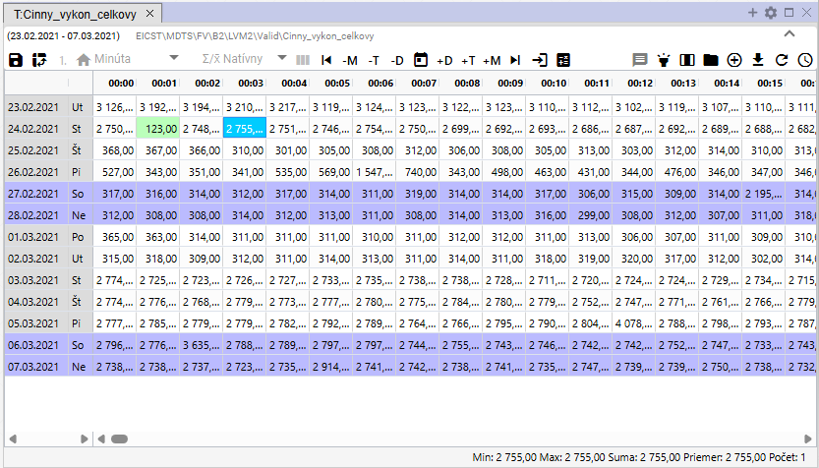

Image 432: Updated value in table

1. You save the changes by pressing the button "Save changed values", which is located in the top part of the Tabulator window.



Picture 433: Save changed values button

## Change profile definition

You can adjust the definition of the calculated profile in the Table window. Proceed:

1. "Click on the right mouse button on the profile in the Tabuľka window."
2. "A window will appear where you select the item 'Edit definition'."

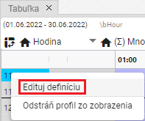

Picture 434: Edit Definition Item

1. The window "Change definition of profile" will appear.

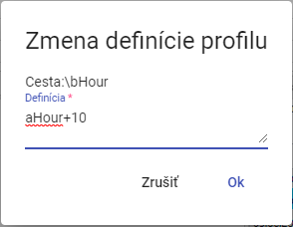

Picture 435: Window "Change Profile Definition"

1. "Adjust the definition and confirm by pressing the 'OK' button."

## I will remove the profile from the table.

"Before removing your profile, proceed with:"

1. Click on the right mouse button on the row of the profile you want to remove.
2. "A window will appear where you select the item 'Remove profile from view'."

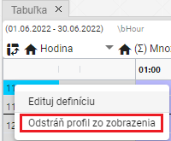

Image 436: Remove profile from display

1. His profile was removed from the window "Table".

## How to activate automatic column width settings

"Normally cells in a table have fixed width. With the button "Automatic column width setting", Image 437, you can set it up so that the entire content of a cell is visible, Image 438."

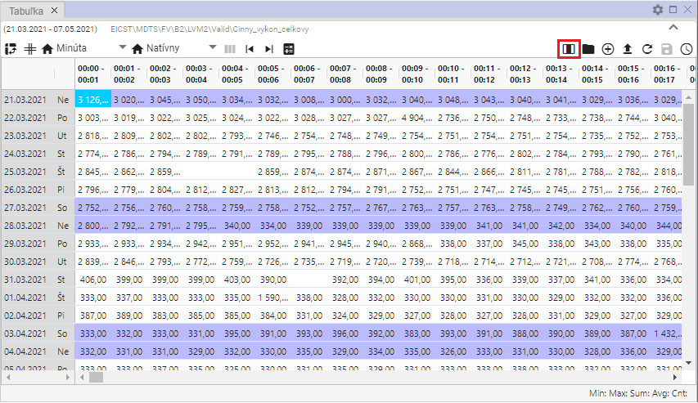

Image 437: Button "Set column width automatically"

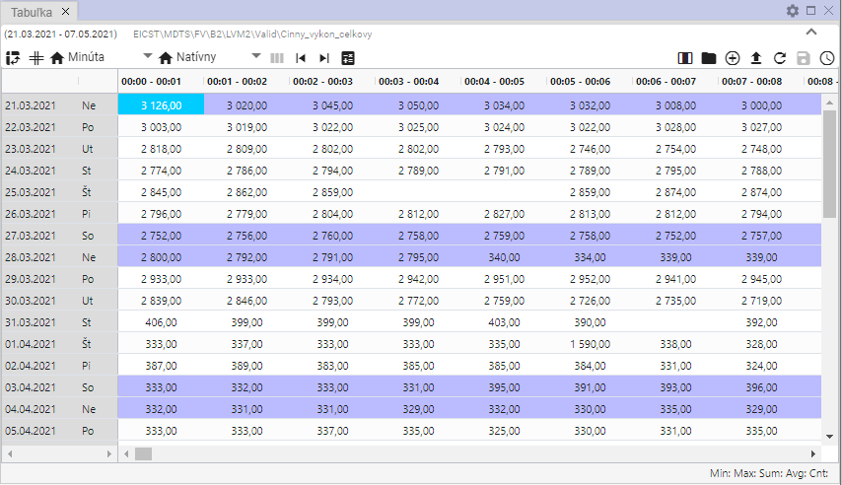

Picture 438: Auto-width column settings are on

## When opening profile settings

"Button 'Open profile settings', Picture 439, serves for opening the profile from a table window in a tree structure, Picture 440."

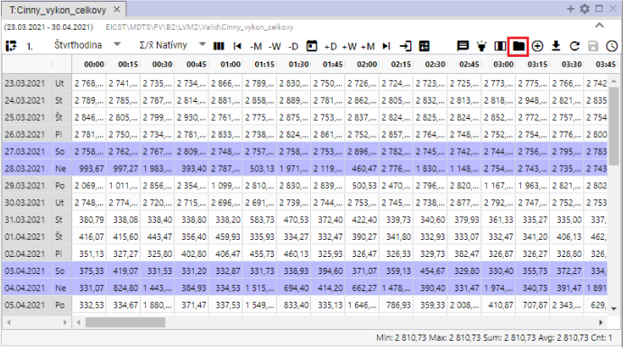

Image 439: Button "Open profile placement"

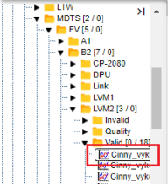

Picture 440: Opening profile in a network structure

## Add Profile

"Before adding the profile to the window 'Table' proceed:"

1. "Click on the button 'Add profile', which can be found in the top-right corner of the window 'Table'."

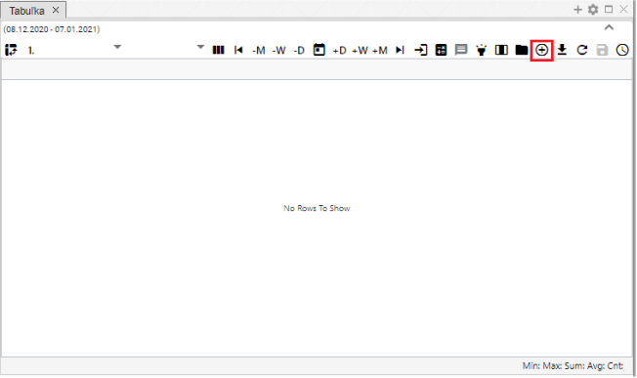

Image 441: Add Profile Button

1. "A window titled 'Add profile' will appear, where you can enter the path to a profile in a tree structure or click a button and a window titled 'Select profile' will appear."

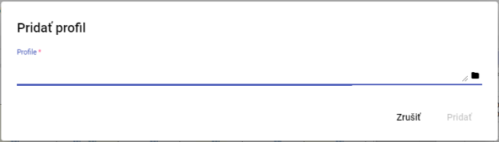

Image 442: Add Profile Window

1. "In the 'Profile selection' window, search for the profile and click the 'Select' button."

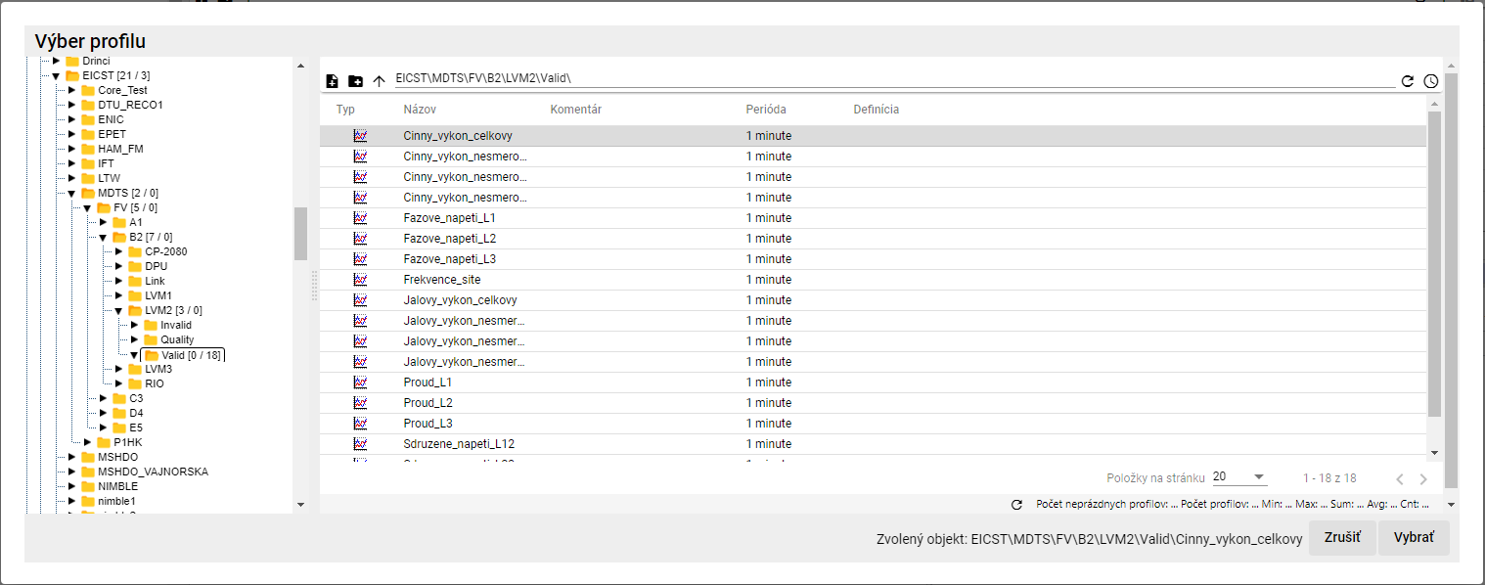

Image 443: Profile selection window

1. "In the window 'Add profile' will be displayed a path to the profile."

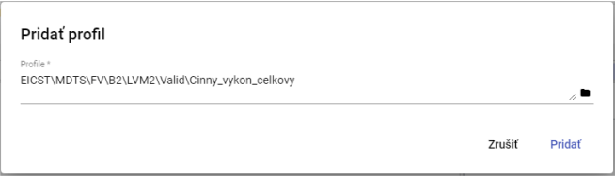

"Image 444: Path to Profile"

1. Confirm by pressing the "Add" button.
2. "In the window 'Table' will appear additional profile."

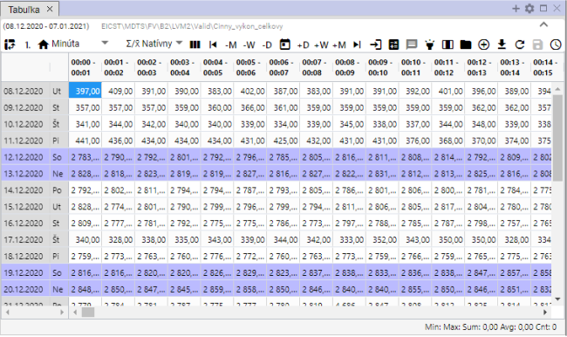

Image 445: Added profile in window "Table"

1. **[TRANSLATION FAILED AFTER 3 RETRIES] Ak je v tabuľke zobrazený profil a pridáte ďalší profil, automaticky sa zapne multiprofilové zobrazenie.**

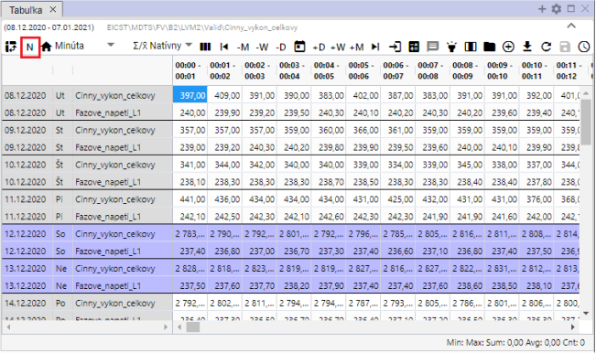

Image 446: Multifunctional display

## How to Export shown data to CSV

"The data shown in the 'Table' window can be downloaded by clicking on the 'Export shown data to CSV' button. A file then downloads, Image 448."

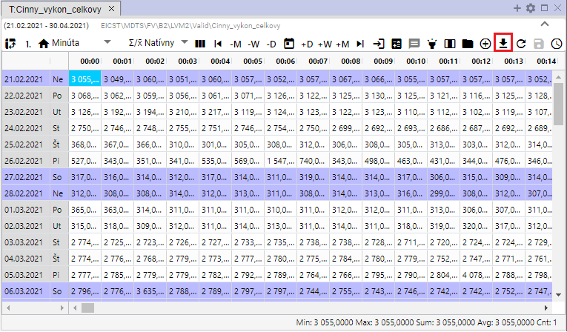

Image 447: Button "Export shown data to CSV"



Image 448: Downloaded Export

## I want to change the definition

You can edit the definition before calculation:

1. **[TRANSLATION FAILED AFTER 3 RETRIES] Kliknite pravým tlačidlom myši na ktorúkoľvek bunku v tabuľke.**
2. "A selection will be shown where you can choose the item 'Change definition'."

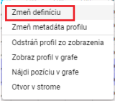

Image 449: Entry "Change definition"

1. "A window titled ‘Change Profile Expression’ will appear, where you can edit the definition of the calculated profile."

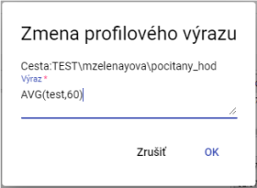

Picture 450: Window "Change Profile Expression"

1. Changes will be saved by pressing the "OK" button.

## Change profile metadata

Proceed:

1. "Click on the right mouse button on the cell in the table."
2. "An offer will be shown where you click on the item 'Change profile metadata'."

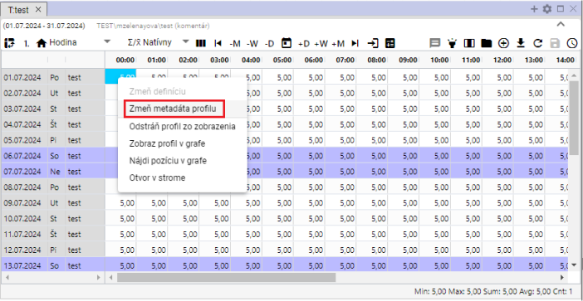

Image 451: Item "Change profile metadata"

1. "A window called 'Edit Profile' will appear."

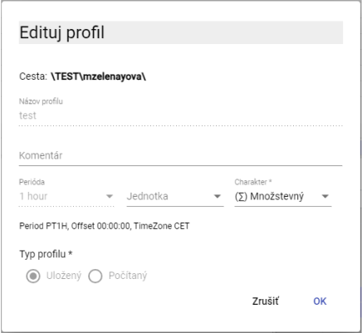

Image 452: Edit profile window for saved profile

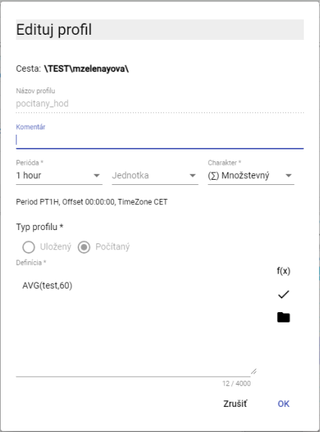

Image 453: Edit Profile window for calculated profile

1. You can edit fields: Comment, Unit and Character for the pre-stored profile. For the calculated profile you can also edit the field "Definition".
2. Changes will be saved by pressing the "OK" button.

## "Remove profile from view"

"Before profile deletion from table:"

1. **[TRANSLATION FAILED AFTER 3 RETRIES] Kliknite pravým tlačidlom myši na ktorúkoľvek bunku v tabuľke.**
2. "An offer will be displayed where you select 'Remove profile from view'."

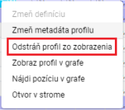

Image 454: Remove profile from view option

1. The profile has been removed from the table.

## Show profile in graph

If you want to display the profile from the table as a graph, proceed:

1. "Click on the window title bar where you want to display the graph. This will make that window active. If a table window is active, the graph will be displayed in the table window."

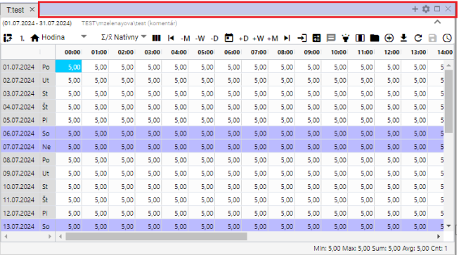

Picture 455: Active window

1. "Click on any cell in the table with the right mouse button."
2. "An offer will appear where you select the item 'Show profile on graph'."

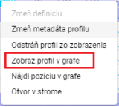

Profile picture: Item "Show profile in graph"

1. "In the active window, a new tab will be added with graph display."

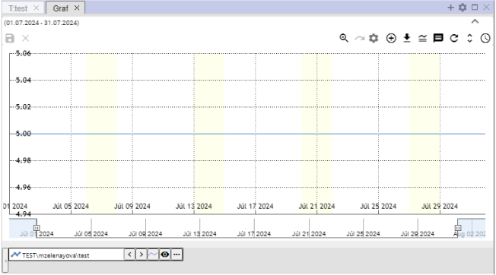

"Image 457: Displaying profile from table in graph"

## How to find position on graph

Proceed:

1. Show profile in table as well as in graph.
2. Click the right mouse button on the cell in the table/where you want to show in the graph.
3. "The offer will be displayed, where you select the item 'Find position in chart'."

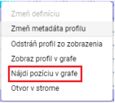

Image 458: Item "Find Position on Graph"

1. In the graph, a location representing a cell from the table will be displayed. The graph will move so that the selected location is in the center of the graph. A line will appear in the center of the graph after one second.

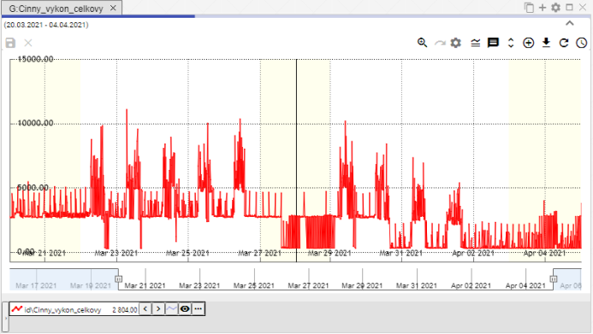

"Image 459: A line in the center of the graph will be displayed, representing a selected cell from the table"

## To open a profile on the train

"Before opening the profile in stream:"

1. "Click on the right mouse button on any cell in the table window."
2. "The offer will open, where you choose the item 'Open in stream'."

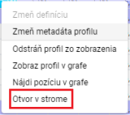

Image 460: Item "Gap in the Wire"

1. "In the stream it will open an address book, in which the profile shown in the table is located."

## Select block using left mouse button

"Click on the chosen cell in the table with the left mouse button to mark a block in the table. Hold down the left mouse button and select the block."

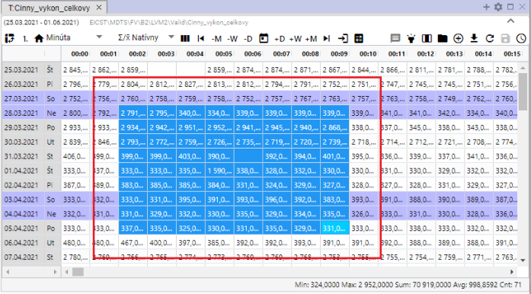

Image 461: Cell identification in table

## "To set up so that a cursor is moving within the table by means of a mouse wheel"

In the table you can navigate using your mouse cursor. The navigation is one day at a time. You may also navigate outside of the set range in the table. It's necessary to have an active cell set in the table.

Follow instructions:

1. "Click on the 'Settings' button, which is located in the top bar of the application."



Picture 462: Settings button

1. "A window called 'Settings' will appear."
2. Click on the item "Wheel moves cursor" in the section "Tablet".

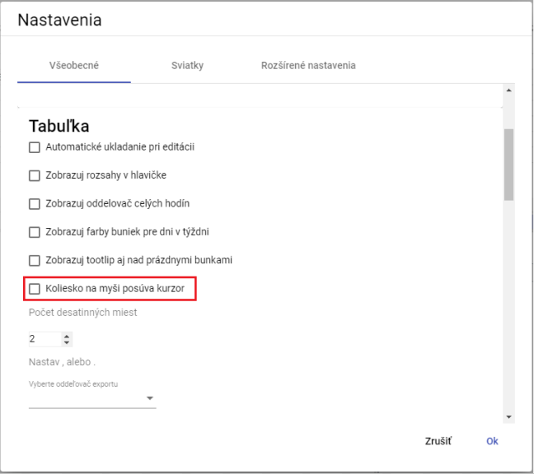

Image 463: Item "Wheel on mouse moves cursor"

1. Press the "OK" button.
2. "Then move the cursor in the table by using the mouse wheel. The cursor is an active cell in the table. This cell has a blue color."

"If the box labeled 'Mouse wheel moves cursor' was not checked, moving the mouse wheel moves rows in the table."

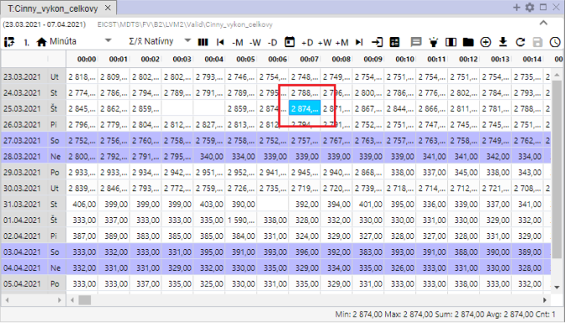

Image 464: Active cell in table

## "How to change the order of profiles in the table"

"Before changing the profile order in the table, it's necessary to switch the display to columns. Each profile represents one column. The order of columns can be changed. After changing the column order, you can turn the display back to rows again."

Proceed:

1. "Show requested profiles in the table."
2. Press the button "Switch to column view".

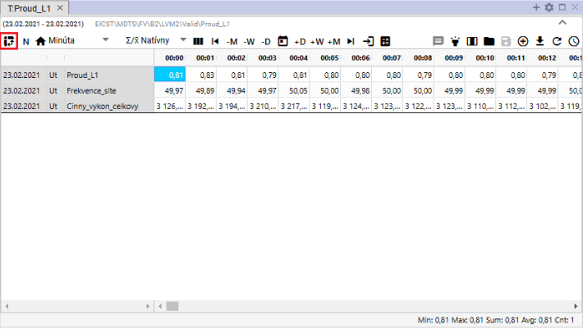

Picture 465: Button "Switch to column display"

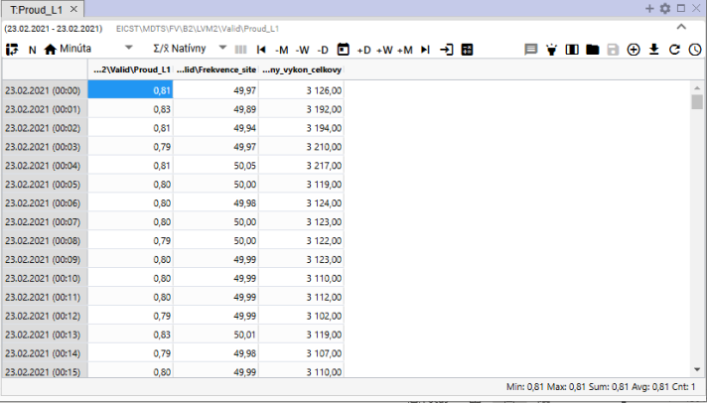

Picture 466: Column chart in a table

1. "Click on the column header with your left mouse button and drag the column to its desired location. Then release."

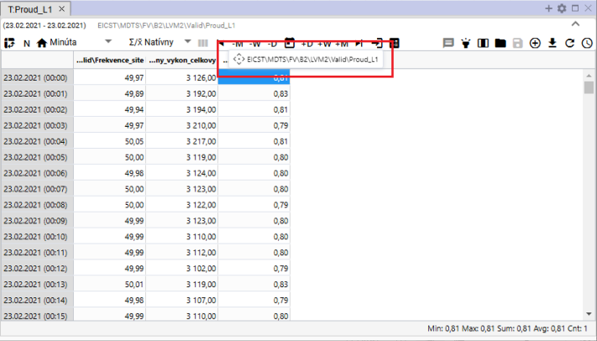

Image 467: Pressing of the pillar

1. "After the column has been moved, you can switch back to the grid display of profiles."

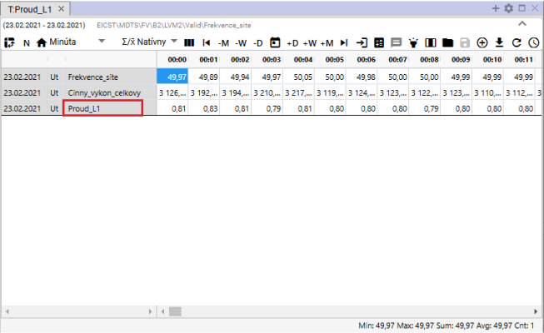

Picture 468: Altered order of profiles

# Arithmetic counted profiles

## Precautionary rules

"In arithmetic operations with profiles that have different periods, their calculation leads to carry-over. This carry-over has its own rules, which mainly depend on the character of the input profiles set for the operation. Detailed carry-over rules are described in the following text."

### The rules of converting input profile to output with considering character.

Example: Output_profile := input_profile1 + input_profile2 * input_profile3 ...

1. "If the input profile is within an aggregate function (avg, sum, min, max, count) or cp(), then its sampling is determined explicitly by its parameter and the following rules are not considered."
2. "If not, then the input profile is still substituted for sampling of output profile according to the following rules:"
3. This character is considered default and was looked at before the introduction of characters.
4. "If the input and output profiles are identical, there is no distortion and neither character is taken into account at all. Values are copied 1:1."
   1. "They have different profiles and we want to convert between them, so we need to do it manually using a pattern in the profile arithmetic. The most common is conversion from ¼-h power to ¼-h energy by input_profile / 4"
5. Different periods of entry and exit will be synchronized.
   1. "Down-sampling: it involves sampling from finer to coarser sampling."
6. "In bulk quantities, an aggregation using SUM will be used"
7. During operations, aggregation will be used through AVG.
8. Up-sampling: it up-samples from a coarser to finer sampling.
9. At the population level before exit, the input value is multiplied by the ratio of the output and input periods.
10. The input value multiplies itself (unchanged) under certain conditions.
11. In preprocessing, only the character of the input profile is considered. The output character is not taken into account at all.

## Calculated profile

"Create your profile according to the following procedure:"

1. In the address list, click the right mouse button on the name of the recipient where you want to create a new counted profile. A window will appear with options, place the cursor of the mouse on the item "New" and select "Profile", Figure 469. The "New Profile" window will open, Figure 470.

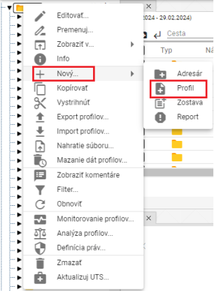

Image 469: Item "Profile"

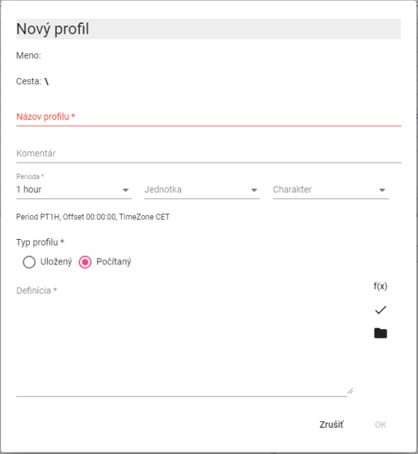

Image 470: Window for creating calculated profile

1. In the field "Name of profile" enter the name for the profile. The name of the profile must start with a letter, and may then contain digits and underscore "_". The name of the profile may not exceed 22 characters. The profile is designated by its name, or optionally by specifying a path to the profile and name (path\profile).
2. You can submit a comment.
3. Choose period, unit and character.
4. Choose "Calculated" in the section "Profile Type".
5. "In defining the calculated profile we can use buttons:"
6. **[OLLAMA FORMATTING ERROR - MANUAL REVIEW NEEDED] ak chceme pracovať so štandardnými funkciami pre počítaný profil**
7. **[OLLAMA FORMATTING ERROR - MANUAL REVIEW NEEDED] ak chceme použiť v definícii iný uložený alebo počítaný profil. Pre počítaný profil môžeme použiť v definícii aj iný počítaný profil.**
8. You will create a profile by pressing the "OK" button.

My profile is designated by the name, optionally by specifying the path to the profile and its name (path/profile).

* "You can also use plugin functions (described later) in the profile calculated before."

Warning

"Vo versions of Xenergie G2, it is not possible to create Oracle profiles. According to the specifics of a particular implementation of Xenergie G2, it is possible to preserve their backward compatibility."

### Method of notation

"We define the calculated value in the window 'Definition'."

The name of the profile must start with a letter, then it can also contain digits and an underscore character "_". The name of the profile may contain up to 22 characters. The profile is identified by its name, possibly by specifying the path to the profile and its name (path/profile).

"In creating definitions, there is no distinction between uppercase and lowercase letters."

Examples:

**[OLLAMA FORMATTING ERROR - MANUAL REVIEW NEEDED] \cez**

A link to your profile on Google Drive.

**[OLLAMA FORMATTING ERROR - MANUAL REVIEW NEEDED] ..\cez**

"link to profile above the address book by one level"

**[OLLAMA FORMATTING ERROR - MANUAL REVIEW NEEDED] ..\..\oprava\cez**

A link to the profile above level of address by more than 2 levels in the subaddresser "repair"

**[OLLAMA FORMATTING ERROR - MANUAL REVIEW NEEDED] 100**

The profile will contain a value of 100 for the entire time period.

The number format is [-]n.nnnE[-]e.

The expression may contain spaces, tables and new line characters. These are ignored.

### Calculation of an expression

The expression is calculated for the required time period separately for each time (hour, minute).

The profile at the time of calculation does not have a value, work is being done with an invalid value.

"If any of the values entering into an operation +, -, *, /, >, <, >=, <=, =, !=, |, &, ! is invalid, then result is an invalid value."

Division by zero produces an invalid value.

"The program calculates all values, even though they are not necessarily necessary, so for example alt(100.0,unknown_profile) is an incorrect expression"

### Arithmetic operations:

* Counting (plus plus)
* Subtraction - --
* Multiplication * **
* Division by //
* **[TRANSLATION FAILED AFTER 3 RETRIES] Zátvorky ()**

Operation are numbered from left to right. The highest priority have (), then "*", "**", and "/", "//".

"The operations '++', '--', '**', '//' replace the invalid value with the value 0."

### Functions

By clicking on the button a window will open where you can select one of the standard functions. The functions are stored in categories:

* Aggregative functions
* Alternative
* **[OLLAMA FORMATTING ERROR - MANUAL REVIEW NEEDED] Kompozičné funkcie**
* **[OLLAMA FORMATTING ERROR - MANUAL REVIEW NEEDED] Podmienené**
* **[OLLAMA FORMATTING ERROR - MANUAL REVIEW NEEDED] Zastarané funkcie**
* **[OLLAMA FORMATTING ERROR - MANUAL REVIEW NEEDED] Iné**
* **[OLLAMA FORMATTING ERROR - MANUAL REVIEW NEEDED] Funkcie zaokrúhľovania**
* **[OLLAMA FORMATTING ERROR - MANUAL REVIEW NEEDED] Funkcie znaku**

"After selecting a category, a list of functions will open with a guide to the functions."

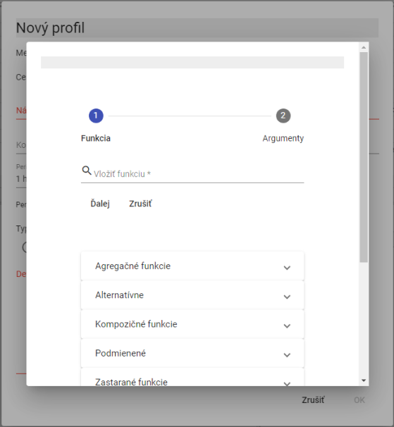

Picture 471: List of functions

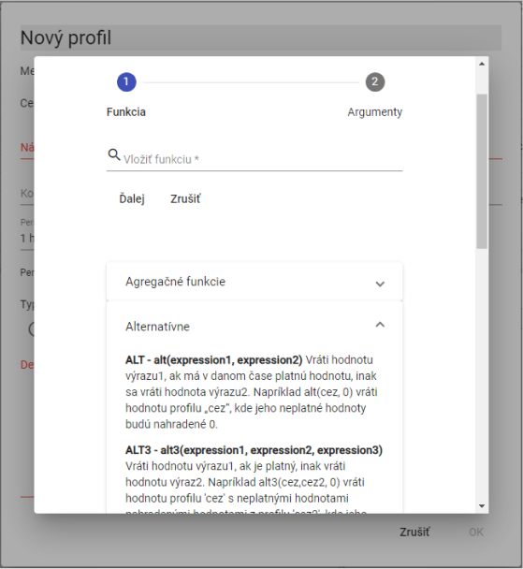

"Image 472: List of functions with guidance to features"

#### Aggregative functions

Aggregate functions have two parameters.

1. **[OLLAMA FORMATTING ERROR - MANUAL REVIEW NEEDED] profil – názov profilu,**
2. **[OLLAMA FORMATTING ERROR - MANUAL REVIEW NEEDED] perióda – perióda, s ktorou sa má daná funkcia počítať. Perióda sa zadáva nasledujúcimi konštantami (pre počítanie v platnom čase sú konštanty začínajúce písmenom „P“):**

Constants for setting period are necessary to be entered always in capital letters.

**[OLLAMA FORMATTING ERROR - MANUAL REVIEW NEEDED] D, PD – denná perióda (v SEČ a v platnom čase – v lete v LSEČ)**

**[OLLAMA FORMATTING ERROR - MANUAL REVIEW NEEDED] W, PW – týždenná perióda /týždeň začína v pondelok a končí v nedeľu/**

**[OLLAMA FORMATTING ERROR - MANUAL REVIEW NEEDED] E, PE – týždenná perióda /týždeň začína v sobotu a končí v piatok/**

**[OLLAMA FORMATTING ERROR - MANUAL REVIEW NEEDED] M, PM – mesačná perióda**

**[OLLAMA FORMATTING ERROR - MANUAL REVIEW NEEDED] Q, PQ – štvrťročná perióda**

**[OLLAMA FORMATTING ERROR - MANUAL REVIEW NEEDED] Y, PY – ročná perióda**

"We can enter the period in minutes into calculated profiles. It does not have to be entered as an abbreviation."

**[OLLAMA FORMATTING ERROR - MANUAL REVIEW NEEDED] sum(profil, perioda)**

"Synchronization with the given period in CET."

(Period: D, W, E, M, Q, Y, while in calculated profiles, period can be entered in minutes.)

"Note that we calculate the function sum(summarization, M) with a one-hour period of measurement profile. The resulting profile will include the sum of values of the measurement profile for each given month."

**[OLLAMA FORMATTING ERROR - MANUAL REVIEW NEEDED] avg(profil, perioda)**

Standardization with given period in CET

We will now calculate the function avg(temperature, 60), where the temperature profile has a minute period. In the resulting profile we will get hourly averages of temperature.

**[OLLAMA FORMATTING ERROR - MANUAL REVIEW NEEDED] min(profil, perioda)**

The minimum value for a period in CET.

"For each period, the minimum value is calculated."

**[OLLAMA FORMATTING ERROR - MANUAL REVIEW NEEDED] max(profil, perioda)**

Maximum value during period. Function works in CET (Central European Time).

"Before each period, one calculates the maximum value."

**[OLLAMA FORMATTING ERROR - MANUAL REVIEW NEEDED] csum(profil, perioda)**

Cumulative summation of profile values on time units given by the parameter period. The output profile at a given time point provides a value which is the sum of all preceding input profile values, from the start of the time interval (defined by the parameter period) up to and including the specific time point.

"By definition, the output profile with a daily period defined as 'csum(profil_vstup, PD)' will have in each day, at its last hour (in standard time), a value equal to the total sum for this entire day)."

**[OLLAMA FORMATTING ERROR - MANUAL REVIEW NEEDED] pavg(profile,perioda)**

"Simulation with given period in real time."

**[OLLAMA FORMATTING ERROR - MANUAL REVIEW NEEDED] pcsum(profile, perioda)**

Scheduling with given period. Function works in real time.

At any moment, the value at time t is determined by the sum of values from the start of the period up to time t.

**[OLLAMA FORMATTING ERROR - MANUAL REVIEW NEEDED] pmax(profile,perioda)**

"The maximum value during the period of full time."

**[OLLAMA FORMATTING ERROR - MANUAL REVIEW NEEDED] pmin(profile,perioda)**

"The minimum value within the period in continuous time."

**[OLLAMA FORMATTING ERROR - MANUAL REVIEW NEEDED] psum(profil ,perioda)**

"Scheduling with given period in real time."

(Period: D, W, E, M, Q, Y, while in calculated profiles the period can be entered in minutes.)

The function with P at the beginning of the command causes the time to be divided into intervals that are intended to be accumulated.

"P means Valid Time, which during summer switches from UTC+1 to UTC+2."

Functions PSUM, PAVG, PMIN, PMAX are outdated. (others, such as PHOUR, PDAY, PTDIV, ...) are not.)

We recommend using instead functions without P in their name and to use P as a time parameter prefix.

Instead of using the term PAVG(profile, X), we recommend using AVG(profile, PX).

"Under the term 'obsolete', we mean that these functions are no longer recommended for use when setting up new calculations."

"These 'outdated' functions in the system remain as they are. However, their behavior will not be modified."

Functions without P, which we recommend as a replacement, have more comprehensive use and will be gradually extended to new periods.

Old functions can still be used. However, for creating new patterns, we recommend using the newer universal versions instead.

#### Alternative

**[OLLAMA FORMATTING ERROR - MANUAL REVIEW NEEDED] alt(vyraz1,vyraz2)**

**[OLLAMA FORMATTING ERROR - MANUAL REVIEW NEEDED] alt3(vyraz1,vyraz2,vyraz3)**

**[OLLAMA FORMATTING ERROR - MANUAL REVIEW NEEDED] ...**

**[OLLAMA FORMATTING ERROR - MANUAL REVIEW NEEDED] alt9(vyraz1,vyraz2,...,vyraz9)**

That expression1 does not have a valid value, the calculation continues with expression2 and if that one also doesn't have a valid value, then another expression will be used...

**[OLLAMA FORMATTING ERROR - MANUAL REVIEW NEEDED] alt(vyraz1,vyraz2)**

"The expression 1 does not have a valid value, it takes expression 2."

Alt(DGC2000_cez, 0)

"The profile "...cez" does not have a valid value, the function will use the value 0 in processing."

**[OLLAMA FORMATTING ERROR - MANUAL REVIEW NEEDED] alt3(výraz1, výraz2, výraz3)**

This expression 1 does not have a valid value, the expression 2 will be used; if neither of those has a valid value then expression 3 will be taken.

"Alternative functions can sometimes be suitably replaced by:"

**[TRANSLATION FAILED AFTER 3 RETRIES] Príklad:**

**[OLLAMA FORMATTING ERROR - MANUAL REVIEW NEEDED] alt(dodavatel1,0)+alt(dodavatel2,0)**

Do something instead

Supplier1+Supplier2

"Sum two profiles by replacing an invalid value with 0."

**[TRANSLATION FAILED AFTER 3 RETRIES] Príklad:**

Alt(Ceze,Alt(Cez2,0))

or

Altitude (in feet) between ceilings cez and cez2 with respect to sea level.

"An invalid value in profile "cez" will be replaced by a value from the "cez2" profile. If "cez2" does not contain a valid value either, the value 0 will be used. The second variant is, of course, more effective."

#### Error containment / error suppression

**[OLLAMA FORMATTING ERROR - MANUAL REVIEW NEEDED] nv()**

A function that returns an empty (invalid) value. (NO_VALUE). All operations with invalid values produce an invalid value.

Examples:

**[OLLAMA FORMATTING ERROR - MANUAL REVIEW NEEDED] nv()**

**[OLLAMA FORMATTING ERROR - MANUAL REVIEW NEEDED] nv()+100**

The result will be a profile containing invalid values. (Not containing any values)."

"On good terms (with)"

If there's an error when acquiring the profile values (for example, it doesn't exist), the result is invalid values. If the VALID function isn't used and the provided profile doesn't exist, the program will display an error message (the definition of the calculated profile is incorrect) and the expression won't be executed.

Example

**[OLLAMA FORMATTING ERROR - MANUAL REVIEW NEEDED] test**

or

**[OLLAMA FORMATTING ERROR - MANUAL REVIEW NEEDED] alt(test,0)**

If the profile is wrong ("test") (or doesn't exist), the program will notify an error when entering the following expressions.

"If the profile 'test' becomes incorrect after entering this term, an error message will be displayed in the information window of the resulting profile."

Example

"valid test"

The resulting profile will be fine, but it won't contain a valid value.

If (test is valid, 0)

The resulting profile will be okay and will contain values of 0.

#### Simple condition

**[OLLAMA FORMATTING ERROR - MANUAL REVIEW NEEDED] cond(logicky_vyraz,vyraz1,vyraz_nepravda)**

If the expression is logically correct, then expression1 will be executed. If it's false or has an invalid value, expression_false will be executed.

A logical expression may contain

* Expressions and numerical values
* Comparison operators : “>”, “<”, “>=”, “<=”, “=”, “<>”

logical expressions can be connected using logical operations.

* Logical product (and at the same time): &
* logical sum (or): |
* "Negotiation: !"

The evaluation order of logical operations is: !, &, | and we can adjust it using ( ).

Example:

Select between cezar and cez in case of equality (i.e., when both values are 0).

"All values below zero in the profile will be replaced by a value of zero."

Example:

COND(Cez=Cez, 1, 0)

"The account profile contains a valid value, if so the result will be 1, otherwise the result will be 0."

**[TRANSLATION FAILED AFTER 3 RETRIES] Príklad:**

If(0 <= x AND x <= 1000), no_value, otherwise

If(0 <= cez AND cez <= 1000), cez, ""

The resulting profile in both cases will not contain values less than 0 and greater than 1000. Parentheses in these cases are not necessary.

#### Multiple condition

**[OLLAMA FORMATTING ERROR - MANUAL REVIEW NEEDED] cond2(logický_výraz1, výraz1,logický_výraz2, výraz2, výraz_nepravda)**

**[OLLAMA FORMATTING ERROR - MANUAL REVIEW NEEDED] ...**

**[OLLAMA FORMATTING ERROR - MANUAL REVIEW NEEDED] cond9(logický_výraz1, výraz1,…logický_výraz9, výraz9, …výraz_nepravda)**

"If logical_expression1 is true, execute expression1; if logical_expression2 is true, execute expression2; ... if none of the logical_expressions are true, execute false_expression."

Example:

**[TRANSLATION FAILED AFTER 3 RETRIES] cond(real<zjed*1.02,1,cond(real<zjed*1.05,1.1,1.2))**

**[TRANSLATION FAILED AFTER 3 RETRIES] cond2(real<zjed*1.02,1,real<zjed*1.05,1.1,1.2)**

**[TRANSLATION FAILED AFTER 3 RETRIES] V obidvoch prípadoch, ak je hodnota profilu real menšia ako 102 % hodnoty profilu zjed, vráti hodnotu 1, ak je väčšia ako 102 % a menšia ako 105 %, vráti hodnotu 1.1, inak vráti 1.2 .**

#### Accounting functions

**[OLLAMA FORMATTING ERROR - MANUAL REVIEW NEEDED] day(výber_dní)**

The output is a profile containing units and zeros. The function will write 1 for those days of the week specified in the argument. The function works in standard time. A day of the week is identified by the digit in order: Monday (1), Tuesday (2), Wednesday (3), Thursday (4), Friday (5), Saturday (6) and Sunday (7).

"Entry day (136) creates a 0-1 profile that will have units on Mon (1), Wed (3), and Sun (6)."

**[OLLAMA FORMATTING ERROR - MANUAL REVIEW NEEDED] hour(výber_hodín)**

The output is a profile containing units and zeros. The function returns 1 for hours of the day specified in the argument. The function works in UTC.

"Record for calculated profile: hour(1, 5 - 10, 18, 24) will record the value 1 for hours 1, 5, 6, 7, 8, 9, 10, 18 and 24."

**[OLLAMA FORMATTING ERROR - MANUAL REVIEW NEEDED] month(výber_dní)**

"The output is a profile containing units and zeroes. The function writes 1 for the days of the month listed in the argument. The function works in UTC."

"Entry: month(1, 3, 10 - 13, 30) will return the value 1 for days 1, 3, 10, 11, 12, 13, 30."

**[OLLAMA FORMATTING ERROR - MANUAL REVIEW NEEDED] pday(výber_dní)**

**[TRANSLATION FAILED AFTER 3 RETRIES] Výstupom je profil obsahujúci jednotky a nuly. Funkcia vráti 1 pre tie dni v týždni, ktoré sú uvedené v argumente. Funkcia pracuje v platnom čase. Deň v týždni je identifikovaný číslicou v poradí: Po(1), Ut(2), St(3), Št(4), Pi(5), So(6) a Ne(7).**

"Entry: Friday (March 13th) will return such a 0-1 profile, which will have units on Monday (1st), Wednesday (3rd) and Sunday (6th)"

The function works during business hours.

**[OLLAMA FORMATTING ERROR - MANUAL REVIEW NEEDED] phour(výber_hodín)**

The output is a profile containing units and zeroes. This function writes 1 for the hours of day that are specified in the argument. This function works in real time.

"Log entry: phour(1, 5 - 10, 18, 24) returns value 1 for hours 1, 5, 6, 7, 8, 9, 10, 18 and 24."

The function works within office hours.

**[OLLAMA FORMATTING ERROR - MANUAL REVIEW NEEDED] pmonth(výber_dní)**

"The output is a profile containing ones and zeros. The function returns 1 for the days in the month that are listed in the argument. The function works in real time."

"Note: pmonth(1, 3, 10 - 13, 30) returns the value 1 for dates 1, 3, 10, 11, 12, 13, 30."

The function works within business hours.

**[OLLAMA FORMATTING ERROR - MANUAL REVIEW NEEDED] ptdiv(výraz0, čas1,výraz1,...., časX, výrazX )**

"Profile creation according to time. Until time t1 it uses the profile values of expression0, from t1 inclusive to t2 it uses the profile values of expression2, ..., from tX inclusive use the profile values of expressionX."

"The time is entered in the format DD.MM.RR[RR] [HH:MM]. The year can be entered either fully (1990-2030), or shortened (00-30, 90-100)."

The function ptdiv operates in working hours.

**[OLLAMA FORMATTING ERROR - MANUAL REVIEW NEEDED] tdiv(výraz0, čas1,výraz1,...., časX, výrazX)**

"Profile creation according to time. Until time time1 uses the profile values of expression0, from time1 inclusive until time2 uses the profile values of expression2, ..., from timeX inclusive will use the profile values of expressionX."

The time is set in the format DD.MM.YYYY[YY] [HH:MM]. The year can be entered in full form (1990-2030), but also shortened (90-100, 00-30).

The IT department works from noon (or 12:00 PM) onwards.

**[OLLAMA FORMATTING ERROR - MANUAL REVIEW NEEDED] vdiv(vstupny_výraz, výraz0, hodnota1, výraz1,... hodnotaX, výrazX)**

"Profile creation based on value. If the input_expression is smaller than value1, it is replaced by expression0. If it is larger (equal to) than value1 and smaller than value2 it is replaced by expression1, ... . If it is larger (equal to) than valueX it is replaced by expressionX."

Before calculation, the profile function assigns the value NO_VALUE to itself.

#### Smoothing functions

The parameter počet_desatinných_miest determines the position to which rounding occurs. If this number is positive - we round to units, tens, ..., for negative numbers we round to tenths, hundredths...

"If the decimal places represent number 2, then rounding functions will round to whole tens."

**[OLLAMA FORMATTING ERROR - MANUAL REVIEW NEEDED] round(výraz, počet_desatinných_miest)**

"Mathematical rounding (from top 5 absolute value). If the parameter number_of_decimal_places = 0, the number 1.5 rounds to 2. The number -1.5 rounds to -2."

**[OLLAMA FORMATTING ERROR - MANUAL REVIEW NEEDED] roundup(výraz, počet_desatinných_miest )**

"Rounding always upwards in absolute value. If the parameter number_of_decimal_places = 0, the number 1.1 rounds to 2. The number -1.1 rounds to –2."

**[OLLAMA FORMATTING ERROR - MANUAL REVIEW NEEDED] trunc((výraz, počet_desatinných_miest )**

"Rounding of the specified number of decimal places. If the parameter number_of_decimal_places is equal to zero, the number 1.1 will be rounded to 1 and the number -1.1 will be rounded to -1."

#### Warning functions

**[OLLAMA FORMATTING ERROR - MANUAL REVIEW NEEDED] abs(výraz)**

The absolute value from every value in the profile.

**[OLLAMA FORMATTING ERROR - MANUAL REVIEW NEEDED] minus(výraz)**

Values greater than 0 will replace 0.

**[OLLAMA FORMATTING ERROR - MANUAL REVIEW NEEDED] plus(výraz)**

Values less than 0 will be replaced by 0.

**[TRANSLATION FAILED AFTER 3 RETRIES] Príklad:**

Conditioned on <condition>, -1 times conditioned on <condition> minus <condition>.

I am like an excuse (for being late)

Example:

"cond(invert<0,0,invert)"

I don't know it's like a minus (odch), though.

**[TRANSLATION FAILED AFTER 3 RETRIES] Príklad:**

Don't touch (the stove).

That is impossible, like a negative number.

# Additional/Supplementary functions

"Additional features are not a standard part of the 'Profile Manager' delivery, but are ordered separately."

## Profile monitoring

The function serves for monitoring profiles. A monitoring task serves for safeguarding profiles. It monitors, for example, that the value in the profile does not drop below zero or is not higher than 100. The following chapters deal with the creation, modification, deletion and export of the monitoring task.

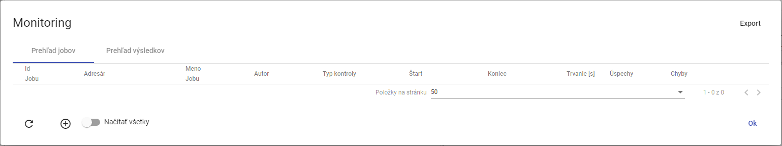

Image 473: Window "Monitoring"

### I want to create a new monitoring job

**[OLLAMA FORMATTING ERROR - MANUAL REVIEW NEEDED] Pre vytvorenie nového monitorovacieho jobu postupujte:**

1. Click with the right mouse button on the folder in the directory structure.
2. "The offer will be shown where you select the item 'Monitoring Profiles'."

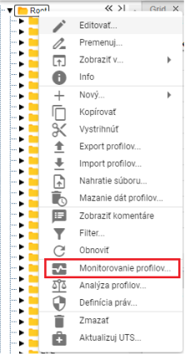

Image 474: Item "Monitoring profiles"

1. The "Monitor" window will appear.
2. "Click the button or right-click on an existing job and select 'Create new job'."

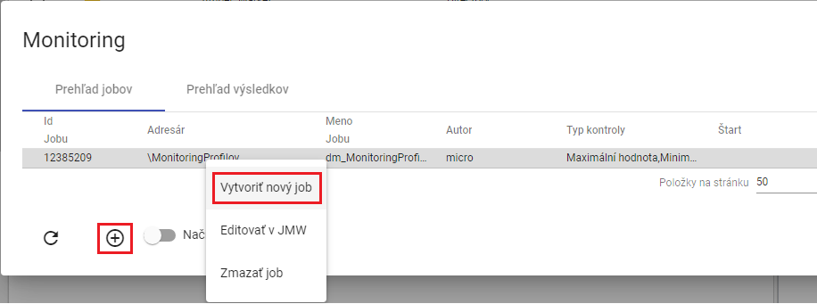

Image 475: Item "Create new job"

1. A window entitled “New monitoring job” will be shown. Explanation of fields:

* **[TRANSLATION FAILED AFTER 3 RETRIES] „Kritériá“ - kritéria podľa ktorých sa profil monitoruje,**
* **[TRANSLATION FAILED AFTER 3 RETRIES] „Zmena hodnoty“ - kritérium kontrolujúce zmenu hodnoty v monitorovanom profile. Profil je monitorovaný v stanovenom časovom intervale, ak sú všetky hodnoty v intervale rovnaké, zobrazí sa chybové hlásenie.( Profile: „Názov profilu“ No change in value in interval 27.3.2017 1:00:00 - 27.3.2017 4:00:00),**
* **[OLLAMA FORMATTING ERROR - MANUAL REVIEW NEEDED] „Monotónne“ - kritérium kontrolujúce monotónnosť hodnôt v monitorovanom profile v stanovenom intervale. Ak sa pri zvolenej stúpajúcej monotónnosti v časovom úseku nachádzajú hodnoty porušujúce stúpajúcu monotónnosť, zobrazí sa chybové hlásenie. (Profile: „Názov profilu“ Monotony condition of the series is not fullfilled at time point 6.4.2017 11:00:00),**
* **[OLLAMA FORMATTING ERROR - MANUAL REVIEW NEEDED] „Stúpajúce“ – kritérium kontroluje stúpavosť. Profil musí stále rásť.**
* **[OLLAMA FORMATTING ERROR - MANUAL REVIEW NEEDED] „Maximálna hodnota“ - kritérium kontrolujúce dosiahnutie maximálnej hodnoty v monitorovanom profile. Ak sa v hodnotách zvoleného profilu v stanovenom časovom intervale nachádza hodnota presahujúca zvolenú maximálnu hodnotu, zobrazí sa chybové hlásenie.(Profile: „Názov profilu“ 1.1.2013 0:00:00 > 14 is larger than allowed max: 8),**
* **[OLLAMA FORMATTING ERROR - MANUAL REVIEW NEEDED] „Minimálna hodnota“ - kritérium kontrolujúce dosiahnutie minimálnej hodnoty v monitorovanom profile. Funguje analogicky ako kritérium maximálnej hodnoty,**
* **[OLLAMA FORMATTING ERROR - MANUAL REVIEW NEEDED] „Chýbajúca hodnota“ - kritérium kontrolujúce počet chýbajúcich hodnôt v monitorovanom profile v stanovenom intervale. Ak počet chýbajúcich hodnôt v stanovenom intervale presiahne parameter „Chýbajuca hodnota“, zobrazí sa chybové hlásenie.(Profile: „Názov profilu“ Interval 1.1.2013 0:00:00 - 2.1.2013 0:00:00 contains 3 empty values.),**
* **[OLLAMA FORMATTING ERROR - MANUAL REVIEW NEEDED] „Rozdielna hodnota“ - kritérium kontrolujúce rozdiel medzi maximálnou a minimálnou hodnotou v monitorovanom profile v stanovenom intervale. Ak rozdiel max a min hodnoty v stanovenom intervale presiahne parameter „Rozdielna hodnota“, zobrazí sa chybové hlásenie.( Profile: „Názov profilu“ Difference in values was 12),**
* **[TRANSLATION FAILED AFTER 3 RETRIES] „Začiatok intervalu (D:H:M:S)“ - je Interval začiatku monitorovania dát v profile. Vzťahuje sa relatívne k času spustenia akcie alebo k zadanému absolútnemu času,**
* **[OLLAMA FORMATTING ERROR - MANUAL REVIEW NEEDED] „Koniec intervalu (D:H:M:S)“ - je Interval konca monitorovania dát. Vzťahuje sa relatívne k času spustenia akcie alebo k zadanému absolútnemu času,**
* **[TRANSLATION FAILED AFTER 3 RETRIES] „Časová zóna“ - je zóna v ktorej sa nachádza server na ktorom beží JMW. Zóna sa zohľadňuje pri posuvnom časovom okne, kedy sa podľa nej určuje lokálny čas spustenia akcie,**
* **[OLLAMA FORMATTING ERROR - MANUAL REVIEW NEEDED] „Zarovnanie“ - voľba zarovnanie umožňuje zarovnať časové okno dát monitorovaného profilu na nasledovné časové obdobia:**
  + **[OLLAMA FORMATTING ERROR - MANUAL REVIEW NEEDED] deň v platnom čase**
  + **[OLLAMA FORMATTING ERROR - MANUAL REVIEW NEEDED] hodinu v platnom čase**

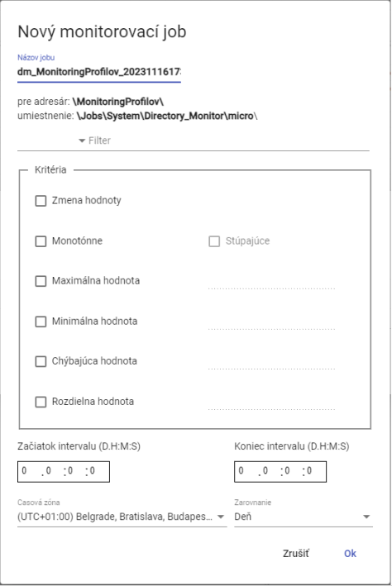

Picture 476: Window "New monitoring job"

1. The name of the job is standardly prefilled. In the field "Name of the job" you can enter a name for the job.
2. "Click on the field to the left of the word 'Filter', a window will appear in which you select the condition for the filter."

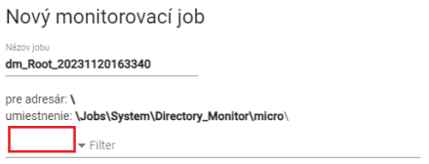

Image 477: Pole for filter selection

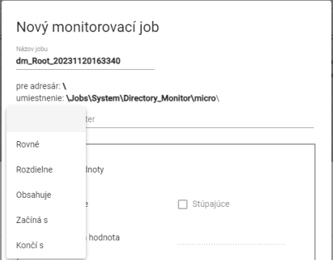

Image 478: Window for selection of conditions into filter

1. **[TRANSLATION FAILED AFTER 3 RETRIES] Kliknite do poľa „Filter“ a zadajte hodnotu pre filter. Napríklad: Začína s písmenom A – bude prechádzať len profily, ktorých názov začína písmenom A.**



Image 479: Pole for entering value for filter

1. In the block "Criteria" set criteria for monitoring.

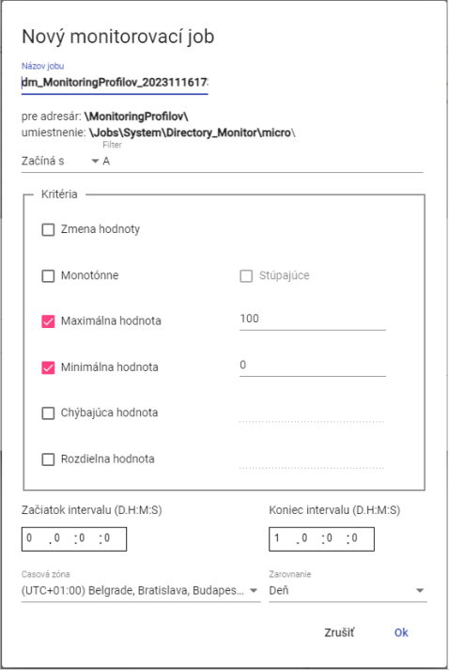

Image 480: Left task

1. Enter the start and end of the interval.
2. You can select time zone and adjust.
3. "Before creating a monitoring job, click on the 'OK' button."
4. In the window "Monitoring" will appear a new monitoring job.

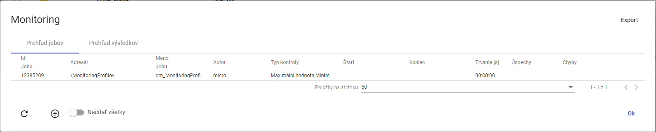

Picture 481: Created monitoring job

### **[OLLAMA FORMATTING ERROR - MANUAL REVIEW NEEDED] Ako editovať job v JMW**

**[OLLAMA FORMATTING ERROR - MANUAL REVIEW NEEDED] Pre úpravu jobu postupujte:**

1. **[OLLAMA FORMATTING ERROR - MANUAL REVIEW NEEDED] Kliknite pravým tlačidlom myši na job a vyberte položku „Editovať v JMW“.**

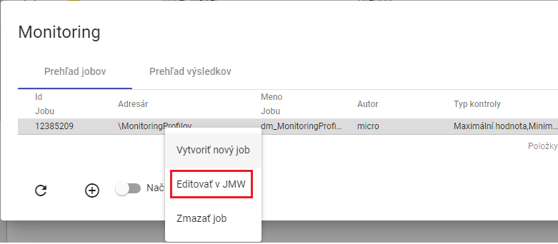

Image 482: Item "Edit on JMW"

1. **[OLLAMA FORMATTING ERROR - MANUAL REVIEW NEEDED] V novej záložke v prehliadači sa otvorí job v aplikácii „Job Manager“.**

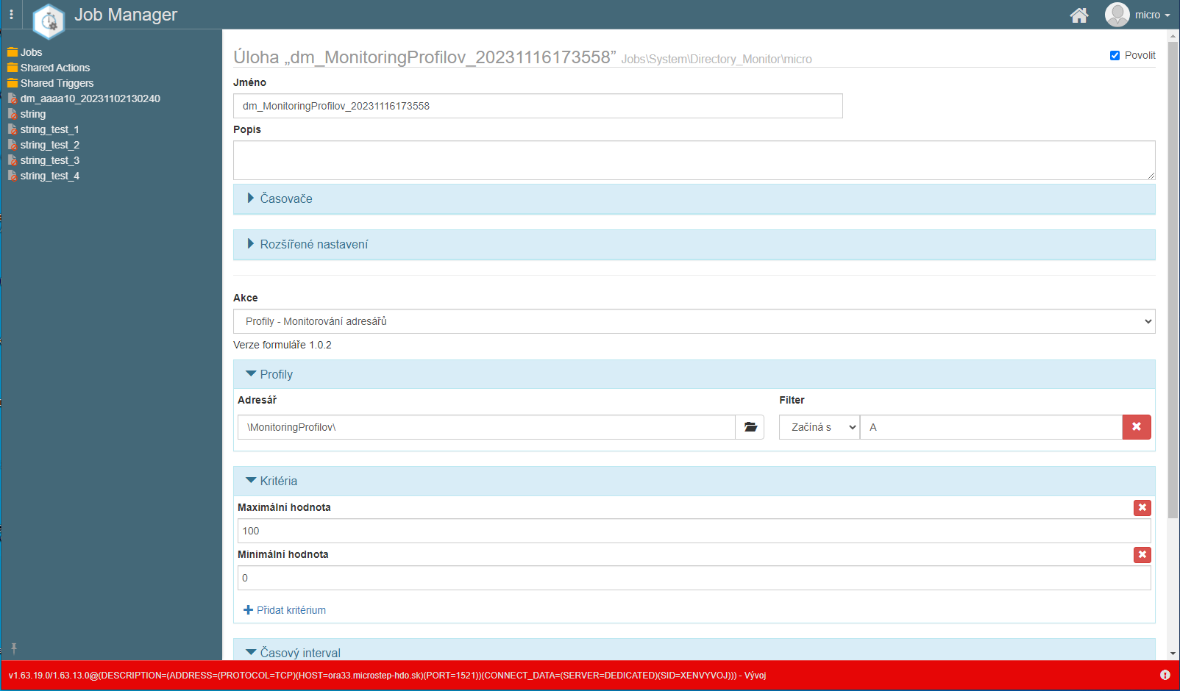

Picture 483: Adjustment of right in application "Job Manager"

1. **[OLLAMA FORMATTING ERROR - MANUAL REVIEW NEEDED] Postup pre úpravu jobu sa nachádza v dokumentácii k aplikácii „Job Manager“.**

### **[OLLAMA FORMATTING ERROR - MANUAL REVIEW NEEDED] Ako zmazať job**

**[OLLAMA FORMATTING ERROR - MANUAL REVIEW NEEDED] Pre zmazanie jobu postupujte:**

1. **[OLLAMA FORMATTING ERROR - MANUAL REVIEW NEEDED] Kliknite pravým tlačidlom myši v okne „Monitoring“ na job, ktorý chcete zmazať.**

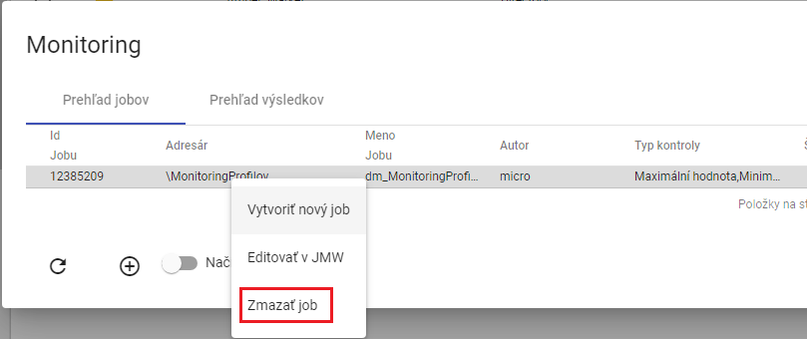

"Picture 484: Item 'Delete job'"

1. **[OLLAMA FORMATTING ERROR - MANUAL REVIEW NEEDED] Zobrazí sa okno pre potvrdenie vymazania, v ktorom stlačte tlačidlo „Áno“.**

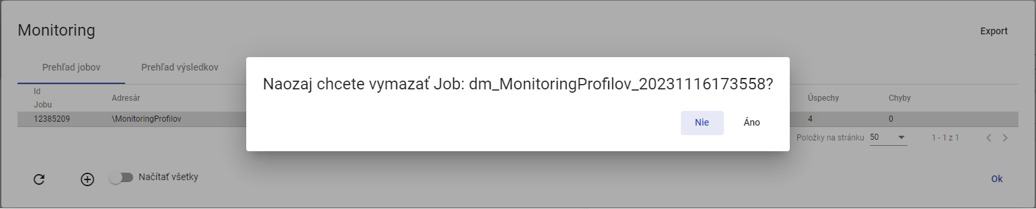

Picture 485: Window for confirming deletion of job

### **[OLLAMA FORMATTING ERROR - MANUAL REVIEW NEEDED] Ako exportovať monitorovacie joby a výsledky jobov**

**[OLLAMA FORMATTING ERROR - MANUAL REVIEW NEEDED] Pre exportovanie jobov v záložke „Prehľad jobov“ stlačte tlačidlo „Export“, ktoré sa nachádza v pravom hornom rohu okna „Monitoring“. Pre exportovanie výsledkov jobov zobrazte záložku „Prehľad výsledkov“ a stlačte tlačidlo „Export“. Stiahne sa CSV súbor.**

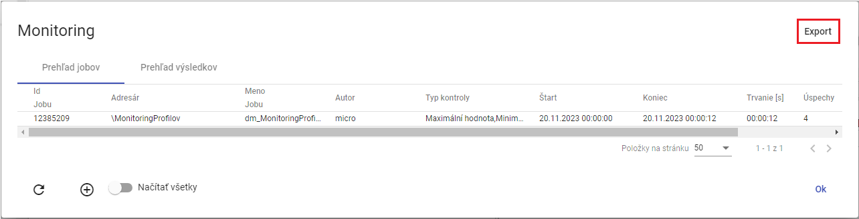

Image 486: Export button

### "Show all monitoring jobs"

"Before showing all monitoring jobs click the 'Load All' button. In the 'Monitoring' window, all monitoring jobs from the tree structure will be displayed."

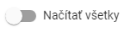

Image 487: Load All button

### "If I were to refresh the list of jobs in the 'Monitoring' window"

"Before preloading the list of jobs, click on the button located in the bottom left corner of the 'Monitoring' window."

### "To view the summary results of a monitoring job"

In the "Monitoring" window, display the tab "Results Overview". A list of running monitoring jobs is located here. If the criteria by which the profile is monitored are violated, the text "ERR" will appear in the column "result", and in the column "detail" there will be a description of the error. If the criteria have been met, the result is "OK".

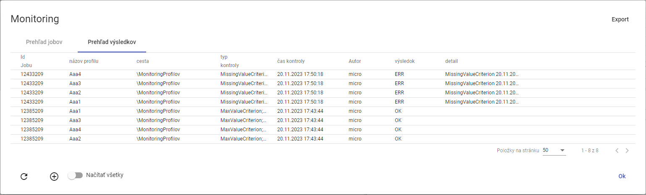

Picture 488: Bookmark "Summary of Results"

## Profile analysis

Analysis of profiles presents a static image at a given time of computation. This means that if someone erased the profile, the analysis of profiles remains preserved. The analysis of profiles allows the user to filter and order data. Chapter 8.2.1 deals with creating an analysis of profiles.

"If you close the profile analysis window, you can reopen it. Opening an existing profile analysis is detailed in chapter 8.2.2."

Analysis of profiles is valid for 15 minutes after creation. Validity can be extended. The procedure is located in chapter 8.2.3.

"The export of the data shown in profile analysis is elaborated on in Chapter 8.2.4."

### Create profile analysis

"Proceed before creating an analysis of profiles:"

1. "Click the right mouse button on the folder with profiles you want to create a profile analysis for in file structure."
2. "A window will appear where you click on the item 'Analysis of profiles'."

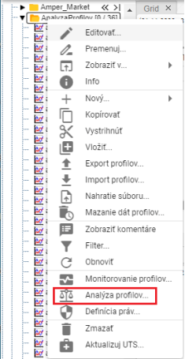

Image 489: Item "Profile Analysis"

1. "The second option is to display the address book with profiles in the 'Explorer' window and click on the 'Statistics' button, which can be found in the top right corner of the 'Explorer' window."



Image 490: Statistics button

1. An analysis window will appear.
2. Standardly, the selected option is "Create a new period".

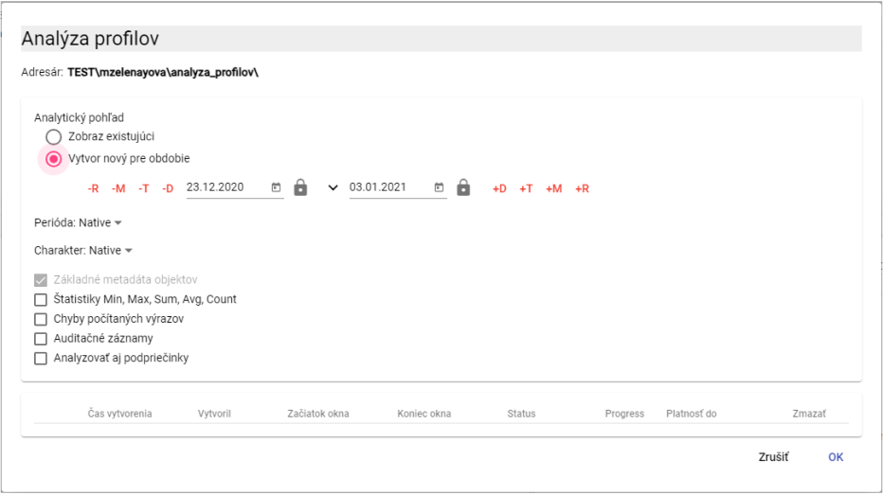

Image 491: Window of "Analysis profiles"

1. "Continue the period for which a profiles analysis will be carried out. Click on the button to display preselected date range options."

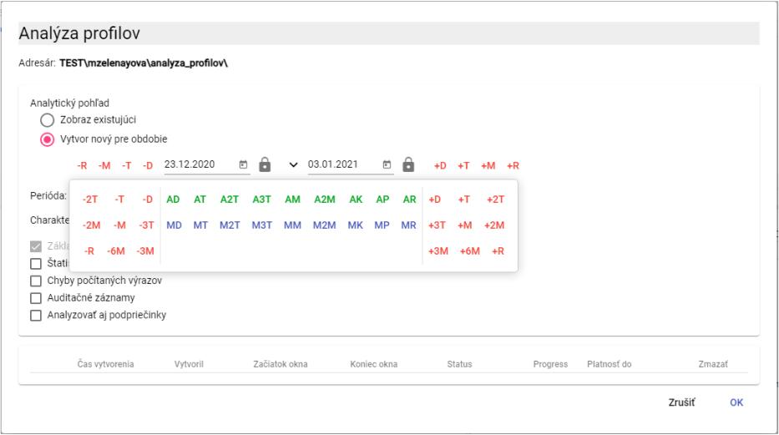

Picture 492: Date selection

1. "Standardly, the value 'Native' is in the field 'Period'. If you want to enter another period, click on the 'Period' field and select a period."

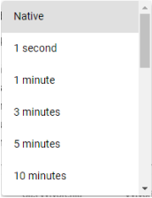

Picture 493: Period selection

1. "The character profile is used for identifying how the values are passed from coarse to finer sampling. Normally, in the 'Character' field, the value is 'Native'. To select a character, click on the 'Character' field and choose 'Counting' or 'Behavioral'."

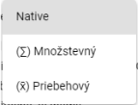

Image 494: Character selection

1. "If you want to calculate statistics in the analysis, click on the box 'Statistics Min, Max, Sum, Avg, Count'."

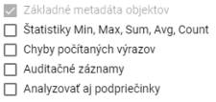

Picture 495: Optional Items in Analysis

1. "If you want an error to be printed in case of occurrence, click on the checkbox 'Counted expressions errors'."
2. "Select the 'Audit Trail' document to print the following information: First Read, Last Read, First Write and Last Write."
3. "All subfolders should also be included in the analysis, click on the box 'Analyze subfolders as well'."
4. "Click on the 'OK' button before running the profile analysis."
5. "In the window 'Inspector' a new tab will be created with the title 'Recipient's name'. Analysis of profiles presents a static image at a given time of calculation."

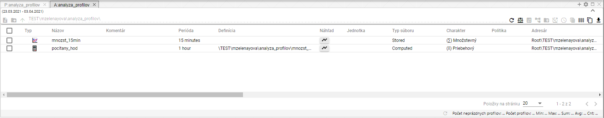

Picture 496: Created profile analysis

1. "In the analysis window profile you can filter data. Move your cursor to the column name where you want to enter a filter. A button for entering a filter will appear."



Image 497: Button for filter assignment

1. "Before sorting data in a column, place the cursor on the column name with your mouse pointer. An arrow icon will appear. Clicking on it will sort the data in the column."



Picture 498: Sorting key for dates in columns.

### To display an existing profile analysis

"If you've already finalized your profile analysis and want to reopen it, you can do so during the validity period of the profile analysis. Profile analysis is valid for 15 minutes after its creation. This validity period may be extended."

"Proceed with existing profile analysis:"

1. "In the window 'Analysis of profiles', click on 'Show existing'""
2. Click on the analysis you want to display.

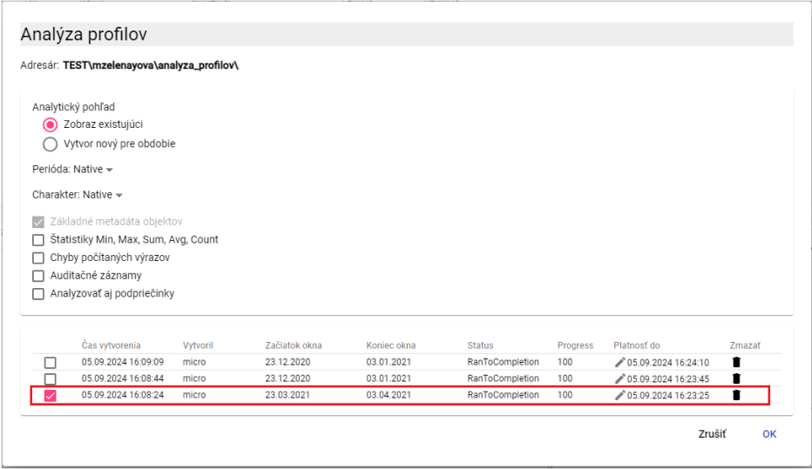

Picture 499: Display of existing analysis profiles

1. Press the button "OK".
2. "In the window 'Surveyor' will display profile analysis."

### "How to change the validity of created profile analysis"

The validity of the profile analysis is standardly 15 minutes, but you can extend it.

"Before extending the validity of profile analysis proceed:"

1. "In the 'Analysis Profiles' window of the analysis you want to extend the validity period, click on the pencil icon button."

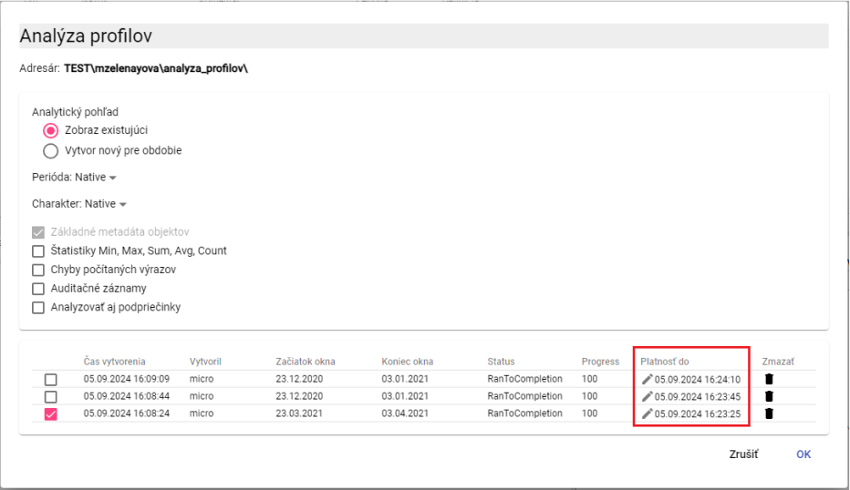

Image 500: Face of "Till Flatness"

1. The "Validity Until" pole becomes available for editing.

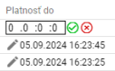

Image 501: Extension of analysis profiles' validity

1. **[TRANSLATION FAILED AFTER 3 RETRIES] Prvé pole reprezentuje dni, druhé pole hodiny, tretie predstavuje minúty, štvrté pole sekundy. Ak chcete platnosť predĺžiť o 2 dni, tak v prvom poli napíšte hodnotu „2“. Ak by ste chceli predĺžiť platnosť o 6 hodín, tak do druhého poľa doplňte hodnotu „6“.**
2. Press the button.
3. The effectiveness of profile analysis is being prolonged.

### Export the data shown in profile analysis

Before exporting data from profile analysis proceed with:

1. Click on the button which is located at the right upper corner of the window "Explorer".

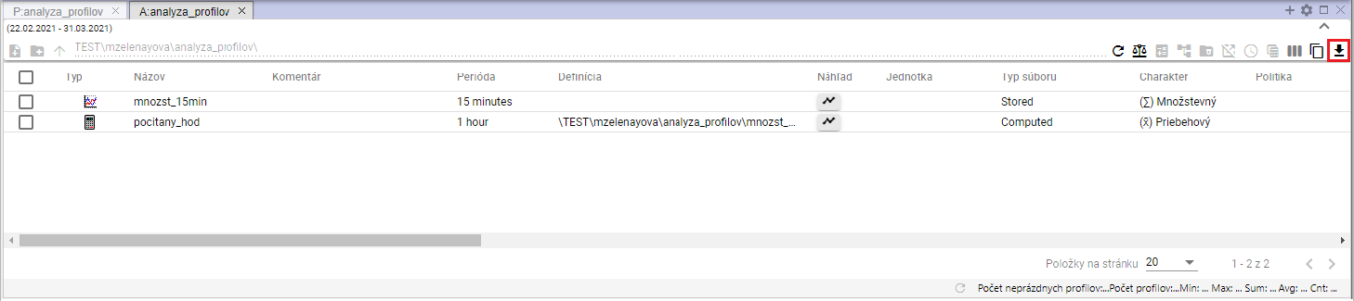

"Image 502: Export button for analysis of profiles"

1. "A window titled „Export“ will be shown."

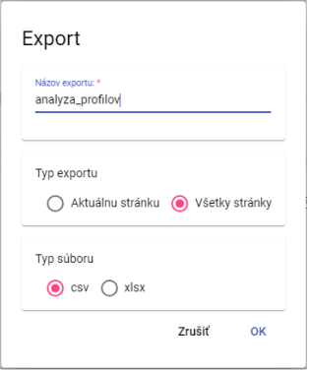

Image 503: Export Window

1. "In the section 'Export type', the standard setting is 'All pages'. All data are exported. If you select 'Current page', only shown data are exported."
2. "In the section 'Type of Collection', choose a type of collection for export."
3. Press the "OK" button after confirmation of export.

## Report Manager

### How to create a new report

Before creating a report, proceed with:

* 1. "In the folder structure, click the right mouse button on the folder where you want to add a new report."
  2. "An offer will appear in which you can click on the point 'New' with your mouse cursor and then select the point 'Report'."

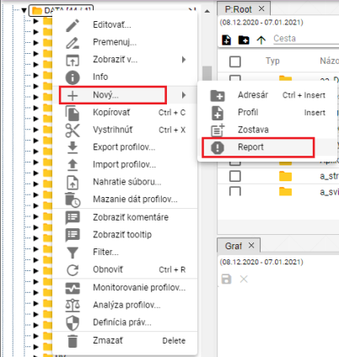

Image 504: Item "Report"

* 1. "A bookmark called 'Report Manager' will be displayed, where you enter data for the new report."

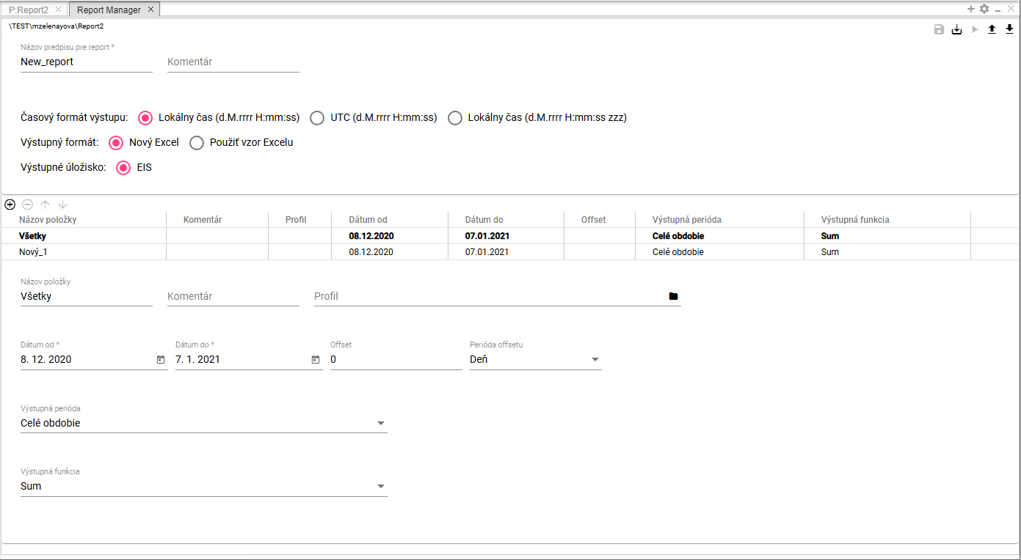

Snapshot 505: Bookmark "Report Manager"

* 1. In field "Name of the regulation for report" is automatically written "New_report". You can change it.

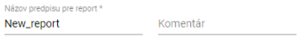

Picture 506: Fields "Name of prescription for reporting" and "Comment"

* 1. "In the 'Commentary' section, you can write a comment."
  2. Select the time output format. By default, select "Local time (d.m.yyyy H:mm:ss)".



Image 507: Poland - Time Format Output

* 1. In the field "Output Format", select an output format for the report. By default, the selection is set to "New Excel".



Image 508: Section "Output Format"

* 1. If you choose the option "Use Excel template", fields "Excel Name" and "Worksheet name in Excel" will appear.

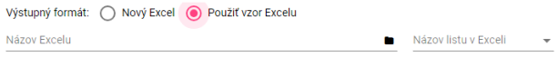

Image 509: Fields for Excel task

* 1. Click on the button "Excel Name" in the forest structure to select an Excel file.

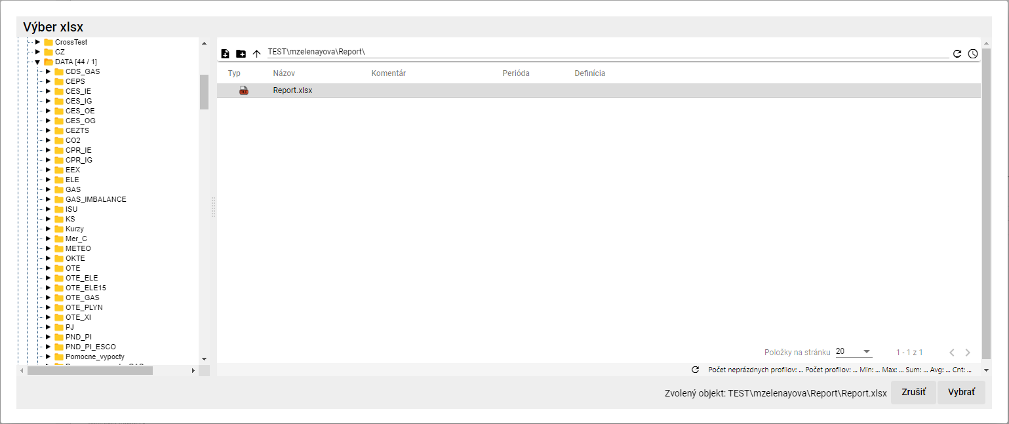

Picture 510: Window "Select xlsx"

* 1. "In the window 'Choose xlsx' after searching for Excel, click on the button 'Select'. The path to Excel will be completed in the field 'Name of Excel', Image 511."
  2. Click on the field "Sheet name in Excel" and select the sheet name.



Picture 511: Fields filled with the name of Excel and the name of the sheet in Excel.

* 1. Fill out data for items.

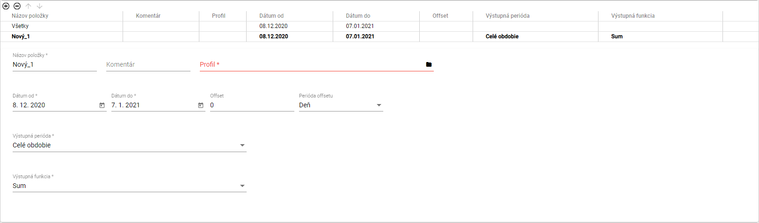

Image 512: Task data for items

* 1. "If you want to fill the same data for all items at once, click on the item 'All'. The data you enter will be filled in for all profiles."
  2. "If you want to fill in the data for each profile separately, click on the item in the table whose data you want to enter."



Image 513: Selected item in table

* 1. Fill in the data below the table. The data will automatically be filled into the table.
  2. In the field "Name of item" is automatically filled with "New_1". You can change the name.
  3. You can write a comment on the website “Commentary”.
  4. In the field "Profile" write the path to your profile or click on the button and a window titled "Select Profile" will appear.
  5. In the window “Profile selection” search for the profile and click on the button “Select”.

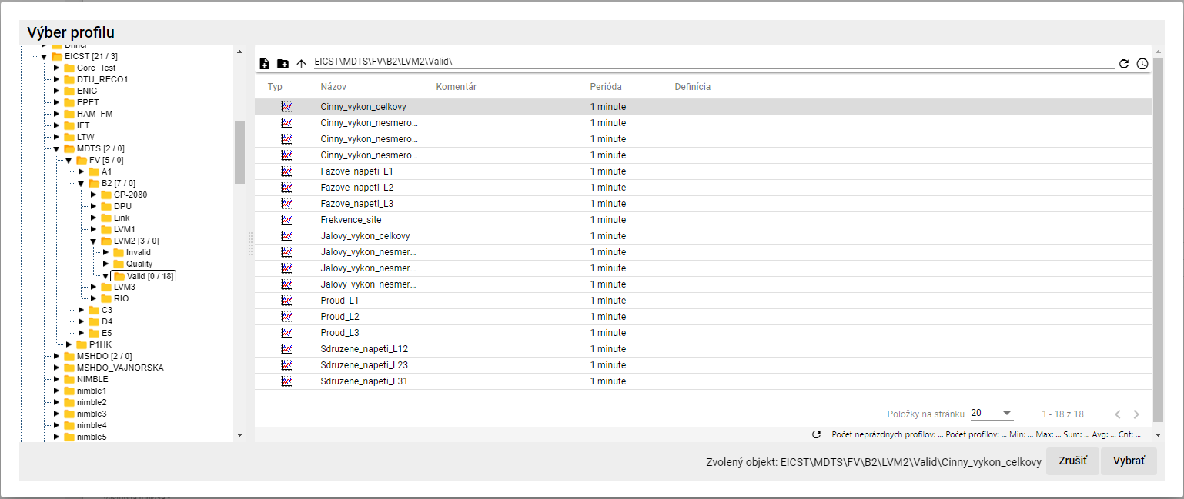

Picture 514: Profile selection window

* 1. Select dates "Date from" and "Date until".
  2. In the menu "Offset" you can enter an offset.
  3. Choose an era of "The Offset Period".
  4. Click on the field "Output period" and from the displayed offer select the period.
  5. Click on the field "Exit Function" and select the function.

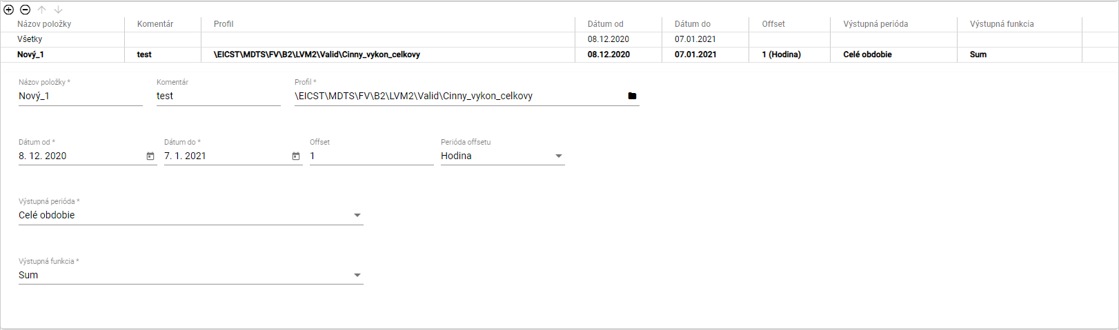

Image 515: Filled-in data for item

* 1. You can also add a profile by dragging it from the tree structure to a table in the "Report Manager" bookmark. In the tree structure, click on the profile with your left mouse button and drag the profile over the table. Release the profile, which will be added as a new item to the table.

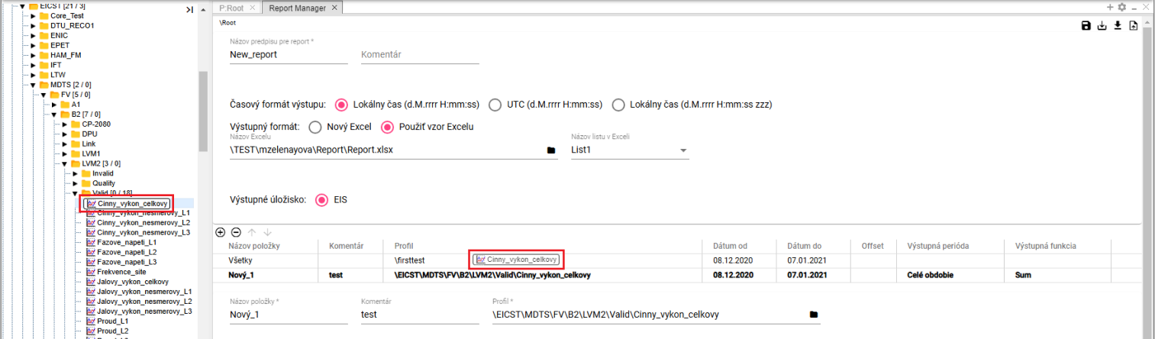

"Image 516: Profile transfer from tree structure to table"



Picture 517: Added profile from tree structure

* 1. You can also add profiles to the "Report Manager" bookmark from a scanner. Click on the profiles you want to transfer to the table in the "Report Manager" bookmark in the scanner window. Grab the profiles with the left mouse button and move them over the table in the "Report Manager" bookmark. Release the profiles. The profiles are added to the table in the "Report Manager" bookmark.

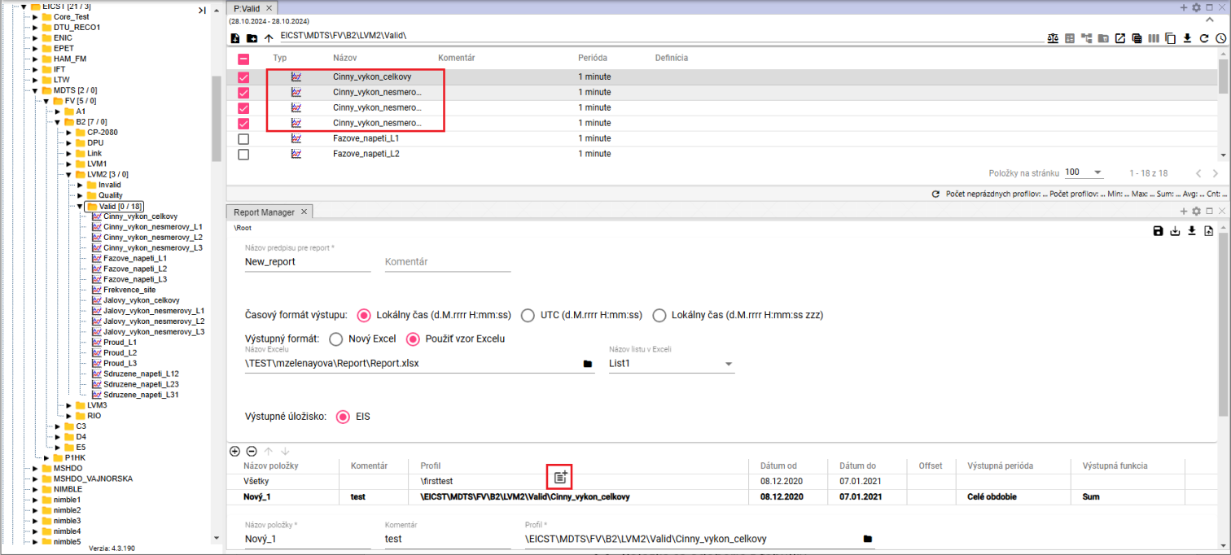

Image 518: Importing profiles from a table into the Report Manager using the Drag and Drop function

* 1. "You can add another item by clicking on the button ."
  2. "If you want to remove an item, click on the item in the table and press the button . The item will be removed from the table."
  3. "The order of columns in the table can be changed using buttons ."
  4. "You will save the report by pressing the button 'Save', which is located in the top right corner of the screen 'Report Manager'. The report will be saved to the folder with a tree-like structure where you created the report."



Image 519: Save button

* 1. If you want to save the report to another recipient, click on the button "Save as..."
  2. The window "New Report" will appear.
  3. In the menu "Path", set a path to a new recipient or find an address book using the button "."

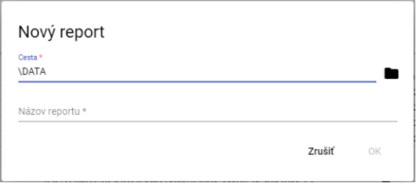

Image 520: Window "New Report"

* 1. In the field "Report title" write the title of the report.
  2. You will save the report by pressing the "OK" button.
  3. "A report will be generated by clicking on the 'Generate Report' button, which can be found in the top right corner of the 'Report Manager' screen."



Picture 521: Generate Report Button

* 1. "A window titled 'Time Range Settings' will appear, where you can select the time range."

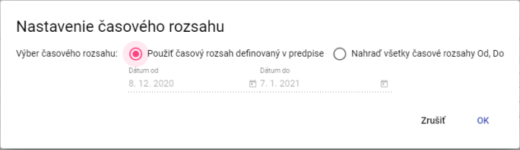

Image 522: Window "Time Range Settings"

* 1. "Click on the 'OK' button before generating the report."
  2. "Click on the 'Export' button in the top toolbar after generating a report to display the 'Export' window."
  3. "Click on the 'Download' button located in the line generated report, which is labeled as 'Export'."

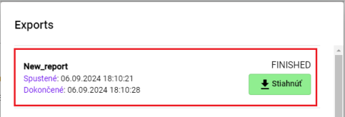

Picture 523: Generated report

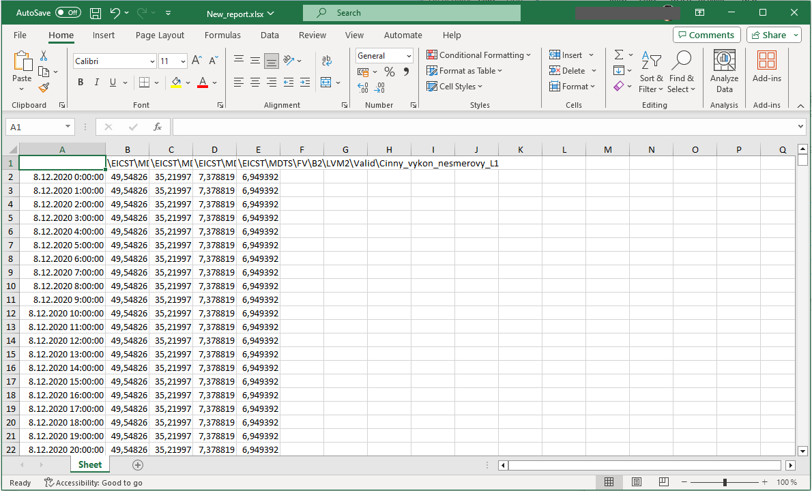

Image 524: Downloaded report

* 1. "You can save the summary on the disk in CSV or PGZ2 format. To download the summary, click the 'Save summary to disk...' button and select the report format in which it should be downloaded. The report will be saved among the downloaded files on your computer."

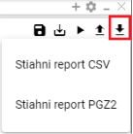

Image 525: Offers a printer "Save configuration to disk..."

### Rights for Report Manager

Before "Report Manager", it is possible to set rights:

* The read-only user does not have the right to "read", will not open a form or pgz and/or pgz2.
* The user does not have the right to "Create", is not allowed the button "Save as..." and will not appear in the menu "New..." option to create a "Report".
* The user will not have the right to "Write", the "Save" button will be disabled, and only the "Save As..." option with saving on disk will be allowed.
* The user does not have permission to execute, the 'Generate Report' button is not allowed.

## "If I could restore deleted items from the basket"

You will restore items from your shopping cart.

1. Show the contents of the basket in a tree structure or in the Windows Explorer, 4.14.



Picture 526: A tree with a cavity in its structure

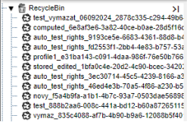

"Picture 527: Displaying basket contents in a tree structure"

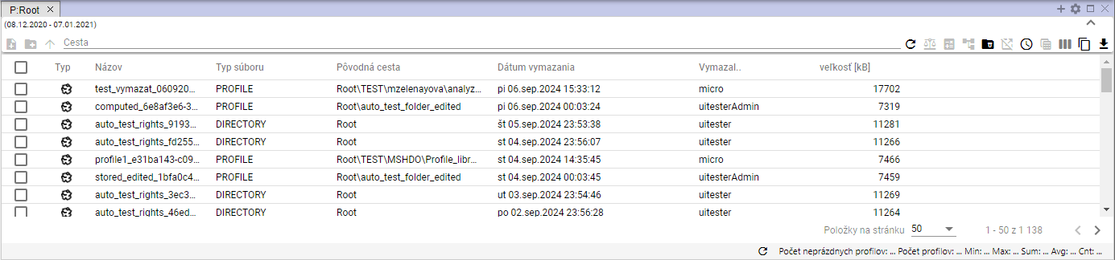

Image 528: Screenshot of contents of basket in window.

1. "Click on the right mouse button on the item you want to restore in your basket."
2. "An offer will be shown where you select 'Restore from basket'."

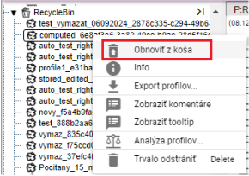

Image 529: Item "Restore from trash"

1. "A window called 'Restore collection' will be shown."

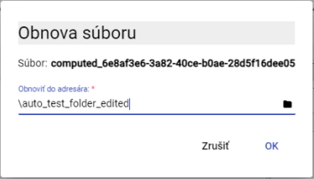

Image 530: Window "Reconstruction of the Church"

1. In the directory "Restore to recipient" you will find the path to the recipient from which the file was deleted. If you want to restore the file to another recipient, enter the path to the recipient or search for the recipient using the button "."
2. "After confirmation of the orchestra's revival, click on the 'OK' button."



2025 MicroStep - HDO spol. s r.o.

"MicroStep and MicroStep-HDO are registered trademarks. This document is the intellectual property of company MicroStep-HDO s.r.o. and may be used only for purposes to which it was delivered."

*MicroStep-HDO s.r.o., Vajnorská 158, 831 04  Bratislava*

*www.microstep-hdo.com, e-mail: info@microstep-hdo.sk*